Hi!
If you read this document so you bought my asset!
In this game all is simple. All code has summaries.

- Before building this game to your phone you need to download the latest version of Admob plugin for Unity from there: https://github.com/googleads/googleads-mobile-unity/releases/tag/v4.0.0
- After downloading complete import GoogleMobileAds.unitypackage to project. And finish steps from guide here:
https://developers.google.com/admob/unity/start
- In the Unity editor click Menu→Assets→Play Services
Resolver→Android→Force Resolve.
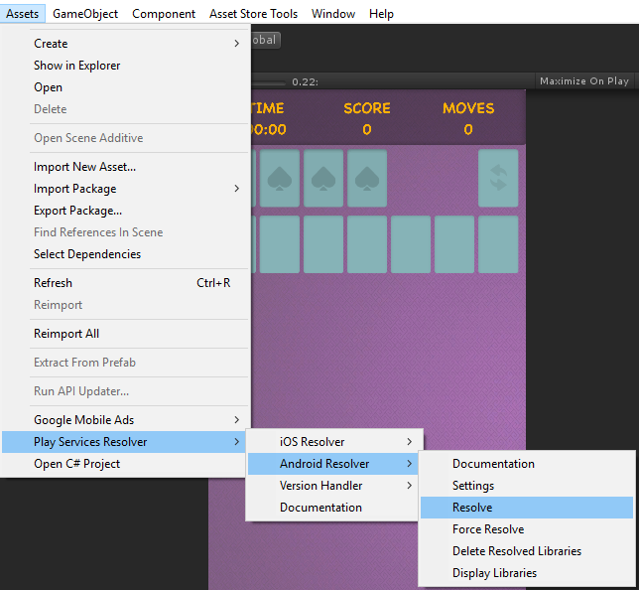
Then to show advertisement in your build you need to change advertisement id:
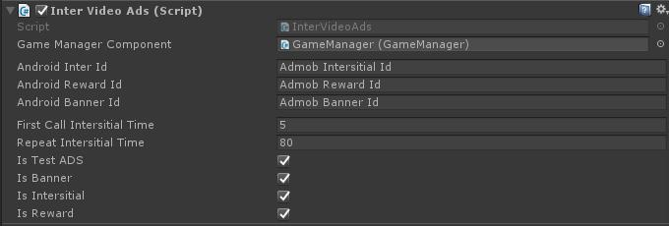
- Open InterVideoAds.cs script in the scene, (It was added to object AdsManager) and change it there.

- For activating test ADS you should set IsTestADS variable to TRUE before play (like on screen). For deactivating test ADS you should set IsTestADS variable to FALSE before play.
- Undo logic has option for counting available uses. When counter equals 0 for getting additional uses user should watch Rewarded video. More information in videos at asset page. 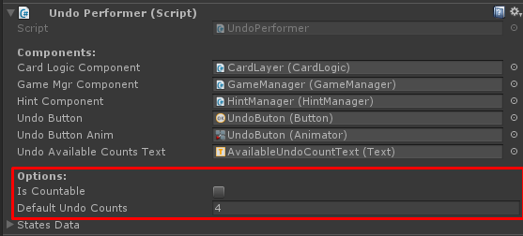

- Game include “Last game” option. You can check it at:
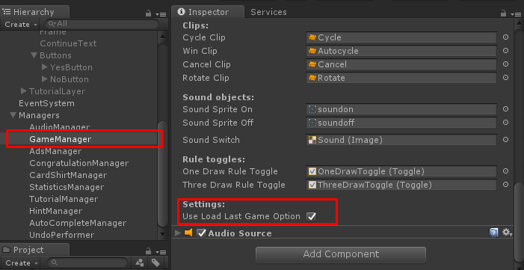
Principle of work:
- User open new game session. When user close application the system save last game state(decks, cards, score, time, steps). When user open game again the system show popup:
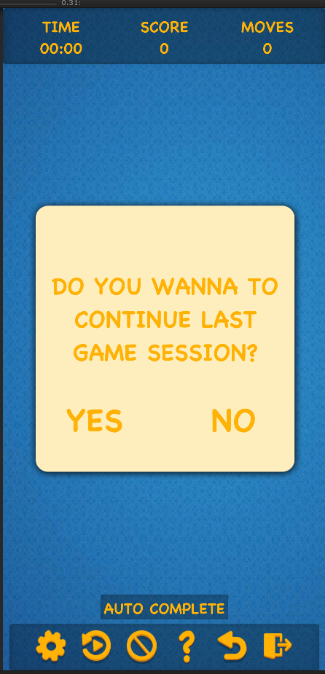
For other questions write me an email: support@selvassets.ltd.ua
Thank you for advance!

