THE STOLEN SZECHAUN SAUCE

By: Max Daguste

:

For: LIGHTHOUSE LABS WEEK 10

Table of Contents
- Introduction
  - Overview and Objectives
  - Tools Used

- Analysis
  - Server Operating System
  - Server Local Time and Network Activity
  - Encryption Details
  - Desktop Operating System
  - Confirmation of Breach
- Summary
  - Key Findings
- Conclusion
  - Lessons Learned
- References

Introduction:
In the following task, we are set to conduct an analysis of the CASE-001 and CASE-002 files, which pertain to the infamous Stolen Szechaun sauce case https://dfirmadness.com/the-stolen-szechuan-sauce/ . Our analytical approach will involve the utilization of three essential tools: FTK Imager, Registry Ripper, and Autopsy. It cannot be overstated how crucial it is to operate exclusively on a duplicate of the disk image. This precautionary measure guarantees that no modifications or adjustments are made to the original data. Preserving the integrity of the data is paramount, as any irreversible changes could potentially hinder future recovery efforts and compromise its viability as admissible evidence.
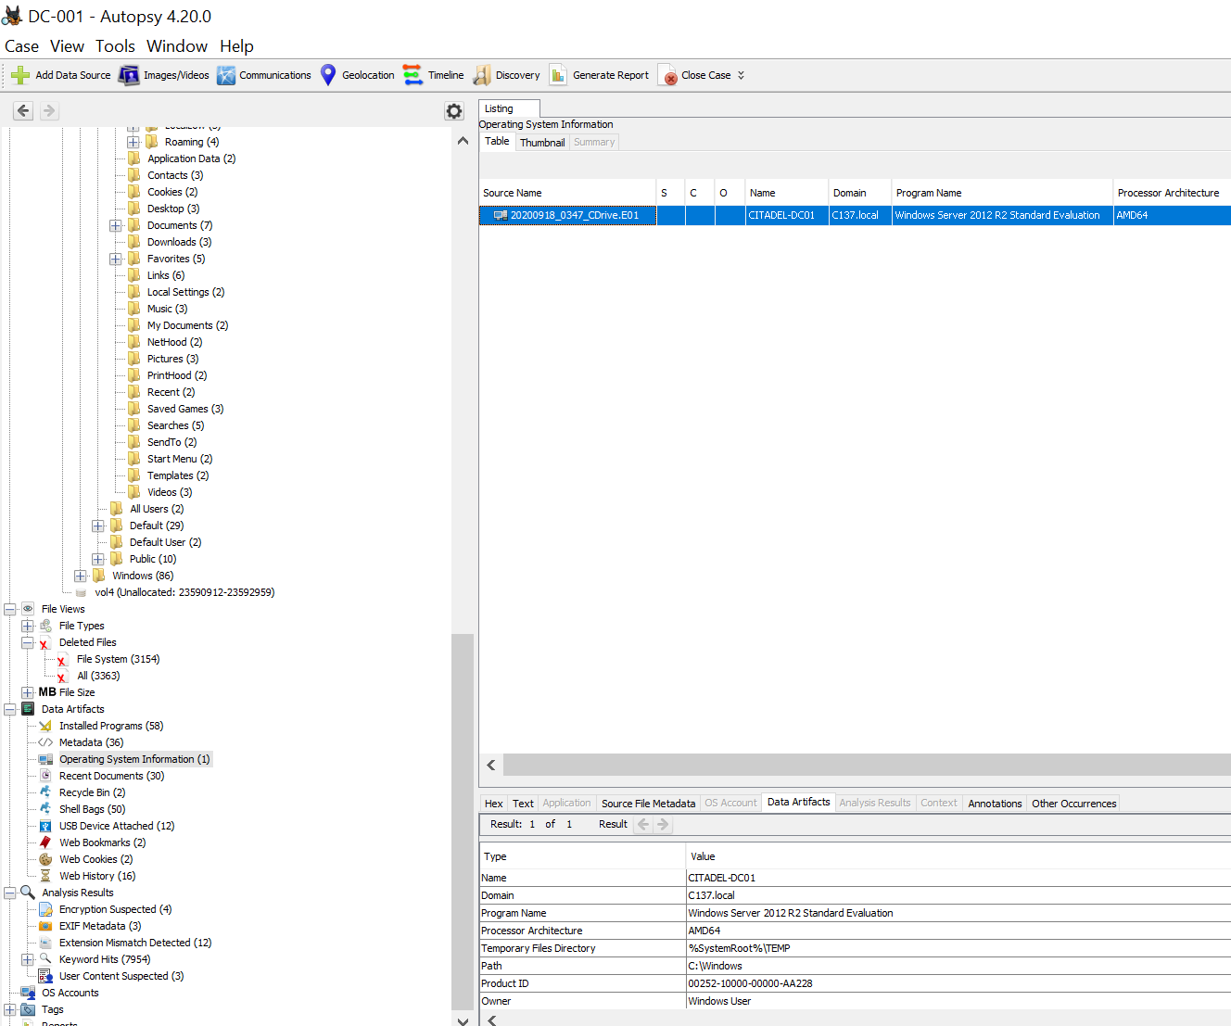
Figure 1

Questions to Answer / Goals
- What’s the Operating System of the Server?

Looking into the cd drive E01, analyzing the artifacts, going through the operating system section, and selecting the meta data revealed that the Operating System is Window Server is 2012 (Figure 1).

- What was the servers Local time?
Figure 2
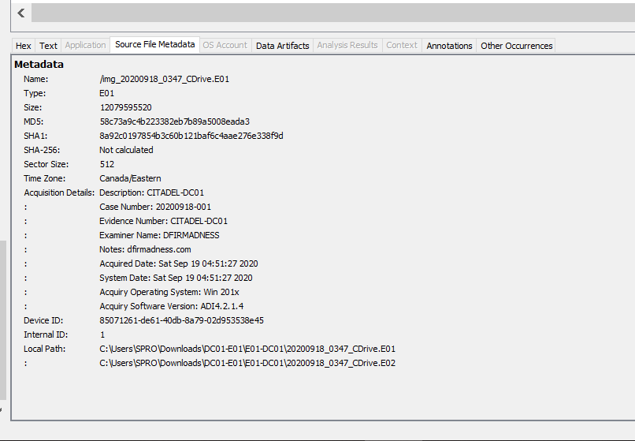

The server’s local displays Saturday September 19, 2020, at 04:51:27 in the morning. The absence of AM/PM suggest the data is registered on a 24h clock (Figure 2). Confirming the potential time of the attack, a Wireshark capture of the specific time and date has been searched through the following filter frame.time relative >= 27636.296028 && frame.time relative < 27637.296028. The following has been uncovered:

Figure 3
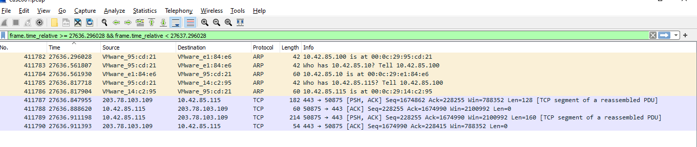

The provided (Figure 3) network capture indicates the presence of an NMAP scan within the network. Multiple Address Resolution Protocol (ARP) requests in the capture suggest that the scanning activity was underway. Notably, the IP address associated with the attacker's system is identified as 10.42.85.100.
During this scanning activity, the attacker successfully uncovered crucial network information. Specifically, on line number 411786 of the capture, the attacker identified the IP address of a target system as 10.42.85.115 and also determined its associated MAC address as '00:0c:29:14:c2:95.' This reconnaissance phase is indicative of an attempt to gather information about the targeted system, potentially for further exploitation or unauthorized access.

Figure 4
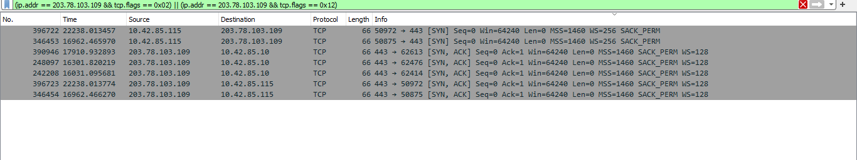
In the packet capture (Figure 4), we observed a three-way handshake on port 443, indicating the establishment of a TCP connection. The handshake was initiated by the unauthorized IP address 203.78.103.109, which sent a SYN (Synchronize) packet. In response, the remote IP address 10.42.85.115 replied with a SYN-ACK (Synchronize-Acknowledge) packet. Finally, the unauthorized IP address 203.78.103.109 acknowledged the response with an ACK (Acknowledge) packet.

Details about the encryption MD5 and SHA1 (From Figure 2):

SHA-1 (Secure Hash Algorithm 1) and MD5 (Message Digest Algorithm 5) are cryptographic hash functions that were widely used in the past but are now considered deprecated and insecure for several reasons:

SHA-1 flaw:
Prone to Brute Force Attacks: As computational power increases, it becomes easier for attackers to carry out brute-force and collision attacks. This means that over time, the security of SHA-1 deteriorates further.
The Server IP Address is 10.42.85.115

MD5 flaw:
Prone to pre-image attacks: MD5 is also susceptible to pre-image attacks. These attacks involve finding an input that matches a given hash value. While these attacks are generally harder than collision attacks, they are still a concern for MD5's security.

Due to these vulnerabilities, both SHA-1 and MD5 are no longer recommended for cryptographic purposes. Instead, more secure hash functions like SHA-256 and SHA-3 are recommended for applications where data integrity, authentication, and security are critical.

- What’s the Operating System of the Desktop? Windows 2010
To uncover the Operating System of the Desktop, the same process of question one has been applied.

Figure 5
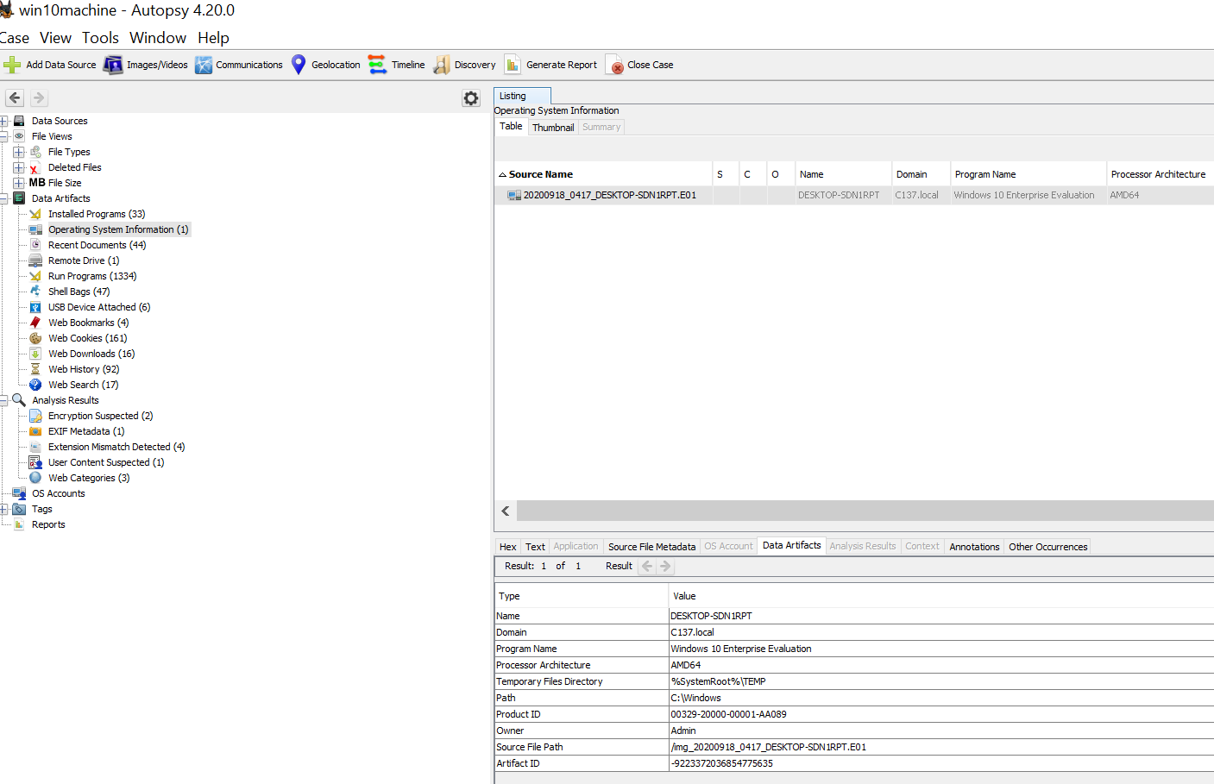

- Was there a breach; Yes there was a breach.

Auto run Files: While reviewing the auto run files, I didn't come across any anomalies. However, it's essential to grasp the significance of these files in the context of malware analysis. Even if malware has been detected and the security team has taken steps to patch the system and remove the malware, it remains crucial to inspect registries and auto run files to confirm that any alterations made have been identified and mitigated. These files can serve as a means for threat actors to maintain persistence on a system. If changes are not detected, or if the issue is not thoroughly addressed, the malware may potentially restart during a system reboot and subsequently relaunch or execute." Even though a breach has happened. It has been difficult has of yet to identify and locate the information detailing the information that has been exfiltrated from the system. There has been a couple of NMAP and the system has not been secured properly with poor encryption processes. There could have been multiple point of entry, but the highly likely one is through port 443.

Figure 6
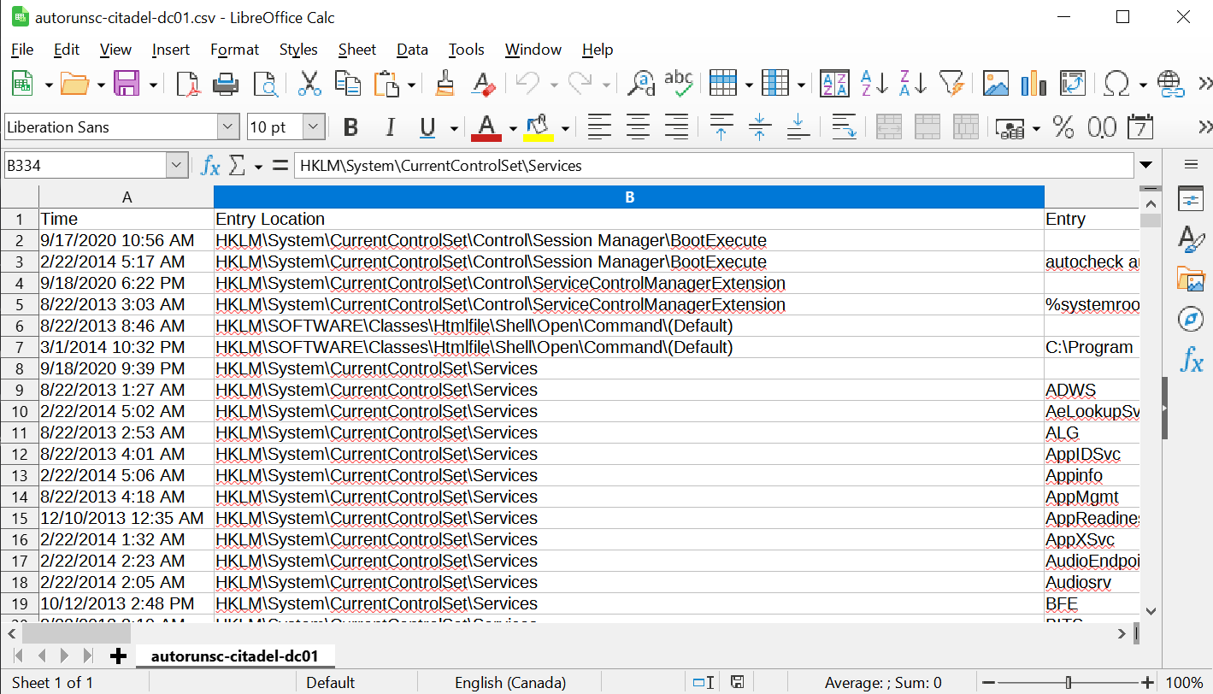
Collaboration with Shawn Perreault

By utilizing the "find packet" feature within the edit tab, I successfully conducted a search for .exe files within the packets. Subsequently, I proceeded to dissect the contents further by employing the "follow TCP stream" option for analysis.

Figure 7
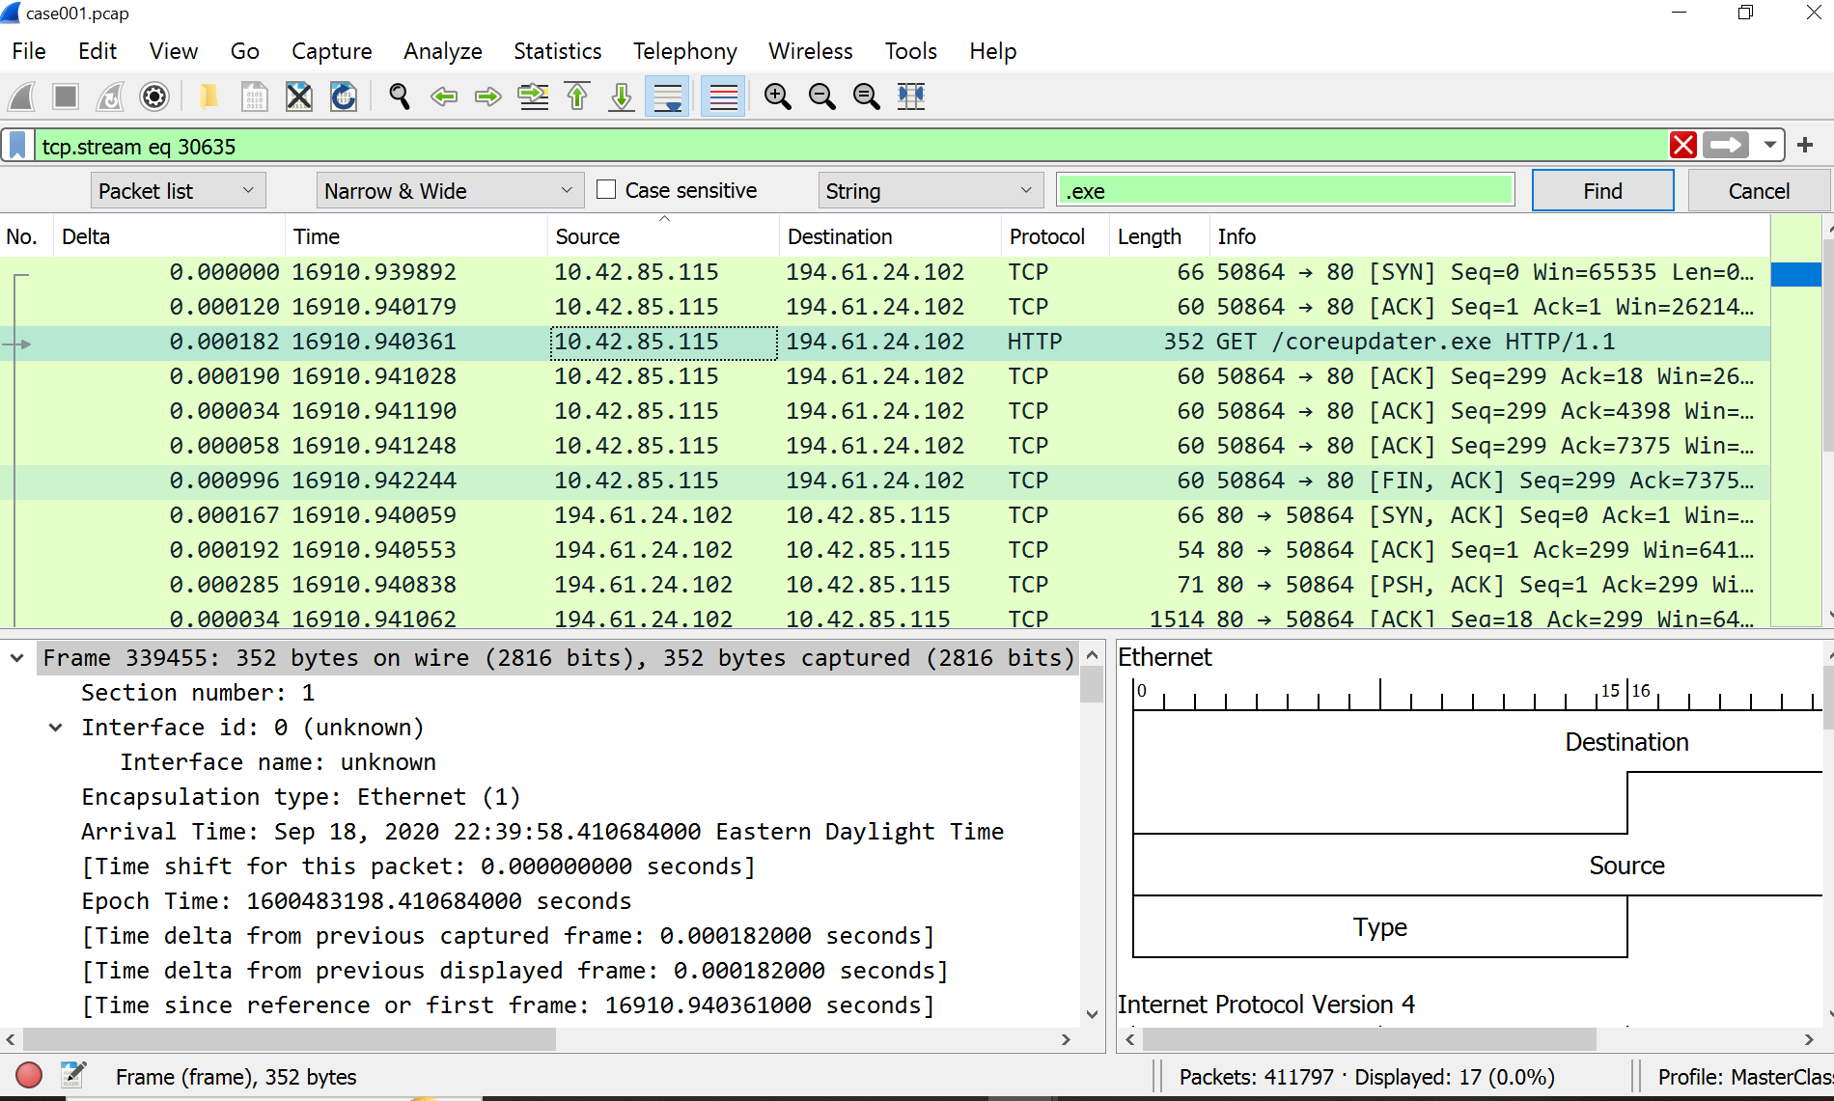

Figure 8

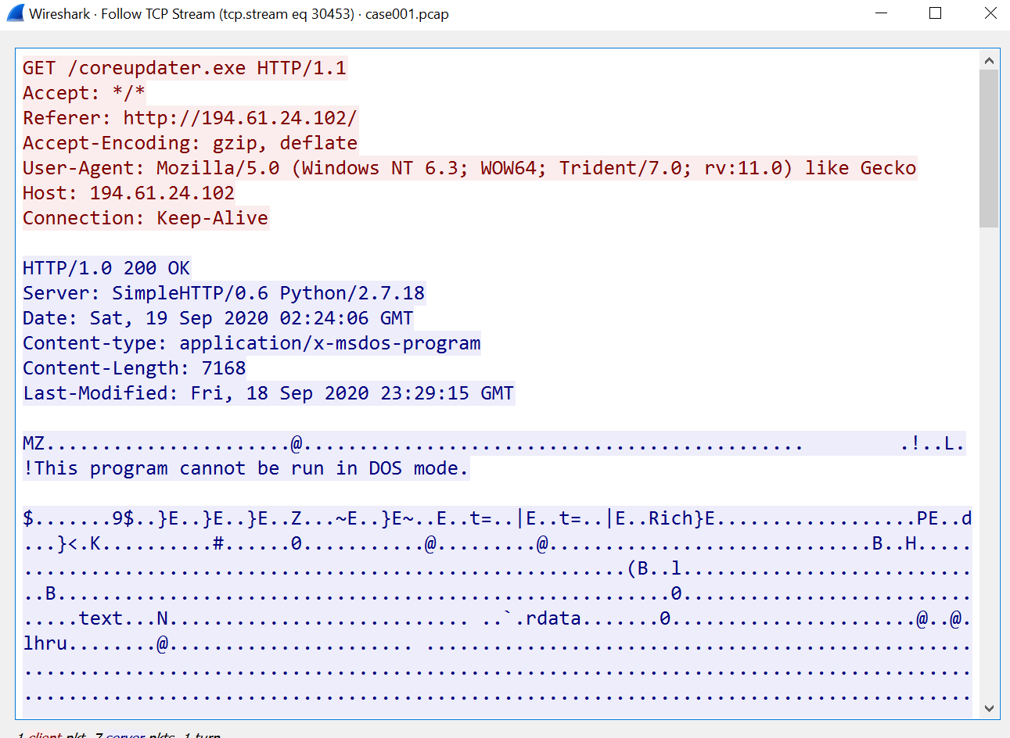

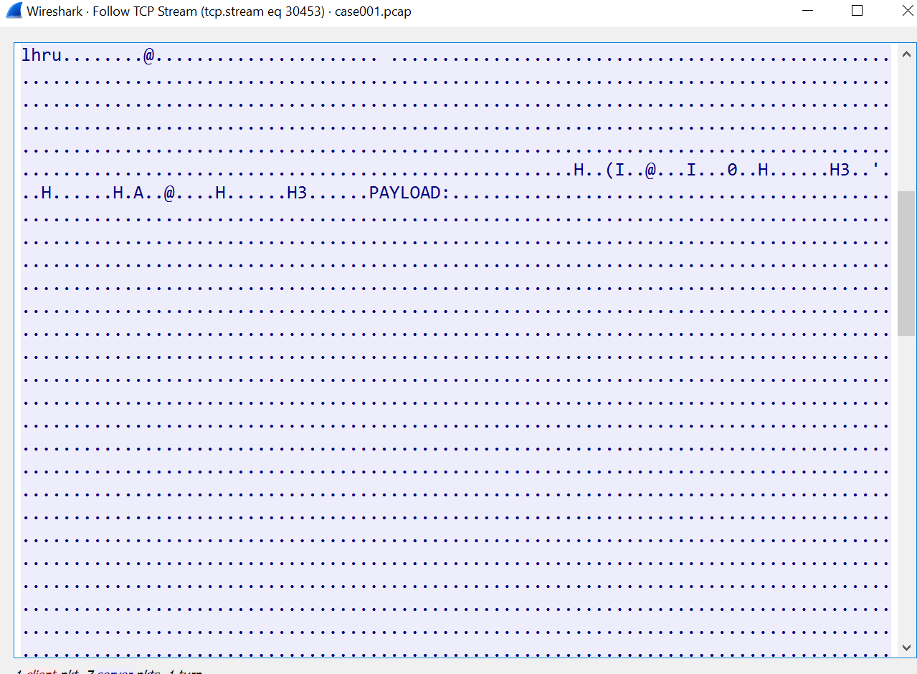
Figure 9

It is unclear whether the attacker had access to the company’s Payload or information, but the data is displayed in the above mentioned capture (Figure 9).

Utilizing Autopsy to search for the file discovered in the Wireshark packet, I successfully exported it to VirusTotal (see Figure 10 below) and conducted a scan on the .exe file. The scan results confirmed the malicious nature of the file. The file is a trojan and was likely the initial way the attacker accessed information from the company before moving laterally through the system with his various scans. This has yet to be proved but is a common practice among attackers/hackers.

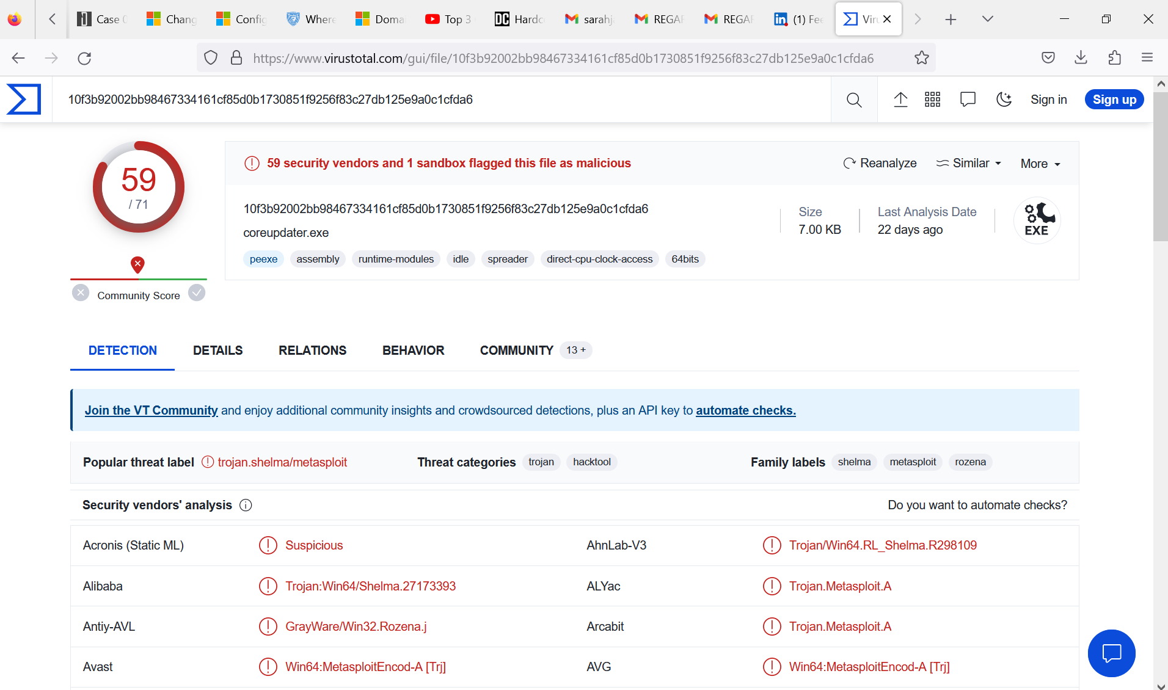
Figure 10

Collaboration with Shawn Perreault

Summary

In this analysis, we focused on examining two key files, CASE-001 and CASE-002, associated with the infamous Stolen Szechuan Sauce case, as detailed in the source here. Our investigative approach relied on three essential tools: FTK Imager, Registry Ripper, and Autopsy. It was emphasized throughout the process that all operations were conducted on a duplicate of the disk image to ensure data integrity and prevent any alterations to the original data.
We set out to answer several critical questions and achieve specific goals:
- We successfully identified that the Operating System of the server in question was Windows Server 2012.
- We determined the server's local time to be Saturday, September 19, 2020, at 04:51:27 AM, using a 24-hour clock format. Furthermore, a Wireshark capture revealed an NMAP scan at this specific time, providing potential insights into the timing of the attack.
- The analysis indicated that the operating system of the desktop was Windows 2010.
- Our investigation confirmed the presence of a breach, primarily due to poorly secured encryption processes and vulnerabilities in the system. While auto run files appeared normal, their importance in malware analysis was highlighted, as they can serve as a persistence mechanism for threat actors.
- Despite confirming a breach, the specific details of the exfiltrated information remain elusive. Multiple points of entry into the system were considered, with port 443 identified as the most likely vector.
- We employed Wireshark to search for .exe files within the packets, followed by a detailed analysis using the "follow TCP stream" option.
- Lastly, we utilized Autopsy to search for and export a file found in the Wireshark packet to VirusTotal, where the scan results conclusively identified the file as malicious.

Conclusion:
The analysis of CASE-001 and CASE-002 files pertaining to the Stolen Szechuan Sauce case provided valuable insights into the security incident. The confirmation of a breach highlighted the importance of robust cybersecurity measures, especially in securing sensitive information and properly encrypting data. The presence of an NMAP scan and unauthorized access attempts further underscored the need for vigilant monitoring and proactive security measures.
While the breach was established, the exact nature and scope of the information exfiltrated from the system remain a critical area of concern. This underscores the challenges associated with post-incident forensics and the importance of continuous monitoring and threat detection.
In conclusion, this analysis serves as a reminder of the evolving nature of cybersecurity threats and the necessity for organizations to adopt comprehensive security practices to safeguard their data and systems. Collaboration with classmates like Shawn Perreault has been instrumental in conducting a thorough examination of the evidence and uncovering potential areas of vulnerability.

References

Research Structure and process
https://www.cisa.gov/news-events/cybersecurity-advisories/aa20-245a

Windows event Loggin Analysis
https://www.csoonline.com/article/569759/how-to-optimize-windows-event-logging-to-better-investigate-attacks.html

Windows registry analysis and what it is
https://learn.microsoft.com/en-us/troubleshoot/windows-server/performance/windows-registry-advanced-users

How to Use FTK Imager (was used as a guideline to understand autopsy)
https://www.hackingloops.com/forensics-toolkit/

What is Malware and how to analyse malware
https://www.fortinet.com/resources/cyberglossary/malware-analysis
https://www.pondurance.com/resource/whitepapers/getting-started-with-malware-analysis/

