Question 1

The model setting is shown as follows:

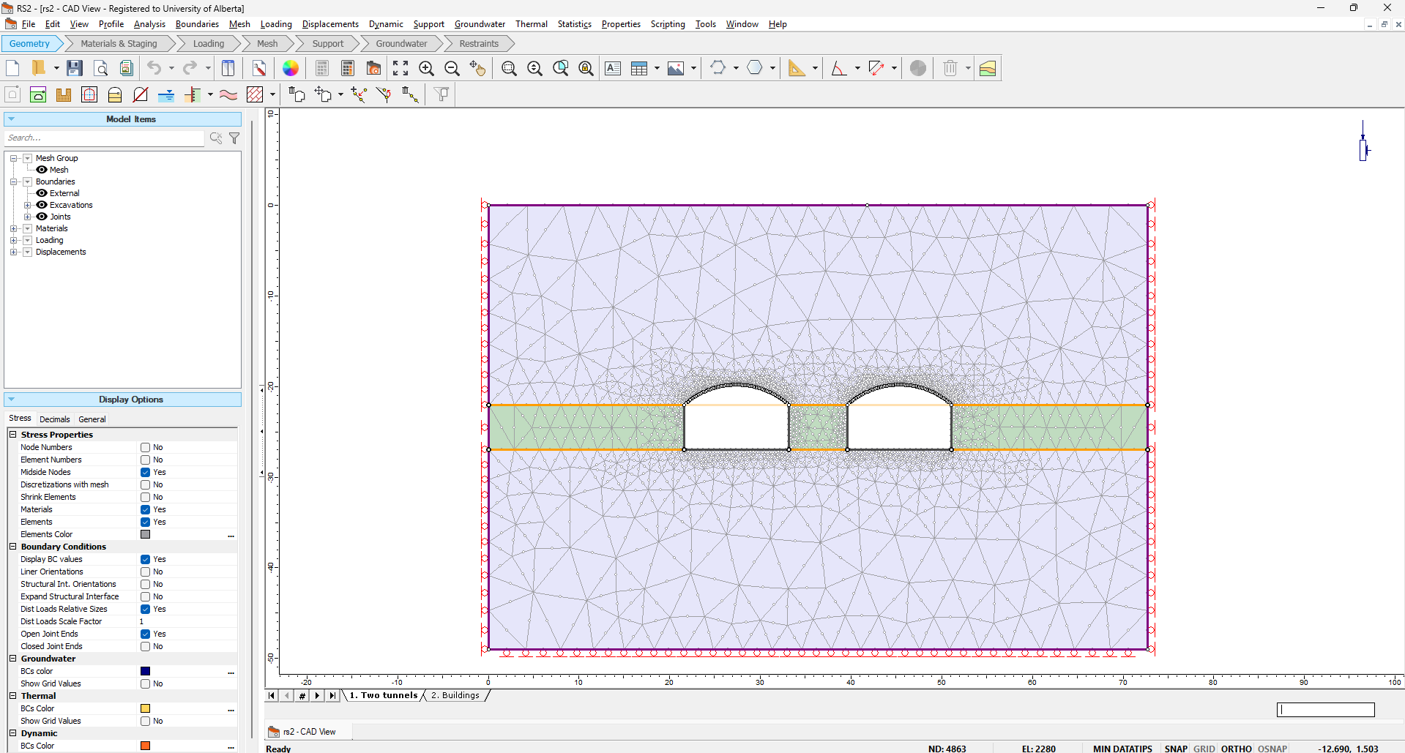 | 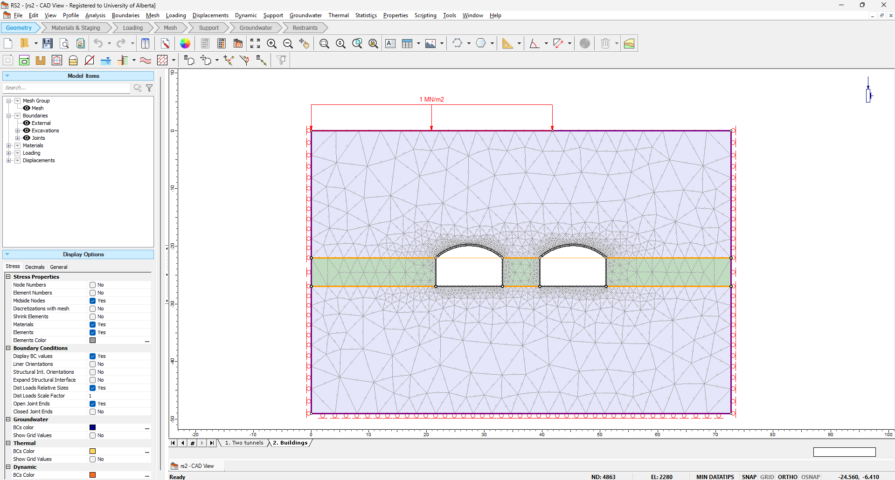
Model setting of Stage 1 | Model setting of Stage 2

After computing, the analysis results can be obtained from the interpretation. The FS (factor of safety) is shown below:
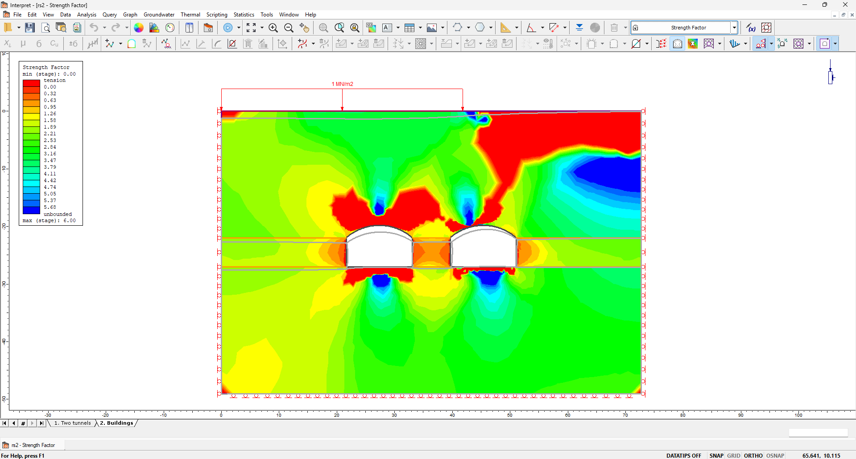

By setting the contour range to 0-1, the dangerous areas can be easily observed.
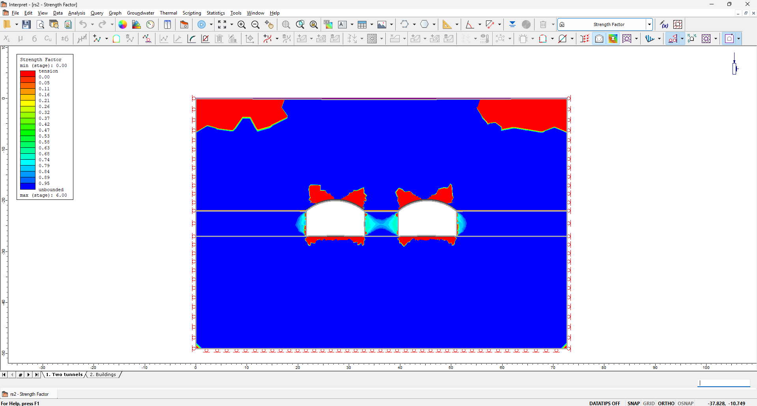 | 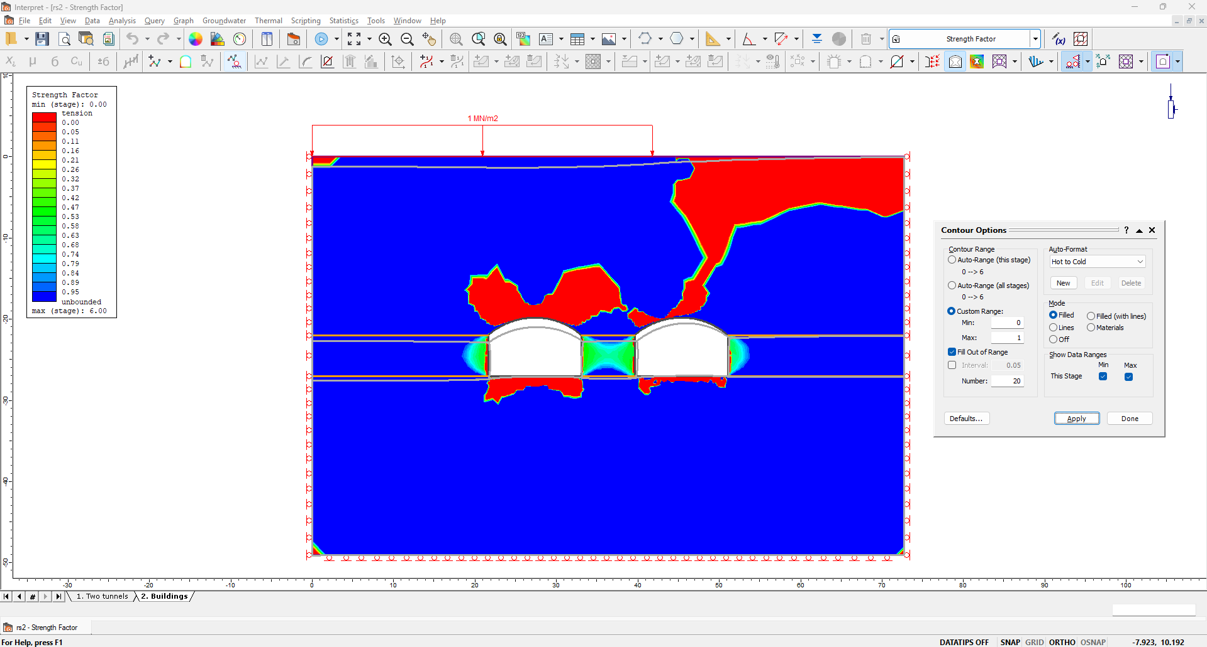
The FS (0-1) of stage 1 | The FS (0-1) of stage 2

Based on this, these two tunnels are unstable. There are massive red areas (FS<1) existing in stage 1 and stage 2, which means these two tunnels will fail.

Changing the analysis to displacement, we found that the rock mass underneath the building will generate relatively large vertical displacement, as shown below.

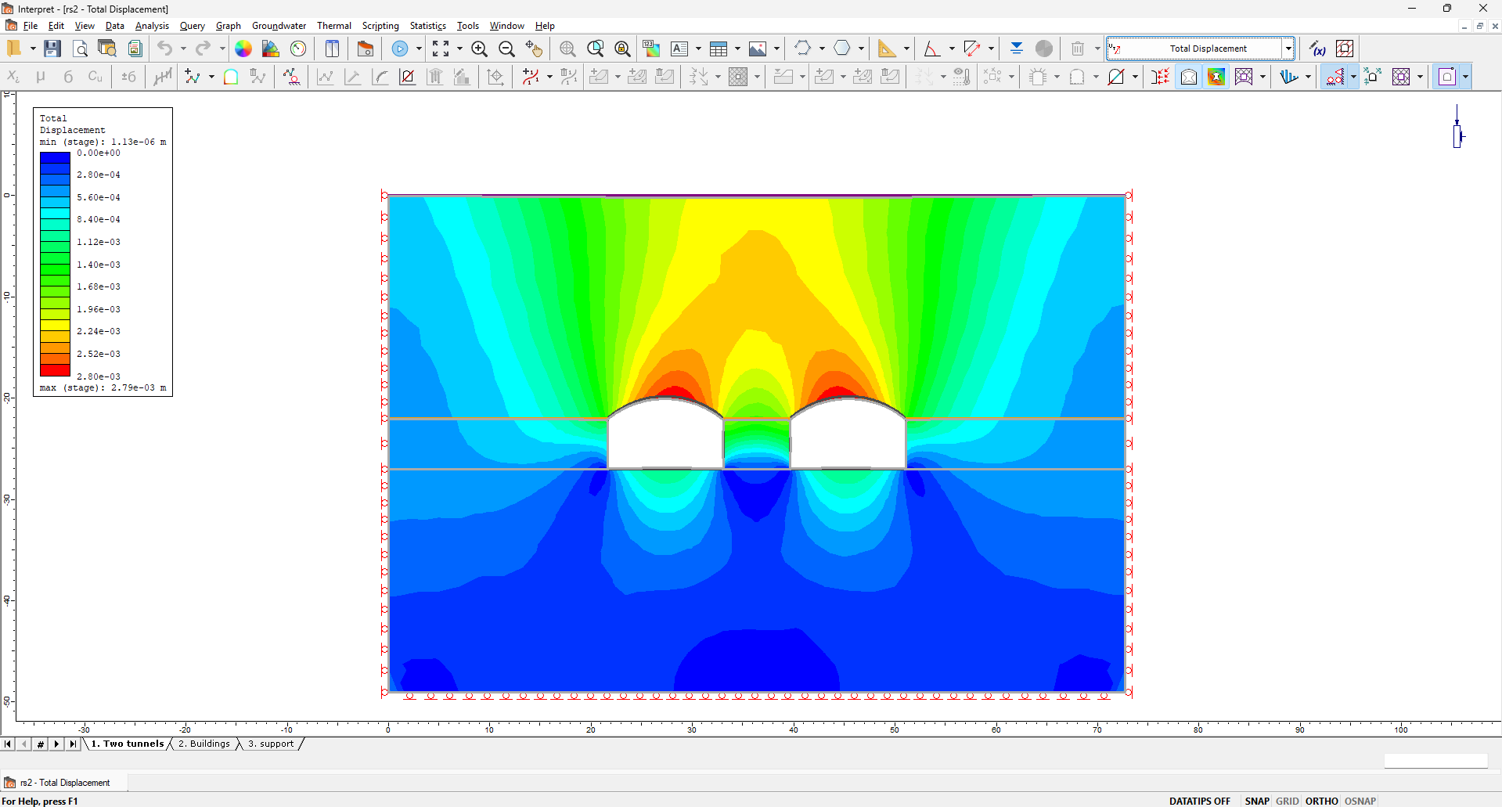 | 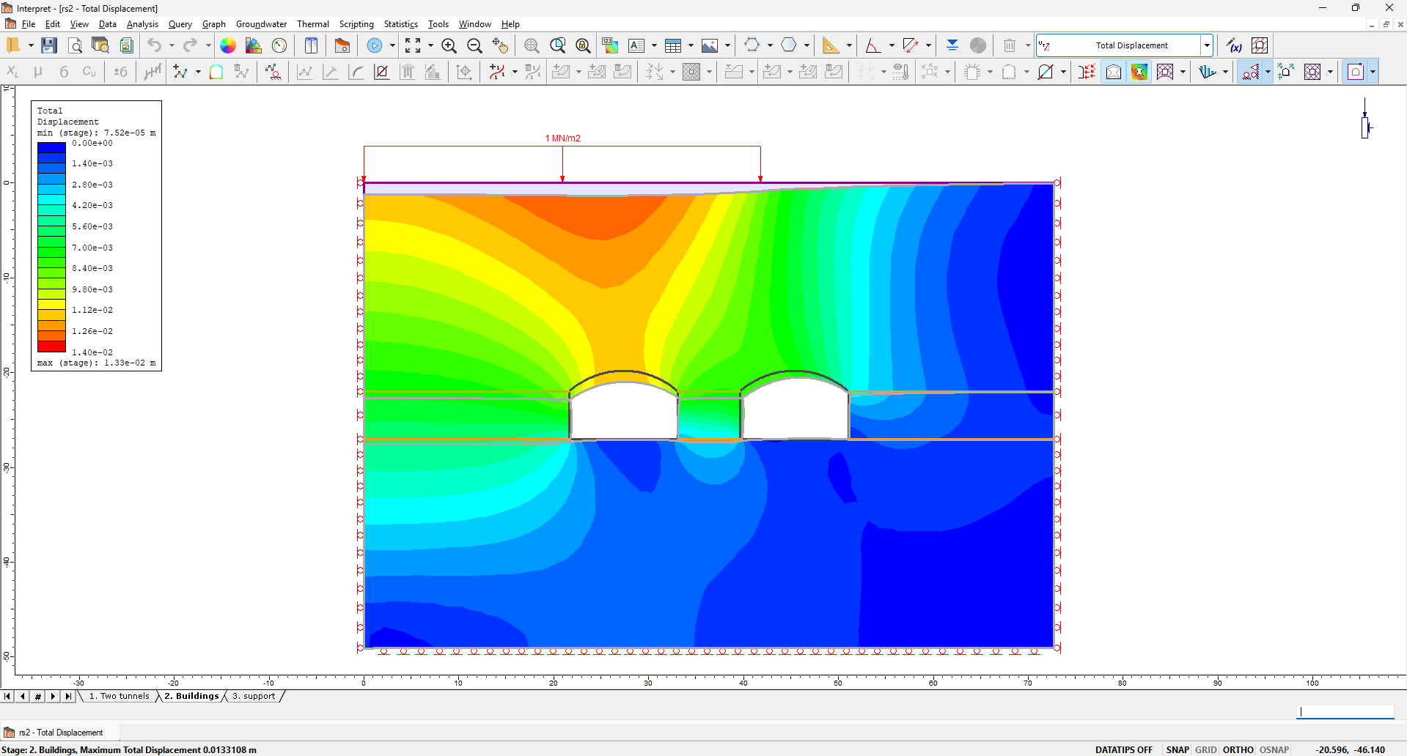
Displacement of stage 1 | Displacement of stage 2

Question 2

The strain YY of stage 1 and stage 2 is shown as
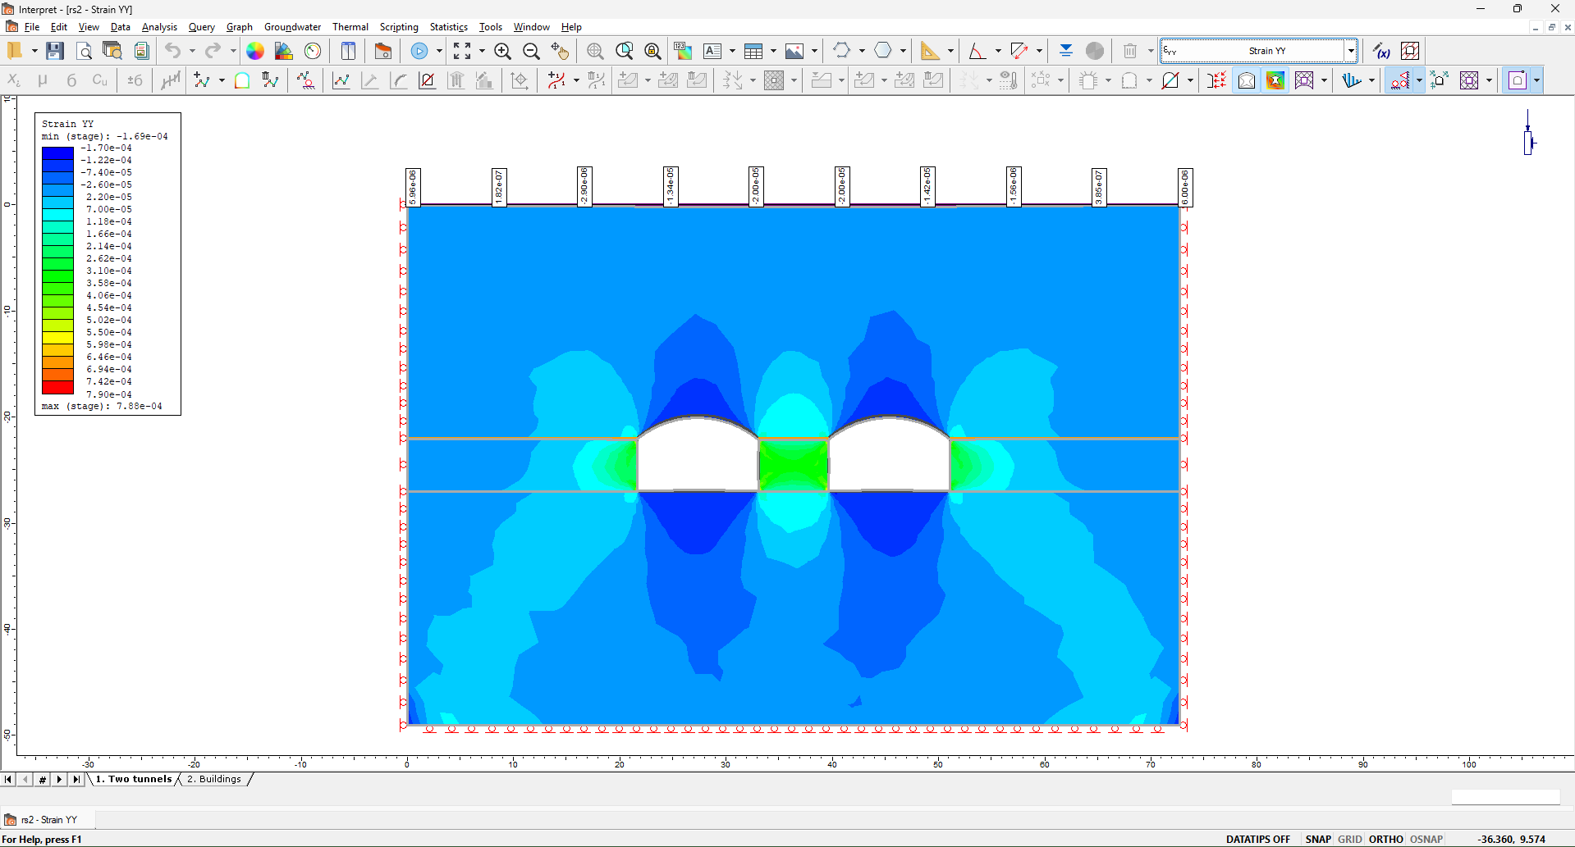 | 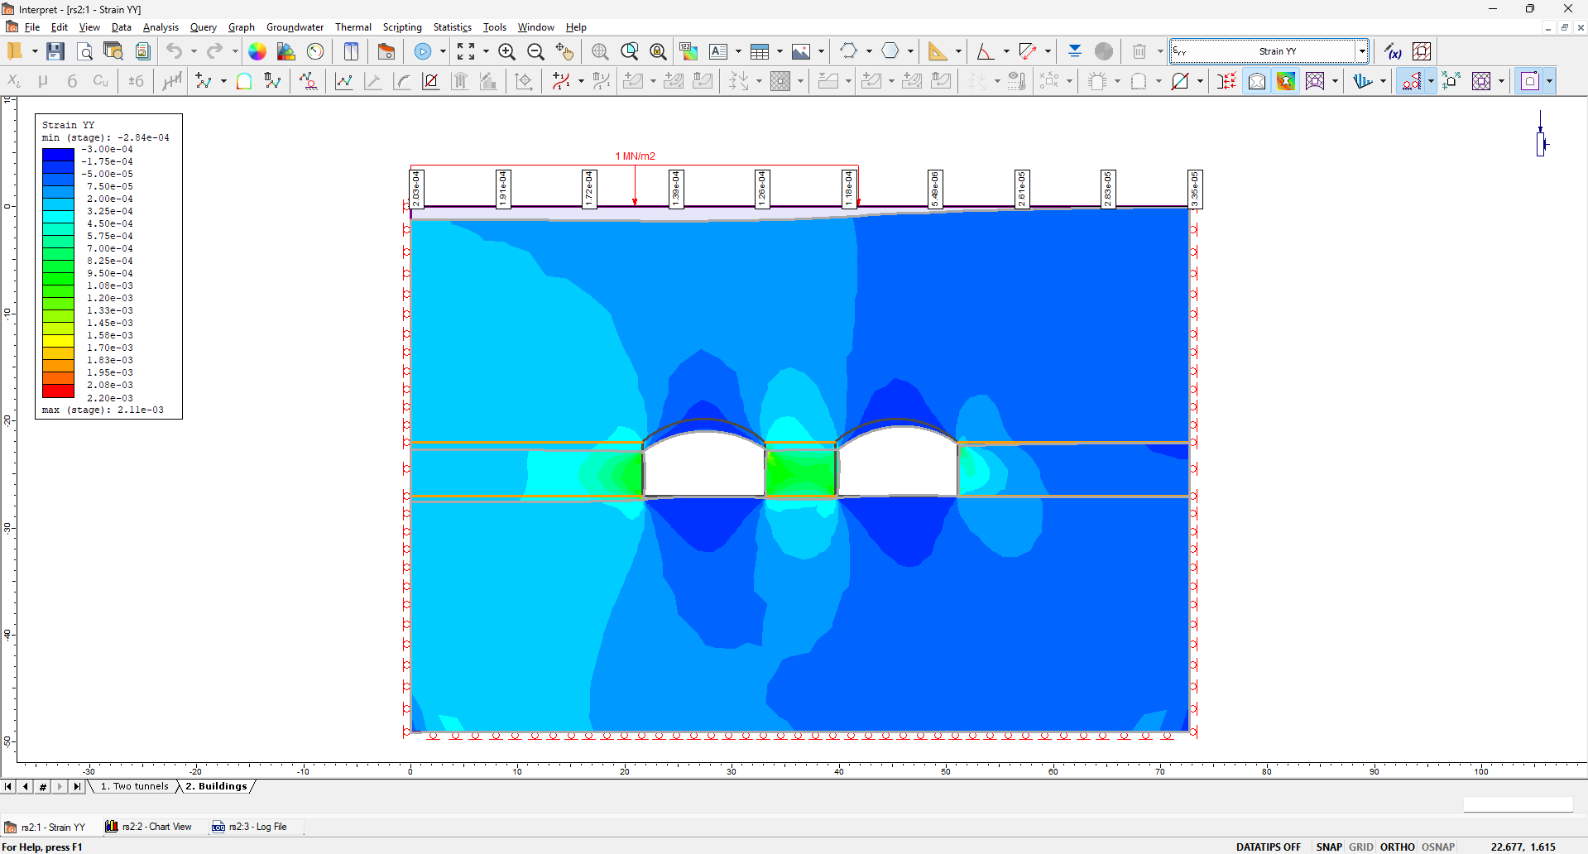
The strain YY of stage 1 | The strain YY of stage 2

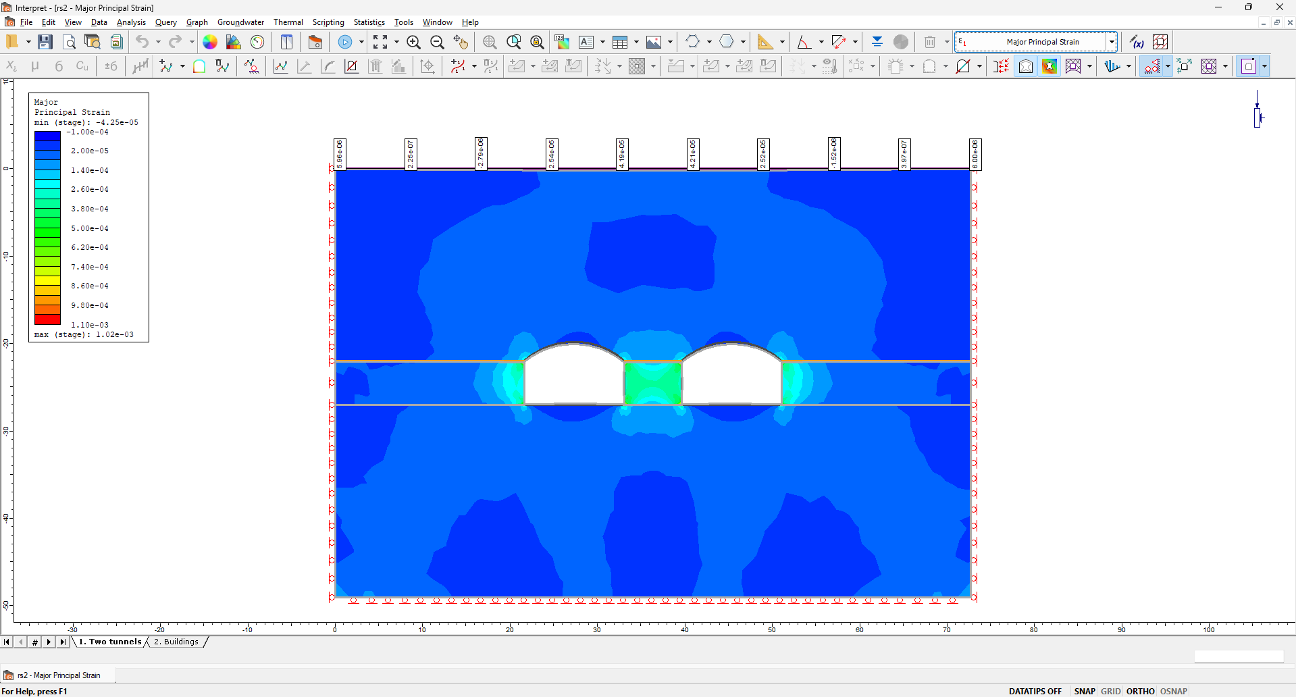 | 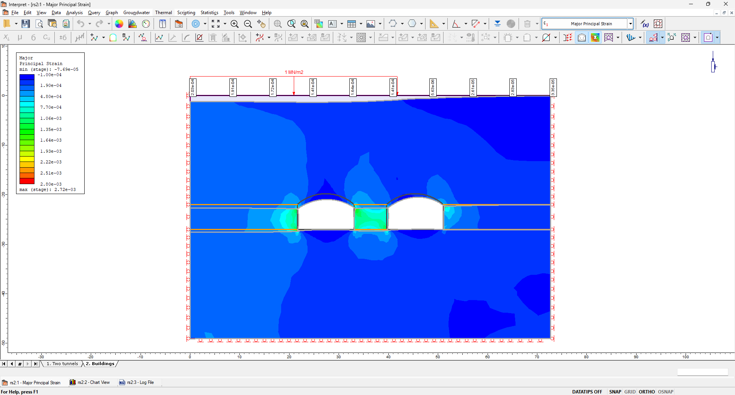
Major principal strain of stage 1 | Major principal strain of stage 2

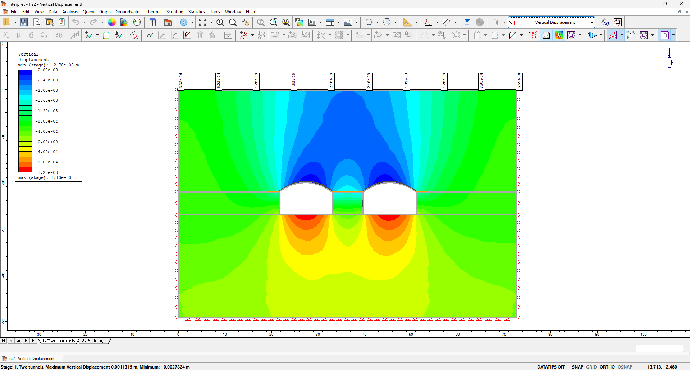 | 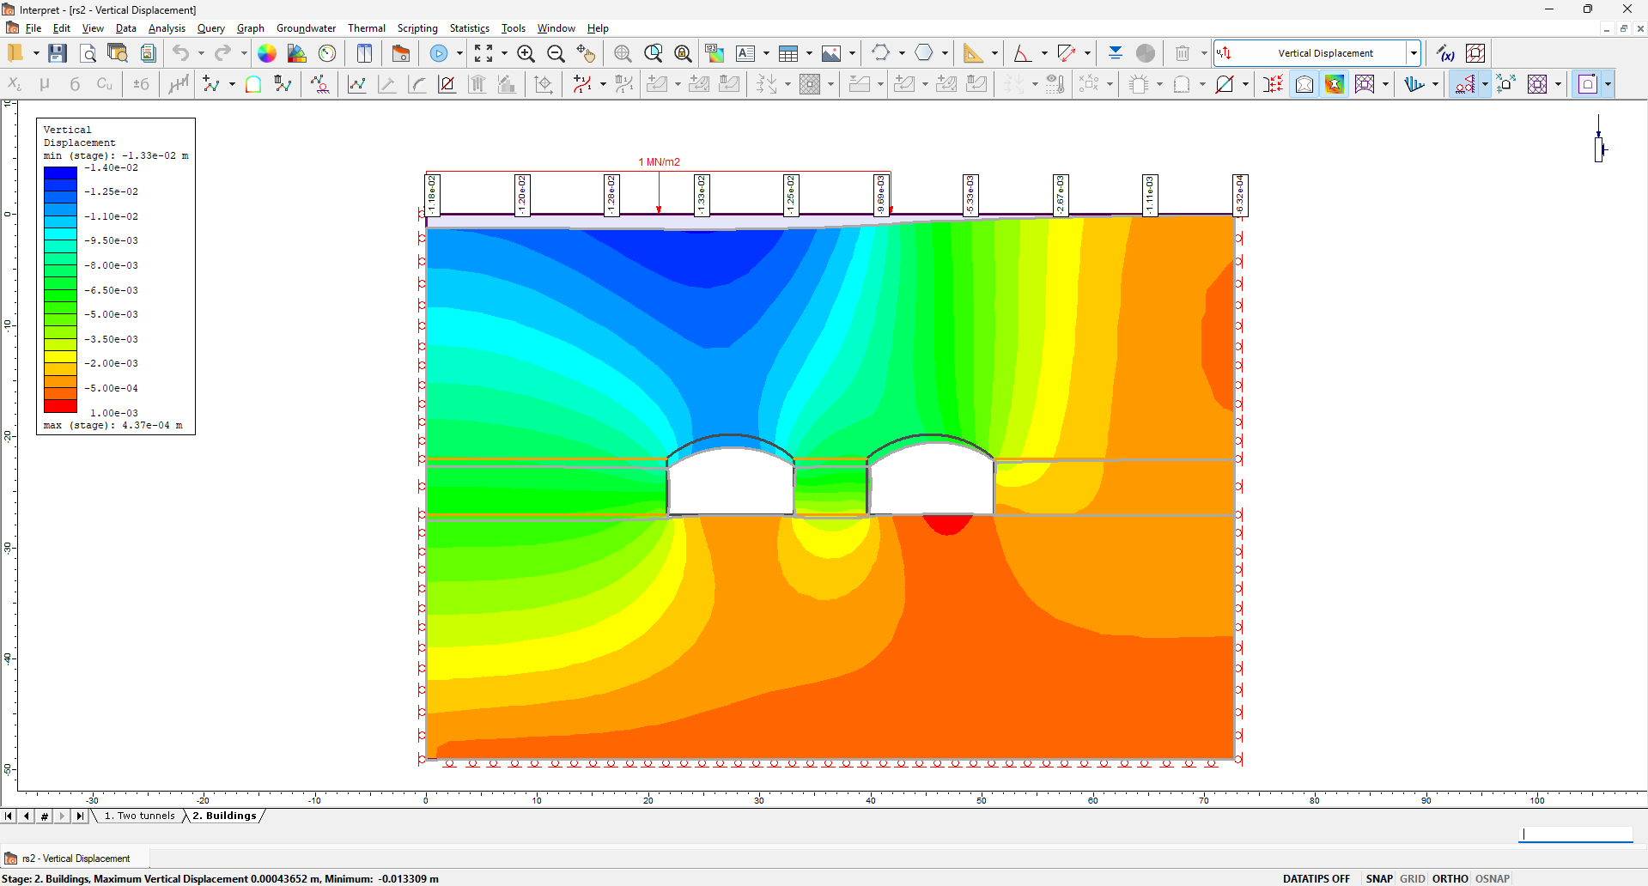
Vertical displacement of stage 1 | Vertical displacement of stage 2

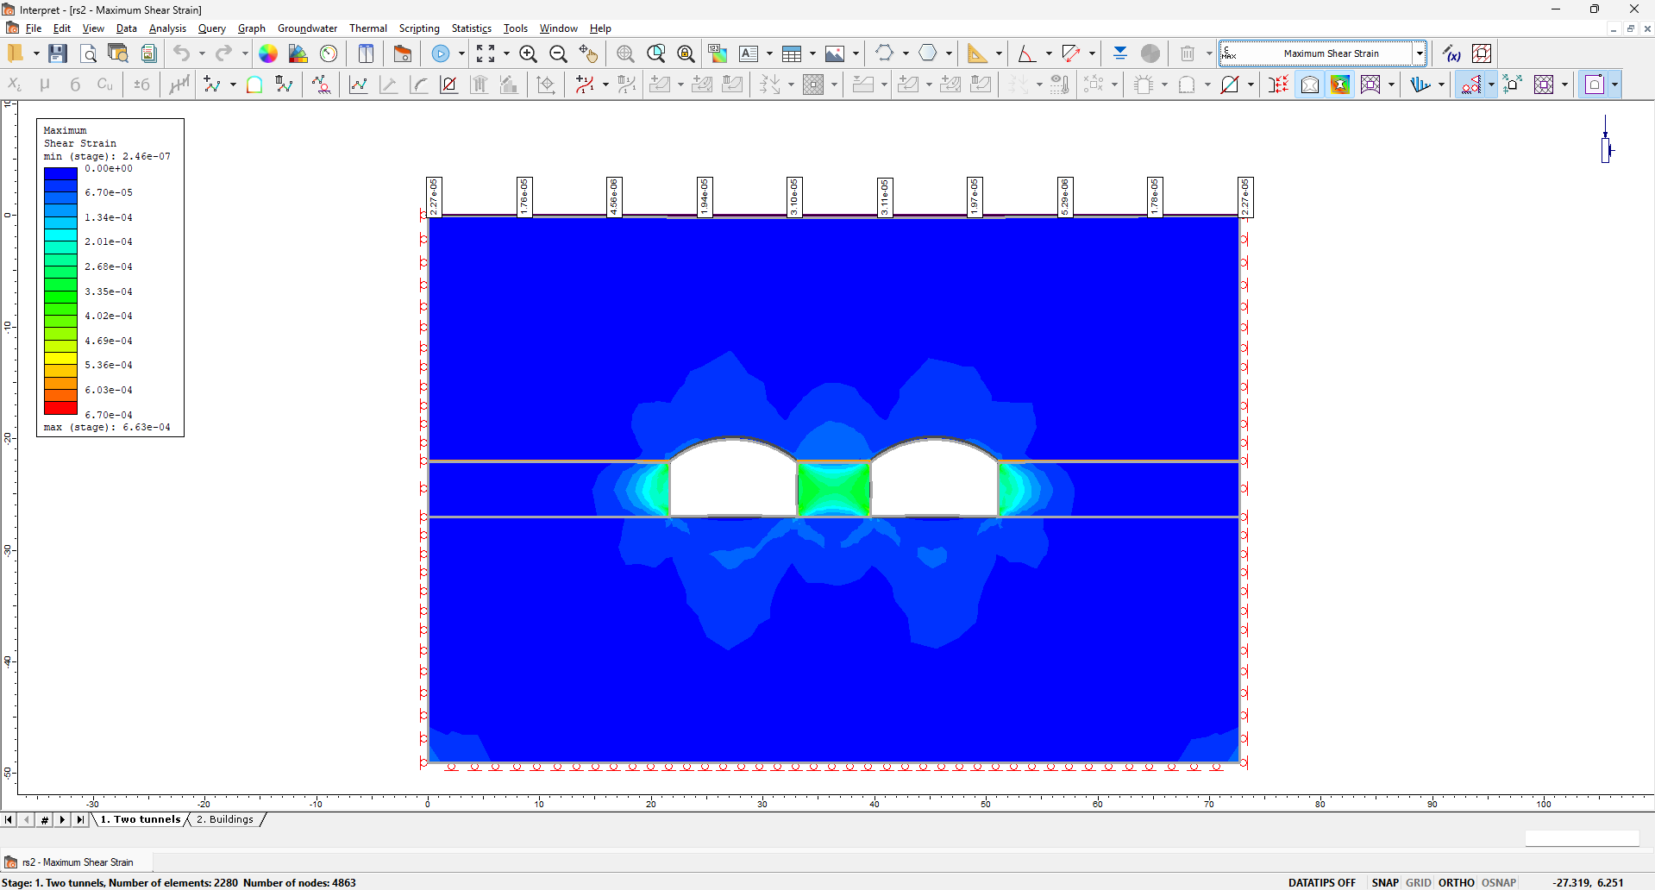 | 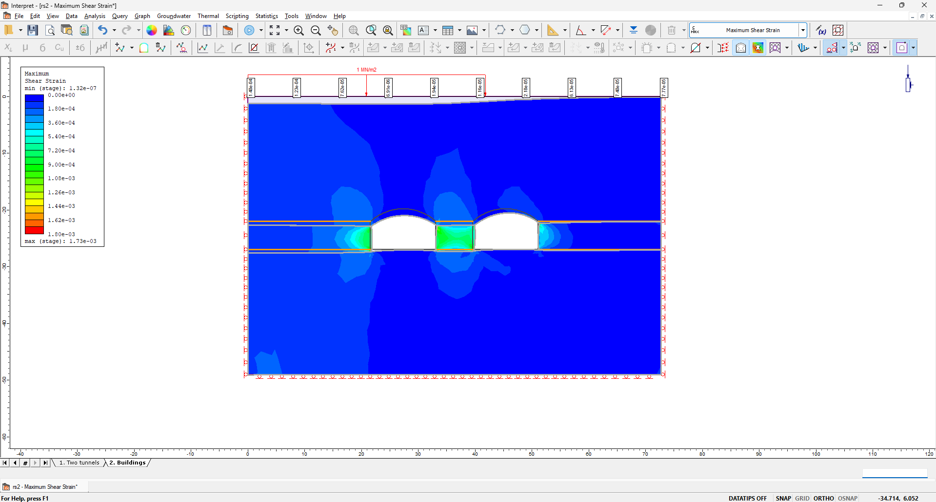
Maximum shear strain of stage 1 | Maximum shear strain of stage 2

Question 3
These two tunnels are totally unstable, and some necessary support measures should be implemented, such as adding bolts or lining the tunnel surface.

The default liner 1 properties:
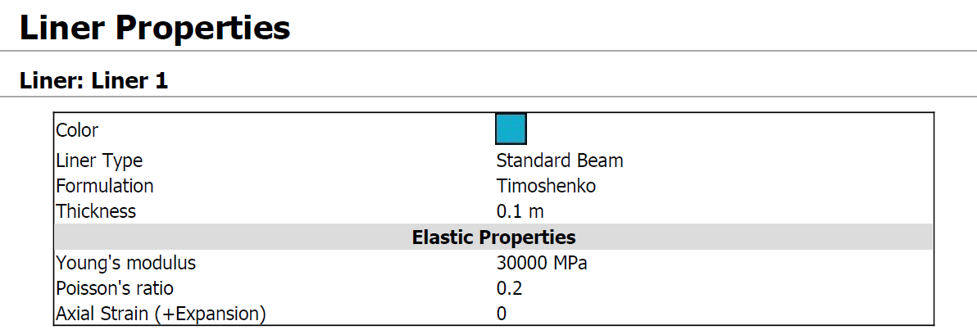
The default bolt 2 properties:
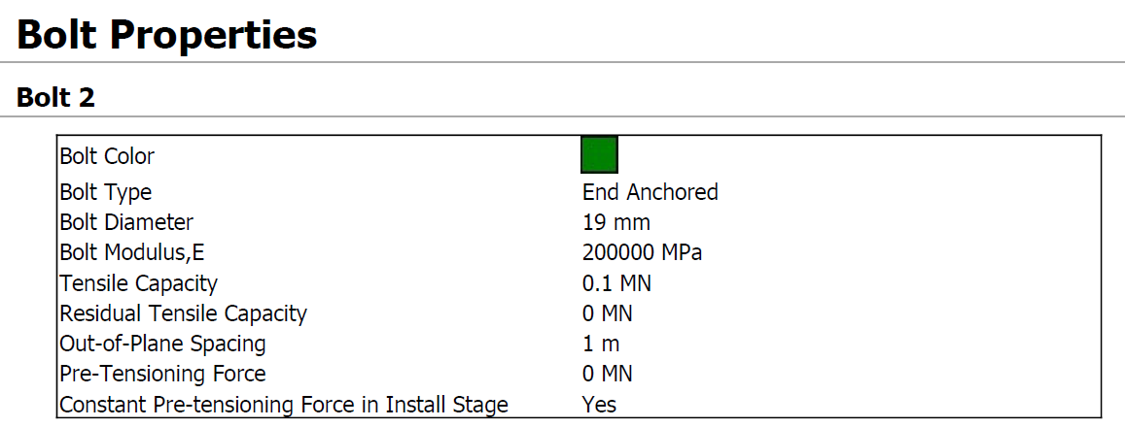
However, though the bolts and liners are both applied, the results show that the left upper and right upper corners are still unstable. They are only a little bit affected by the tunnels (Compare with the non-adding bolts and liners).
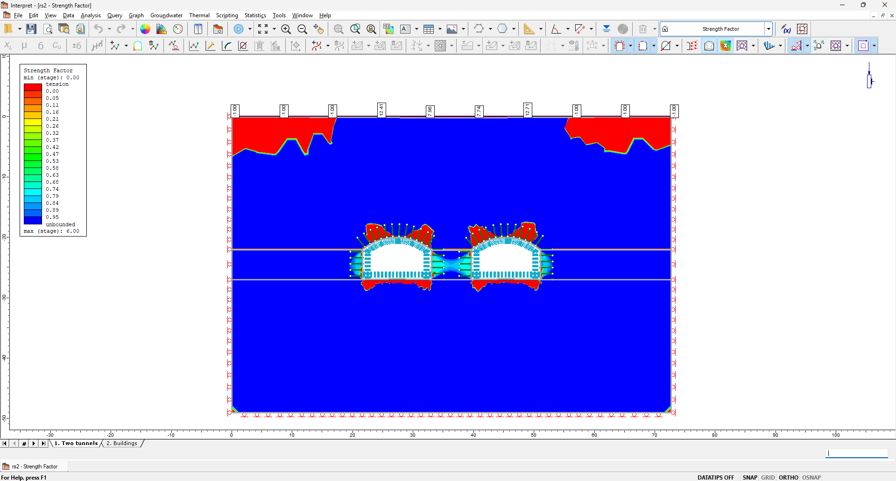 | 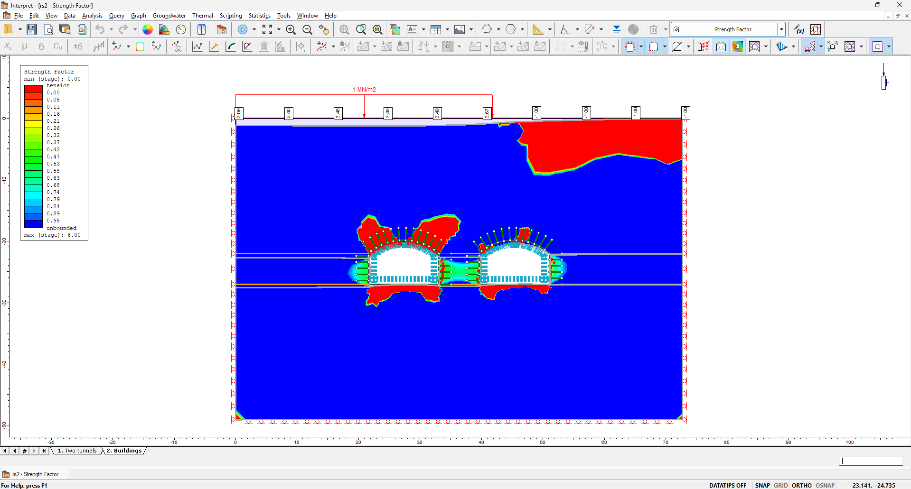
The FS of stage 1 (after adding supports) | The FS of stage 2 (after adding supports)

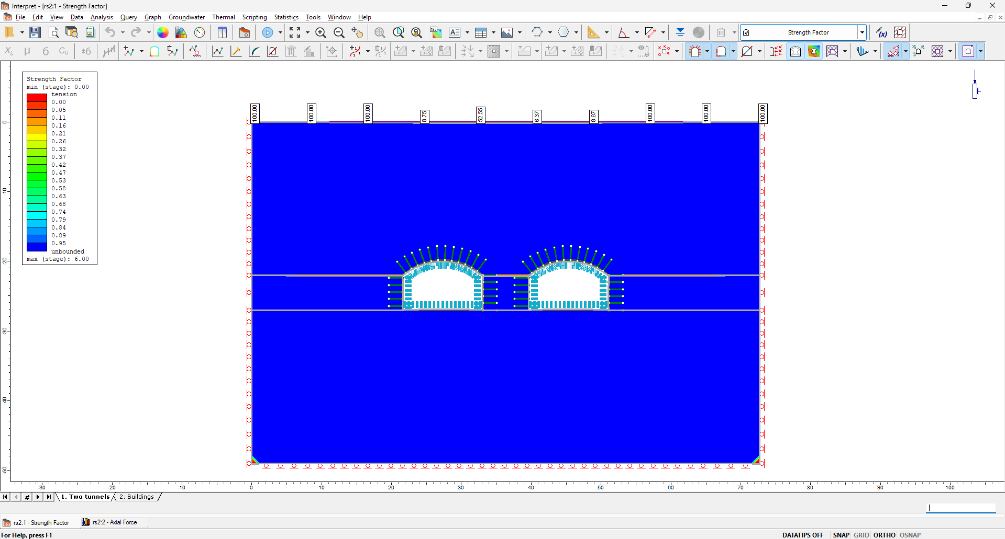 | 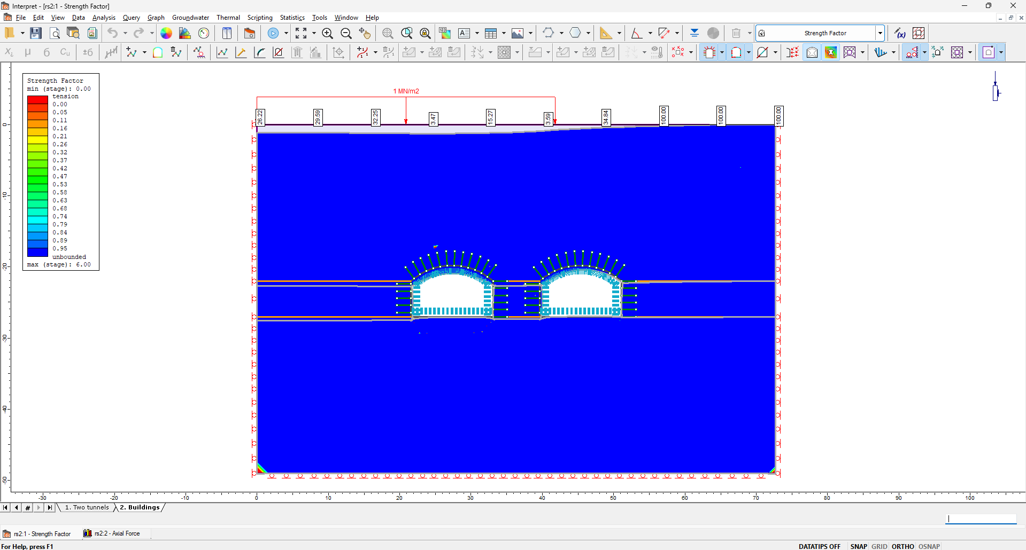
Change the Granitic-Gneiss and Fault to plastic, stage 1 | Change the Granitic-Gneiss and Fault to plastic, stage 2

The above figures I got after changing the material to plastic, and they showed that everywhere is safe. Actually, it still doesn’t make sense, because I noticed that the residual cohesion is larger than peak cohesion in the default setting. Even though I tried to change it to a more reasonable number, the RS2 reports that some error occurred, and it can not give the correct answer.

Therefore, I guess that due to our rock mass and the fault being too weak, we assume they are elastic, and they will not generate plastic deformation. So, the liners and bolts can not play a role in this case.

