Lab Report – 2

Network Commands for Testing and Troubleshooting

Objective
The objective of this laboratory experiment is to become familiar with commonly used network commands that assist in testing network connectivity and troubleshooting basic network-related issues.

Tools and Requirements
- Computer system with command-line interface access
- Active network connection (wired or wireless)

Theory
Network diagnostic commands are essential tools for understanding how data travels across a network, verifying connectivity, and identifying configuration or routing problems. Different operating systems provide various command-line utilities to analyze network behavior. Proper knowledge of these commands helps network administrators quickly detect and resolve network issues.

Network Commands Used
- ping
- ipconfig / ifconfig
- tracert / traceroute
- netstat (-a, -n)
- nslookup
- arp
- telnet
- pathping
- route print
- getmac
- nbtstat
- whois

Description of Commands along with output
ping: Tests reachability of a host and measures round-trip time. 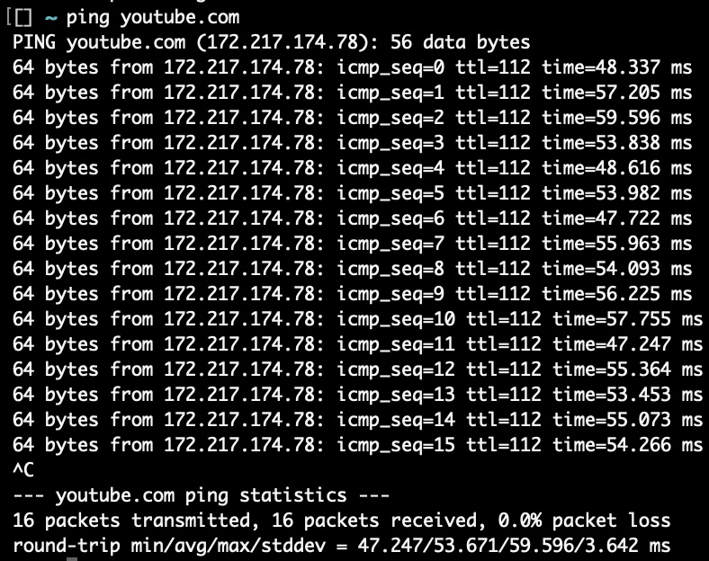

ipconfig / ifconfig: Displays current network configuration details.
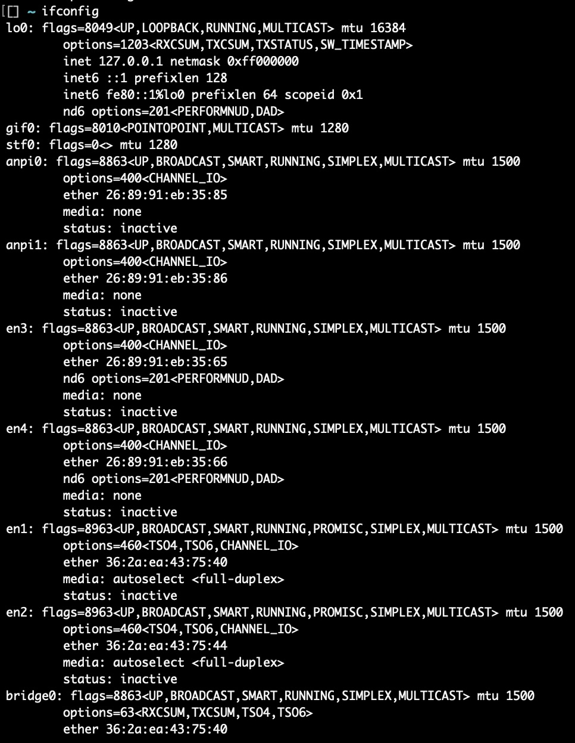

tracert / traceroute: Shows the route taken by packets to reach a destination.
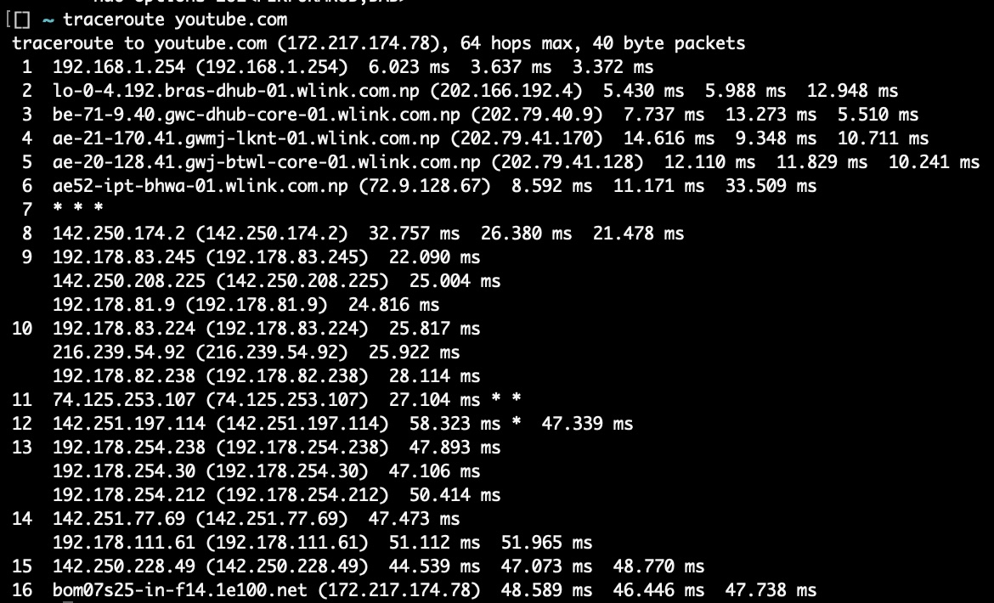
netstat: Displays active connections, listening ports, and network statistics.
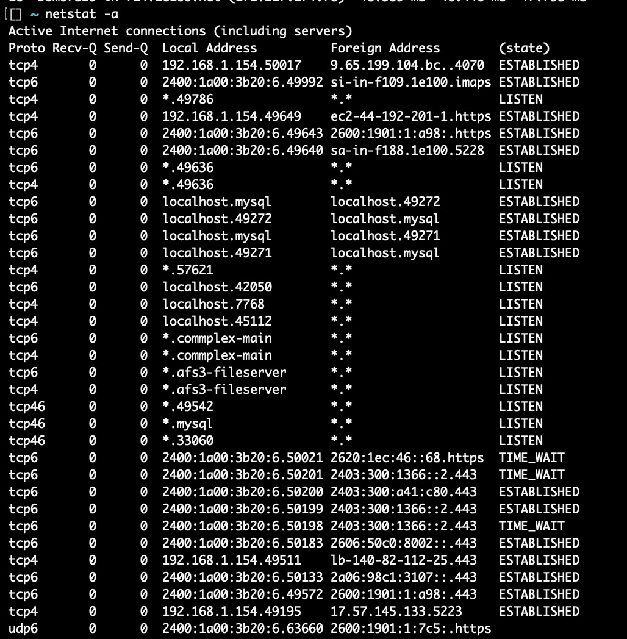

nslookup: Retrieves DNS information for a given domain.
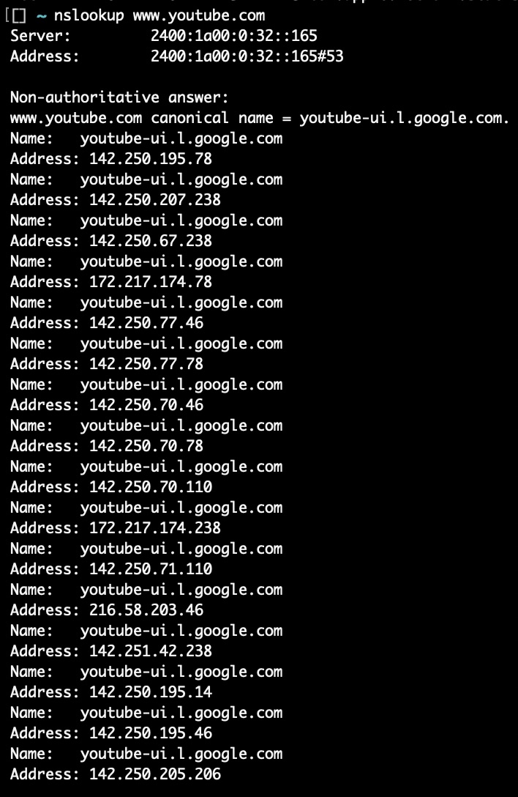
arp: Displays IP to MAC address mappings.
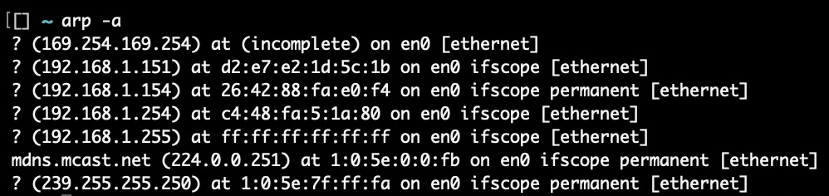

telnet: Tests connectivity to a specific host and port.
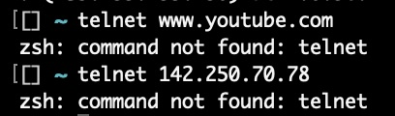
pathping: Combines ping and tracert to analyze packet loss and latency (Windows only).
route print: Displays the system routing table (Windows only).
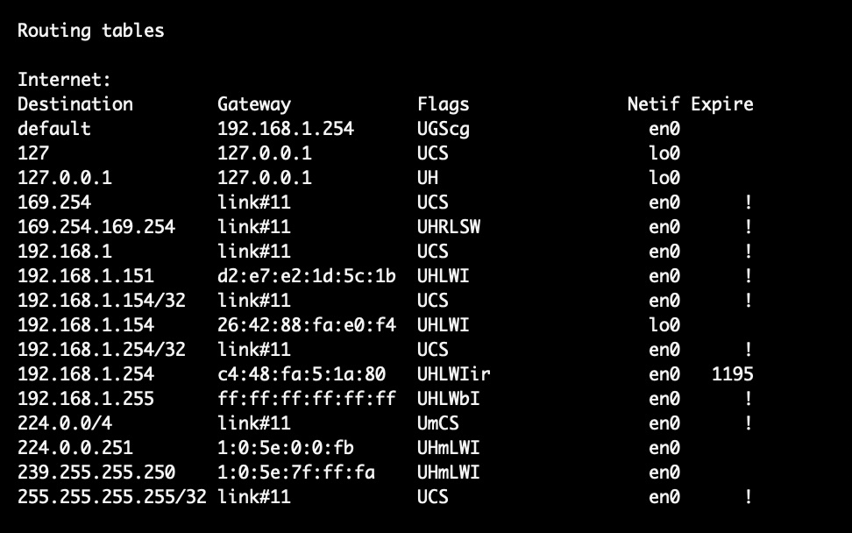
getmac: Displays MAC addresses of network interfaces (Windows only).
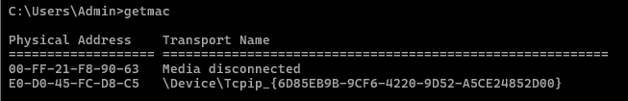
nbtstat: Displays NetBIOS over TCP/IP statistics.
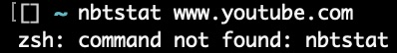

whois: Retrieves domain registration information.

Procedure
1. The command-line interface was opened on the system.
2. Network configuration was checked using ipconfig or ifconfig.
3. The listed network commands were executed as required.
4. Outputs of each command were observed and saved.

Observations
The commands produced outputs corresponding to network configuration, connectivity, and routing information. Some commands such as pathping, route print, and getmac were found to be specific to Windows systems. Equivalent macOS commands were used where applicable.

Result
The network diagnostic commands were successfully executed, and their outputs were collected for analysis.

Conclusion
This lab provided hands-on experience with essential network troubleshooting commands. Understanding these commands is important for diagnosing connectivity issues and maintaining reliable network operations.

Precautions
- Ensure an active network connection before executing commands.
- Use correct command syntax based on the operating system.
- Save outputs carefully for future reference.

