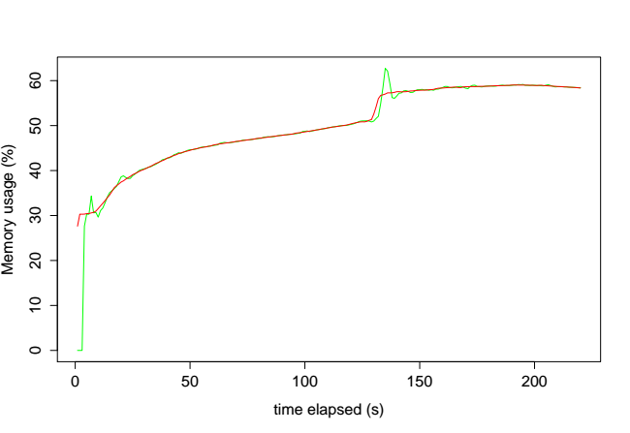

) % ( e g a s u y r o m e M

0 6

0 5

0 4

0 3

0 2

0 1

0

0 50 100 150 200

time elapsed (s)