

**ACTIVIDAD SEMANA 5**

**ACTIVIDAD 6.2:**  Ejercicio de programación 3

**MATERIA**: PRUEBAS DE SOFTWARE Y ASEGURAMIENTO DE LA CALIDAD

**ALUMNO**: DANIEL HERNANDEZ MORA

**MATRICULA**: A01793538

**PROFESOR TITULAR**: DR GERARDO PADILLA ZÁRATE

**TUTOR**: MTRA. YETNALEZI QUINTAS RUIZ

**FECHA**: 11/02/2024

**CDMX**



Contenido

**Analysis PyLint y Flake** 3

Pylint. 3

Flake8 4

Outputs 5

# **Analysis PyLint y Flake**

## Pylint.

* PRE

┌──(noblek3n8㉿noble)-[~/Desktop/python]

└─$ pylint computeSales.py

************* Module computeSales

computeSales.py:74:0: C0301: Line too long (114/100) (line-too-long)

computeSales.py:76:0: C0301: Line too long (117/100) (line-too-long)

computeSales.py:82:0: C0305: Trailing newlines (trailing-newlines)

computeSales.py:1:0: C0114: Missing module docstring (missing-module-docstring)

computeSales.py:1:0: C0103: Module name "computeSales" doesn't conform to snake_case naming style (invalid-name)

computeSales.py:5:0: C0116: Missing function or method docstring (missing-function-docstring)

computeSales.py:7:13: W1514: Using open without explicitly specifying an encoding (unspecified-encoding)

computeSales.py:17:0: C0116: Missing function or method docstring (missing-function-docstring)

computeSales.py:35:0: C0116: Missing function or method docstring (missing-function-docstring)

computeSales.py:68:9: W1514: Using open without explicitly specifying an encoding (unspecified-encoding)

-----------------------------------

Your code has been rated at 8.46/10

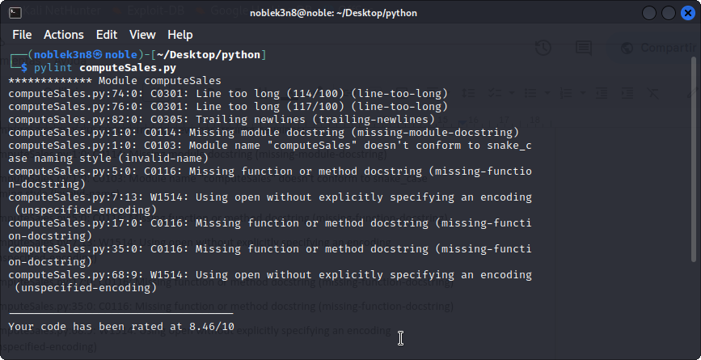

* POST

┌──(noblek3n8㉿noble)-[~/Desktop/python]

└─$ pylint --version

pylint 3.0.3

astroid 3.0.3

Python 3.11.4 (main, Jun 7 2023, 10:13:09) [GCC 12.2.0]

┌──(noblek3n8㉿noble)-[~/Desktop/python]

└─$ pylint compute_sales.py

--------------------------------------------------------------------

Your code has been rated at 10.00/10 (previous run: 10.00/10, +0.00)

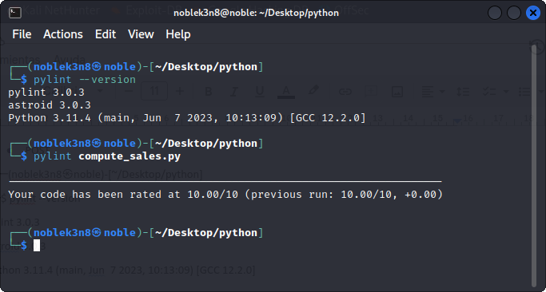

## Flake8

* PRE

┌──(noblek3n8㉿noble)-[~/Desktop/python]

└─$ flake8 computeSales.py

computeSales.py:5:1: E302 expected 2 blank lines, found 1

computeSales.py:17:1: E302 expected 2 blank lines, found 1

computeSales.py:24:80: E501 line too long (85 > 79 characters)

computeSales.py:29:80: E501 line too long (81 > 79 characters)

computeSales.py:31:80: E501 line too long (84 > 79 characters)

computeSales.py:35:1: E302 expected 2 blank lines, found 1

computeSales.py:37:80: E501 line too long (83 > 79 characters)

computeSales.py:56:80: E501 line too long (80 > 79 characters)

computeSales.py:57:80: E501 line too long (81 > 79 characters)

computeSales.py:61:80: E501 line too long (95 > 79 characters)

computeSales.py:63:80: E501 line too long (95 > 79 characters)

computeSales.py:69:80: E501 line too long (99 > 79 characters)

computeSales.py:70:80: E501 line too long (100 > 79 characters)

computeSales.py:71:80: E501 line too long (98 > 79 characters)

computeSales.py:74:80: E501 line too long (114 > 79 characters)

computeSales.py:75:80: E501 line too long (98 > 79 characters)

computeSales.py:76:80: E501 line too long (117 > 79 characters)

computeSales.py:77:80: E501 line too long (96 > 79 characters)

computeSales.py:80:1: E305 expected 2 blank lines after class or function definition, found 1

computeSales.py:82:1: W391 blank line at end of file

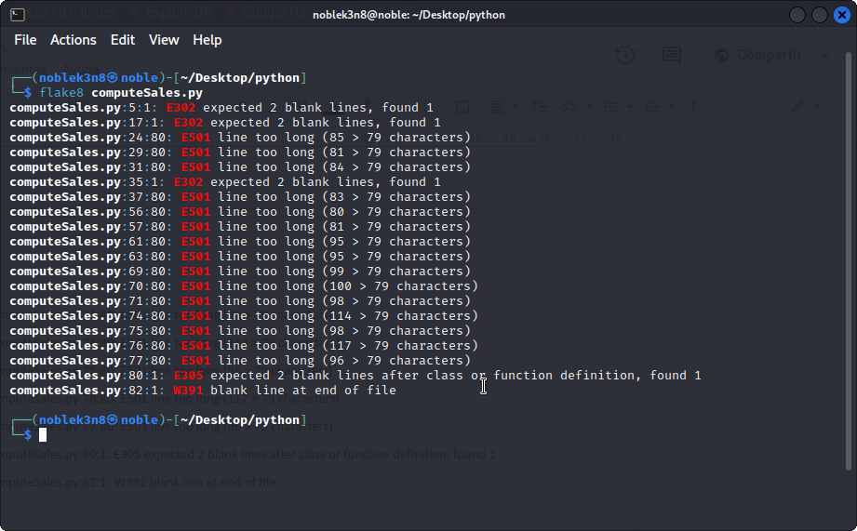

* POST

┌──(noblek3n8㉿noble)-[~/Desktop/python]

└─$ flake8 compute_sales.py

┌──(noblek3n8㉿noble)-[~/Desktop/python]

└─$

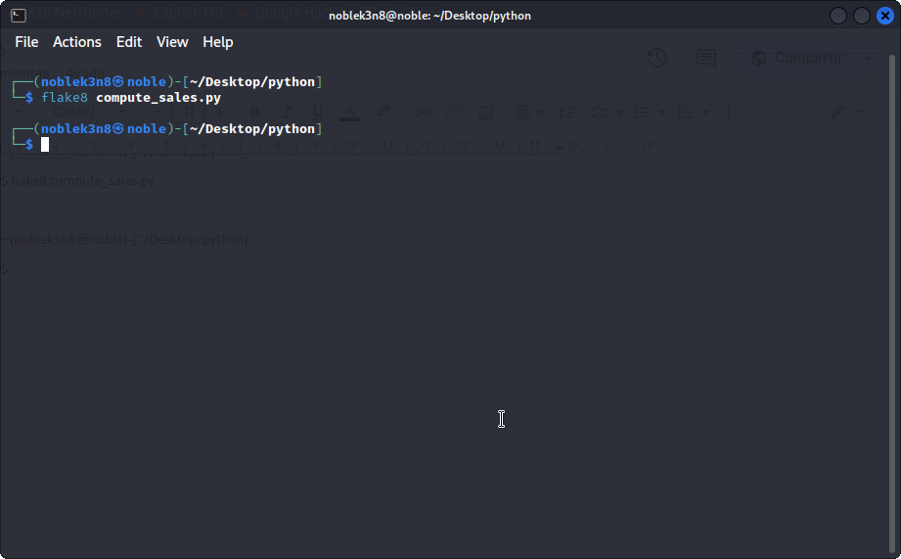

## Outputs

TC1

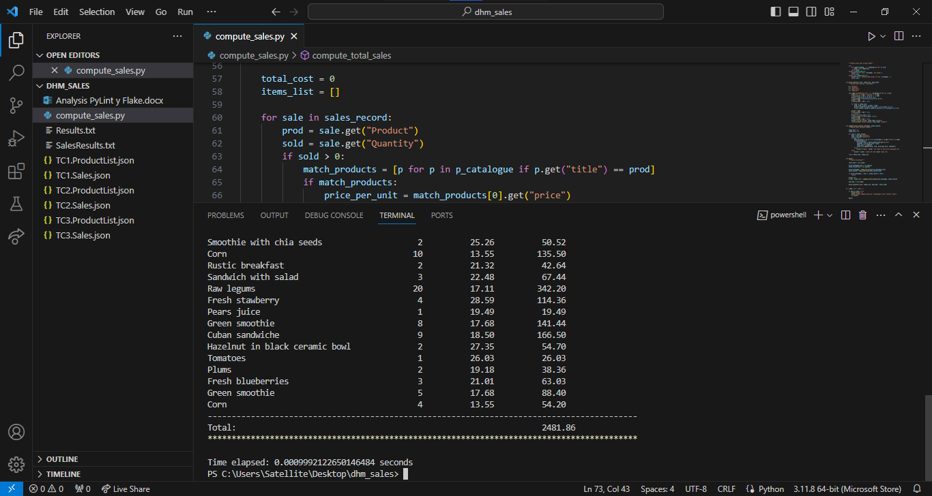

TC2

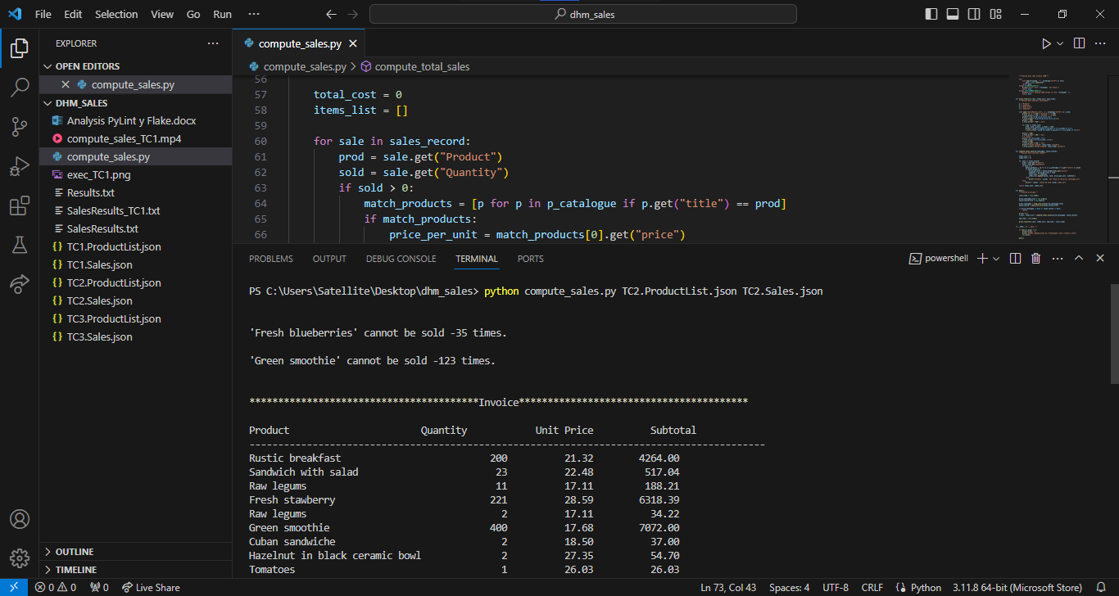

TC3

