# **Sample Runs and Analysis.**

## Bisection

Inputs:

* Initial guesses:
* Precision: 0.00001
* Max iterations:

Outputs:

* Root:
* Time:
* Iterations:
* Precision:
* Theoretical Error =

Function plotting & step simulation.

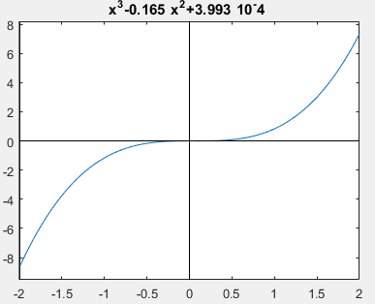

Function plotting

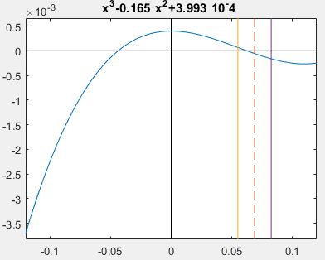

Bisection 3rd iteration

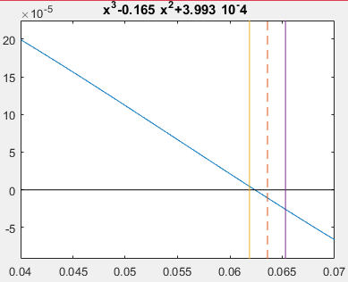

Bisection 6th iteration

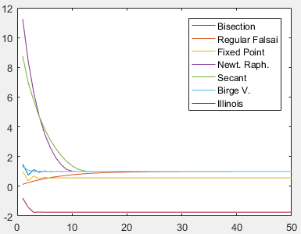

Comparison between the obtained root and number of iterations for each method.

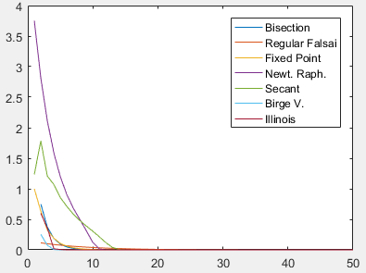

Comparison between the relative error and number of iterations for each method.

## False-Position

* First Test Case

Inputs:

* Initial guesses:
* Precision: 0.00001
* Max iterations:

Outputs:

* Root:
* Time:
* Iterations:
* Precision:
* Theoretical Error =

Function plotting & step simulation.



Function plotting

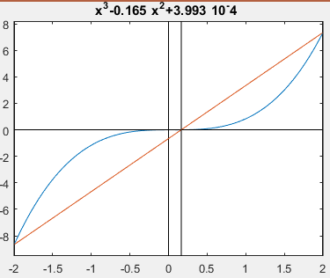

False-Position 1st iteration

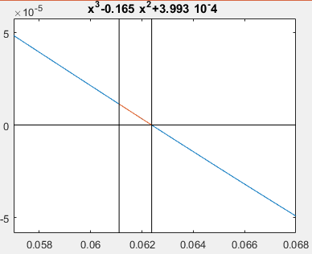

False-Position 5th (Last) iteration

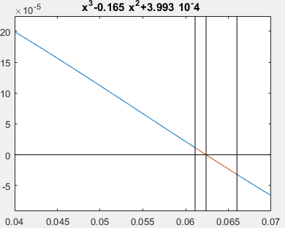

False-Position 3th iteration

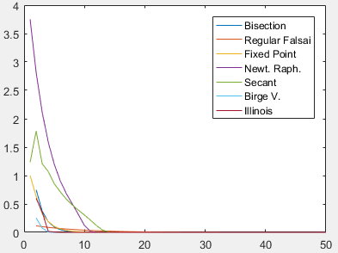

Comparison between the relative error and number of iterations for each method.

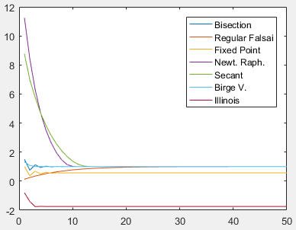

Comparison between the obtained root and number of iterations for each method.

* Second Test Case

Inputs:

* Initial guesses:
* Precision: 0.00001
* Max iterations:

Outputs:

* Root:
* Time:
* Iterations:
* Precision:
* Theoretical Error =

Function plotting & step simulation.

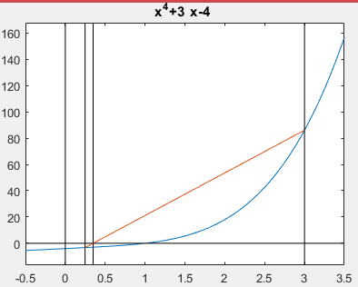

False-Position 3th iteration

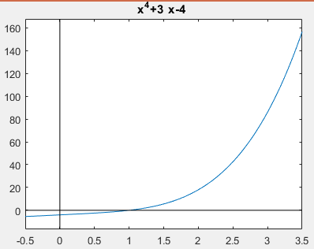

Function plotting

**Node:** The difference between the plot for the 3rd and the 6th is very small because this method is very slow for this test case.

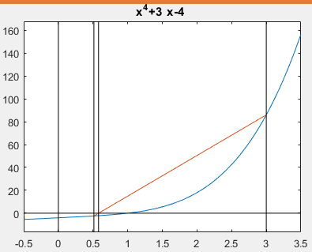

False-Position 6th iteration

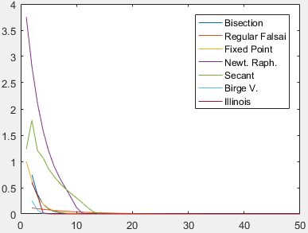

Comparison between the relative error and number of iterations for each method

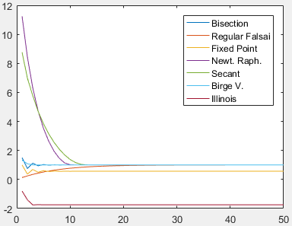

Comparison between the obtained root and number of iterations for each method.

## Fixed Point

Inputs:

* Initial guesses:
* Precision: 0.00001
* Max iterations:

Outputs:

* Root:
* Time:
* Iterations:
* Precision:
* Theoretical Error =

Function plotting & step simulation.

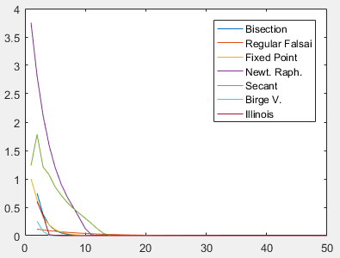

Comparison between the relative error and number of iterations for each method

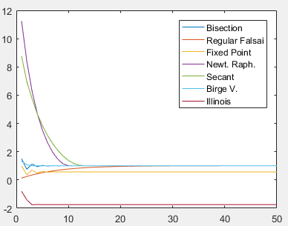

Comparison between the obtained root and number of iterations for each method.

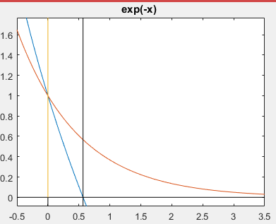

12th iteration plotting

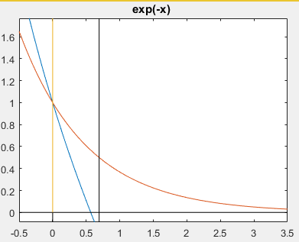

3rd iteration plotting

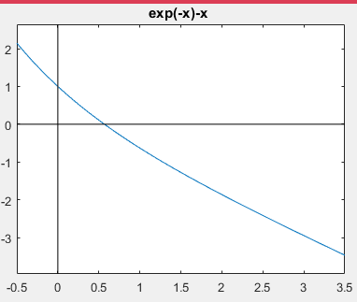

Function Plotting

## Newton-Raphson

Inputs:

* Input equation:
* Initial guesses:
* Precision: 0.00001
* Max iterations:

Outputs:

* Root:
* Time:
* Iterations:
* Precision:
* Theoretical Error =

Function plotting & step simulation.

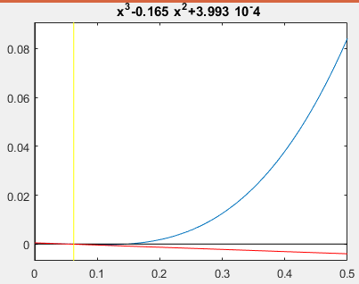

Third (last) iteration

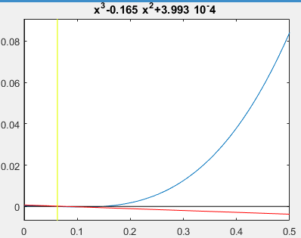

Second iteration

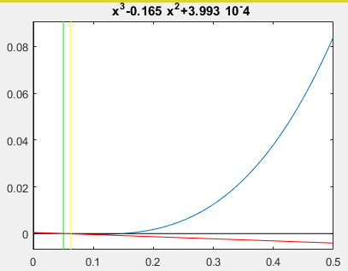

First iteration

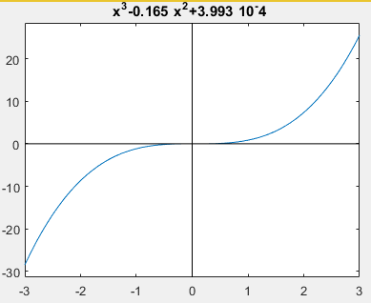

Function plotting

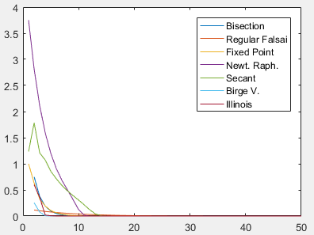

Comparison between the relative error and number of iterations for each method

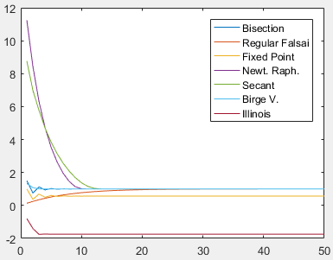

Comparison between the obtained root and number of iterations for each method.

## Secant Method

Inputs:

* Input equation:
* Initial guesses:
* Precision: 0.00001
* Max iterations:

Outputs:

* Root:
* Time:
* Iterations:
* Precision:
* Theoretical Error =

Function plotting & step simulation.

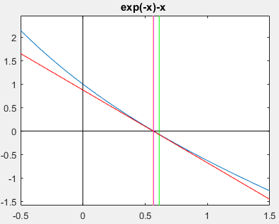

3rd iteration plotting

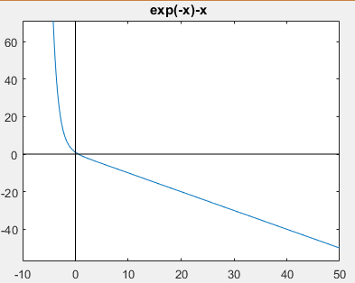

Function plotting

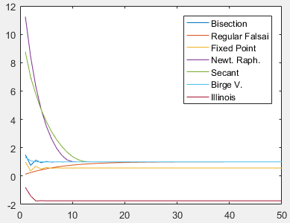

Comparison between the obtained root and number of iterations for each method.

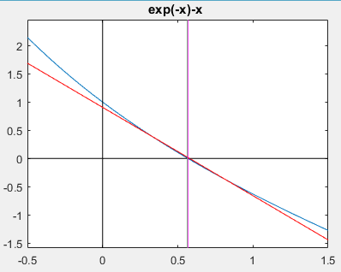

4rd (Last) iteration plotting

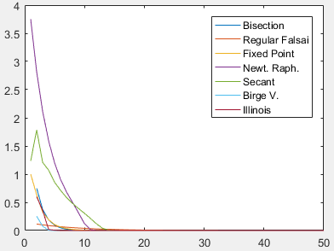

Comparison between the relative error and number of iterations for each method