JichenDai_HW#2
10448922

1.
(1) Yes, It is linearly separable.
As we can see in the graph below, there is a line separate positive and negative.

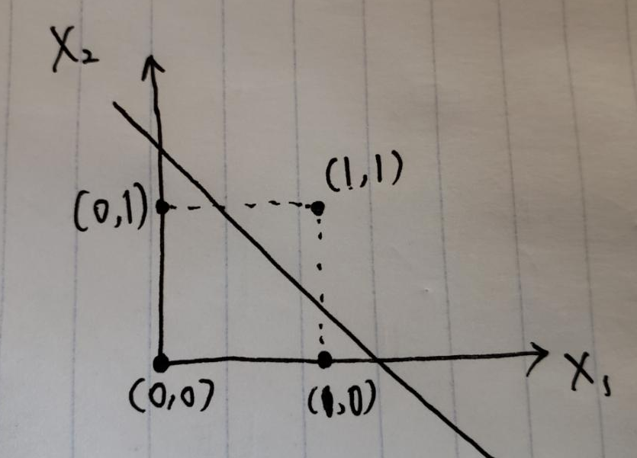

(2) Yes, it is possible.
Set Learning Rate = 0.2.
Since x1 + x2 - 1/2 = 0,
w0 = -0.5, w1 = 1, w2 = 1

Input P1:
y = 0*1 + 1*1 - 0.5
= 0.5 > 0
Prediction is wrong, update the weights:
w0 = w0*(1+0.2) = 0.6
w1 = w1*(1-0.2) = 0.8
w2 = w2*(1-0.2) = 0.8

Input P2:
y = 1*0.8 + 1*0.8 - 0.6
= 1 > 0
Prediction is correct

Input P3:
y = 1*0.8 + 0*0.8 - 0.6
= 0.2 > 0
Prediction is wrong, update the weights:
w0 = w0*(1+0.2) = 0.72
w1 = w1*(1-0.2) = 0.64
w2 = w2*(1-0.2) = 0.64
Input P4:
y = 0*0.64 + 0*0.64 - 0.72
= -0.72 < 0
Prediction is correct.

Input P1:
y = 0*0.64 + 1*0.64 - 0.72
= -0.08 < 0
Prediction is correct.

Input P2:
y = 1*0.64 + 1*0.64 - 0.72
= 0.56 > 0
Prediction is correct.

Input P3:
y = 1*0.64 + 0*0.64 - 0.72
= -0.08 < 0
Prediction is correct.

Input P4:
y = 0*0.64 + 0*0.64 - 0.72
= -0.72 < 0
Prediction is correct.

So, now the weight can correctly classify all 4 points, final decision boundary is:
0.64 * X1 + 0.64 * X2 - 0.72 = 0

2
(1)
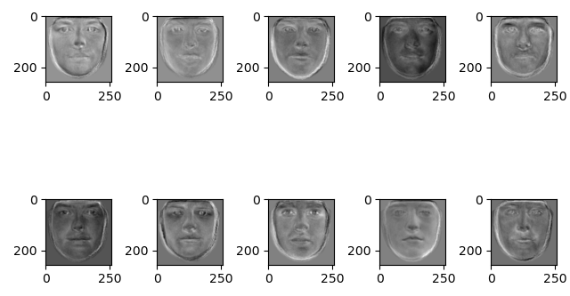
(2) error is 9441
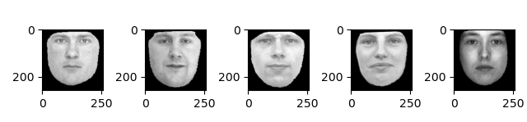
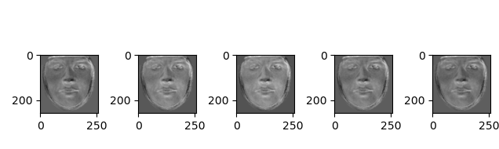

(3)
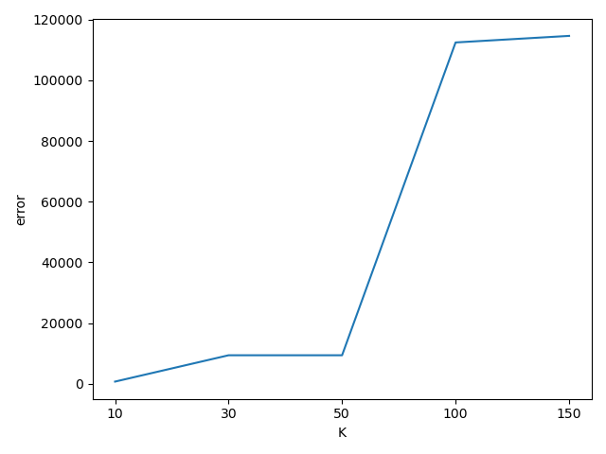

Source code:

import numpy as np
from PIL import Image
from os import listdir
import matplotlib.pyplot as plt
# load data with shape 177*65536
def load_image(path):
vectors = []
for bmp in listdir(path):
vector = np.array(Image.open("face_data/" + bmp)).flatten()
vectors.append(vector)
return np.array(vectors, dtype=np.float64)
def plot(images, row, col):
plt.figure()
for i in range(col * row):
plt.subplot(row, col, i + 1)
image = images[i].reshape(256,256)
plt.imshow(image, cmap = 'gray')
plt.show()
def cal_error(origin, recon):
row, col = origin.shape
sum = 0
for i in range(origin.shape[0]):
for j in range(col):
sum += (origin[i,j] - recon[i,j])**2
return sum / (row*col)
def norm(faces):
norm = []
for face in faces:
if(face.sum() != 0):
norm.append(face / face.sum())
else:
norm.append(face)
return np.array(norm)
####################
# load data
data = load_image("face_data")
training, test = data[:156], data[157:]
# calculate mean (Y = X - avg(X))=>(156*65536)
[r, c] = training.shape
mean = np.mean(training, 0)
Y = training - mean
# compute covariance (Y * Y_t / size_train)=>(156*156)
cov = np.dot(Y, Y.T) / c
# get eigen vetor
values, vectors = np.linalg.eig(cov)
# sort vectors according to values
ascending_order = np.argsort(values)
descending_order = ascending_order[::-1]
vectors = vectors[:, descending_order]
# select top (K = 30)=>(30*156)
selected_V = vectors[:30]
# do projection (Y_t * eigenvectors) =>(30*65536)
eigenfaces = np.dot(selected_V, Y)
eigenfaces = norm(eigenfaces)
# display top 10 eigenfaces
plot(eigenfaces[:10], 2, 5)
#################### Question 2 ######################
# show 5 original testing images
plot(test[:5], 1, 5)
# show 5 reconstructed ones.
Y_test = np.dot(test[:5] - mean, eigenfaces.T)
Y_test = np.dot(Y_test, eigenfaces) + mean
plot(Y_test, 1, 5)
# compute error value
error = cal_error(test[:5], Y_test)
print(error)
################ Question 3 #######################
def given_K_return_error(K):
eigenfaces = np.dot(vectors[:K], Y)
eigenfaces = norm(eigenfaces)
Y_test = np.dot(test[:5] - mean, eigenfaces.T)
Y_test = np.dot(Y_test, eigenfaces) + mean
error = cal_error(test[:5], Y_test)
return error
Ks = [10, 20, 50, 100, 150]
errors = []
for K in Ks:
errors.append(given_K_return_error(K))
plt.plot(['10', '30', '50', '100', '150'], errors)
plt.xlabel("K")
plt.ylabel("error")
plt.show()

