CS 520: Bus Simulation - Project Report
Name: Jichen Dai Student ID: 10448922

Abstract
In this project, a bus service simulation system is constructed and the a strategy to maintain the distanced between buses is applied. This program uses a two-dimensional array records[][] to store each station’s maximal, minimal and average waiting queue. Additionally, since the distance between buses cannot remain the same, this program applies a strategy to eliminate this problem.
Strategy for the scheduling policies
I applied a strategy to keep distances between buses: when someone is boarding, all the other buses should stop and wait until this people finished boarding.
Results
Part 1: The comparison of maximal, minimal and average waiting queue before and after applying strategy.
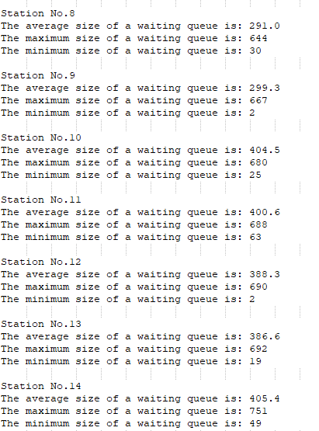
As you can see below, the average and maximum waiting queue before applying strategy is really large. This is because we didn’t keep paces of buses, they gradually meet with each other and stays at the same position at the same time as we shown in Result Part 2. Which makes the people in a station have to wait for the bus to run a whole circle.
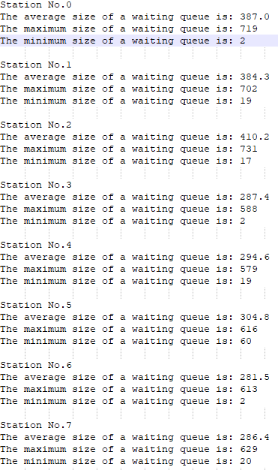

Image 1：Each station’s maximal, minimal
and average waiting queue before applying strategy
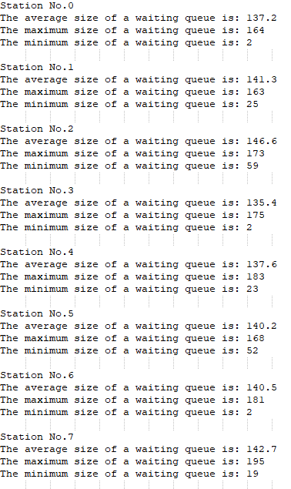
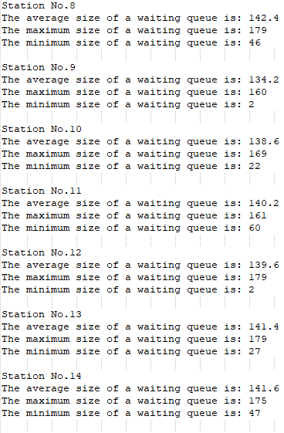

Image 2：Each station’s maximal, minimal
and average waiting queue before applying strategy

Part 2: The stations of buses before and after applying strategy are shown below.

AFTER APPLYING STRATRGY
Time: 0:30:00 (Before use strategy)
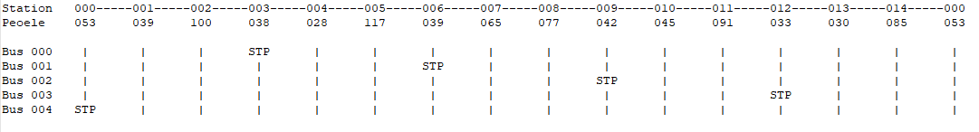
Time: 1:00:00 (Before use strategy)
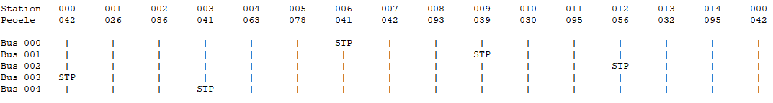
Time: 2:00:00 (Before use strategy)
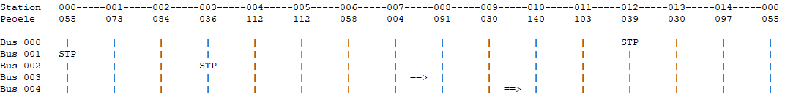
Time: 3:00:00 (Before use strategy)
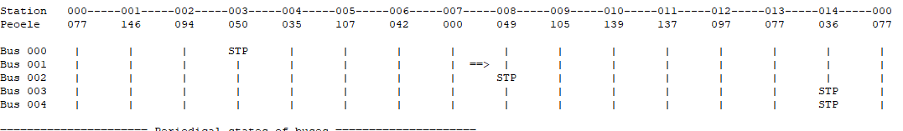
Time: 4:00:00 (Before use strategy)
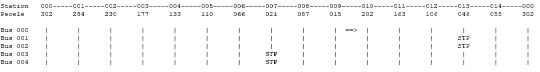
Time: 5:00:00 (Before use strategy)
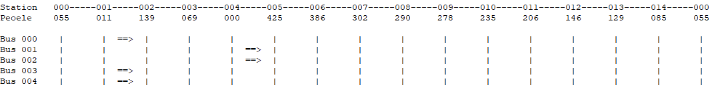
Time: 6:00:00 (Before use strategy)
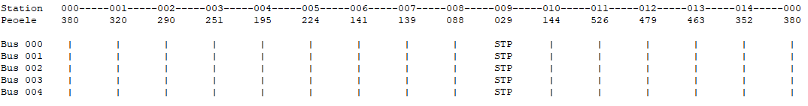
Time: 7:00:00 (Before use strategy)
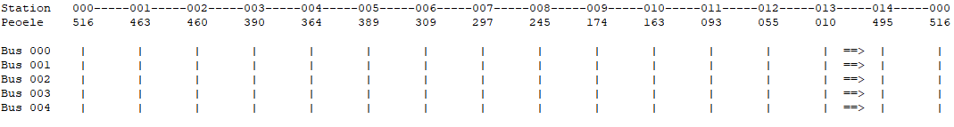

As we can see in above, since we didn’t do anything to control the pace of buses, the distance between them gradually became massive. Additionally, as you can see in Time: 6:00:00 and Time: 7:00:00, buses finally meet each other and cannot leave each other because they have the same running time between stations and has the same boarding time for same number of people.

AFTER APPLYING STRATRGY
Time: 0:30:00( After using strategy)
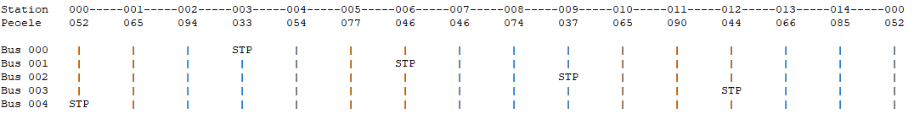
Time: 1:00:00( After using strategy)
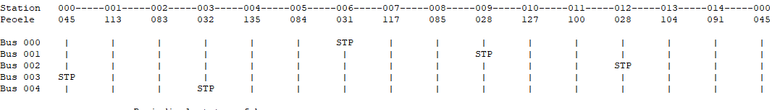
Time: 2:00:00( After using strategy)
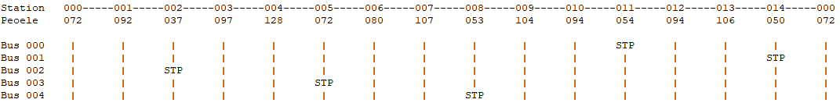
Time: 3:00:00( After using strategy)
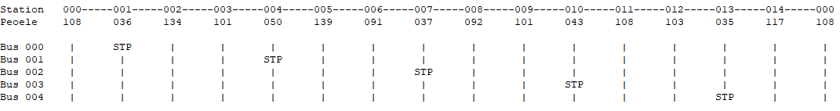
Time: 4:00:00( After using strategy)
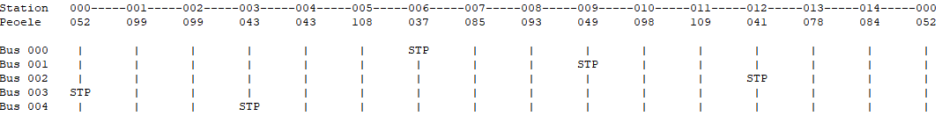
Time: 5:00:00( After using strategy)
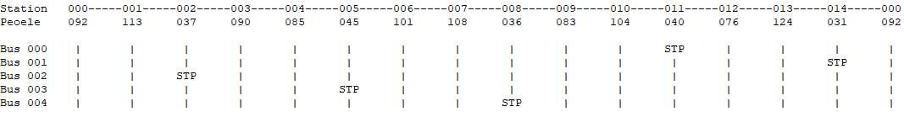
Time: 6:00:00( After using strategy)
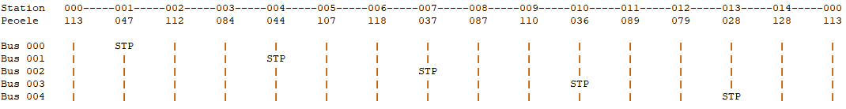
Time: 7:00:00( After using strategy)
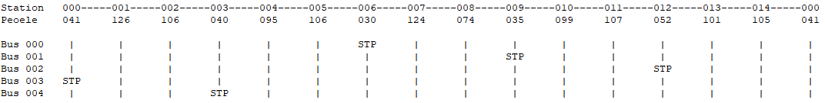
As shown above, after applying the strategy (when someone is boarding, all the other buses should stop and wait), the buses got the capacity of keep constant distance, because the only one reason that could leads to the different schedules between buses is the boarding time. The bus that boarded more people will staying longer in a station, which increase the risk to be caught by bus behind it.
Additionally, since the distance between two buses is constant, the waiting time before the arrival of next bus is relatively constant, This means people won’t wait too long.

