CS 520: Simulation Program - Project Report
Name: Jichen Dai Student ID: 10448922

Abstract
In this project, three system is constructed to simulate FCFS, SJF and RR respectively. Then, a series of experiments are designed to explore their properties and the results are stored in several .txt files.
a) FCFS & SJF
This part shows the results of FCFS and SJF. When using SJF, three different values of α ( 1, 1/2, 1/3) is experimented respectively to observe their effect on the results.
The project requires us to set process execution time between 120s - 240s. As you can see in part1, there isn’t a significant difference between different scheduling strategy and different value of alpha. Maybe it’s because the times between I/O request is too short compared to total execution time so that the scheduling algorithm is meaningless.
So, I changed process execution time to 120ms - 240ms. After doing this, the impact of different scheduling strategy and different value of alpha is obviously. The average waiting time decreased as value of alpha increased. As shown in Image 4.
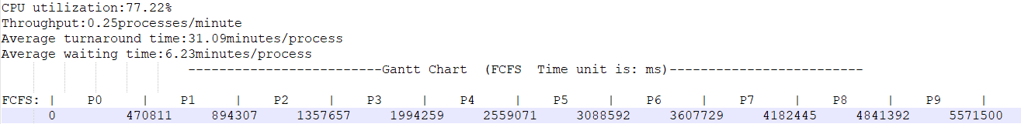

Image 1：Result of FCFS
( Process execution time 120s - 240s )

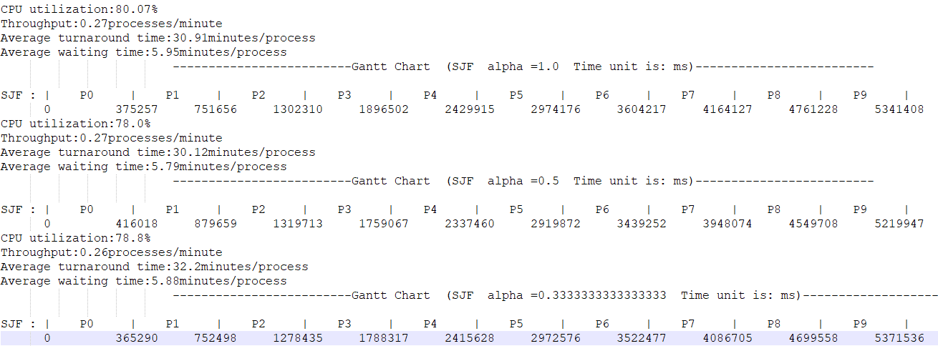

Image 2：Result of SJF ( alpha = 1, 1/2, 1/3 )
( Process execution time 120s - 240s )
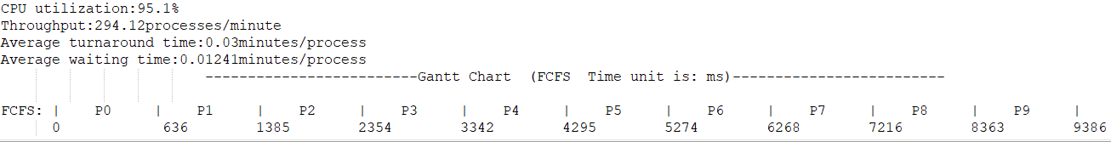

Image 3：Result of FCFS
( Process execution time 120ms - 240ms )
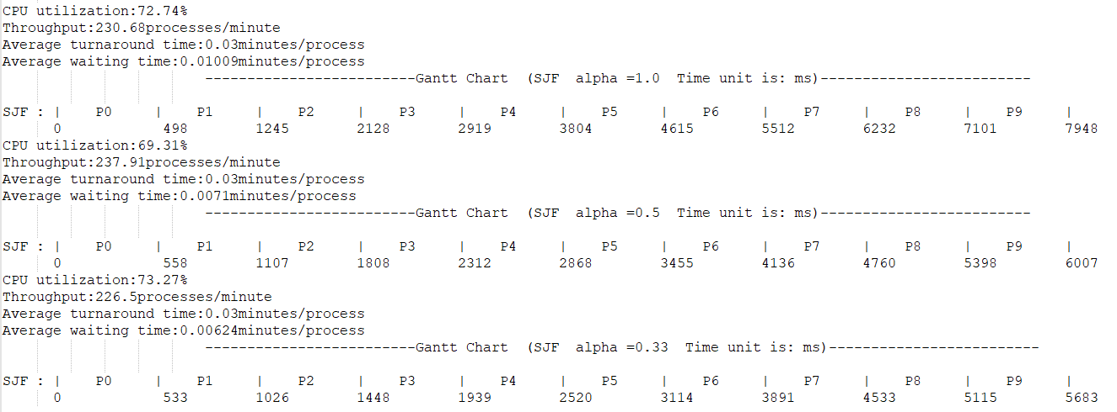

Image 4：Result of SJF ( alpha = 1, 1/2, 1/3 )
( Process execution time 120ms - 240ms )

b) Statement
When the quantum is smaller than the largest inter-I/O intervals, the average waiting time increases with the decreasing quantum.
Under no circumstances , the average waiting time decreases with the decreasing quantum.
When the quantum is larger than the largest inter-I/O intervals, the average waiting time no longer be affected by the quantum.
c) Design experiments to test statement in b)
When the execution time of processes is set to be 120s - 240s, no matter how I change the size of quantum, there is not a significant difference. Because the quantum is too small compare to process execution time. As we can see in Image 5.
So, I changed process execution time to 120ms - 240ms.
I first set the quantum to be 5, 15, 25, 35, 45, 55, 65, 75 respectively and observe the difference. As shown in Image 6, the average waiting time increases with the decreasing quantum.
Then, I set the quantum to change from 80 to 300. As shown in Image 7, the average waiting time no longer be affected by the quantum.
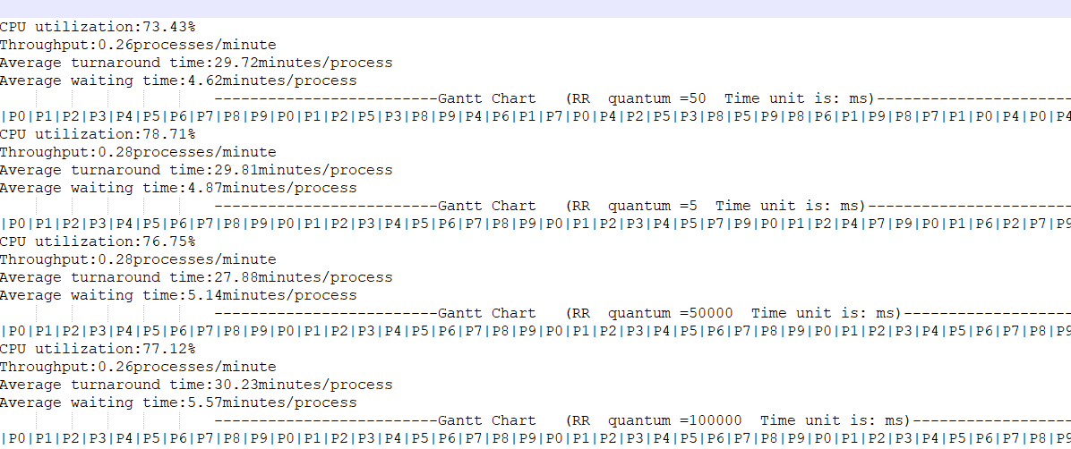

Image 5：Result of RR ( quantum = 5, 50, 50000, 100000 )
( Process execution time 120s - 240s )

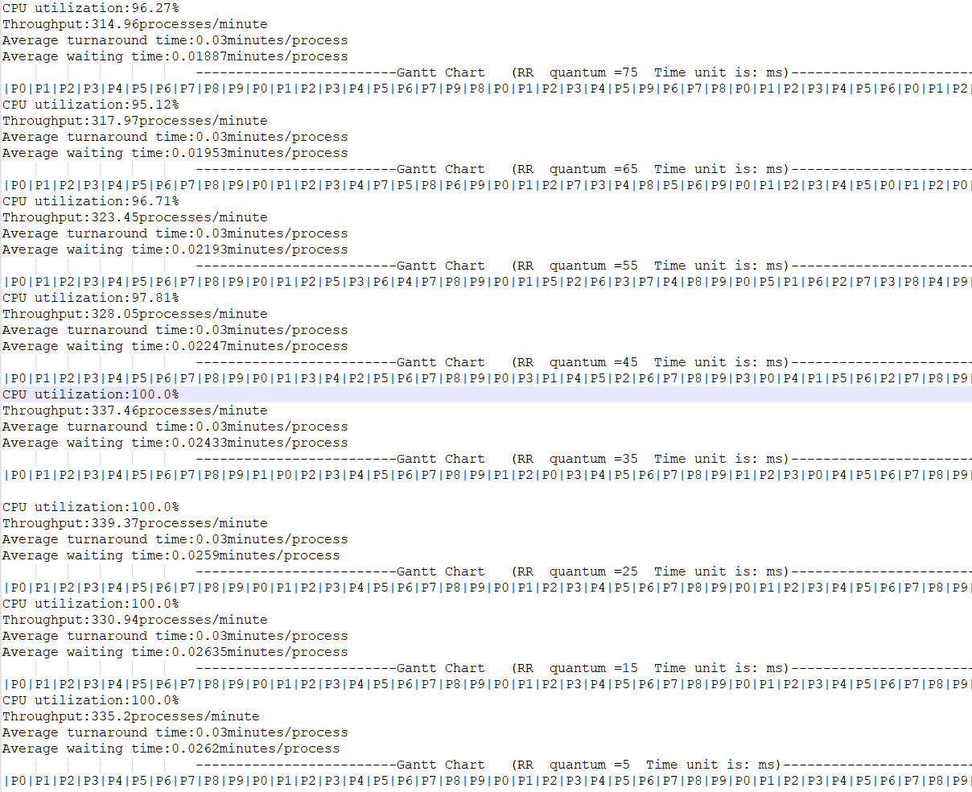

Image 6：Result of RR ( quantum = 5, 15, 25, 35, 45, 55, 65, 75)
( Process execution time 120ms - 240ms )

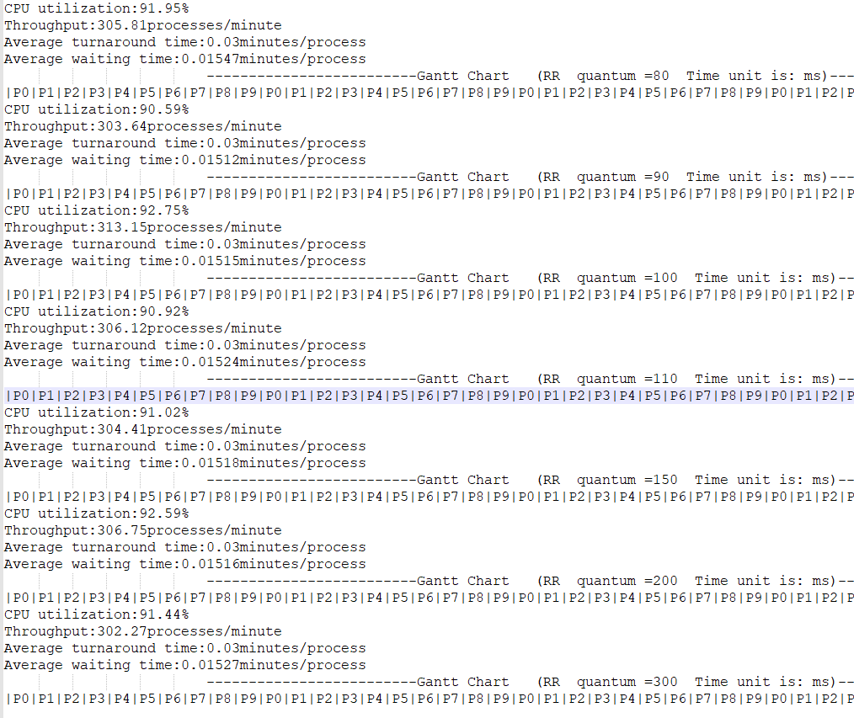

Image 7：Result of RR ( quantum = 80, 90, 100, 110, 150, 200, 300)
( Process execution time 120ms - 240ms )

