JichenDai_CS520_HW01

1. 1. Consider modifying the Enter_Critical procedure (see Lecture 1) to assign the Id
of the executing process (rather than other) so that the procedure looks like that:
void Enter_Critical (int process) /* 0 or 1 */
{
int other;
other = 1 – process;
flag[process] = TRUE; /* show my interest */
turn = process; /* grab it! */
while (flag [other] == TRUE && turn == process);
}
Will the algorithm still work (i.e., provide the critical section access satisfying all three criteria)? Why or why not? (15 points.)
Answer: Algorithm works! When while(flag[1]==TRUE&&turn==0) is true, P0 do not enter the critical section. It waits until the condition evaluates to false. As soon as P1 sets turn=1, while loop condition at P0 evaluates to false, hence P0 enters critical section. But now at P1, while(flag[0]==TRUE&&turn==1) is true. Hence P1 waits outside CS.

2. Does the busy waiting solution work when the two processes are running on a
shared-memory multiprocessor?
Answer: YES, it will work. If we use a turn variable, the turn variable will be in shared-memory, and two process run on different CPU.

3. Study the Bakery Algorithm and prove the following property: If Pi is in a critical
section and Pk (k i) has already chosen its number[k]  0, then (number[i], i) <
(number[k], k). Once that is proven, complete the proof that only one process can
be in the critical section.
Consider two cases.
1. 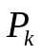 has already chosen its number when 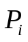 dose the last test before entering critical section.
Proof by Contradiction:
If (number[i], i) > (number[k], k), 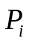will looping at while((number[t] != 0) && less(number[t], t, number[process], process) until the condition dose not hold. And will not be able to enter critical section,
This conflicts with “Pi is in a critical section”.
So, (number[i], i) < (number[k], k) since they cannot be equal.

2. 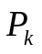did not chose its number whendose the last test before entering critical section.
In this case, since has chosen it’s number when is in critical section, must chose its number later than . So number[k] will be bigger than number[i]. So (number[i], i) < (number[k], k)。

4. When a computer is being developed, it is often first simulated by a program that runs one instruction at a time. (Even multiprocessors are simulated strictly
sequentially like this.) Is it possible for a race condition to occur in such
situations?
Answer: YES, It is possible to occur a race condition.
If two process write the same file, it will cause a race condition even though we runs one instruction at a time.
For example:
First, CPU process P1, P1 writes some things to a file, but is interrupted before P1 finish writing( maybe because of clock interruption)
Then, CPU start to process P2, P2 writes on the same file, but P1 don’t know it.
After P2 is processed, CPU start to execute P1 again, and mistakes will occur.

5. In early literature, semaphore operations wait and signal have been respectively
referred to as P and V. Why?
Answer：Beacuse P and V comes from Dutch Words.
The wait() was originally termed P, it is from the Dutch proberen, “to test”.
The signal() was originally called V, it is from the Dutch verhogen, “to increment”.

6. Suppose a queue in a semaphore is implemented not as a first-in-first-out (FIFO)
queue, but as last-in-first-out (LIFO) stack. Show how this can result in
starvation, that is a situation when a process is indefinitely queued in a semaphore
and thus can never progress.
Proof:
When we use FIFO to implement a queue, the process which is pushed last is always removes first by the scheduler.
If processes keep on coming, the previous processes may be held indefinitely and will never be removed from the queue. This leads to starvation.

7. One reason semaphores are used is for mutual exclusion—that is ensuring that
only one process enter a critical session to avoid race conditions. The other reason
is synchronization, that is ensuring the events happen in certain sequence. The
lecture specifies three semaphores mutex, empty, and full. Which ones of these are used for mutual exclusion, and which ones—for synchronization? Explain your
answer.
Answer: Mutex is used for mutual exclusion, empty and full is used for synchronization.
There are only one muter, wait(mutex) and signal(mutex) appear in pairs. So only one process can use mutex at a time.
The empty and full counting the number of empty and full buffers.
If full ≠ 0, then consumer can take a process away from the buffer.
If empty ≠ 0, then producer can put a process in the buffer.

8. Study the Bounded_Buffer problem (Section 7.1.1) carefully. Suppose the two
wait statements of Figure 7.1 were reversed by the programmer [so that
wait(mutex) is executed before wait(empty)]. What will happen when the buffer is
full?
Answer: Both producer and consumer will be blocked when the buffer is full, if two wait statements of Figure 7.1 were reversed.
Proof:
1.Producer execute wait(mutex), set mutex = 0.
2.Producer execute wait(empty), it will loop at while(empty <= 0).
3. Now, if customer execute wait(mutex), it will loop at while(mutex <= 0).
So, both produce and customer is blocked.

9. The Sleeping-Barber Problem. A barbershop consists of a waiting room with n
chairs and the barber room containing the barber chair. If there are no customers
to be served, the barber goes to sleep. If a customer enters the barbershop and all chairs are occupied, then the customer leaves the shop. If the barber is busy but chairs are available, then the customer sits in one of the free chairs. If the barber is asleep, the customer wakes up the barber.
Using the semaphore constructs described in the textbook (and used for solving
other problems) write a program to coordinate the barber and the customers.That
is, write one procedure for the Barber process and one procedure for the customer
process.) [Hint: define the customers, barbers, and mutex semaphores.]

Program Description: This is just similar to the Bounded-Buffer Problem.
#define N = number of chairs in waiting room;
semaphore fullChairs = 1, freeChairs = N, mutex = 0;
int in = 0, out = 0;

while(TRUE)
{ /* customer */
come_in( &name );
wait(freeChair)
wait(mutex)
buffer[in] = name
in = (in+1)%N
signal(mutex)
signal(fullChair)
}

While(TRUE)
{ /* barber */
wait(fullChair)
wait(mutex)
who_got_haircut = buffer[out]
out = [out+1]%N
signal(mutex)
signal(freeChair)
cut_hair( who_got_haircut)
}

10. Artists and Viewers. In the new Center for Strange Arts (CESA) in New York
City, there is a famous Weird Hall, open 24 hours a day, with a very large painting
being perpetually developed by the walk-in artists. Because the artists tend to fight with one another as well as accost viewers, only one artist at a time may enter the Weird Hall, and once an artist is there, no other artists or viewers are allowed in. (They have to wait in front of the Weird Hall.) If no artist is in, the viewers may come in at any time and in any numbers; they are not queued behind the artists.
Furthermore, as long as there is at least one viewer is in the Weird Hall, no artist is allowed in. Write the pseudo-code for synchronization of viewers and artists using semaphores.
Program Description:This is similar to readers-writers problem.
semaphore available_ for_artist = 1, mutex = 1;
int viewer_count = 0；

artist(){
while(true){
wait(available_ for_artist); //make sure only one artist inside.
draw_painting();
signal(available_ for_artist);
}
}

viewer(){
while(true){
wait(mutex);
viewer++;
if(viewer = = 1)
wait(available_ for_artist);
signal(mutex);

viewing();

wait(mutex);
viewer--;
if (viewer = = 0)
signal(available_ for_artist)
signal(mutex);
}
}

JichenDai_CS520_HW02
5.1 A CPU-scheduling algorithm determines an order for the execution of its scheduled processes. Given n processes to be scheduled on one processor, how many different schedules are possible? Give a formula in terms of n.
Answer: n!
Proof:
The 1th schedule has n choices.
The 2th schedule has n-1 choices.
.
.
.
The last schedule has only 1 choices.

So, the number of possible different schedules is n*(n-1)*(n-2)*......*1 = n!

2. Prove formally that the Shortest Job First scheduling algorithm is optimal in that it minimizes the average waiting time. For simplicity, assume that 1) all n processes are already in the system at the time the scheduling decision has to be made and 2) all processes have arrived at the same time.
Hint: Use the formula for average waiting time in the Lecture.
Proof:
According to the lecture, average waiting time for an arbitrary set of n processes is:
W = 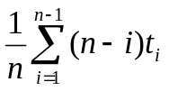 = ((n-1) + (n-2) + ∙∙∙ + 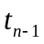)) / n (1)
Suppose there exist two process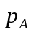and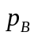, such that A<B, 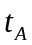>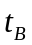.
We switch their order of execution, then the new average waiting time is:
W’ = ((n-1)+ (n-2)+∙∙∙ + (n-A)+∙∙∙ + (n-B)+ ∙∙∙ + ) / n (2)

Formula (2) subtract formula(1）：
W’ - W = ((n-A)+ (n-B)- (n-B)+ (n-A)) / n
= ((A-B) + (B-A)) / n
=(B-A)(-) / n
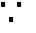 A<B & >
W’ - W<0.
W’<W //the average running time is shorter after switch.

Repeating this process over and over again to move shorter jobs in front of long jobs, we will eventually got a schedule that has minimal average waiting time.

So, for an arbitrary set of n processes, it achieves minimal average waiting time when using Shortest Job First algorithm.

5.3 Suppose that the following processes arrive for execution at the times
indicated. Each process will run for the amount of time listed. In answer
ing the questions, use nonpreemptive scheduling, and base all decisions
on the information you have at the time the decision must be made.
Process ArrivalTime BurstTime
P1 0.0 8
P2 0.4 4
P3 1.0 1
a. What is the average turnaround time for these processes with the
FCFS scheduling algorithm?
b. What is the average turnaround time for these processes with the
SJF scheduling algorithm?
c. The SJF algorithm is supposed to improve performance, but notice that we chose to run process P1 at time 0 because we did not know that two shorter processes would arrive soon. Compute what the average turnaround time will be if the CPU is left idle for the first 1 unit and then SJF scheduling is used. Remember that processes P1 and P2 are waiting during this idle time, so their waiting time
may increase. This algorithm could be known as future-knowledge
scheduling.
(1) FCFS scheduling:

P1 |  | P2 |  | P3
0.0 | 8 |  | 12 |  | 13

Average turnaround time = (8 + (12-0.4) + (13-1)) ≈ 10.533

(2)SJF scheduling:

P1 |  | P3 |  | P2
0.0 | 8 |  | 9 |  | 13

Average turnaround time = (8 + (9-1) + (13-0.4)) ≈ 9.533

(3) Future-knowledge-scheduling scheduling:
idle |  | P3 |  | P2 |  | P1
0 | 1 |  | 2 |  | 6 |  | 14

Average turnaround time = ((2-1) + (6-0.4) + 14) ≈ 6.866

5.4 Consider the following set of processes, with the length of the CPU burst
time given in milliseconds:
Process BurstTime Priority
P1 2 2
P2 1 1
P3 8 4
P4 4 2
P5 5 3
The processes are assumed to have arrived in the order P1, P2, P3, P4, P5,
all at time 0.
a. Draw four Gantt charts that illustrate the execution of these processes using the following scheduling algorithms: FCFS, SJF, nonpreemptive priority (a larger priority number implies a higher priority), and RR (quantum = 2).
b. What is the turnaround time of each process for each of the
scheduling algorithms in part a?
c. What is the waiting time of each process for each of these scheduling algorithms?
d. Which of the algorithms results in the minimum average waiting
time (over all processes)?
Answer: SJF achieves the minimum average waiting time.
Gantt chart for FCFS:
P1 |  | P2 |  | P3 |  | P4 |  | P5
0 | 2 |  | 3 |  | 11 |  | 15 |  | 20

Process | turnaround time | waiting time | average waiting time
P1 | 2 | 0 | (0+2+3+11+15) / 5  = 6.2
P2 | 3 | 2 | (0+2+3+11+15) / 5  = 6.2
P3 | 11 | 3 | (0+2+3+11+15) / 5  = 6.2
P4 | 15 | 11 | (0+2+3+11+15) / 5  = 6.2
P5 | 20 | 15 | (0+2+3+11+15) / 5  = 6.2

Gantt chart for SJF:
P2 |  | P1 |  | P4 |  | P5 |  | P3
0 | 1 |  | 3 |  | 7 |  | 12 |  | 20

Process | turnaround time | waiting time | average waiting time
P1 | 3 | 1 | (1+0+12+3+7) / 5  = 4.6
P2 | 1 | 0 | (1+0+12+3+7) / 5  = 4.6
P3 | 20 | 12 | (1+0+12+3+7) / 5  = 4.6
P4 | 7 | 3 | (1+0+12+3+7) / 5  = 4.6
P5 | 12 | 7 | (1+0+12+3+7) / 5  = 4.6

Gantt chart for non-preemptive:
P3 |  | P5 |  | P1 |  | P4 |  | P2
0 | 8 |  | 13 |  | 15 |  | 19 |  | 20

Process | turnaround time | waiting time | average waiting time
P1 | 15 | 13 | (13+19+0+15+8) / 5  = 11
P2 | 20 | 19 | (13+19+0+15+8) / 5  = 11
P3 | 8 | 0 | (13+19+0+15+8) / 5  = 11
P4 | 19 | 15 | (13+19+0+15+8) / 5  = 11
P5 | 13 | 8 | (13+19+0+15+8) / 5  = 11

Gantt chart for RR(quantum = 2):
P1 |  | P2 |  | P3 |  | P4 |  | P5 |  | P3 |  | P4 |  | P5 |  | P3 |  | P5 |  | P3
0 | 2 |  | 3 |  | 5 |  | 7 |  | 9 |  | 11 |  | 13 |  | 15 |  | 17 |  | 18 |  | 20

Process | turnaround time | waiting time | average waiting time
P1 | 2 | 0 | (0+2+12+9+13) / 5  = 7.2
P2 | 3 | 2 | (0+2+12+9+13) / 5  = 7.2
P3 | 20 | 12 | (0+2+12+9+13) / 5  = 7.2
P4 | 13 | 9 | (0+2+12+9+13) / 5  = 7.2
P5 | 18 | 13 | (0+2+12+9+13) / 5  = 7.2

Above all,11>7.2>6.2>4.6, SJF achieves the minimum average waiting time.

5. The Snooty Clam restaurant does not take reservations. The dining room contains a single table seating twenty patrons. When space becomes free, parties are seated in the order in which they arrived, except that a party that cannot be seated in the available space is passed over.
(1) What is the effect on large party?
Answer: This will lead to starvation of large parties.
If small party keeps coming, large parties might keep waiting forever. However, it improves utilization of the table.
(2) What is the effect on utilization if parties are seated strictly in the order they arrive?
Answer: This will leads to poor utilization of the table.
It’s like FCFS scheduling, it gives every party equal chance to eat, but the average waiting time will increase.

5.8 Suppose that a CPU scheduling algorithm favors those processes that have used the least processor time in the recent past. Why will this algorithm favor I/O-bound programs and yet not permanently starve CPU-bound programs?
Answer: It favor I/O-bound programs because I/O-bound programs spends more times doing I/O than doing computations.
It wouldn’t permanently starve CPU-bound because the I/O-bound programs will often put aside the CPU to do their I/O.
JichenDai_CS520_HW04

Problem 8.1 List three examples of deadlocks that are not related to a computer
system environment.
Answer：
1. Two man across a single-plank bridge form opposite directions.
2. Two trains running on the same track from opposite directions.
3. A man going down a ladder while another man is climbing the same ladder.

Problem 8.2 Suppose that a system is in an unsafe state. Show that it is possible for the threads to complete their execution without entering a deadlocked state.
Answer: Consider the situation that we have 10 resources allocated among two processes P1 and P2. They are allocated according to the following policy:

 | MAX | Current | Need
P1 | 9 | 5 | 4
P2 | 6 | 2 | 4
In this situation, this system is in an unsafe situation since we only have 3 resources available. However, it is possible that P1 may release one resource before asking for more resources. Thereby, the number of available resources will increase to 4. This allows P2 to be completed, then P1 will also be completed.

Problem 8.3 Is the system in a safe state?
If a request from thread T1 arrives for (0,4,2,0), can the request be granted immediately?
Answer:
(1) Matrix Need = Max - Allocation =
0 | 0 | 1 | 2 | - | 0 | 0 | 1 | 2 | = | 0 | 0 | 0 | 0
1 | 7 | 5 | 0 | - | 1 | 0 | 0 | 0 | = | 0 | 7 | 5 | 0
2 | 3 | 5 | 6 | - | 1 | 3 | 5 | 4 | = | 1 | 0 | 0 | 2
0 | 6 | 5 | 2 | - | 0 | 6 | 3 | 2 | = | 0 | 0 | 2 | 0
0 | 6 | 5 | 6 | - | 0 | 0 | 1 | 4 | = | 0 | 6 | 4 | 2

(2) Yes, it is in safe state.
The sequence of process execution is <P0, P2, P3, P4, P1>
The process are shown above:
P0 executed and free (0 0 1 2), now Available is (1 5 3 2)
P2 executed and free (1 3 5 4), now Available is (2 8 8 6)
P3 executed and free (0 6 3 2), now Available is (2 14 11 8)
P4 executed and free (0 0 1 4), now Available is (2 14 12 12)
P1 is executed.

(3) Yes, it can be granted immediately
Because Request (0 4 2 0) < Available (1 5 2 0)
and Request(0 4 2 0) + Allocation(1 0 0 0) < Max(1 7 5 0)
Moreover, after grant this request immediately, there exist a safe sequence<P0, P2, P1, P3, P4>.
The process are shown above:
P0 executed and free (0 0 1 2), now Available is (1 1 1 2)
P2 executed and free (1 3 5 4), now Available is (2 4 6 6)
P1 executed and free (1 4 2 0), now Available is (3 8 8 6)
P3 executed and free (0 6 3 2), now Available is (3 14 11 8)
P4 is executed.

1. In the lecture, we noted that process trajectories (a two-process case) can travel only North or East. What condition prevented them from moving diagonally (i.e., North-East)? Under which condition could they move North-East? Could they
move South-West?
(1) If they are using a resource that is NOT shareable ( i.e., there is only one CUP), the two process will not move diagonally.
(2) If all the resources they need is shareable(e.g., they read the same file and don’t write it) or has two instance(e.g., there are two CPU, two printers), they will move North-East.
(3)No, they cannot move South-West since it’s the wrong direction to go to the final point. And move South-West means that process rolled back to the previous state.

2. Consider the following snapshot of a system:
Allocation Max
ABCD ABCD
T0 3014 5117
T1 2210 3211
T2 3121 3321
T3 0510 4612
T4 4212 6325
Using the banker’s algorithm, determine whether or not each of the following states is unsafe. If the state is safe, illustrate the order in which the threads may complete. Otherwise, illustrate why the state is unsafe.
a. Available = (0, 3, 0, 1)
b. Available = (1, 0, 0, 2)

Answer:We first calculate Need Matrix
 | Allocation | Max | Need
Process | A B C D | A B C D | A B C D
T1 | 3014 | 5117 | 2103
T2 | 2210 | 3211 | 1001
T3 | 3121 | 3321 | 0200
T4 | 0510 | 4612 | 4102
T5 | 4212 | 6325 | 2113

a. Available = (1, 3, 0, 1), The state is unsafe
First, for T3, Need (1 0 0 1)<Available (0 3 0 1)
So, Available = (0 3 0 1) + (3 1 2 1) = (3 4 2 2)
Second, for T2, Need(1 0 0 1) < Available(3 4 2 2)
So, Available = (3 4 2 2) + (2 2 1 0) = (5 6 3 2)
Third, for T4, Need (4 1 0 2) < Available (5 6 3 2)
So, Available = (5 6 3 2) + (0 5 1 0) = (5 11 4 2)
Now, T1 and T5 cannot be satisfied, so it is unsafe.

b. Available = (1, 0, 0, 2), The state is safe, safe order is < T2, T3, T4, T5, T1>.
First, for T2, Need (1 0 0 1) < Available (1 0 0 2)
S0, Available = (1 0 0 2) + (2 2 1 0) = (3 2 1 2)
Second, for T3, Need (0 2 0 0) < Available (3 2 1 2)
So, Available = (3 2 1 2) + (3 1 2 1) = (6 3 3 3)
Third, for T4, Need (4 1 0 2) < Available (6 3 3 3)
So, Available = (6 3 3 3) + (0 5 1 0) = (6 8 4 3)
Fourth, for T5, Need (2 1 1 3) < Available (6 8 4 3)
So, Available = (6 8 4 3) + (4 2 1 2) = (10 10 5 5)
Fifth, for T1, Need (3 0 1 4) < Available (10 10 5 5)
So, Available = (10 10 5 5) + (3 0 1 4) = (13 10 6 9)
Thus, system is safe, sequence is <T2, T3, T3, T5, T1>

3.
Transfer (char[] account_from, char[] account_to, int amount){
if (account_from == account_to)
return;
else if (account_from < account_to){
lock(account_from)
lock(account_to)
}
else {
lock(account_to)
lock(account_from)
}
/* Do the fund transfer here */
release(account_from)
release(account_to)
}
4.Prove that the worst complexity of Banker’s Algorithm is O(n2m), where n an m
are, respectively, the number of processes and the number of resource types.
Proof:
The while loop will be executed for n times.
In the worst case, in each while loop, the good process is always at the end of the loop.
The first time, n processes were compared whether their 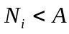.
The second time, n-1 processes were compared.
Thus, in the worst case, there are n + (n-1) + (n-2) + ...... + 2 + 1 = n(n+1)/2 = O(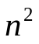)
and each vector comparison ofwill cost O(m).
So, the total operation is O(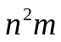)

前三章笔记
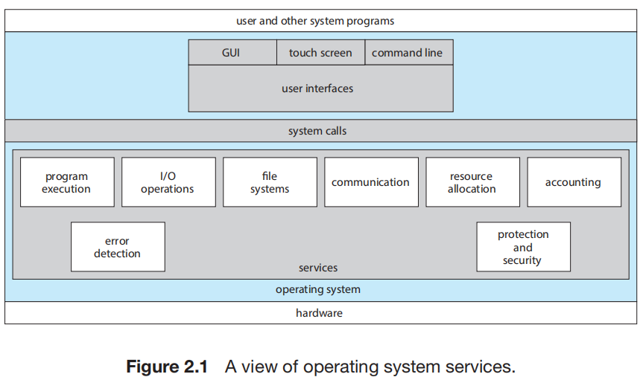
3 kinds of OS interface: Command Interface, Graphical User Interface, Touch-Screen Interface.
System calls provide an interface to the services made available by an operating system.
System call is the programmatic way in which a computer program requests a service from the kernel of the operating system it is executed on. A system call is a way for programs to interact with the operating system. A computer program makes a system call when it makes a request to the operating system’s kernel. System call provides the services of the operating system to the user programs via Application Program Interface(API). It provides an interface between a process and operating system to allow user-level processes to request services of the operating system. System calls are the only entry points into the kernel system. All programs needing resources must use system calls.
System calls can be grouped roughly into six major categories: process control, file management, device management, information maintenance, communications, and protection.
Operating System services, also known as system utilities, provide a convenient environment for program development and execution. Some of them are simply user interfaces to system calls. Others are considerably more complex.
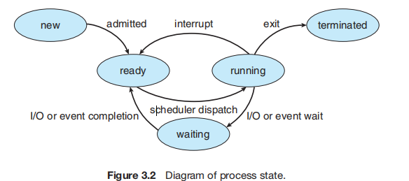
A process is a program in execution.
The layout(布局) of a process in memory is represented by four different sections: (1) text, (2) data, (3) heap, and (4) stack.
There are four general states of a process: (1) ready, (2) running, (3) waiting, and (4) terminated.
A process control block (PCB) is the kernel data structure that represents a process in an operating system.
The role of the process scheduler is to select an available process to run on a CPU.
An operating system performs a context switch when it switches from running one process to running another.
Race condition: Several processes access and manipulate the same data concurrently and the outcome of the execution depends on the particular order in which the access takes place.

MidTerm Prediction
1. The Ordean Pass problem. Two countries, Ardia and Ordea (the
countries are located in a beautiful continent of Atlantida), are separated by a high
Hordia mountain range. The industrious peoples of both countries have cooperated on
building a railroad passing through the only pass high in the mountains. Up to the
pass, on both sides, the railroad has two tracks for the trains going in different
directions, but because the pass is very narrow, only one track was built to connect
the countries as shown in the adjoining figure.
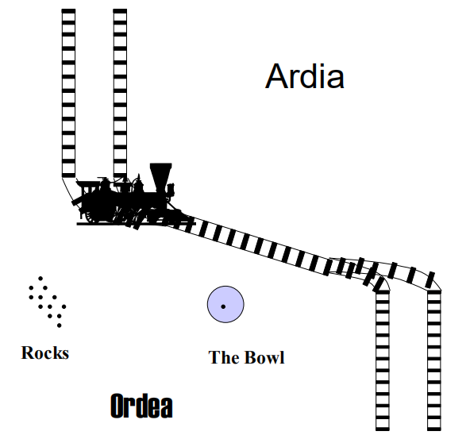

Some train operators in Ardia and Ordea are both blind and deaf; therefore the
Ardian and Ordean laws require that all signaling be implemented in a way
suitable for blind and deaf. Accordingly, the governments of both states
developed the procedures for accessing the single track, which stipulate that

• When arriving at the pass, each train must stop before entering it. After
stopping, the train operator walks to the Bowl;
• The operator must check the bowl:
a. If it is empty, the operator must go find a rock (please see the picture) and put it in the Bowl. Then the operator must return to the train and drive it over the pass to the appropriate truck on the other side where it is save to stop. Then the operator stops the train, walks back to the Bowl, throws the rock out, and returns to the train.
b. If the Bowl contains a rock in it, it means that the other train owns the track. Thus, the operator is to take a rest for a few minutes and check the Bowl again. This procedure must be repeated until the Bowl is empty. At this point, the operator must follow the a) procedure outlined in the previous paragraph

After the pass had been opened and trains successfully operated for a month, there was suddenly a collision, followed by another one two weeks later. The pass was closed and thorough investigations were ordered independently by both governments. Both investigations determined that the operators had followed the rules in every detail.
Then a scandal happened. A consultant, Professor Alec Smart of the Ardia Institute of Technology, when subpoenaed to the investigation court, testified that the procedures were flawed. As the result, Ministers of Transportation in both countries who developed the procedures for crossing the pass were asked to resign.
Question 1.1: Was Dr. Smart correct? If so, please explain how a crash could happen when the operators followed the defined procedures. (10 points).

Dr. Smart recommended that the procedures be immediately modified so that the Ordean operator may move only when the Bowl is empty (so the Ordean operator must wait for the Bowl to be empty), and that he or she be required to put the rock in the Bowl after the train went through the pass. Similarly, the Ardian operator may move only when the Bowl has a rock in it (and if it is not there, the Ardian operator must wait until it is there), and that he or she be required to take the rock out after the train went through the pass.
Question 1.2: Will Dr. Smart’s recommendation prevent crashes? (Please answer only “Yes” or “No.”) (10 points)

The recommended procedures were implemented, but a few months later the Ordean government received a complaint from its new Minister of Transportation that the procedures were grossly unfair to Ordeans. The minister explained that there were three trains a day from Ordea to Ardia, but only one train a day from Ardia to Ordea. The minister claimed that there was a terrible back-up of the Ordean trains, which had to wait for days before crossing the path, while there was no disruption in the schedule of the trains that originated from Ardia. The Ardian government ignored the complaint, so the case was taken into the International Court of Atlantida, which has determined that the procedures were indeed unfair to Ordeans. The decision of the court has allowed Ordeans to close the pass until a better solution was found.
Question 1.3: Was the International Court of Atlantida right? Please explain why or why not. (10 points)

Dr. Smart (who was under the investigation for receiving a bribe from some
Ardian businesses, which allegedly influenced his previous recommendation) had
pressured to find a new solution to clear his name. He suggested that the second
bowl, called the Ardian bowl, be placed next to the Bowl (which he now called
the Ordean bowl). Dr. Smart suggested that the presence of the rock in the Ordean
bowl is to signal the intention of the Ordean operator to enter the pass, while the
presence of the rock in the Ardian bowl is to signal the intention of the Ardian
operator to enter the pass. Only an Ordean operator is allowed to put a rock into
or remove it from the Ordean bowl. Similarly, only an Ardian operator is allowed
to put a rock into or remove it from the Ardian bowl. The new procedures to
follow were as follows:
a. After an operator stops the train, he or she walks to the bowl of the country
the train originated in and puts a rock in it. Then the operator checks the bowl
of the destination country. If there is no rock there, the train may proceed;
otherwise, the operator is to wait until the destination country’s bowl is empty.
b. Once the train goes to the other side of the pass, its operator is to return to the
origination country’s bowl and remove the rock from it.
The new procedures were implemented at once, but in two weeks, the traffic
through the pass stopped while the trains were backing up for days, eventually
causing the states of emergency in both countries.
Question 1.4: How could this happen? (10 points)

By that time, the bribery investigation against Dr. Smart was dropped. Yet, a
much worse thing happened: He was considered incompetent. The Ministers of
Transportation of both countries intervened and agreed to modify his latest
procedure a). (Dr. Smart protested and warned that there could be a crash, but he
was ignored.) The procedure was modified so that the operator first checks the
bowl of the destination country, and only when there is no rock in it, he or she
puts the rock in the bowl of the originating country, just before proceeding
through the pass.
Unfortunately, the collision has indeed taken place in three months. The Ordean
government, remembering that Dr. Smart predicted a collision, started to suspect
that the disgruntled scientist had caused it.
Question 1.5: Could the collision really happen without foul play? Please
explain. (5 points)
But Dr. Smart had an alibi: he was out of the continent of Atlantida during the
crash. When it happened, he was in the USA, busy studying Operating Systems in
the Stevens Institute of Technology in Hoboken, New Jersey. There he learned
everything he needed to know to solve the problem. When he returned, he presented his report to the governments of Ordea and Ardia, in which he proposed
a solution. What was phenomenal was that he proved that the solution would
work! The only hardware modifications required by the solution for the
installation of the third bowl. Also proving he was a competent and honorable
scientist, Dr. Smart has given credit for the solution to its original inventor whose
1981 paper he cited in his report.
Question 1.6: What exactly were the procedures, which the operators had to
use with these three bowls? (Please describe them.) (10 points)

2. List causes of interrupts and traps and explain how an operating system, in concert with hardware support, services interrupts and traps. (20 points)
Interrupts are caused, asynchronously with the program execution, by external events (I/O request completion, input arrival, clock)
Traps are triggered synchronously by an instruction. For example:
1.Referring to a wrong address (bus error) as in MOVE R1, FFFFFFFF
2.Performing a wrong arithmetic operation (e.g., dividing by 0)
3.Attempting to execute an undefined (or illegal) instruction
4.Executing (intentionally) a trap instruction

A hardware device triggers an interrupt by sending a signal to the CPU to alert the CPU that some event requires attention. The interrupt is managed by the interrupt handler.

The interrupt must transfer control to the appropriate interrupt service routine. The straightforward method for managing this transfer would be to invoke a generic routine to examine the interrupt information. The routine, in turn,would call the interrupt-specific handler.
Whenever a trap or interrupt occurs, the hardware switches from user mode to kernel mode
When control is given to a user application, the mode is set to user mode. Eventually, control is switched back to the operating system via an interrupt, a trap, or a system call.

A system call usually takes the form of a trap to a specific location in the interrupt vector.
This trap can be executed by a generic trap instruction, although some systems have a specific syscall instruction to invoke a system call.

Once hardware protection is in place, it detects errors that violate modes. These errors are normally handled by the operating system. If a user program fails in some way—such as by making an attempt either to execute an illegal instruction or to access memory that is not in the user’s address space— then the hardware traps to the operating system. The trap transfers control through the interrupt vector to the operating system, just as an interrupt does. When a program error occurs, the operating system must terminate the program abnormally. This situation is handled by the same code as a user-requested abnormal termination. An appropriate error message is given, and the memory of the program may be dumped. The memory dump is usually written to a file so that the user or programmer can examine it and perhaps correct it and restart the program.

3. Five jobs have been submitted simultaneously and now are waiting to be run. Their expected run times are 9, 6, 3, 5, and X. In what order should they be run to minimize average response time? (The response time of a job here is defined as the time from the submission of the job to its completion.)
Answer：In order to minimize average response time, we should use SJF scheduling.
If x<=3, then the order should be x, 3, 5, 6, 9
If 3<x<=5, then the order should be 3, x, 5, 6, 9
If 5<x<=6, then the order should be 3, 5, x, 6, 9
If 6<x<=9, then the order should be 3, 5, 6, x, 9
If 9<x, then the order should be 3, 5, 6, 9, x

4. A computer has six tape drives, with n processes competing for them. Each process may need two drives. For which values of n is the system deadlockfree? (Please list these values explicitly, and show that there is no deadlock for each of them; then show that there may be a deadlock with any other value other than those you have listed.)
Answer: If n = 1 or 2 or 3 or 4 or 5, then the system will be deadlock free.
It is obvious that the worst situation is each process got 1 tape driver and require for another one.
When there are 5 processes, Need = {1;1;1;1;1}, Allocation = {1;1;1;1;1}, Available = {1}.
.
.
So.......

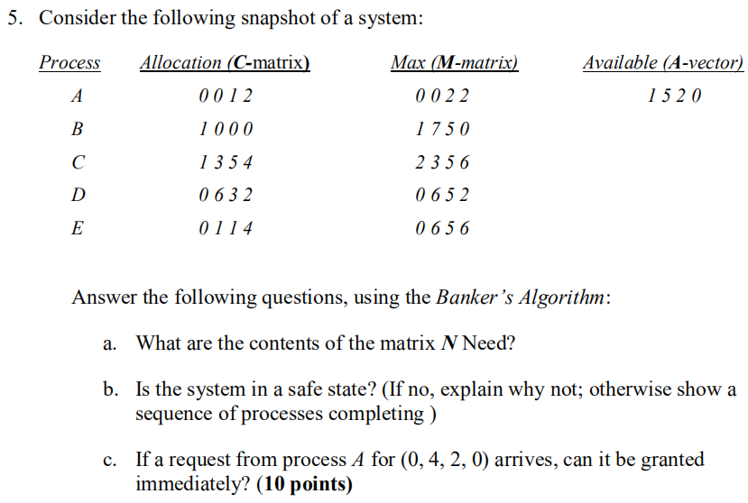
Answer:
(1) Matrix Need = Max - Allocation =
0 | 0 | 1 | 2 | - | 0 | 0 | 1 | 2 | = | 0 | 0 | 0 | 0
1 | 7 | 5 | 0 | - | 1 | 0 | 0 | 0 | = | 0 | 7 | 5 | 0
2 | 3 | 5 | 6 | - | 1 | 3 | 5 | 4 | = | 1 | 0 | 0 | 2
0 | 6 | 5 | 2 | - | 0 | 6 | 3 | 2 | = | 0 | 0 | 2 | 0
0 | 6 | 5 | 6 | - | 0 | 0 | 1 | 4 | = | 0 | 6 | 4 | 2

(2) Yes, it is in safe state.
The sequence of process execution is <P0, P2, P3, P4, P1>
The process are shown above:
P0 executed and free (0 0 1 2), now Available is (1 5 3 2)
P2 executed and free (1 3 5 4), now Available is (2 8 8 6)
P3 executed and free (0 6 3 2), now Available is (2 14 11 8)
P4 executed and free (0 0 1 4), now Available is (2 14 12 12)
P1 is executed.

(3) Yes, it can be granted immediately
Because Request (0 4 2 0) < Available (1 5 2 0)
and Request(0 4 2 0) + Allocation(1 0 0 0) < Max(1 7 5 0)
Moreover, after grant this request immediately, there exist a safe sequence<P0, P2, P1, P3, P4>.
The process are shown above:
P0 executed and free (0 0 1 2), now Available is (1 1 1 2)
P2 executed and free (1 3 5 4), now Available is (2 4 6 6)
P1 executed and free (1 4 2 0), now Available is (3 8 8 6)
P3 executed and free (0 6 3 2), now Available is (3 14 11 8)
P4 is executed.

