JichenDai_CS520_HW04
1.
See the source code Source_Code_BuddySystem.pdf in attachment.
Or see https://github.com/DaiJiChen/Buddy_System
Below are screenshot of output:
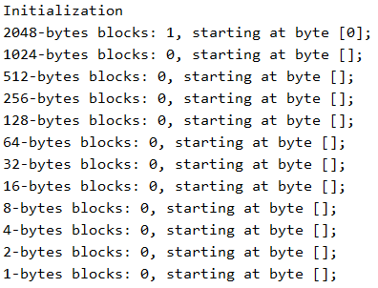
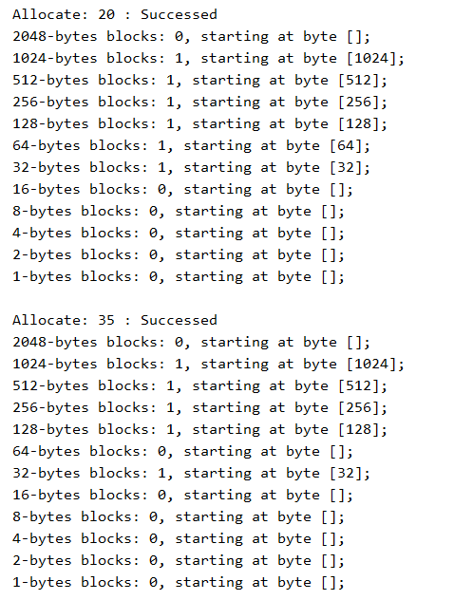
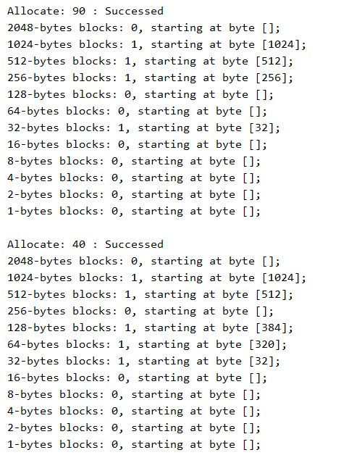
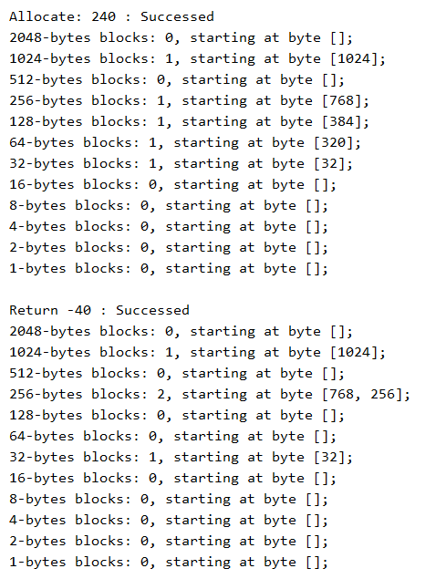
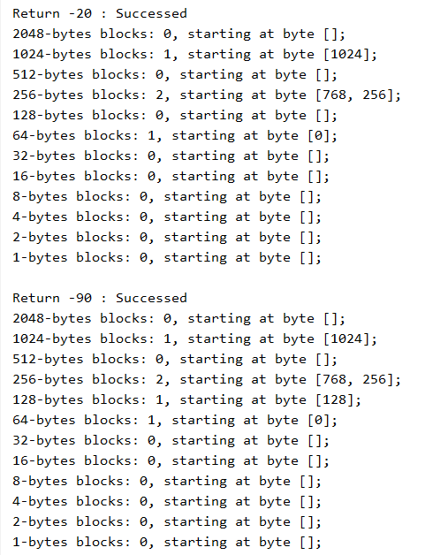
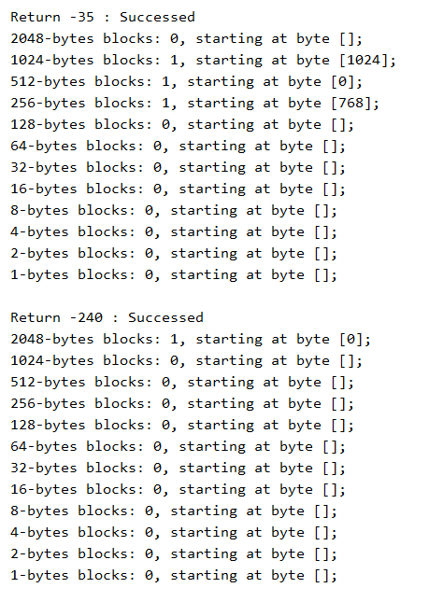
2.
Offset=32-9-11=12
Page size =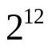= 4,096
How many in the address space: 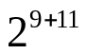=1,048,576

3. The page reference string is 3, 15, 3, 19, 3, 19, 8, 19, 8, 8, 9
Proof:
Instruction | Address | Calculation of Address
Load word 8118 into register 0 | 2020 | Address of Program
Push register 0 onto the stack | 2024 | 2020+4
Call the procedure at 4120, stacking the return address | 2028 | 2024+4
Remove on word from the stack | 4120 | Call to procedure at 4120
Compare the actual parameter to the immediate constant 7 | 4124 | 4120+4
If equal, jump to 5000 | 4128 | 4124+4

1. 2020/512 ≈ 3.94, 8118/512 ≈ 15.86
So, for “Load word 8118 into register 0”, the instruction is at page 3(I), the register 0 is at page 15(D).
2. (2020+4)/512 ≈ 3.95, 10192/512 ≈ 19.91
So, for “Push register 0 onto the stack”, the instruction is at page 3(I), the stack pointer is at page 19(D).
3. For “Call a procedure at 4120(the return address is stacked)”, the instruction is at page 3(I), the stack pointer is still at page 19(D).
4. 4120/512 ≈ 8.05
So, for “remove one word from the stack” is at page 8(I), the stack is at page 19(D).
5. For “compare the actual parameter to constant 7” is at page 8(I).
6. 5000/512 ≈ 9.77
So, for “If,equal, jump to 5000”, instruction is at page 8(I), address to be jumped to is at page 9(D).

4.
(a) linear inverted page table
Advantage: saves memory. Because it has single entry per page and each entry is assigned with process ID.
Disadvantage:
Increased the amount of time needed to search table.
We need to store one entry for every page, this may lead to more page fault.
(b)hashing inverted page table
Advantage: it decreased search time in linear inverted page table

(c) TLB
Advantage:
The hit rates is high and access memory very fast.
TLB only stores currently executing pages so that large programs only need a small TLB.
Decreases the page fault.
2) the physical page frame number corresponding to virtual page numbers 0,1,2 of Process 1 are 4, 2, 0.

5.
1) For MRU.
There will be 3 fault in the beginning.
And when it comes to (4,5,6), 4 or 5 or 6 will always be removed since they are Most Recent Used.Number of fault is 3l.
So the total number of fault is 3+3l = 3(l+1)

2) For LFU.
There will be 3 fault in the beginning.
And when it comes to (4,5,6), 4 or 5 or 6 will be removed until the time they are used is larger that k. Number of fault is 3min(k,l).
So the total number of fault is 3+3min(k,l) = 3(min(k,l)+1)
3) For FIFO.
There will be 3 fault in the beginning.
And when it comes to (4,5,6), 1 and 2 and 3 will be replaced rapidly in 3 round since they came first. Number of fault is 3. and after that, 4, 5,6 will all stay at memory and no replace happens.
So the total number of fault is 3+3 = 6

4) LRU is similar to FIFO.
There will be 3 fault in the beginning.
And when it comes to (4,5,6), 1 and 2 and 3 will be replaced rapidly in 3 round since they came first. Number of fault is 3. and after that, 4, 5,6 will all stay at memory and no replace happens.
So the total number of fault is 3+3 = 6

