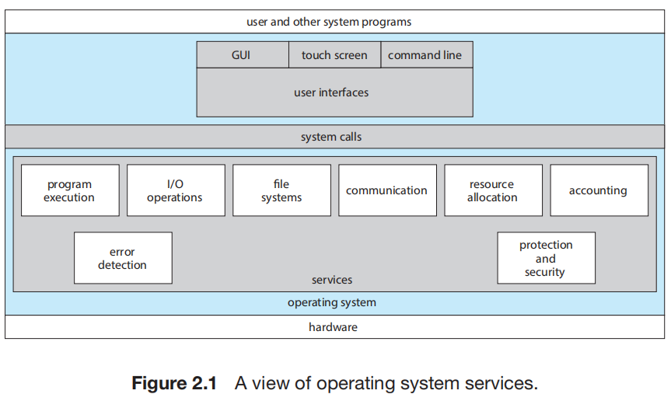
3 kinds of OS interface: Command Interface, Graphical User Interface, Touch-Screen Interface.
System calls provide an interface to the services made available by an operating system.
System call is the programmatic way in which a computer program requests a service from the kernel of the operating system it is executed on. A system call is a way for programs to interact with the operating system. A computer program makes a system call when it makes a request to the operating system’s kernel. System call provides the services of the operating system to the user programs via Application Program Interface(API). It provides an interface between a process and operating system to allow user-level processes to request services of the operating system. System calls are the only entry points into the kernel system. All programs needing resources must use system calls.
System calls can be grouped roughly into six major categories: process control, file management, device management, information maintenance, communications, and protection.
Operating System services, also known as system utilities, provide a convenient environment for program development and execution. Some of them are simply user interfaces to system calls. Others are considerably more complex.
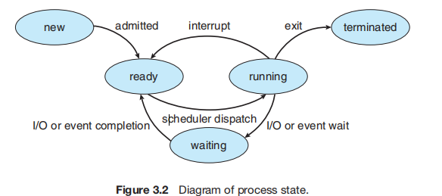
A process is a program in execution.
The layout(布局) of a process in memory is represented by four different sections: (1) text, (2) data, (3) heap, and (4) stack.
There are four general states of a process: (1) ready, (2) running, (3) waiting, and (4) terminated.
A process control block (PCB) is the kernel data structure that represents a process in an operating system.
The role of the process scheduler is to select an available process to run on a CPU.
An operating system performs a context switch when it switches from running one process to running another.
Race condition: Several processes access and manipulate the same data concurrently and the outcome of the execution depends on the particular order in which the access takes place.

