MINUTES OF MEETING
HELD SUNDAY 8th JULY, 2007
THE CELTIC MANOR, CAERLEON, SOUTH WALES

Those Present: Huw Gallagher (HG)
James Hawkins (JH)
Tim Parker (TP)
Ben Morse (BM)
Jim Morse (JM)
David Champs (DC)

Apologies: Matthew Harris (MH)
Tom Lewis (TL)
Nicholas Bellew (NB)
Matthew Parker (MP)
Anthony Hard (AH)
Paul Griffiths (PG)

Minutes taken by: Huw Gallagher
 |  | Action
1.0 | INTRODUCTIONS
1.1 | Apologies accepted by those members who submitted them.
2.0 | MINUTES OF LAST MEETING
2.1 | Minutes were accepted and posted on the Web Site. | HG
3.0 | GREEN JACKET AWARD
3.1 | Congratulations to PG for winning the award for the first time this month. PG beat the opposition with Centrica and an overall rise of 1%. Bought at 379.75pps and the final price was 383.5pps. | PG
3.2 | The nominations for this months Green Jacket Award :  Category: FTSE Top 250 shares:  HG – Tullow Oil (TLW) 521.5pps  TP – Michael Page Intl. (MPI) 595pps  BM – Admiral Group (ADM) 926pps  JM – Umnro (UMB) 158pps  DC – Bellway Homes (BWY) 1305pps  JH – Vodafone (VOD) 163.5pps
3.3 | Next months sector is non UK shares | ALL
4.0 | FINANCIAL REVIEW
4.1 | AGM Financial Review – JH to post on web-site as a separate attachment. | JH / MP
4.2 | £536 in bank, £9,648 in portfolio. £10,181 total. Up on last month. | JH
4.3 | DC, AH, NB, HG, JM & TL need to update their payments to the agreed £25- month fee. | SOME
4.4 | Vodafone – JH argues the case we keep them as they are widely tipped to buy. | JH
4.5 | £1027 to spend this month | ALL
5.0 | NEW PROPOSALS
5.1 | Alternatives to the Stock Market: UKplc is turning from Bull to Bear. We need to keep 5yp stocks (i.e. VOD) and encourage similar investments. Outside UKplc it might benefit the group if we look into Investments Trusts, GILTS, money, metals etc. | JH
5.2 | Reiterating 5.1, we need a stable long term low risk share. DC pips up with the fact we just sold Serco! | JH
5.3 | Look to place 20% of the fund into investment trusts. High risk and good annual growth. Pacific Horizon’s 12mth graph shows the most promise. | JH
5.4 | USD $$ - Now at $2 to the £. Very lucrative indeed. | JH
5.5 | Premium Bonds – 3.6% return on average. | JH
5.6 | Group needs to look at offsetting portfolio interests to other members. | JH
5.7 | TP suggests looking into a property tracker. | TP
5.8 | DC suggests categorisation of the portfolio. | DC
6.0 | RATIFICATION OF NEW VENTURES
6.1 | £1,000 in the high risk investment trust. The trust in question is Pacific Horizons | JH
6.2 | DC to set up alternative trading account with Hoodless Brennen. | DC
6.3 | All to look at alternative investment opportunities in readiness for next months meeting. | ALL
6.4 | As a preliminary understanding, it was decided to shape the fund in roughly the following way:  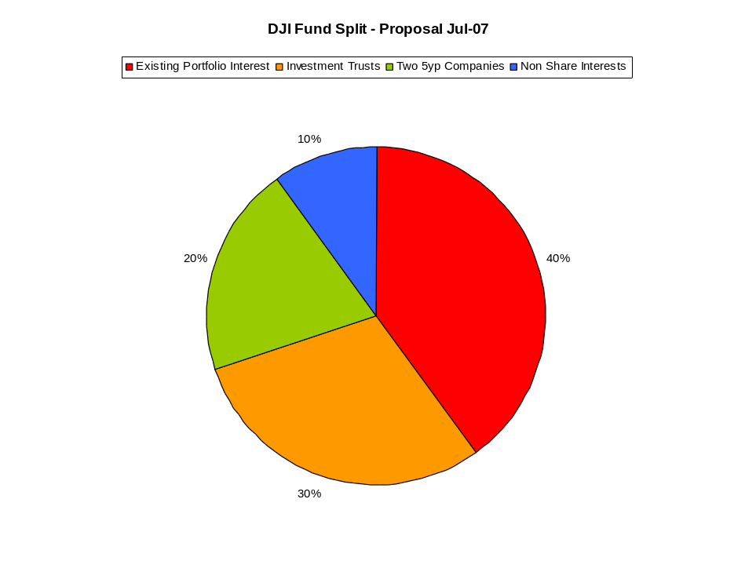  This proposal should last until y/e 2007 before next review. | ALL
7.0 | WEB SITE REVIEW
7.1 | Web site still exists – www.daijones.tk.
7.2 | It was mentioned that some members would like to see more graphs; akin to the one in 6.4 I suppose. | MP / JH
7.3 | Those with rally photos are most welcome to post them on the site. | SOME
8.0 | ANY OTHER BUSINESS
8.1 | Raft Race: Race is on Sunday 2nd September so we need to ‘crack on’. TP to arrange transport and a factory unit for undertaking repairs. | TP
8.2 | Log Cabin w/e: JH proposes the 1st week in October. HG to choose mountains. | JH / HG
8.3 | Golf. JH / HG to sort out a course in August for this years event. Course and date TBC | JH / HG
8.4 | TP suggests we start buying land. He likes the idea of a field fund. Asks anyone to join him. | TP
8.5 | Cricket Match. HG to confirm if there is interest in playing NS and his ‘blue collar boys’. HG to confirm | HG
8.6 | Bike Ride, Tour d’Usk. Abergavenny to Caerleon all dayer. TP to organise | TP
8.7 | PG’s 30th Birthday Party will be September 30th. Possibly Caerleon RFC, defiantly fancy dress! | PG
8.8 | DC suggests a meet up for the RWC semi finals. | DC
9.0 | NEXT MEETING DETAIL
9.1 | Next meeting will be on Sunday 5th August, 5pm in Merlin’s Bar, CMR, Caerleon. | ALL

