MINUTES OF MEETING
HELD SUNDAY 6th AUGUST, 2007
THE CELTIC MANOR, CAERLEON, SOUTH WALES

Those Present: Huw Gallagher (HG)
James Hawkins (JH)
Tim Parker (TP)
Ben Morse (BM)
Paul Griffiths (PG)
Anthony Hard (AH)

Apologies: Matthew Harris (MH)
Tom Lewis (TL)
Nicholas Bellew (NB)
Matthew Parker (MP)
Anthony Hard (AH)
Paul Griffiths (PG)
James Morse (JM)
David Champs (DC)

Minutes taken by: Huw Gallagher
 |  | Action
1.0 | INTRODUCTIONS
1.1 | Apologies accepted by those members who submitted them.
2.0 | MINUTES OF LAST MEETING
2.1 | Minutes were accepted and posted on the Web Site. | HG
3.0 | GREEN JACKET AWARD
3.1 | Congratulations to JM who won an overall disappointing GJA this month. JM won with Umbro and with an overall loss of -1.27%. Started at 158pps and ended at 156pps. | JM
3.2 | The nominations for this months Green Jacket Award :  Category: Non UK shares (should make things interesting for MP!!):  From the NYSE:  HG – Boeing (BA) $104.24  TP – American Home Mtg. Invt. (AHM) $.70  BM – Chiquita Brands (CQB) $14.11  From the NASDAQ:  AH – Rio Vista Energy (REVP) $20.12  PG – Google (GOOG) $508.25  JH – Pacific Sunware (PSUN) $12.48
3.3 | Next months sector is shares with the words ‘face’ & ‘book’ in the title!! | ALL
4.0 | FINANCIAL REVIEW
4.1 | AGM Financial Review – JH to post on web-site as a separate attachment. | JH / MP
4.2 | Monies owing: PG £21; DC £10; NB £10; AH £5; JM £5 & TL £80  Treasurer asks if all members can settle debts at the earliest opportunity. | SOME
4.3 | General synopsis is that the month has been a bad time for the FTSE. Four shares on the FTSE make up c.25% and that includes Vodafone. Due to the inclusion of VOD, our portfolio is directly affected by upturns and down turns.
4.4 | It was noted that we are under strength in some sectors as agreed in the portfolio breakdown last month:  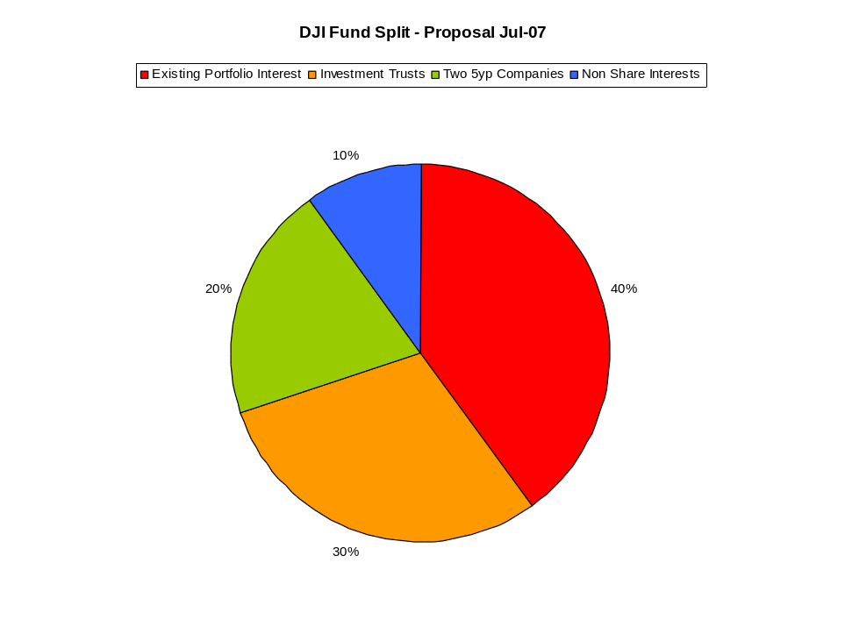 | JH
4.5 | Fund value in June: £9,894; July £10,181 & August £10,091. Value per member is £840.96 | ALL
4.6 | £300.36 to spend this month. | ALL
4.7 | DC suggested last month we categorise the portfolio. Well here it is:  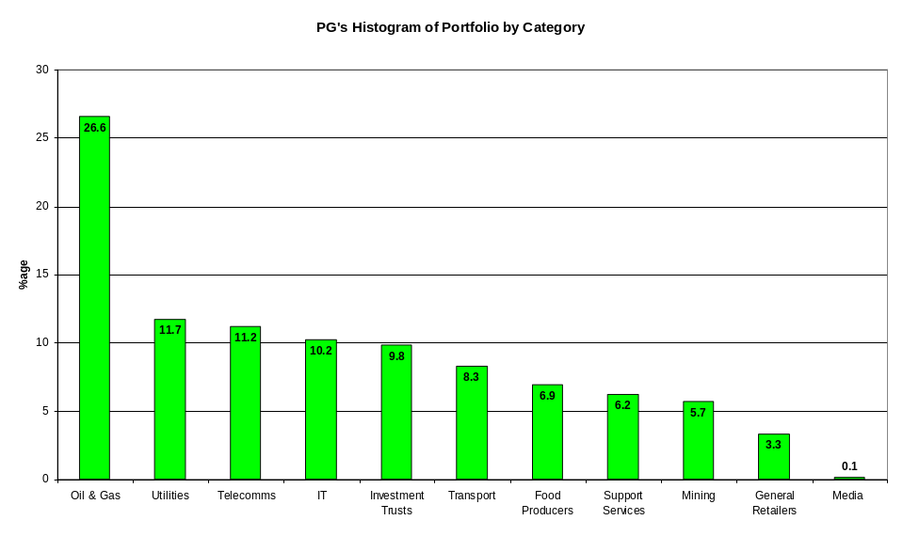
5.0 | NEW PROPOSALS
5.1 | Sell Rockhopper (ROK) if we intend down turn high risk stocks into investment trusts | JH
5.2 | Invest into land: Land sighted for future development or woodland. | TP
5.3 | Look to place 20% of the fund into investment trusts. High risk and good annual growth. Need to look at trusts specialising in New Ventures. | JH et al.
5.4 | Property. Especially foreign property; Hungary & Slovakia to be more exact. Small cottages can be bought for the value of the portfolio including taxes and fees. | AH
5.5 | TP suggests we buy wine. To the bar then! | TP
5.6 | AH recommends we set stop gains and losses on the portfolio. This will stop the cumbersome way we tend to make decisions between meetings. Automating the sale, if you like. | AH
6.0 | RATIFICATION OF NEW VENTURES
6.1 | Nothing bought or sold this month.
6.2 | TP to prepare a paper on buying land. | TP
6.3 | AH to prepare a paper on investing in foreign property. | AH
6.4 | All to gain interest in what they see as stop gains and stop losses for all investments. Prices will be fixed at the next meeting. | ALL
7.0 | WEB SITE REVIEW
7.1 | Web site still exists – www.daijones.tk.
8.0 | ANY OTHER BUSINESS
8.1 | Raft Race: Race is on Sunday 2nd September so we need to ‘crack on’. TP to arrange transport and a factory unit for undertaking repairs. | TP
8.2 | Log Cabin w/e: JH proposes the 2nd or 3rd week in October. HG to choose mountains. | JH / HG
8.3 | Golf. JH to book Dewstow for the afternoon of Saturday 15th September. Names and numbers by the end of August please. | JH
8.6 | Bike Ride, Tour d’Usk. Abergavenny to Caerleon all dayer. TP to organise | TP
8.7 | PG’s 30th Birthday Party will be September 30th. Possibly Caerleon RFC, defiantly fancy dress! | PG
8.8 | DC suggests a meet up for the RWC semi finals. | DC
9.0 | NEXT MEETING DETAIL
9.1 | Next meeting will be on Sunday 9th September, 5pm in Merlin’s Bar, CMR, Caerleon. | ALL

