MINUTES OF MEETING
HELD SUNDAY 4th NOVEMBER, 2007
THE CELTIC MANOR, CAERLEON, SOUTH WALES

Those Present: Huw Gallagher (HG)
James Hawkins (JH)
Anthony Hard (AH)
Matthew Parker (MP)
James Morse (JM)
Ben Morse (BM)
Timothy Parker (TP)
David Champs (DC)
Nicholas Bellew (NB)

Apologies: Matthew Harris (MH)
Tom Lewis (TL)
Paul Griffiths (PG)

Minutes taken by: Huw Gallagher
 | MEETING 55 | Action
1.0 | INTRODUCTIONS
1.1 | Apologies accepted by those members who submitted them.
2.0 | MINUTES OF LAST MEETING
2.1 | Minutes were accepted and posted on the Web Site. Thanks to HG for writing them. | HG
3.0 | GREEN JACKET AWARD
3.1 | Congratulations to AH who won his 3rd GJA this month. AH won with Emblaze (BLZ) and with an overall gain of 18.38% ‘Bought’ at 58.5pps and ‘sold’ at 69.25pps. | AH
3.2 | The nominations for this months Green Jacket Award :  Category: Big fallers. As agreed at the last meet, this will be the category until favourable trends are established. DC not quite understanding the rule picks a big gainer. ‘Big gainer’ translates as ‘Big Gaynor’ to much hilarity amongst some members…  HG – British Airways (BAY) 418.25pps  MP – Patientline (PTL) 0.91pps  NB – RBS (RBS) 475.5pps  TP – Erinaceous (ERG) 21pps  AH – Emblaze (BLZ) 69.25pps  JH – Morgan Sindall (MGNS) 1503pps  JM – Minerva (MNR) 168.75pps  DC – Care UK (CUK) 515pps  BM – Johnson Service Group (JSG) 129pps
3.3 | “Right, I was a bit bored again this afternoon so I’ve now updated the spreadsheet (attached) to show the percentage increase from the date 'purchased' to the date 1 month on from when the green jacket award is made, i.e. 2 months on from when they were chosen.  The share price of the GJA winners one month on from when we stop tracking has increased on average by 19.49%.  Is this a good return on average? It may be something we can stick a bit of money in each month. Or is this just a risky method?”  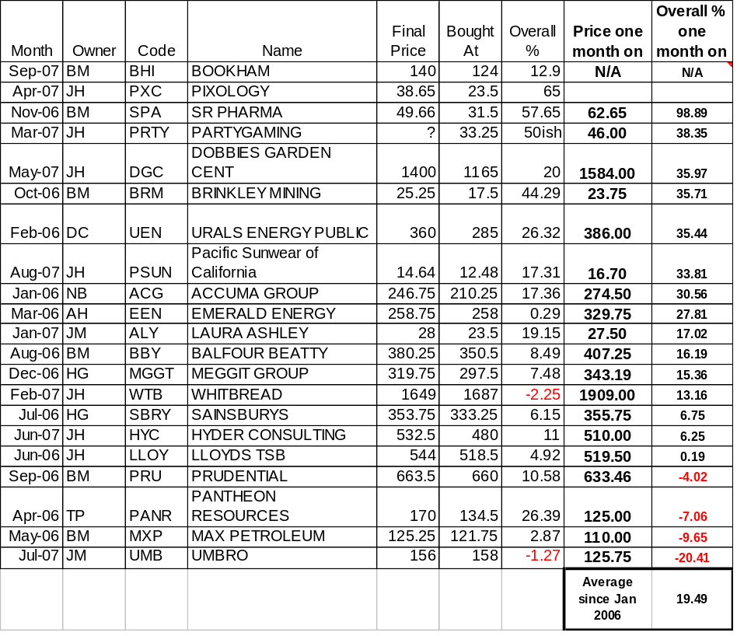 | PG
3.4 | Next months sector is a free for all. | ALL
4.0 | FINANCIAL REVIEW
4.1 | JH announces to the group that UK plc will suffer a downturn over the next eighteen months. The group should look at investing in other markets. | JH
4.2 | Fund up from -11% to -7.5% (stocks only). | JH
4.3 | Fund now worth £11,801.98. That’s £983.50 a man. | JH
4.4 | Dividend payments this financial year currently total £73-. | JH
4.5 | Two graphs were shown from HB detailing portfolio breakdown. Very interesting they were too. | ALL
4.6 | Money to spend this month = £293.09 | ALL
5.0 | NEW PROPOSALS
5.1 | DC compliments the CMR music selection this evening. | DC
5.2 | GJA winner should remain with his choice the following month (as implemented in section 3.2). | JH
5.3 | £500 Slush fund for investing into GJA winners. | JM
5.4 | Barrett Developments. Fund under valued. Looks promising for a 3 – 4 year return. | JH
5.5 | Overseas investments. India, China, Russia (for ultimate risk). | DC
5.6 | Warthog: Prices down to 0.04pps. The mention of this leads to someone stating, “the second bite of the cherry”. | BM
5.7 | JH – Africa worth a punt. HG – No way, it’s a melting pot. End of. | JH / HG
5.8 | Emblaze: Tipped in the Times as ‘one to watch’. CEO has invested £11m personally. It’s suggested we chuck the £300- into this. | AH
6.0 | RATIFICATION OF NEW VENTURES
6.1 | A split vote decision was made not to invest in stock and shares this month. | ALL
6.2 | It was decided not to place any stop gains or losses this month. | ALL
7.0 | WEB SITE REVIEW
7.1 | Web site still exists – www.daijones.tk.
8.0 | ANY OTHER BUSINESS
8.1 | Welsh Mountain Walk: This year was a successful event. The mountaineers climbed Pen y Fan (19), Corn Du (21), Cribyn (38) & Fan y Big (65). | SOME
8.2 | DJI Christmas Din-dins. Meet 5pm at the CMR on the evening of Saturday 1st December. Destination is Monmouth. TP to book. | ALL
8.3 | Raft Race: For those who have not paid up please pay BM the £30- fee. | SOME
9.0 | NEXT MEETING DETAIL
9.1 | Next meeting will be on Sunday 2nd December, 5pm in Merlin’s Bar, CMR, Caerleon. | ALL

