Table of Content

General Interface Introduction .............................................2

GIS Data Layers and Toolbars ...............................................3

Create flyover map (i.e. overview map generation) ..........................5

Change map display preference and visual styles (replacing Map Options) ....5

Import Scenario (removed) ..................................................6

Map Import/Export ..........................................................6

Select by Region and Group Editing .........................................8

Simulation Output Map Display and Change Display Styles ....................9

Window Close/Open Controls ................................................13

Measure Distance and Area on Map ..........................................14

Edit Vertex ...............................................................15

General Interface:

SWMM and EPANET share the same general familiar user interface (UI) layout as shown below:

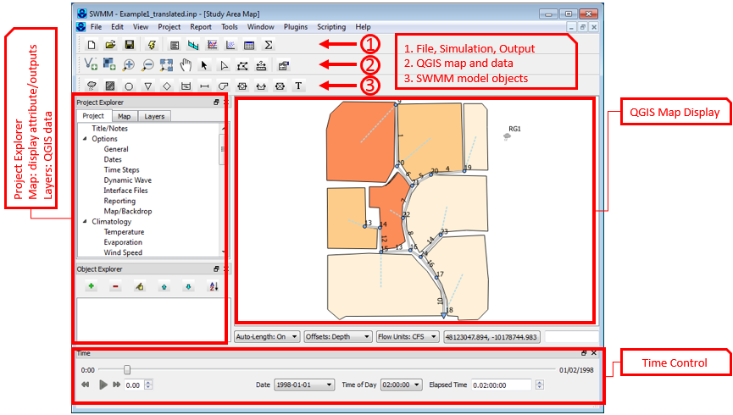

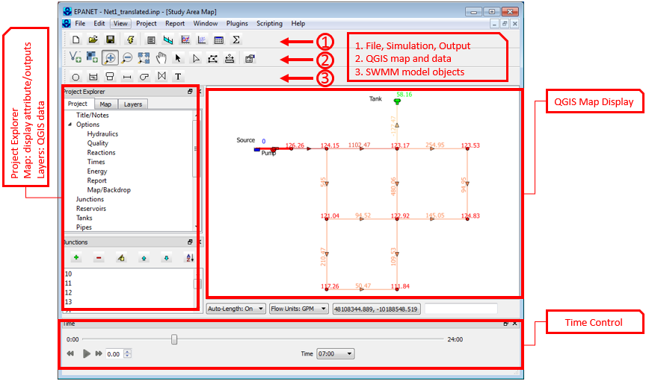

The new UIs adopt the same or similar workflow and functionalities of the original UIs for the two programs.

The major improvements come with the incorporation of open source QGIS mapping capabilities and the plugin structure that allows users to develop custom python scripts to interact with and to control various aspects of an active modeling session.

The main map display is powered by QGIS mapping library, hence, it is no longer a simple graphic drawer as in the original programs. It can display all vector and raster GIS data formats supported by QGIS. The important implication from this improvement is that now users can start building their model network on a known GIS data projection of their choosing, hence, rendering their entire model network to be geo-referenced right from the start and all geospatial dimensions are to scale. The distances and areas are ground truth values, instead of mere symbolic as in the original UIs.

The ‘Plugin’ menu option provides a way for users to develop their own python scripts that can directly interact with all aspects of mapping display, model parameterization, and simulation controls.

In this document, we will introduce some common GIS related operations to familiarize users with the new UIs. The topics are tutorials in nature and are presented in a piecemeal fashion with no particular grand scheme of organization. Many of the GIS features work the same way in both programs, differences will be noted where they arise.

**GIS Data Layers and Toolbar**

In the new UIs, there is a new ‘tab’ in the project explorer window, i.e. ‘Layers’, this is where the GIS data layers are organized into 3 major groups as shown below:

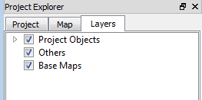[**Project Objects**]: this group contains the model object GIS data layers; one layer per model object type

[**Others**]: this group contains all of users’ custom GIS vector data layers

[**Base Maps**]: this group contains all of users’ raster data layers

In the EPANET UI, the project object group contains the following GIS data layers:

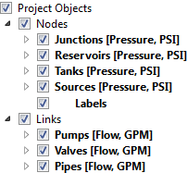

After simulation, when users select the constituent to be displayed on map for nodes and links, the constituent name and unit is displayed in square bracket next to GIS layers’ names. In this instance, ‘Pressure’ (unit: PSI) is chosen for Nodes and ‘Flow’ (unit: GPM) is chosen for Links. The color ramps displayed on map will be based on these chosen quantities across all model objects.

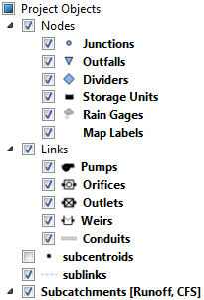In the SWMM UI, the project object group contains the following GIS data layers:

Users can easily turn on/off any layer on the map by checking/unchecking the checkboxes. The ‘subcentroids’ and ‘sublinks’ layers are for internal use only (subcatchment linkage to other model objects), users should not modify these layers.

The two programs share the same GIS Toolbar as shown below:

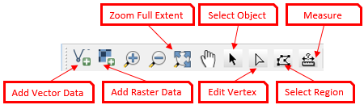

The ‘Add Vector Data’ and ‘Add Raster Data’ buttons allows users to bring in custom GIS data that will be put under ‘Others’ (vector) and ‘Base Maps’ (raster) groups on the Layer tab.

**It is important to note** that the new UIs employ QGIS mapping functions to facilitate model construction, visualization, and analysis only. It is not meant to be a full-fledged GIS software, hence, ‘Select Object’, ‘Edit Vertex’, and ‘Select Region’ tools only work with model object layers. Currently, all custom GIS data layers (in the ‘Others’ and ‘Base Maps’ groups) are for reference only and they cannot be modified or manipulated in the new UIs. Future development of the new UIs could add additional GIS functions to allow such capabilities.

**Create flyover map (i.e. overview map generation)**

The menu options ‘View’ 🡪 ‘Overview’ will generate a overview map as below: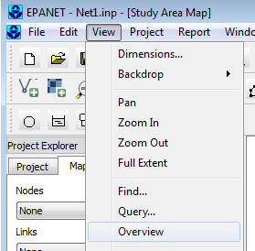 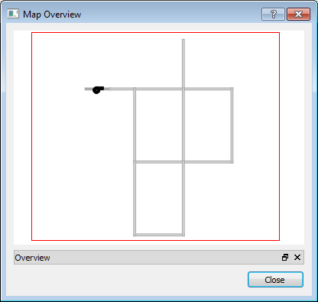

The red box in the overview map is a viewing window. Users can click-n-drag it to different portion of the network and the main map display will ‘pan’ accordingly to the corresponding portion as well.

**Change map display preference and visual styles (replacing Map Options)**

In the original UIs, there is the ‘Map Options’ dialog where users can change visual objects’ display styles etc. The new UIs use the symbology editor and other map options to replace the ‘Map Options’ dialog as shown below:

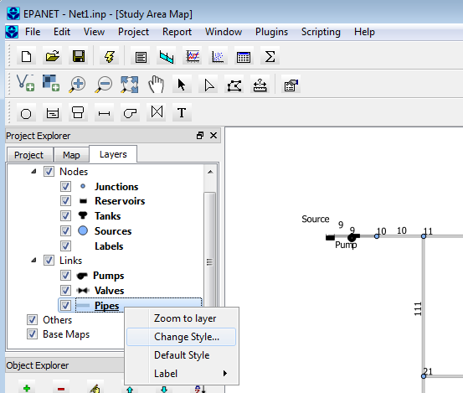

Right-mouse click on any model object data layer will display a context menu as shown above. Specifically, ‘**Zoom to layer**’ will zoom to full extent of the chosen layer; ‘**Change Style…**’ will open the symbology editor to allow style change; ‘**Default Style**’ will revert to default style; ‘**Label**’ has three options: ‘**By Name**’, ‘**By Value**’, and ‘**Off**’, which means labeling visual objects on map by their model ID (or name), by output value (model output values of chosen output category). ‘**Off**’ means turning off label for visual object in the selected layer.

Selecting the ‘**Change Style…**’ option will launch the symbology editor as shown below:

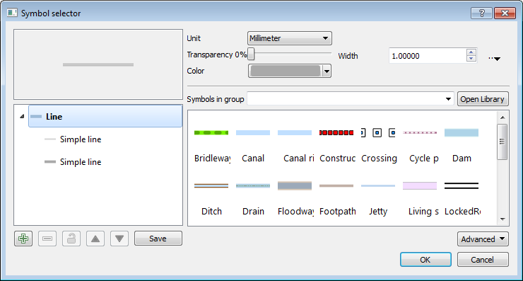

The changes to the display style will be retained during animation as well. If users decide the resulting display style to be less than satisfactory, they can always choose the ‘**Default Style**’ option to revert to the original default styles. Please note that only SWMM and EPANET model object layers have default display style, whereas users’ own custom GIS data do not, hence this option will have no effect on them.

**Import Scenario (removed)**

The ‘Scenario Import’ feature in the original UIs is to read in a listing of partial set of parameters. This type of scenario generation can be easily accomplished by using the “Save As” menu option to save a snapshot version of the INP file at any time, meaning unlimited versions (or scenarios) off of the original INP file can be created easily. It is decided that this function is no longer needed in the new UIs.

**Map import/export**

The ‘Export Map’ feature is implemented and can be accessed via menu options: ‘**File**’ 🡪 ‘**Export**’ 🡪 ‘**Map…**’, which will save the current project into a GeoJSON file that includes the geospatial location of all visual objects and list of their attributes.

The ‘Import Map’ feature is implemented and can be accessed via menu options: ‘**File**’ 🡪 ‘**Import**’ 🡪 ‘**Map’.** This option will import user specified GeoJSON file with correct data format and build a model network from the imported information as shown below:

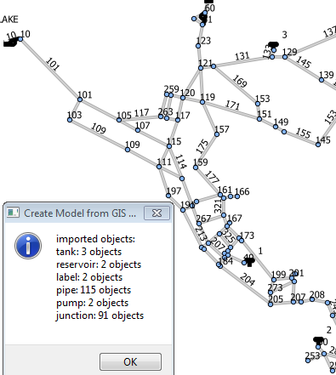

Alternatively, users can also carry out import of GIS data via the plugin menu as shown below:

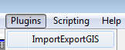

Selecting the ‘ImportExportGIS’ will trigger a new menu item to be created on the main menu bar as shown below:

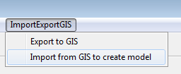

The ‘Export to GIS’ and ‘Import from GIS to create model’ options here are equivalent to those options under the ‘**File**’ menu (described above).

**Select by Region and Group Editing**

The group editing feature is implemented and can be accessed via “Edit”🡪”Select Region” menu option or by clicking the ‘select region’ toolbar icon (). Either way, the tool will enter selection mode. The user can start clicking around a region to select all features inside of it as shown below:

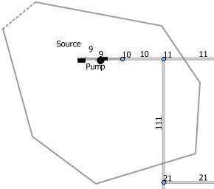 🡪🡪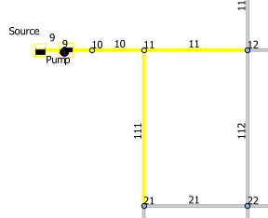

Next, via the “**Edit**” 🡪 “**Edit Object…**” menu option, the user can bring up the “Choose a Type” dialog (shown below) to choose which category of model objects (from all of the selected objects) to edit. Subsequently, the property editor of the chosen object type will be displayed (shown below) where the select model objects can be edited together:

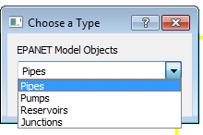 🡪 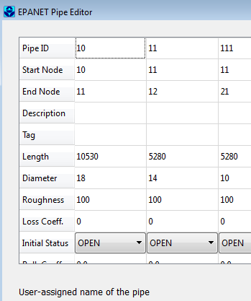

**Simulation Output Map Display and Change Display Styles**

The symbology editor is implemented for changing visual object display styles. This is for changing both the default display style and the output display style.

For example, after running the Net1.inp model, choosing to display flow for link objects, the map display will be as below:

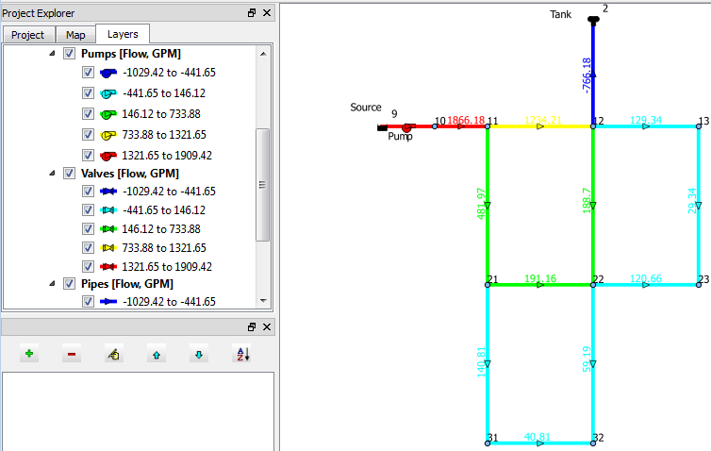

The output “Flow” in the unit of “GPM” are displayed and labelled in the layer legend and it is conveniently positioned right next to the map display, hence it is determined it would be quite redundant to have another copy of the same legends displayed on the map itself.

Right-mouse-click on any layer in the legend will allow the user to access the symbology editor via the “Change Style…” option. For example, right click on the ‘Pipes’ layer in the legend and select ‘Change Style…’ option will bring up the symbology editor as shown below:

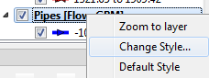 **🡪🡪**🡺 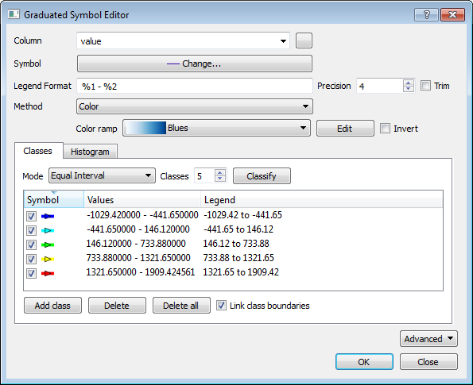

Here, the user can change all aspects of the display style, for example, we can change the color ramp by choosing a different one from the color ramp dropdown:

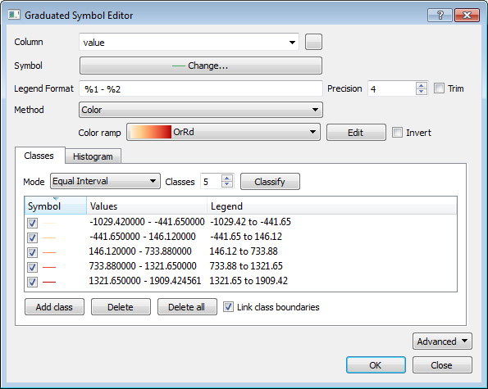

And click on ‘OK’ button to take effect, then the map will change to below:

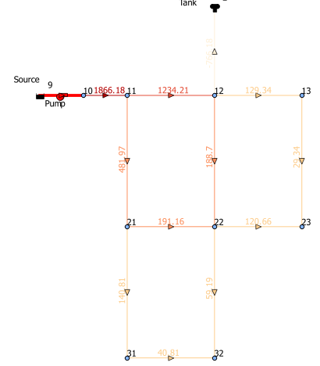

**Window Close/Open Controls**

Users can choose to close or open various windows in the UI via a right-mouse click on the top menu bar to choose toggle on/off of windows as shown below:

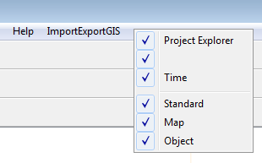

**Measure Distance and Area on Map**

To meausre distance or area on map, click on the measure tool icon (), then, the program enters into digitize mode (the cursor changes to the plus sign), now the user can start click around a feature as shown below:

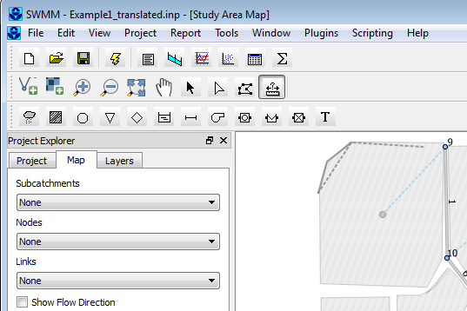

There are two ways to finish a measuring operation:

1. Digitize a closed polygon as shown below:

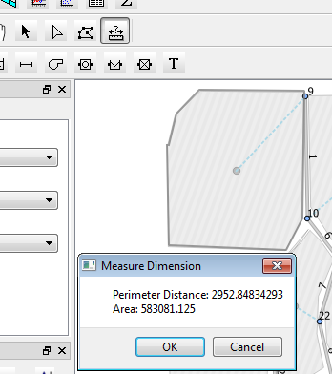

To finish a polygon, simply click on the starting point. **At anytime, press the ‘Esc’ key on keyboard, will terminate the measuring session**.

When a closed polygon is digitized, the measure tool will display both perimeter length and polygon area in the unit of map projection. In this instance, the map projection is ‘NAD_1983_StatePlane_Georgia_East_FIPS_1001_Feet’ or EPSG:102666, its linear unit is feet. Hence, the resulting perimeter is 2952.848 feet long and the polygon area is 583081.125 square feet (about 13.38 acres), which is very close to the defined subcatchment area (13.33 acres).

1. **Right-mouse click** will end a line segment if only length measurement is desired. In the example below, a right-mouse click at the end of the zig-zag line segments terminated the measuring session and the tool displayed the total length as 2900 feet.

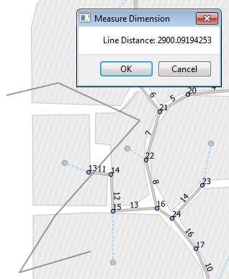

**Note**: the new UI offers a utility that can translate a legacy model network coordinates into known map projection coordinates to take advantage of the ground-truth dimensioning capability. This utility can be accessed via the ‘View’ 🡪 ‘Translate Coordinates’ menu options. A companion tutorial provides detailed instruction to how to apply this utility.

**Edit Vertex**

Please note that, in the new UIs, users can select and drag all model objects to change their locations. The ‘Edit Vertex’ function can work on Subcatchment (polygon) features’ vertices, allowing users to add new vertices and move or delete existing vertices.

Please note that users can undo or redo all of these GIS operations, an improvement from the original programs.

To start editing subcatchment polygon’s vertices, simply click the edit vertex icon () on the map toolbar as shown below.

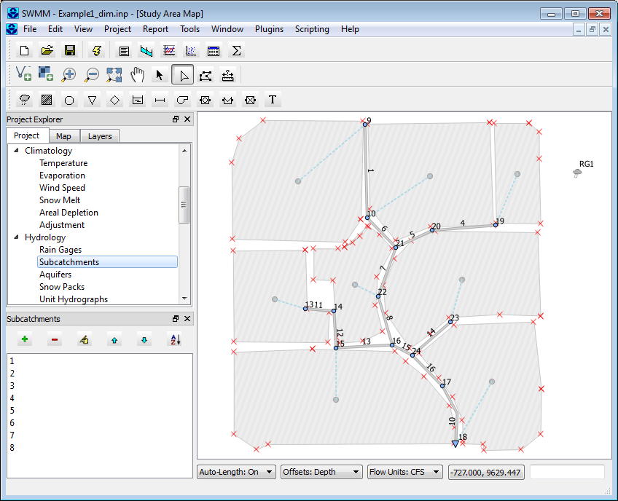

Now, the program enters into vertex editing mode. It highlights all vertices of all subcatchment polygons (red x). Users can click and drag any vertex to new locations. **Double-left-mouse-click** on a line segment will add a new vertex, while a **single-right-mouse-click** on an existing vertex will delete it.

To end a vertex editing session, simply click the ‘Vertex Edit’ icon again to de-select it, then a prompt will be displayed to ask user if they want to save the changes:

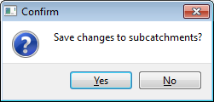

‘Yes’ to save the changes, ‘No’ to discard all changes.