**Item F1: No way to setup things like flyover map, view results etc.**

View 🡪 Overview will generate a overview map as below: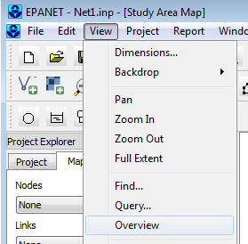 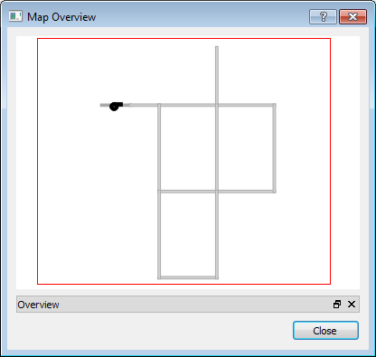

For changing view preference of results on the map, the new UI has now the symbology editor that allows user to change visual objects’ style as shown below:

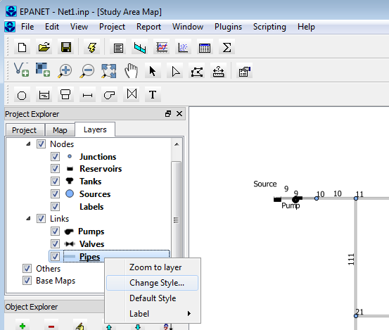

Right-mouse click on any visual object data layer will display a context menu as shown above. Specifically, ‘**Zoom to layer**’ will zoom to full extent of the chosen layer; ‘**Change Style…**’ will open the symbology editor to allow style change; ‘**Default Style**’ will revert to default style; ‘**Label**’ has three options: ‘**By Name**’, ‘**By Value**’, and ‘**Off**’, which means labeling visual objects on map by their model id (or name), by output value (model output values of chosen output category). ‘**Off**’ means turning off label for visual object in the selected layer.

‘**Change Style…**’ will launch the symbology editor as shown below:

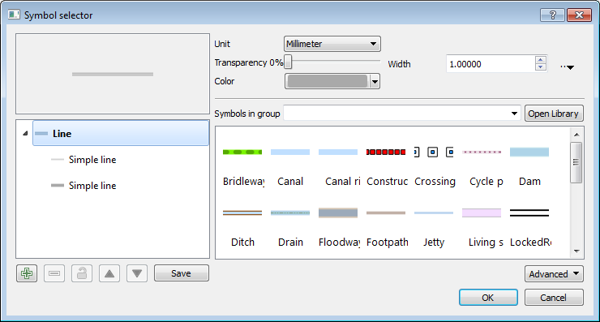

**Item F2: Scenario cannot be imported (feature not working)**

Previous discussions led to the following conclusion:

Geojson file import works. Scenario import will need be defined and then deprecated. In other words, not high priority at this time.

The ‘Scenario Import’ feature in the original software is to read in a listing of partial set of parameters. This type of scenario generation can be easily accomplished by using the “Save As” menu option to save a snapshot version of the INP file at any time, hence unlimited versions (or scenarios) off of the original INP file.

So, please decide if this feature is still needed.

**Item F3: Map import/export (under investigation)**

The ‘Export Map’ feature is implemented and can be accessed via menu options: ‘**File**’ 🡪 ‘**Export**’ 🡪 ‘**Map…**’, which will save the current project into a GeoJSON file that includes the geospatial location of all visual objects and list of their attributes.

The ‘Import Map’ feature is implemented and can be accessed vial menu options: ‘**File**’ 🡪 ‘**Import**’ 🡪 ‘**Map’.** This option will import user specified GeoJSON file that has the necessary format and build a model network from the imported information as shown below:

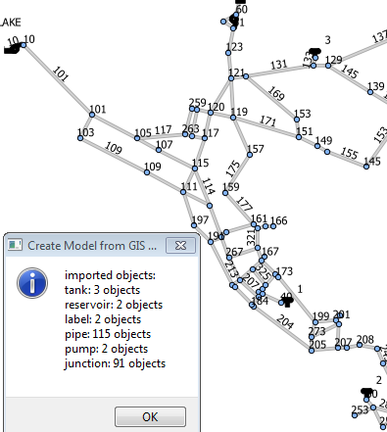

Alternatively, users can also carry out import of GIS data via the plugin menu as shown below:

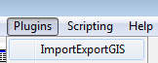

Selecting the ‘ImportExportGIS’ will trigger a new menu item to be created on the main menu bar as shown below:

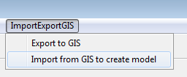 The two choices here are the same as their equivalent options under the ‘**File**’ menu

**Item H1: Help content does not match application, unfinished**

We can definitely work on this part.

**Item H2: Help content on import GeoJSON data to build a project**

We can definitely work on this part.

**Item E1A: No group editing is possible and all items edited one by one**

The group editing feature is implemented and can be accessed via “Edit”🡪”Select Region” menu option or by clicking the ‘select region’ toolbar icon (). Then, the tool will enter selection mode. The user can start clicking around a region to select all features inside of it as shown below:

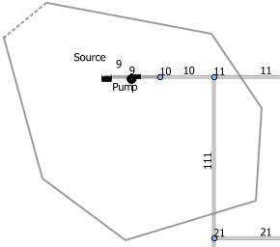 🡪 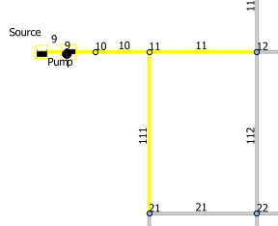

Next, the user can choose to select which category of objects from all of the selected objects via the “**Edit**” 🡪 “**Edit Object…**” menu option. A popup dialog will display the categories of objects selected and allow the user to pick one for editing as shown below:

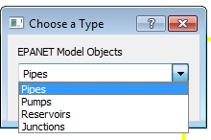 🡪 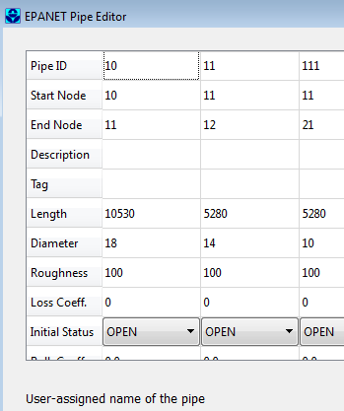

So, this feature is already implemented.

**Items View tools:**

The symbology editor is implemented for changing visual object display styles. This is for changing both the default display style and the output display style.

For example, after running the Net1.inp model, choosing to display flow for link objects, the map display is shown as below:

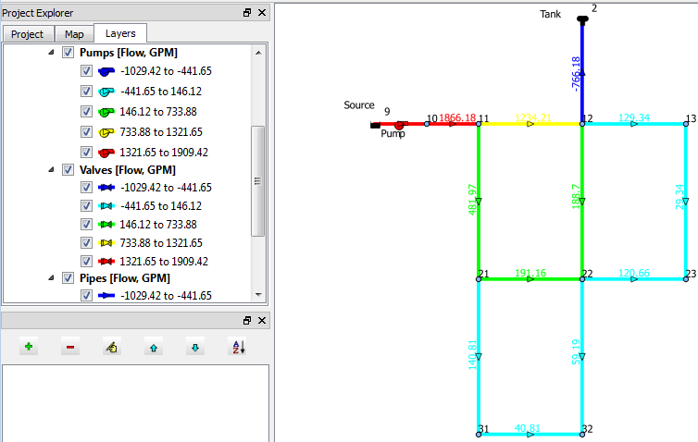

The output “Flow” in the unit of ‘GPM’ are displayed and labelled in the layer legend and it is conveniently positioned right next to the map display, hence it is determined it would be quite redundant to have another copy of the same legends displayed on the map itself.

Right-mouse-click on any layer in the legend will allow the user to access the symbology editor via the “Change Style…” option. For example, right click on the ‘Pipes’ layer in the legend and select ‘Change Style…’ will bring up the symbology editor as shown below:

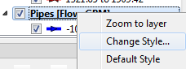 🡺 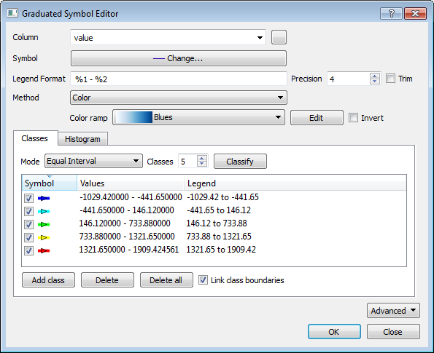

Here, the user can change all aspects of the symbol, for example, we can change the color ramp by choosing a different one from the color ramp dropdown:

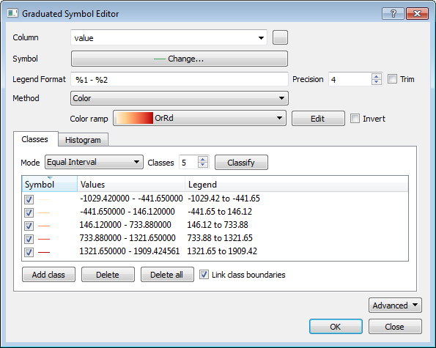

And click on ‘OK’ button to take effect, then the map will change to below:

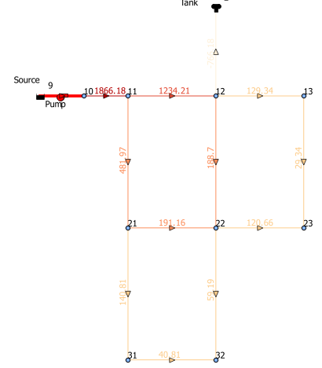

**Item W1: Windows menu doesn’t work**

Windows menu options for arrange console relative positions are not implemented and it is not clear if this feature is still desired? Need clarification and confirmation.

Please note that the closing and re-opening of various windows are already functional via the right-mouse click on the top menu bar to choose toggle on/off of windows as shown below:

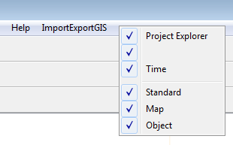

**Items E1A, E1B, and E2 (related to output errors)**

The output errors mostly related to the treatment of simulation warning messages by the EPANET output API, which has been resolved with Michael Tryby’s fix. At this point, the EPANET output API no longer terminate output access when encounters a mere warning message.

The Error #200 is related to parameterization of model object, which was decided that it is users’ responsibility to properly parameterize their models.

**Installation issues:**

The installation package will NOT require any QGis software be pre-installed.

The latest installer has been shown to work (install and launch application) properly on multiple Windows OS with or without QGis installation.

We continue to respond to user’s installation issues as they arise.