Final Project

Game Neko Runner

Daiana Arantes

Game Programming with Data Structure

Dec. 04, 2018

1. **Description & features of the game**

This project is a simple 2D side-scrolling game where you control a cat and have to collect as many coins as possible and avoid touching dogs, by running and jumping on the stage.

The major features for this game are the high score saved in file, recording the player’s name and score, and also the animation of the cat and the stage.

1. **Class diagram**

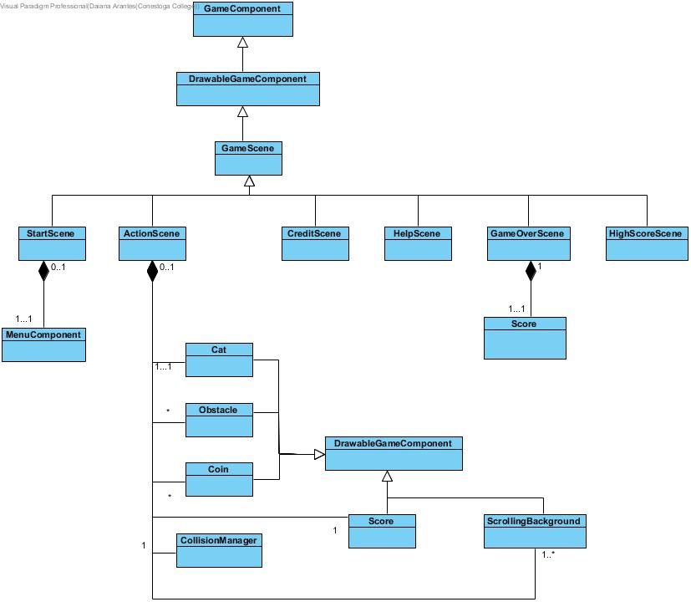

1. **References**

Art, P. (n.d.). Piq_58417_400x400 [Digital image]. Retrieved November 21, 2018, from <https://pixelarttemplates.files.wordpress.com/2015/02/piq_58417_400x400.png>

Bampede. (2015, Mar 16). Grand Chase OST - Main Map (Extended) [Video File]. Retrieved December 04, 2018 from <https://www.youtube.com/watch?v=7NGNA5PzwYk&t=55s> [Converted to audio]

Bfvrp, Z. R. (n.d.). Kitty-cats-digital-vector-drawings-images-pictures-art-artworks-zelko-radic-bfvrp.jpg [Digital image]. Retrieved December 04, 2018, from <https://w-dog.net/wallpaper/kitty-cats-digital-vector-drawings-images-pictures-art-artworks-zelko-radic-bfvrp/id/258029/>

C. (n.d.). Video Game Fonts. Retrieved December 04, 2018, from <https://www.1001fonts.com/dpcomic-font.html>

CionSAGA. (2012, Apr 24). Grand Chase Bonus Track - Hope (Instrumental) [Video File]. Retrieved December 04, 2018 from <https://www.youtube.com/watch?v=uc0gU-BUgYQ>

Games, R. (n.d.). Layer-2 [Digital image]. Retrieved November 22, 2018, from <https://www.rednivargames.com/asset/platformer-background/green_valley_background_for_unity.html>[Edited]

Low, A. (n.d.). Stage-1 [Digital image]. Retrieved November 17, 2018, from <https://www.codeandweb.com/texturepacker/tutorials/how-to-create-sprite-sheets-and-animations-for-easeljs-createjs>[Edited]

Penguin, C. (n.d.). Puffle_Rescue_Coin [Digital image]. Retrieved November 17, 2018, from <http://clubpenguin.wikia.com/wiki/File:Puffle_Rescue_Coin.png>

Players of Chase. (2018, Jun 1). Soundtrack - Floresta do Desafio. [Video File]. Retrieved December 04, 2018 from <https://www.youtube.com/watch?v=JRdGeOhCDa4&t=4s>

ProjectsU012. (2016, March 30). Coins 1 by ProjectsU012. Retrieved November 22, 2018, from <https://freesound.org/people/ProjectsU012/sounds/341695/>

Shepardskin. (2014, February 11). Cat-sprites [Digital image]. Retrieved November 20, 2018, from <https://opengameart.org/content/cat-sprites> [All cat sprites from this link][Edited]

SJM. (2011, Aug 2). Grand Chase Music: Bermesiah [Video File]. Retrieved December 04, 2018 from <https://www.youtube.com/watch?v=QyK8hX5Ne8Q&t=5s>

SJM. (2015, Mar 16). Grand Chase Music: Xenia [Video File]. Retrieved December 04, 2018 from <https://www.youtube.com/watch?v=74r2u1mKaJc&t=41s>

Studio, K. (2015, January 8). Cloud-background [Digital image]. Retrieved November 20, 2018, from <https://marketplace.yoyogames.com/assets/1372/cloud-background>

Tech on the Net (n.d.). Clipart: Computer Keyboard keys - Esc key [Digital image]. Retrieved November 20, 2018, from <https://www.techonthenet.com/clipart/keyboard/esc_key.php>

Tech on the Net (n.d.). Clipart: Computer Keyboard keys - Space bar key (medium) [Digital image]. Retrieved November 20, 2018, from <https://www.techonthenet.com/clipart/keyboard/space_key_m.php>

Themusicalnomad. (2014, Nov 5). Negative_beeps.wav by ProjectsU012. Retrieved November 22, 2018, from <https://freesound.org/people/themusicalnomad/sounds/253886/>