IoT-Based Smart Campus Waste Management System with Near-Real-Time Monitoring and Rule-Based Collection Dispatch
Nguyen Lam Thanh Vu  FPT University, Ho Chi Minh Campus,  Vietnam  nguyenlamthanhvunltv@gmail.com | Dang Phan Minh Ngan  FPT University, Ho Chi Minh Campus,  Vietnam  minhngan1506@gmail.com | Kieu Trong Khanh  FPT University, Ho Chi Minh Campus,  Vietnam  khanhkt@fpt.edu.vn
Thu Le
FPT University, Ho Chi Minh Campus,
Vietnam
thulvm@fpt.edu.vn
Abstract—Waste management in university campuses involves monitoring waste containers, identifying bins that require collection, and coordinating collection activities across different campus areas. Traditional approaches often rely on manual inspection and communication, which can delay the identification of nearly full bins and make collection activities difficult to coordinate. This paper presents SmartWaste, an Internet of Things (IoT)-based campus waste management system designed to support near-real-time bin monitoring and rule-based collection dispatch. The prototype integrates an ESP32 NodeMCU with an HC-SR04 ultrasonic sensor to measure the distance between the sensor mounted beneath the bin lid and the waste surface. The device calculates the estimated filling percentage and periodically transmits the measurement to a Java Servlet-based web application through HTTP requests. On the server side, the application validates incoming sensor data, updates bin information, stores timestamped readings, and applies predefined rules to generate high-fill alerts and emergency collection requests. A web dashboard provides a centralized overview of bin conditions, while collection management functions allow authorized users to review and manage collection requests. The current prototype has one physically connected sensor node, identified as BIN-001, while additional bin records displayed on the dashboard are maintained as database records. Predictive analytics, AI-based waste classification, environmental monitoring, and intelligent route planning are considered future extensions rather than existing capabilities.
CCS CONCEPTS • Computer systems organization → Embedded systems; • Networks → Internet of Things; • Information systems → Information systems applications.
Additional Keywords and Phrases: Internet of Things, Smart Waste Management, ESP32, HC-SR04, Near-Real-Time Monitoring, Java Servlet, Campus Management, Collection Dispatch.
ACM Reference Format:
First Author’s Name, Initials, and Last Name, Second Author’s Name, Initials, and Last Name, and Third Author’s Name, Initials, and Last Name. 2018. The Title of the Paper: ACM Conference Proceedings Manuscript Submission Template: This is the subtitle of the paper, this document both explains and embodies the submission format for authors using Word. In Woodstock ’18: ACM Symposium on Neural Gaze Detection, June 03–05, 2018, Woodstock, NY. ACM, New York, NY, USA, 10 pages. NOTE: This block will be automatically generated when manuscripts are processed after acceptance.
- INTRODUCTION
Waste management is an important operational activity in universities and other large public environments. University campuses contain multiple buildings, classrooms, offices, cafeterias, and outdoor areas, each of which may generate different amounts and types of waste throughout the day. Managing waste containers across these locations requires staff to identify bins that need attention and organize collection activities efficiently.
In traditional waste collection processes, staff members may need to inspect containers manually or depend on reports from other people. This approach can create several operational difficulties. A bin may become full before the next inspection, collection staff may receive information too late, and managers may have limited visibility into the current condition of containers across the campus. When information is collected manually, maintaining an updated overview of waste conditions and coordinating collection activities across different areas can also become difficult.
The Internet of Things (IoT) provides an approach for connecting physical devices to information systems. Sensors collect information from the physical environment, while network-connected microcontrollers transmit measurements to centralized applications [1, 2, 7, 12]. Previous research has investigated the application of IoT technologies in environmental monitoring and smart waste management, including sensor-based monitoring and connected collection systems [3, 4, 5, 6]. These technologies provide opportunities to improve the visibility of waste conditions and support more informed collection decisions.
This paper presents SmartWaste, an IoT-based waste management system designed for a university campus environment. The system connects an ultrasonic sensor installed on a waste container to a Java Servlet-based web application through an ESP32 NodeMCU. Sensor measurements are converted into estimated filling percentages and transmitted to the server, where predefined rules are applied to generate alerts and collection requests. The web application provides centralized monitoring and collection management functions.
The current implementation focuses on monitoring bin conditions by receiving sensor measurements and displaying estimated filling levels through a web interface. It applies predefined thresholds to generate a high-fill alert when the filling level reaches 80% and an emergency collection request when the level reaches 90%. It also supports collection management by recording requests and attempting to assign emergency tasks to staff members associated with the corresponding bin area. These functions establish a foundation for further development toward predictive monitoring and more intelligent campus waste management.
- RELATED PRIOR WORK
IoT architectures commonly involve device-level sensing, communication networks, data processing, and application-level services [1, 2, 7, 12]. These components allow physical devices to collect environmental information and transmit it to centralized systems for storage, analysis, and presentation. In waste management applications, ultrasonic sensors can be installed beneath container lids to periodically measure the distance between the sensor and the waste surface. The measured distance can then be converted into an estimated filling percentage, providing information about the current condition of each container.
Previous studies have explored the use of IoT technologies in waste monitoring and environmental management. Perera et al. [3] discussed context-aware computing for IoT systems, emphasizing the importance of collecting and processing information from surrounding environments. Ighalo et al. [4] examined IoT applications for environmental monitoring and waste assessment, demonstrating the relevance of connected sensing technologies in environmental management. Gunasinghe and Tharmaseelan [6] also investigated smart municipal waste and resource monitoring, highlighting the potential of connected monitoring systems to support waste management activities.
Research has also considered the application of IoT in campus environments. Koh et al. [5] presented a smart campus waste management approach that integrates IoT monitoring with dynamic collection scheduling. Their work illustrates how sensor-based information can support more organized collection activities. In addition, research on IoT device design and implementation provides relevant technical foundations for developing low-cost connected sensing nodes [8].
Although these studies demonstrate the potential of IoT-based waste management, a practical campus deployment must also consider its operational organization. Unlike municipal waste management systems that may cover large geographical areas, a university campus has a more bounded environment with identifiable collection areas, designated sanitation staff, and a specific set of waste containers. The system therefore needs to connect sensor measurements with operational records and collection responsibilities.
SmartWaste addresses this requirement by combining ultrasonic monitoring with server-side threshold rules and collection management functions. Rather than acting only as a dashboard for displaying sensor measurements, the system processes incoming telemetry to generate high-fill alerts and emergency collection requests. Machine-learning-based forecasting and route optimization are not included in the current implementation. They are considered potential extensions once sufficient operational data has been collected.
- METHODOLOGY
  - System Architecture and Operational Workflow
SmartWaste follows a layered architecture that connects physical waste containers to a centralized web management platform. The sensor and device layer uses an ESP32 NodeMCU and an HC-SR04 ultrasonic sensor to measure the distance between the sensor and the waste surface. The communication layer transfers the collected measurements to the server through Wi-Fi using HTTP requests. The application and processing layer receives incoming telemetry through a Java Servlet-based web application, validates the submitted values, calculates the corresponding bin status, and applies predefined rules to generate alerts and collection requests. Finally, the data storage and presentation layer maintains operational records in a relational database and provides updated information through the web dashboard and collection management interface.
Figure 1 illustrates the overall operational workflow, beginning with sensor measurement and continuing through data transmission, server-side processing, database updates, and user-facing outputs. Figure 2 presents the technical block diagram of the system, showing the relationship between the physical sensor node, network communication, backend application, database, and web interface.
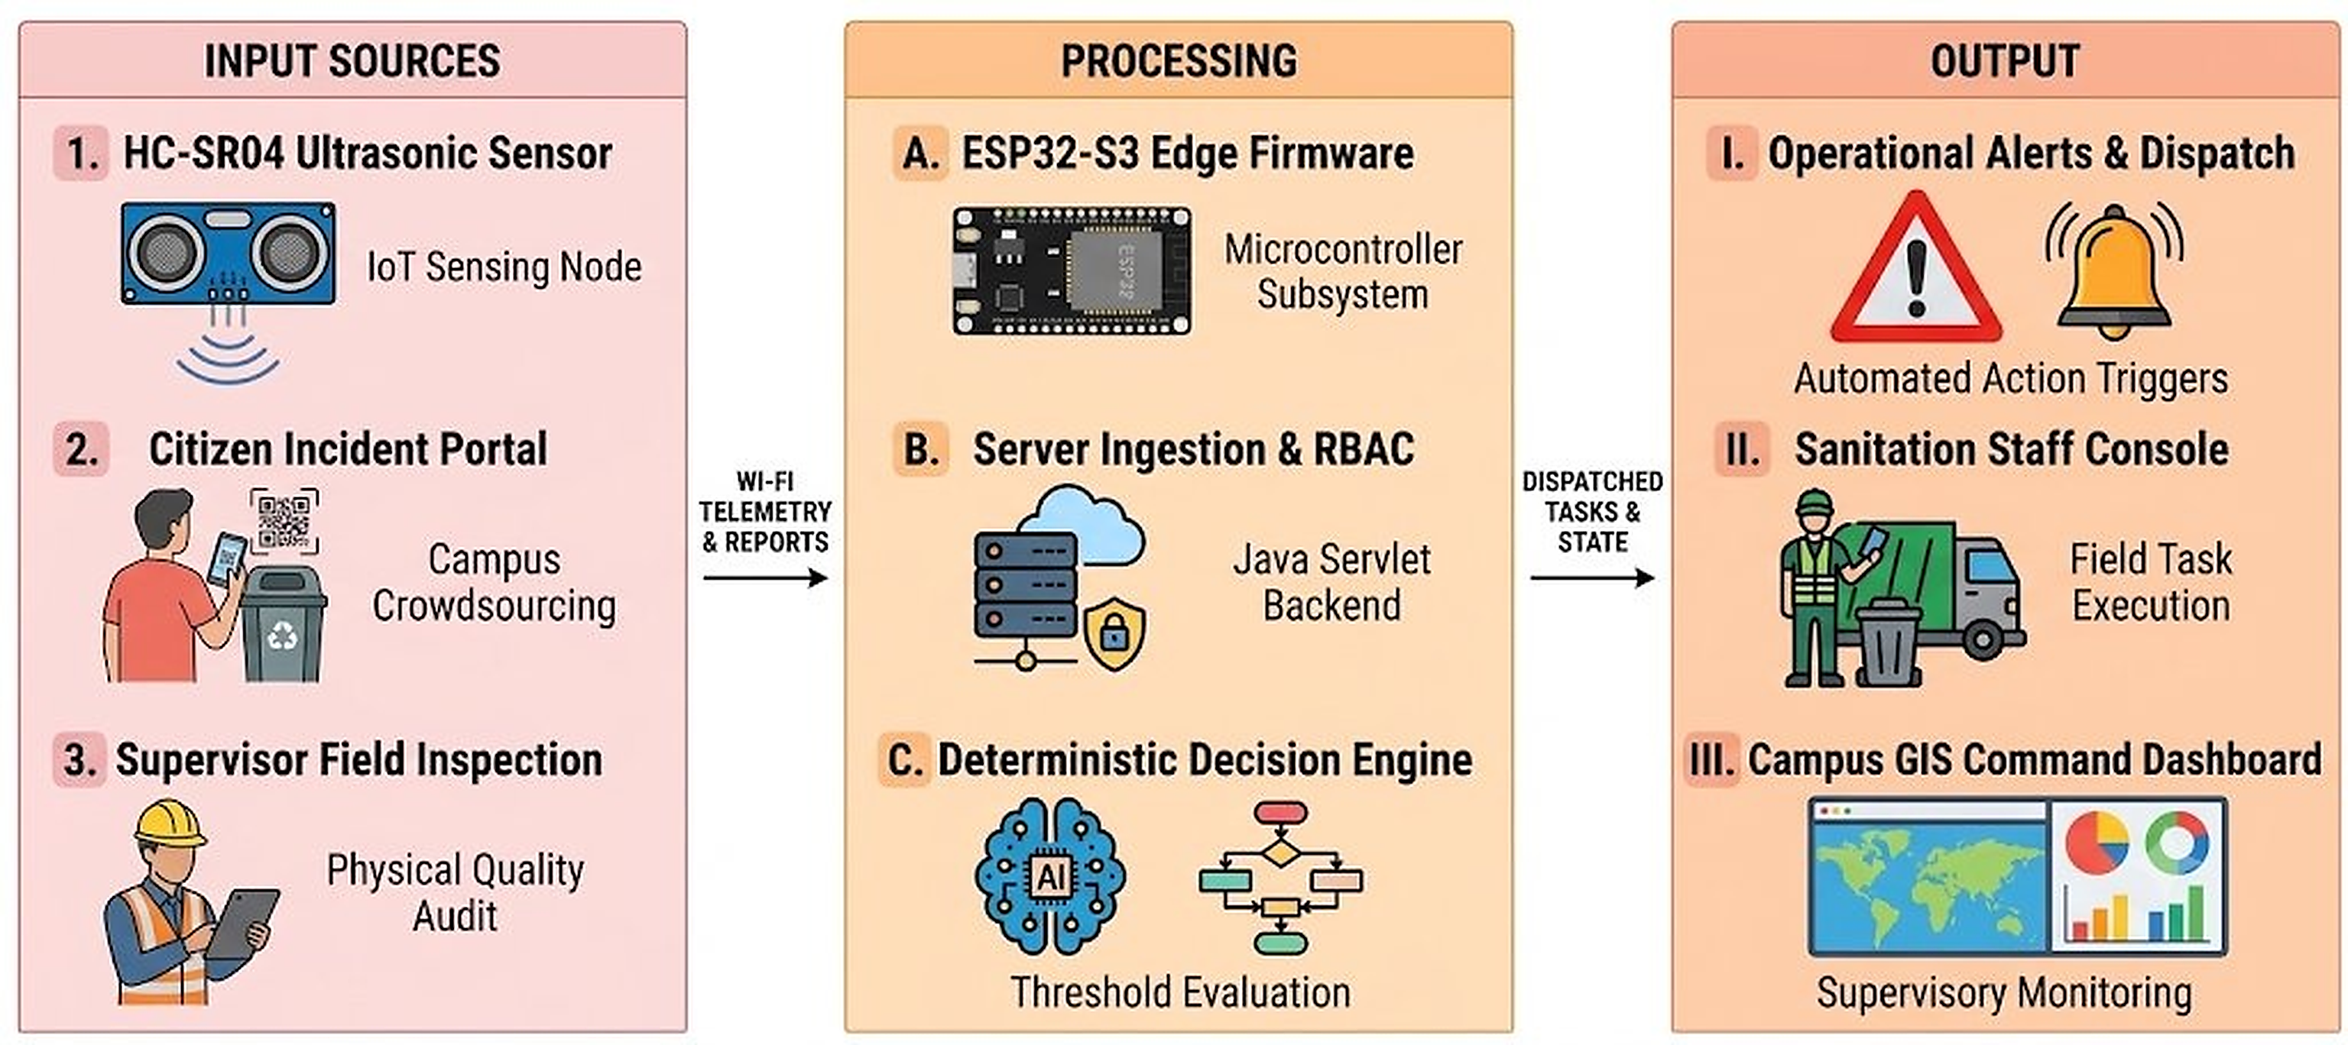
Figure 1: SmartWaste high-level operational workflow across sensor input, edge processing, server processing, and operational outputs.
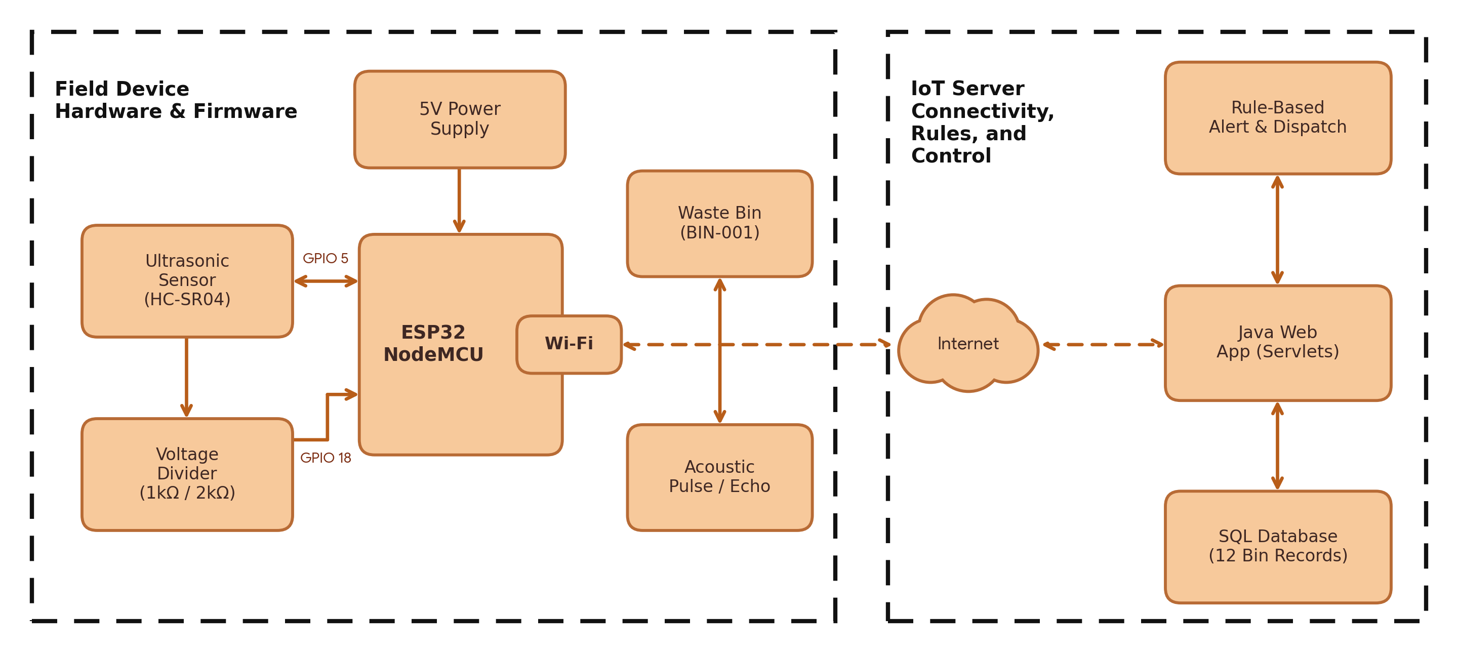
Figure 2: Technical system block diagram of the SmartWaste field hardware node and server platform.
  - Hardware Components and Physical Prototype
The physical prototype consists of an ESP32 NodeMCU development board and an HC-SR04 ultrasonic sensor mounted beneath the lid of a pedal-operated waste bin. The ultrasonic sensor measures the distance between its position and the upper surface of the waste inside the container. The ESP32 receives the sensor measurement and calculates the estimated filling percentage before transmitting the result to the server.
The HC-SR04 operates with a 5V supply and produces a 5V ECHO signal, while the ESP32 GPIO pins operate at a 3.3V logic level. A resistive voltage divider is therefore used to reduce the ECHO signal to a suitable voltage for the ESP32 input. The prototype uses a 1.00 kΩ series resistor and a 2.00 kΩ resistor connected to ground, producing an output of approximately 3.33V from a 5V input. The TRIG signal is controlled by a digital output pin, while the divided ECHO signal is received through a digital input pin.
Figure 3 presents the physical prototype, including the pedal-operated bin, the sensor and ESP32 installation beneath the lid, and the GPIO connection overview. Figure 4 illustrates the circuit connection between the ESP32, HC-SR04 sensor, power supply, and voltage divider. The main hardware and firmware configuration is summarized in Table 1.
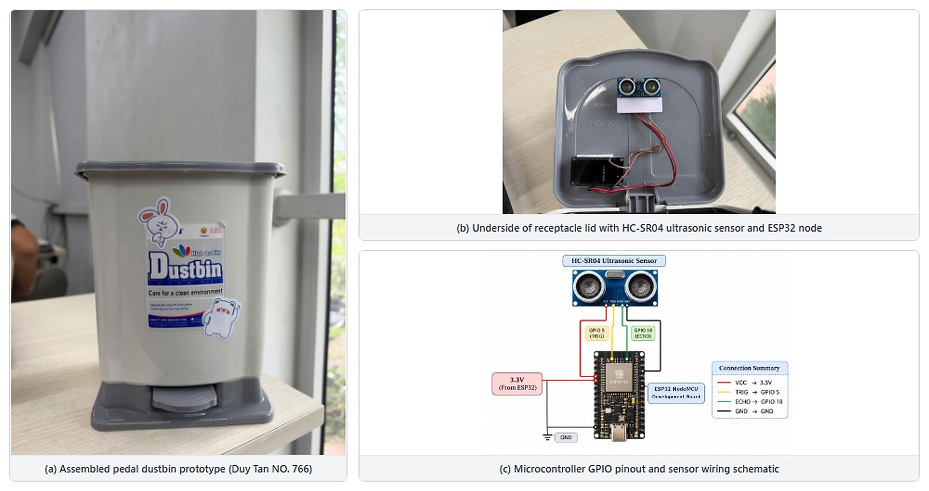
Figure 3: Physical prototype assembly: (a) pedal-operated waste bin, (b) lid-mounted HC-SR04 sensor and ESP32 node, and (c) GPIO connection overview.
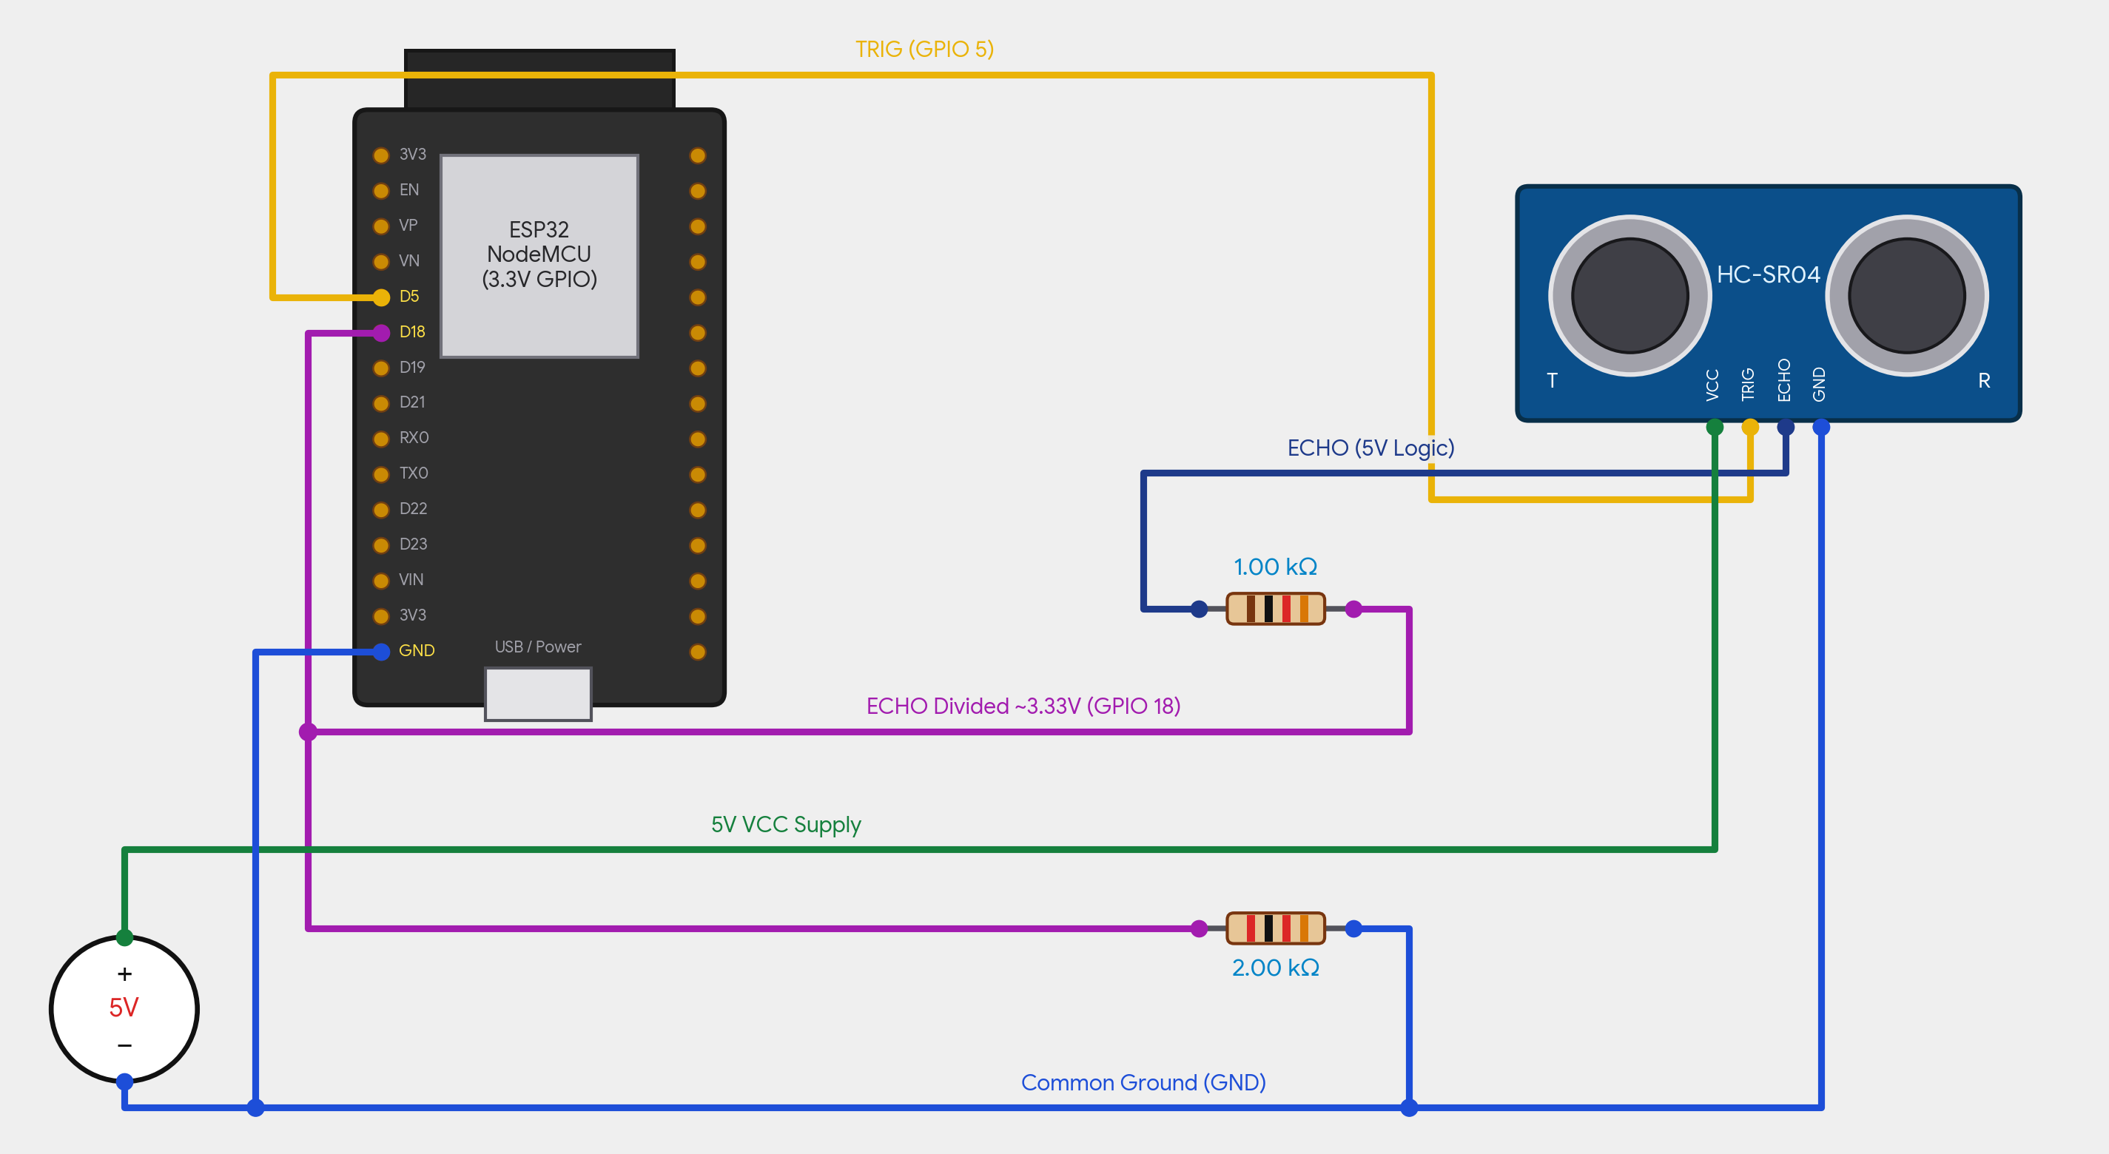
Figure 4: Circuit wiring schematic connecting the ESP32 NodeMCU, HC-SR04 sensor, 5V supply, and resistive voltage divider.
Table 1. Hardware and firmware configuration specifications
Parameter | Configuration
Microcontroller | ESP32 NodeMCU development board with 2.4 GHz Wi-Fi
Distance sensor | HC-SR04 ultrasonic sensor, 5V
ECHO voltage divider | 1.00 kΩ series resistor and 2.00 kΩ ground resistor
Trigger pin | GPIO 5, digital output
Echo pin | GPIO 18, digital input
Configured bin depth (H) | 15.0 cm
Minimum distance boundary (d_{min}) | 2.0 cm
Measurement cycle | 3 seconds
Sensor identifier | BIN-001
Communication method | HTTP POST with GET fallback
Request format | application/x-www-form-urlencoded

  - Distance Measurement and Fill-Level Calculation
The embedded firmware controls the ultrasonic measurement process. During each measurement cycle, the ESP32 sends a 10-microsecond HIGH pulse to the TRIG pin. The HC-SR04 then emits an ultrasonic signal and returns an ECHO pulse whose duration corresponds to the time required for the sound wave to travel to the waste surface and return to the sensor.
The distance between the sensor and the waste surface is calculated using the speed of sound, approximately 0.0343 cm/µs at 20 °C. The relationship is expressed in Equation (1):
$$d =\frac{t × 0.0343}{2}(1)$$
where d represents the measured distance in centimeters and t represents the ECHO pulse duration in microseconds. The division by two accounts for the sound wave travelling from the sensor to the waste surface and then returning to the sensor.
The configured bin depth is 15.0 cm, while the minimum distance boundary is set to 2.0 cm. These values define the measurement range used by the firmware. The 2.0 cm boundary is not a fixed filling threshold; it represents the minimum measurable distance used by the system to handle readings near the sensor and prevent the calculated filling level from exceeding the physical range.
The firmware collects up to three valid distance samples during each measurement cycle. A sample is considered valid when its measured distance is greater than 0 cm and does not exceed 400 cm. The valid samples are averaged to reduce the influence of individual unstable readings. The average distance is then converted into a normalized filling percentage using Equation (2):
$$F =\frac{H − d}{H −d_{min}}× 100\% (2)$$
where F is the estimated filling percentage, H is the configured bin depth, d is the measured distance, and d_{min} is the minimum distance boundary. As the waste surface moves closer to the sensor, the measured distance decreases and the estimated filling percentage increases.
The firmware applies boundary handling before transmitting the calculated value. When the measured distance is less than or equal to 2.0 cm, the filling percentage is set to 100%. When the measured distance is greater than or equal to 15.0 cm, the filling percentage is set to 0%. Calculated values at or below 3% are also reset to 0% to avoid displaying very small residual values when the bin is nearly empty. Any value above 100% is limited to 100%, and the final percentage is rounded to an integer.
Figure 5 illustrates the ultrasonic measurement geometry, including the configured bin depth, minimum distance boundary, and the relationship between measured distance and estimated filling percentage.
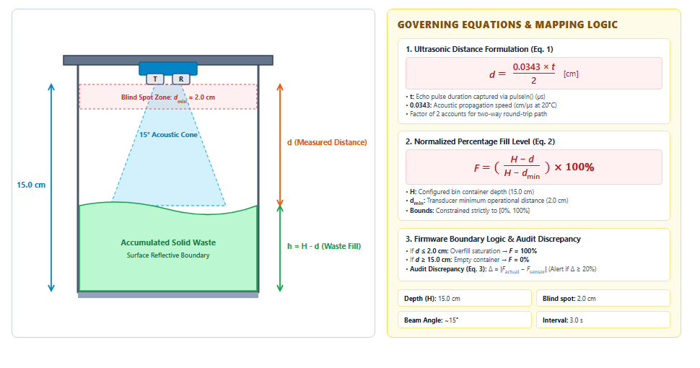
Figure 5: Ultrasonic sensing geometry, minimum distance boundary, and normalized fill-level calculation.
  - Communication and Server-Side Processing
After calculating the filling percentage, the ESP32 transmits the measurement to the Java web application through a Wi-Fi connection. The firmware sends an HTTP request to the endpoint /SmartWaste/api/bin/update-fill. The request uses the application/x-www-form-urlencoded format and contains the configured bin identifier (binID), set to BIN-001, together with the calculated filling percentage (fillPercent). The firmware primarily uses HTTP POST and attempts a GET request as a fallback when the POST request encounters an HTTP error.
On the server side, SensorServlet receives the incoming telemetry and validates the submitted values before updating the database. The servlet checks that the required bin identifier and filling percentage are provided, verifies that the percentage is within the valid range of 0–100, and confirms that the specified bin exists. The backend also supports alternative field names when processing raw JSON payloads, allowing binID or bin_id to represent the bin identifier and fillPercent or fill_level to represent the filling percentage.
When the submitted data passes validation, the server updates the corresponding bin record and stores a timestamped sensor reading. This allows the application to maintain a history of measurements instead of relying only on the most recent filling percentage. Invalid or incomplete payloads are rejected to prevent incorrect values from being stored in the database.
The dashboard obtains updated bin information through the /api/bin/status endpoint. It uses periodic HTTP polling to request the latest status from the server. Therefore, the system provides near-real-time monitoring based on repeated requests rather than continuous WebSocket communication. The polling approach allows the dashboard to refresh displayed information without requiring users to reload the page manually.
  - Rule-Based Alert Generation and Collection Dispatch
SmartWaste applies predefined server-side rules to connect bin monitoring with collection management. These rules use the estimated filling percentage received from the sensor node to determine whether a bin requires attention. The system defines two main operational thresholds: 80% for high-fill alerts and 90% for emergency collection requests.
When a bin reaches or exceeds 80% capacity, the backend checks whether an unresolved high-fill alert already exists for that bin. If no unresolved alert is found, the system creates a new High_Fill alert in the alert table and triggers the notification service. This mechanism helps prevent repeated alerts from being generated for the same unresolved condition.
When the filling percentage reaches or exceeds 90%, the backend checks whether an active collection request already exists. If no active request is found, the system creates an emergency collection request with a Pending status. The application then attempts to assign the request to a collection staff member whose assigned area matches the area associated with the bin. If a matching staff member with the STF role is available, the request can be assigned automatically. Otherwise, the request remains pending without an assigned staff member until it can be handled by an authorized user.
When the filling percentage falls below 80%, unresolved high-fill alerts associated with the bin are automatically resolved. This behavior allows the system to update the alert status after the bin has been emptied or its filling level has decreased sufficiently. Table 2 summarizes the implemented threshold rules and their corresponding server-side behavior.
Table 2. Implemented threshold rules and server-side operational behavior
Condition | System behavior
Filling level (F ≥ 80%) | Create a High_Fill alert in tblAlerts if no unresolved alert exists.
Filling level (F ≥ 90%) | Create an emergency collection request if no active request exists.
Filling level (F < 80%) | Automatically resolve unresolved high-fill alerts associated with the bin.
Matching staff member found | Assign the emergency request to an STF staff member associated with the bin's area.
No matching staff member found | Keep the collection request in the Pending state without an assigned staff member.

  - Programming Flow and Database Design
The firmware and server application work together to complete each monitoring cycle. The ESP32 periodically activates the ultrasonic sensor, collects valid distance samples, calculates their average, and converts the result into a filling percentage. The calculated value is then transmitted to the server through an HTTP request. After receiving the request, the backend validates the payload, updates the corresponding bin record, stores the sensor reading, and evaluates the predefined alert and collection rules. The dashboard subsequently retrieves the updated information through periodic polling. Figure 6 presents this process, including the measurement cycle, data transmission, server-side threshold evaluation, and database operations.
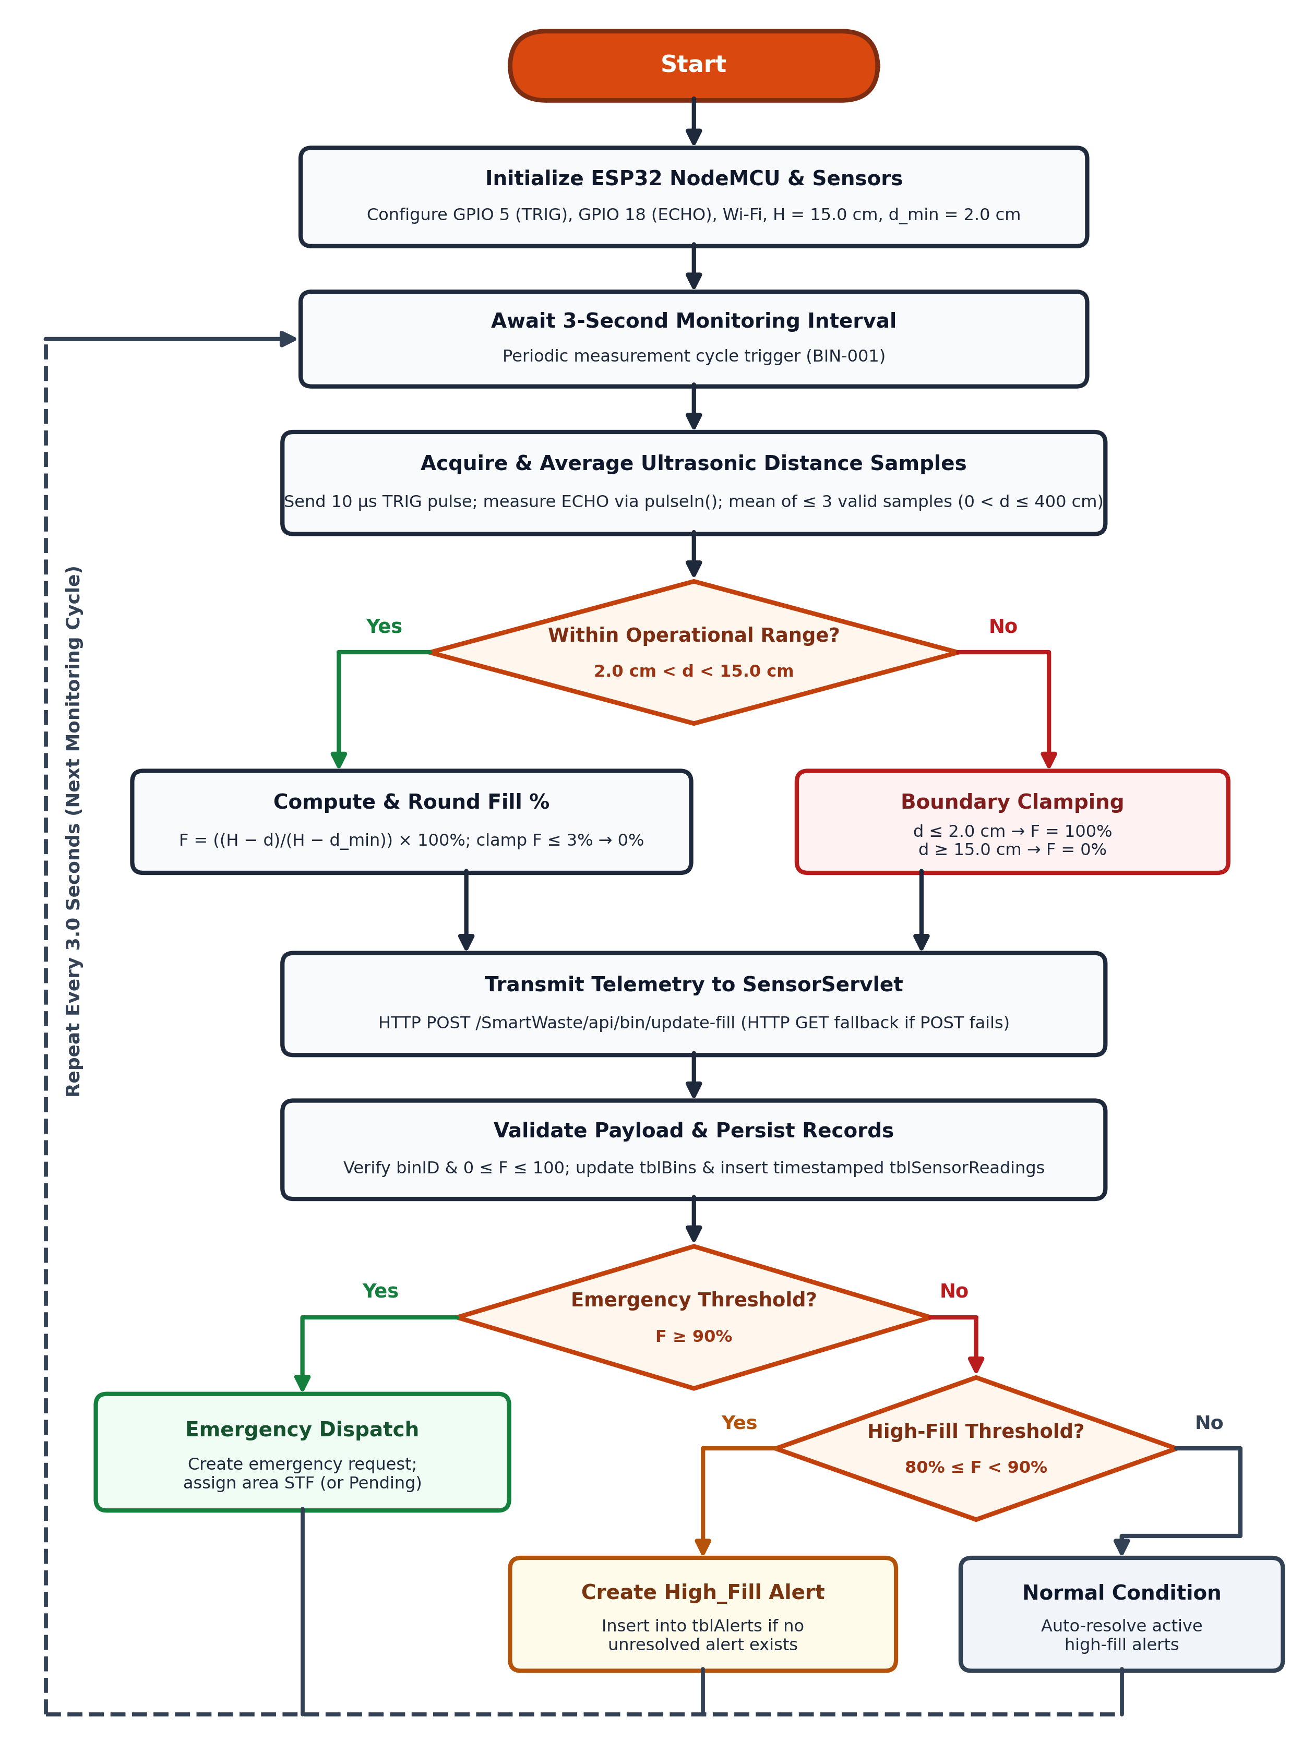
Figure 6: End-to-end firmware measurement, telemetry transmission, threshold evaluation, and collection dispatch flowchart.
The relational database stores the operational information required by the monitoring and collection management functions. The tblBins table stores bin information, including its identifier, assigned area, current filling percentage, and status. The tblSensorReadings table records timestamped measurements received from sensor devices, allowing the application to retain historical telemetry. The tblAlerts table stores alert records generated when predefined conditions are reached, while tblCollectionRequests maintains collection tasks, their priorities, statuses, and assigned staff members. The tblUsers table stores user account information and supports access control for the web application [14, 15].
Specifically, separating current operational state (tblBins) from immutable historical logs (tblSensorReadings) enables fast status queries for dashboard polling while preserving chronological fill-level records. Relational foreign-key associations linking binID and areaID across tblBins, tblAlerts, tblCollectionRequests, and tblUsers ensure referential integrity during automated alert creation, duplicate warning suppression, and area-matched staff dispatch.
- RESULTS AND DISCUSSION
  - Prototype Implementation
The SmartWaste prototype integrates the physical sensor node with a Java Servlet-based web management platform. The hardware prototype uses an ESP32 NodeMCU and an HC-SR04 ultrasonic sensor to measure the filling level of the physical waste bin identified as BIN-001. The sensor node periodically transmits its calculated filling percentage to the backend, where the measurement is validated and stored.
The web dashboard provides a centralized view of bin information and operational status. It displays bin records, filling levels, alert information, and collection-related data through a graphical interface. The dashboard currently contains 12 bin records; however, only BIN-001 is connected to the physical sensor and provides real sensor telemetry. The other 11 bin records are static database records and should not be interpreted as additional active sensor nodes. This distinction is important when evaluating the current hardware deployment and the scope of the collected sensor data.
Figure 7 presents the SmartWaste dashboard, including its bin monitoring interface and campus overview. The displayed information is refreshed periodically through the /api/bin/status endpoint, allowing users to observe changes without manually reloading the page. Figure 8 shows the Collection Management interface, which allows authorized users to review collection requests and manage their operational status. The interface supports the management of request information and provides a centralized view of tasks that require attention.
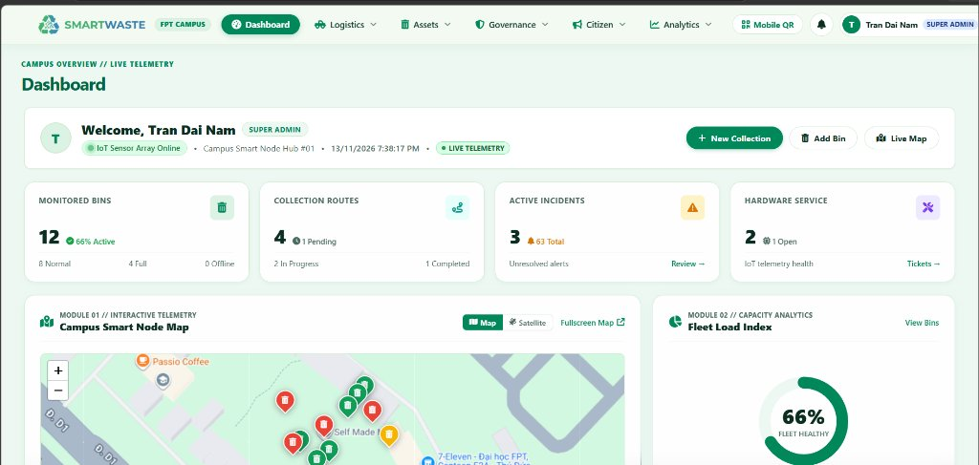
Figure 7: SmartWaste web dashboard showing bin records, filling levels, and campus monitoring information.
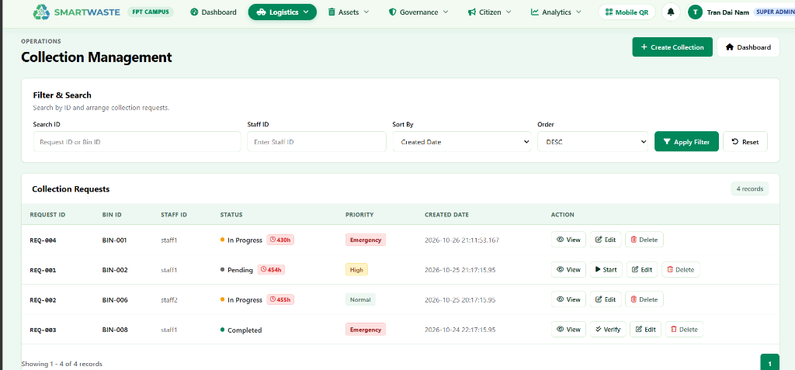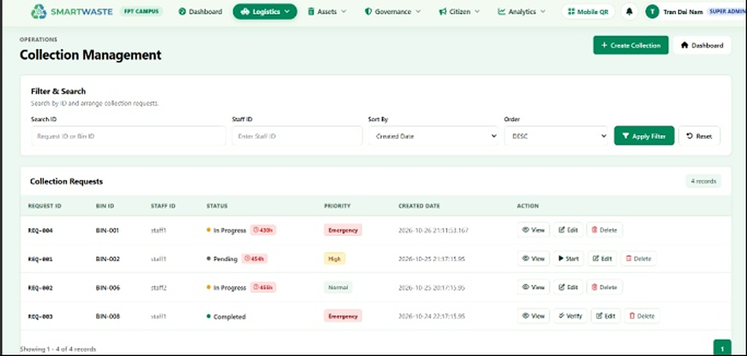
Figure 8: SmartWaste collection management interface for reviewing and managing collection requests.
  - Functional Verification
Functional verification focuses on checking whether the main processing rules operate according to their defined conditions. The scenarios cover normal fill-level monitoring, high-fill alert generation, emergency collection request creation, alert resolution after the filling level decreases, and boundary handling for minimum and maximum sensor distances.
For normal monitoring, a measured distance of 8.5 cm corresponds to an estimated filling level of approximately 50% using the configured bin depth and minimum distance boundary. At this level, the backend should update the bin record without generating a high-fill alert. When the estimated filling percentage reaches 80%, the backend should create a high-fill alert if an unresolved alert does not already exist. When the filling percentage reaches 90%, the system should create an emergency collection request if no active request already exists and attempt to assign it to an eligible staff member associated with the bin's area.
The verification scenarios also consider the behavior after a bin is emptied. When the filling level falls below 80%, unresolved high-fill alerts should be marked as resolved. At the measurement boundaries, the firmware should limit the estimated filling percentage to 100% when the measured distance is less than or equal to 2.0 cm and to 0% when the measured distance is greater than or equal to 15.0 cm. Table 3 summarizes the functional verification scenarios and their expected system behavior.
Table 3. Functional verification scenarios and expected system behavior
Test scenario | Input or condition | Expected system behavior
Normal fill monitoring | Distance d = 8.5 cm (≈ 50%) | Accept the sensor measurement and update the bin filling level without creating an alert.
High-fill warning trigger | Filling level F ≥ 80% (≈ 4.6 cm or less) | Create a High_Fill alert if no unresolved alert exists.
Emergency dispatch trigger | Filling level F ≥ 90% (≈ 3.3 cm or less) | Generate an emergency collection request if no active request exists and attempt area-based staff assignment.
Bin emptied or reset | Filling level F < 80% | Automatically resolve unresolved high-fill alerts associated with the bin.
Minimum and maximum boundaries | d ≤ 2.0 cm or d ≥ 15.0 cm | Limit the calculated filling percentage to 100% or 0%, respectively.

The evaluation is focused on functional behavior and the consistency of the implemented processing rules. No fabricated quantitative accuracy, latency, or large-scale deployment metrics are claimed. The current prototype demonstrates the integration of sensor measurement, HTTP communication, server-side processing, database storage, and web-based monitoring within the defined implementation scope.
  - Discussion and Technical Limitations
The SmartWaste prototype demonstrates how low-cost ultrasonic sensing can be integrated with a web-based management application to support campus waste monitoring and collection dispatch. By converting distance measurements into filling percentages, the system provides a more direct indication of bin conditions than relying only on manual inspection. The server-side rules also connect monitoring information with operational actions by generating alerts and collection requests when predefined thresholds are reached.
However, several limitations remain in the current implementation. At the hardware level, ultrasonic measurements can be affected by irregular waste surfaces, object positioning, and the reflection of sound waves inside the container. These factors may cause variations in the measured distance and therefore influence the calculated filling percentage. The current prototype also uses only one physical sensor node, so the available real sensor telemetry is limited to BIN-001. The additional bin records displayed on the dashboard are database records rather than independently connected devices.
At the communication level, the ESP32 relies on 2.4 GHz Wi-Fi to transmit measurements to the server. Network interruptions may delay the delivery of sensor readings and prevent the dashboard from receiving updated information during the interruption. The dashboard also relies on periodic HTTP polling instead of WebSocket-based communication. Although this approach is sufficient for the current prototype, it does not provide continuous server-pushed updates.
The current firmware focuses on measuring filling levels and transmitting the calculated percentage. It does not yet include additional environmental measurements, hardware heartbeat monitoring, or comprehensive sensor fault diagnostics. On the application side, collection dispatch is based on fixed thresholds and area-based staff assignment. The system does not currently predict when a bin will become full, calculate an optimized collection route, or dynamically allocate staff according to predicted workload. These limitations define the main opportunities for future development.
  - Future Work
Although the current prototype provides near-real-time bin monitoring and rule-based collection dispatch, further development could extend SmartWaste from a monitoring-oriented system into a more comprehensive and intelligent waste management platform. One important direction is to develop a fill-level prediction model using historical sensor readings and time-based waste accumulation patterns [9, 10, 11, 13]. By collecting measurements over longer periods, the system could learn how quickly waste accumulates in different bins and estimate when each bin is likely to reach a predefined threshold. Instead of waiting until a bin reaches 80% or 90% capacity, the system could notify collection staff in advance and recommend an appropriate collection time. This would support proactive planning, reduce the likelihood of overflowing bins, and help staff avoid unnecessary inspections or collection trips.
Another potential extension is the integration of AI-based waste classification using cameras and image recognition models. The system could analyze images of deposited waste and identify common categories such as plastic, paper, metal, and organic waste. This capability could support waste separation at the source and provide information about the types of waste generated in different campus areas. By understanding the composition of collected waste, campus administrators could identify areas where recycling practices need improvement, evaluate waste generation patterns, and make better decisions about recycling facilities and waste disposal processes.
The sensing capability could also be expanded through the integration of additional environmental sensors, such as temperature and humidity sensors. These measurements would provide information beyond the filling percentage currently obtained from the ultrasonic sensor. Temperature monitoring could help identify abnormal heat conditions inside a container that may require attention, while humidity measurements could provide additional information about the condition of organic waste and environmental conditions that may contribute to decomposition or odor formation. Depending on operational requirements, future versions could also investigate other suitable sensors for detecting environmental conditions or potential safety risks. Combining these measurements with filling-level data would give administrators a broader understanding of the condition of waste containers.
In addition, data collected from multiple connected bins could support more intelligent collection planning and resource allocation. By combining predicted filling levels with bin locations, historical waste generation patterns, collection priorities, and staff availability, the system could recommend collection schedules and prioritize bins that require attention. A future route-planning component could also suggest more efficient collection sequences for staff and collection vehicles. This could reduce unnecessary travel, improve the use of available personnel and vehicles, and prevent bins in high-waste areas from remaining full for extended periods.
These extensions would allow SmartWaste to provide more than the current functions of displaying bin conditions and generating threshold-based collection requests. Predictive monitoring could help staff act before bins become full, AI-based classification could support recycling and waste separation, environmental sensing could provide additional information about container conditions, and intelligent collection planning could improve the use of operational resources. Together, these capabilities could help campus administrators make more informed decisions, improve waste handling practices, reduce avoidable collection activities, and maintain a cleaner campus environment.
The full implementation, including the embedded ESP32 NodeMCU firmware and Java Servlet web application source code, is available in a public GitHub repository: https://github.com/Daica-lop3a/Final_Project.
- CONCLUSION
This paper presented SmartWaste, an IoT-based campus waste management system that integrates ultrasonic sensing, ESP32-based communication, Java Servlet processing, relational database storage, and a centralized web interface. The physical prototype uses an HC-SR04 ultrasonic sensor to measure the distance between the sensor and the waste surface. The ESP32 converts the measurement into an estimated filling percentage and periodically transmits the result to the server through HTTP requests.
The backend validates incoming telemetry, updates bin records, stores timestamped sensor readings, and applies predefined rules to support operational monitoring. A high-fill alert is generated when the filling level reaches 80%, while an emergency collection request is created when the level reaches 90%, subject to the existence of unresolved alerts or active requests. The web application provides centralized bin monitoring and collection management functions.
The current implementation demonstrates the integration of physical sensing with server-side processing and operational management. However, the prototype currently has one physical sensor-connected bin, BIN-001, and relies on threshold-based rules rather than predictive analysis or route optimization. Future development will focus on fill-level prediction, AI-based waste classification, additional environmental sensing, and intelligent collection planning. These improvements could extend SmartWaste toward a more proactive and data-driven campus waste management platform.
REFERENCES
- K. Ashton. 2009. That 'internet of things' thing. RFID Journal 22, 7 (2009), 97–114.
- L. Atzori, A. Iera, and G. Morabito. 2010. The internet of things: A survey. Computer Networks 54, 15 (2010), 2787–2805.
- C. Perera, A. Zaslavsky, P. Christen, and D. Georgakopoulos. 2014. Context aware computing for the internet of things: A survey. IEEE Communications Surveys & Tutorials 16, 1 (2014), 414–454.
- J. O. Ighalo, A. G. Adeniyi, and G. Marques. 2021. Internet of Things for Environmental Monitoring and Waste Assessment. Springer, Cham, 245–259.
- Y. Y. Koh, C. L. Kok, N. Ibraahim, and C. G. Lim. 2024. Smart campus waste management with IoT integration and dynamic collection scheduling. Electronics 13, 9 (2024), 1657.
- A. Gunasinghe and J. Tharmaseelan. 2019. Smart municipal waste and resource monitoring system. IEEE Access 7 (2019), 8812–8824.
- I. Zhou, I. Makhdoom, N. Shariati, et al. 2021. Internet of things 2.0: Concepts, applications, and future directions. IEEE Access 9 (2021), 70961–71012.
- D. Hercog, T. Lerher, M. Truntic, and O. Tezak. 2023. Design and implementation of ESP32-based IoT devices. Sensors 23, 15 (2023), 6739.
- M. A. Alsheikh, S. Lin, D. Niyato, and H. P. Tan. 2014. Machine learning in wireless sensor networks: Algorithms, strategies, and applications. IEEE Communications Surveys & Tutorials 16, 4 (2014), 1996–2018.
- R. Chalapathy and S. Chawla. 2019. Deep learning for anomaly detection: A survey. arXiv preprint arXiv:1901.03407.
- E. El-Shafeiy, M. Alsabaan, M. Ibrahem, and H. Elwahsh. 2023. Real-time anomaly detection for smart building telemetry based on multivariate techniques. Sensors 23, 20 (2023), 8613.
- P. Sethi and S. R. Sarangi. 2017. Internet of things: Architectures, protocols, and applications. Journal of Electrical and Computer Engineering 2017 (2017), Article 9324035.
- I. H. Witten, E. Frank, M. A. Hall, and C. J. Pal. 2017. Data Mining: Practical Machine Learning Tools and Techniques. 4th ed. Morgan Kaufmann.
- R. Elmasri and S. B. Navathe. 2016. Fundamentals of Database Systems. 7th ed. Pearson.
- R. S. Sandhu, E. J. Coyne, H. L. Feinstein, and C. E. Youman. 1996. Role-based access control models. IEEE Computer 29, 2 (1996), 38–47.
ACM Reference Format:
First Author’s Name, Initials, and Last Name, Second Author’s Name, Initials, and Last Name, and Third Author’s Name, Initials, and Last Name. 2018. The Title of the Paper: ACM Conference Proceedings Manuscript Submission Template: This is the subtitle of the paper, this document both explains and embodies the submission format for authors using Word. In Woodstock ’18: ACM Symposium on Neural Gaze Detection, June 03–05, 2018, Woodstock, NY. ACM, New York, NY, USA, 10 pages. NOTE: This block will be automatically generated when manuscripts are processed after acceptance.

