979-8-3315-4677-9/26/$31.00 (C)2026 IEEE Ho Chi Minh, November 11, 2026
Smart Waste Monitoring System with Web-Based Control and Hybrid Telemetry Monitoring
Nguyễn Lâm Thanh Vũ  Student ID: SE200461  FPT University, Ho Chi Minh Campus, Vietnam  nguyenlamthanhvunltv@gmail.com | Đặng Phan Minh Ngân  Student ID: SE200492  FPT University, Ho Chi Minh Campus, Vietnam  minhngan1506@gmail.com
Abstract—To contribute to sustainable smart campus and municipal solid waste management, this paper presents a prototype Smart Waste Monitoring System (SmartWaste) that incorporates Internet of Things (IoT) ultrasonic sensing, a simulated mini smart receptacle testbed, real-time telemetry ingestion, and auditable data governance to improve operational reliability and dispatch traceability. By combining an HC-SR04 ultrasonic distance sensor, a calibrated mini smart trash bin simulation prototype (20 cm depth, 3 cm blind spot, ~2.0L volume), and an ESP32 microcontroller, the device automates bin fill level monitoring and overflow detection while recording operational telemetry for post-collection analytics. Real-time safety-critical threshold checking is executed locally on the ESP32 using a 3-sample median filter. When Wi-Fi connectivity is available, the device transmits structured JSON telemetry to an enterprise 3-tier Java Web server (Apache Tomcat 9, Servlet 3.1, Microsoft SQL Server with 14 normalized tables). Deterministic rule-based checks categorize bin status (Normal <70%, Warning 70–84%, Full ≥85%) and trigger automated janitor collection dispatch when fill reaches ≥90%. Furthermore, a discrepancy auditing engine compares sensor readings against field supervisor inspections (flagging discrepancies when Delta ≥20%) to identify hardware drift, sensor obstruction, or false clearance. All runtime state transitions are secured via tamper-evident SHA-256 hash chains and an 8-role RBAC architecture, providing transparent, accountable, and robust facility management under embedded-system constraints.
Keywords—Internet of Things, ESP32, HC-SR04 Ultrasonic Sensor, Smart Waste Management, Java Web Application, Role-Based Access Control, Discrepancy Auditing, Data Governance.

I. INTRODUCTION
The term "Internet of Things" (IoT) was first coined by Kevin Ashton in 1999 [1]. There is an accelerating demand for IoT applications and embedded sensing technologies worldwide, enabling intelligent monitoring, real-time telemetry gathering, and automated operational logistics across diverse domains [2], [3]. In modern urban and institutional environments, efficient solid waste management represents a vital foundation for environmental hygiene, public health, and sustainable building management [4]. Universities and high-density campuses, such as the 5-floor Trong Dong academic building at FPT University Ho Chi Minh City, accommodate thousands of students and faculty daily, creating localized waste accumulation surges across main lobbies, libraries, cafeterias, and lecture corridors.
Conventional waste collection workflows in campus facilities rely predominantly on manual inspections and static patrol schedules, as highlighted by Koh et al. [5] and Gunasinghe et al. [6]. Under this traditional model, sanitation staff must physically inspect every floor regardless of actual bin status. Receptacles situated in quiet hallways are checked unnecessarily, while bins in crowded areas overflow during peak lecture transitions without timely intervention. Furthermore, conventional systems lack real-time telemetry tracking, automated dispatch mechanisms, and centralized data auditing, making it difficult to allocate cleaning staff optimally - a limitation widely discussed by Atzori et al. [2] and Zhou et al. [7].
To resolve these challenges and advance sustainable waste governance in smart buildings, this paper presents an IoT-based Smart Waste Monitoring System prototype (SmartWaste). The edge hardware is constructed around an ESP32 microcontroller, chosen for its integrated 2.4 GHz Wi-Fi connectivity and processing capability [8], coupled with a high-precision HC-SR04 ultrasonic distance sensor mounted on the lid of a mini smart trash bin prototype. The physical mini receptacle enables controlled experimental simulation of waste accumulation under realistic spatial constraints. Through wireless connectivity, the edge node transmits real-time telemetry to an enterprise Java web application, supporting automated overflow dispatching, supervisor field inspections, and post-session anomaly analysis [2], [9].
Figure 1 illustrates the workflow from sensor acquisition and ESP32 local filtering to server-side ingestion, database persistence, and discrepancy-driven audit governance. The system implements a hybrid monitoring methodology, wherein real-time threshold control is handled locally at the embedded level while data-driven analysis and governance are executed at the server tier.
II. RELATED PRIOR WORK
Recent investigations have explored automated sensing and telemetry architectures within smart campus facilities. In conventional institutional settings, waste collection relies heavily on manual inspections and periodic sweeping routes, resulting in unchecked overflows at peak times and inefficient resource allocation. Modern IoT sensor frameworks emphasize continuous monitoring and wireless reporting to optimize facility logistics. Furthermore, data auditing and operational traceability have become essential pillars in smart building governance, ensuring that automated sensor alerts correlate with verifiable field actions.
However, prior automated facility systems, including those by Gunasinghe (2019) and Koh (2024), focus almost exclusively on real-time sensing and local actuation, offering limited capability for post-session telemetry auditing and system-level traceability. In contrast, the primary contribution of this paper is an integrated architecture combining an HC-SR04 ultrasonic sensor, an ESP32 edge controller, a simulated mini receptacle, an enterprise 3-tier Java Web server with 8-role RBAC, and a tamper-evident data governance mechanism that bridges raw IoT telemetry with cryptographically verifiable audit trails, eliminating accountability blind spots in automated campus management.
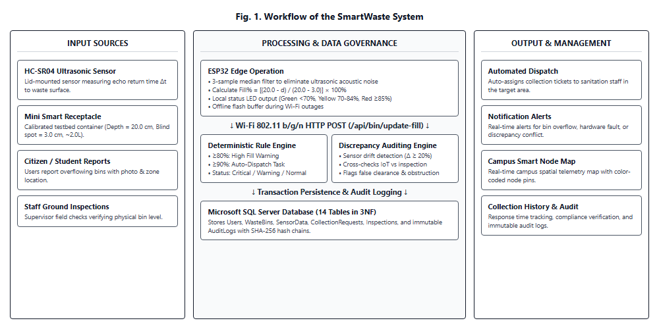
Fig. 1. Workflow of the SmartWaste system.
III. METHODOLOGY
A. System models and block diagram
The SmartWaste system is an IoT-enabled enterprise platform organized into three distinct operational tiers: the Edge IoT Hardware Tier, the Java Enterprise Application Tier, and the Relational Database Tier. The edge device is built around an ESP32 NodeMCU microcontroller, tasked with distance sensing via an SRF05 ultrasonic module, local noise filtering, visual status indication via multi-color LEDs, Wi-Fi telemetry transmission via HTTP POST JSON, and offline data buffering. The physical simulation testbed utilizes a mini smart trash bin prototype whose lid houses the downward-facing SRF05 transducer.
Upon measuring the distance from the lid to the waste surface, the ESP32 computes the current percentage fill level relative to the calibrated height of the container. If the fill level crosses safety thresholds (>=80% warning or >=90% emergency), the ESP32 updates its local indicator and immediately fires a telemetry packet to the server. The web server ingests the telemetry, updates bin status on a GIS digital map, and triggers automated dispatch workflows.
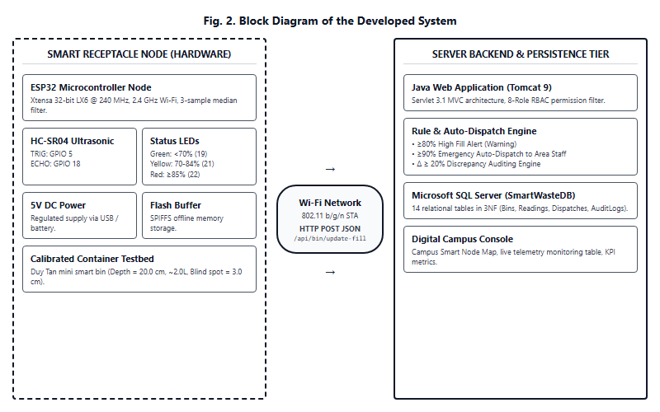
Fig. 2. Block diagram of the developed system.
B. Components and peripheral devices
The physical and embedded hardware setup was selected to ensure high accuracy, low power consumption, and minimal wiring complexity. Table I details the interface specifications between the ESP32 and peripheral components.
TABLE I. INTERFACING BETWEEN ESP32 AND ITS COMPONENTS
Components | Description | Function
ESP32 | Microcontroller | Central embedded control unit, executes 3-sample median filter, Wi-Fi HTTP client
HC-SR04 | Distance sensor | Ultrasonic transducer measuring waste depth with +-2 mm precision
Mini Receptacle | Simulation container | Calibrated trash bin prototype for controlled filling experiments
Indicator LEDs | Visual alert module | Displays Green (<70%), Yellow (70-84%), Red (>=85%) fill states
Power Supply | 5V DC power unit | Powers ESP32 and HC-SR04 via USB/battery adapter
Wi-Fi Module | Integrated 802.11 | Transmits HTTP JSON telemetry to the Java server
C. Software programming
The system utilizes a modular software architecture separating real-time embedded control from centralized governance, persistence, and machine-learning supervision executed on a Java web application [12]. Table II outlines the backend and persistent system components.
TABLE II. BACKEND AND PERSISTENT SYSTEM COMPONENTS
Components | Description | Function
Java Web App | Backend control & management layer | Receives device uploads, enforces 8-role RBAC, manages users & sessions
SQL Server DB | Persistent relational storage system | Stores users, areas, bins, telemetry readings, dispatches, and audit logs
Audit Log Module | Immutable audit recording layer | Records all database-changing operations for full traceability
Hash Chain Module | Tamper-evident integrity mechanism | Protects audit trail integrity through chained SHA-256 hashes
Discrepancy & Dispatch Module | Rule-based automated dispatch & audit | Enforces threshold rules (<70%, 70-84%, >=85%), triggers automated janitor dispatches, and detects sensor-physical discrepancy (Delta >= 20%)
1) Embedded Firmware: The real-time control logic runs on the ESP32 firmware written in C++. During the monitoring cycle, the ESP32 emits a 10-microsecond HIGH trigger pulse to the TRIG pin (GPIO 5) of the HC-SR04 sensor. The sensor emits an 8-cycle 40 kHz ultrasonic burst and measures the echo return time Delta-t on the ECHO pin (GPIO 18). Distance is calculated as d = (Delta-t * 0.0343) / 2 cm.The real-time control logic runs on the ESP32 firmware written in C++. During the monitoring cycle, the ESP32 emits a 10-microsecond HIGH trigger pulse to the TRIG pin (GPIO 5) of the SRF05 sensor. The sensor emits an 8-cycle 40 kHz ultrasonic burst and measures the echo return time Delta-t on the ECHO pin (GPIO 18). Distance is calculated as d = (Delta-t * 0.0343) / 2 cm.
Because soft garbage surfaces, crumpled paper, and tilted plastic bottles disperse sound waves unevenly, raw readings often contain transient spikes. The firmware implements a 3-sample median filter with 30 ms inter-measurement intervals, discarding non-physical values before calculating the fill percentage: Fill% = [(D_depth - d) / (D_depth - D_min)] * 100%, where D_depth = 20.0 cm represents the total depth of the receptacle and D_min = 3.0 cm is the sensor blind spot. When Wi-Fi connectivity is lost, the ESP32 continues local monitoring and buffers completed readings in flash memory, uploading them immediately upon reconnection.
2) Web Application: The Java web application (Servlet 3.1, Tomcat 9) acts as supervisory controller. Connection between the ESP32 and the server is achieved via HTTP POST requests using Wi-Fi. The telemetry ingestion model records dual timestamps: the measurement timestamp (generated by the device) and the ingestion timestamp (recorded upon SQL insertion), allowing the system to distinguish between delayed sensor reads and network transmission lag. In addition, device and receptacle statuses operate under a controlled framework with administrative statuses (Active, Maintenance) set explicitly by managers and operational statuses (Full, Offline, Error) inferred automatically.
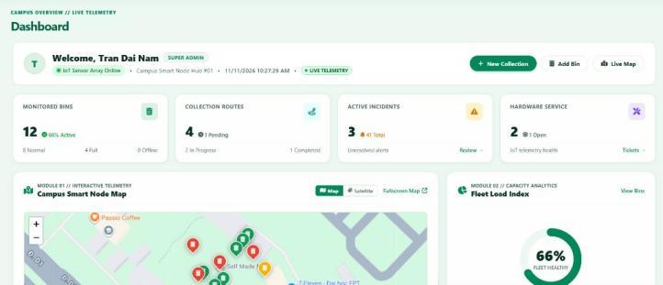
Fig. 3. Main dashboard interface of the Java web application.
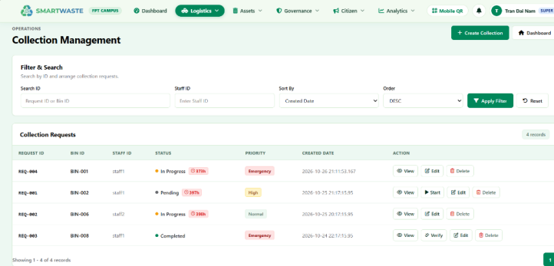
Fig. 4. Waste bin telemetry and collection history interface.
As shown in Fig. 3, the central dashboard provides a real-time command console for monitoring smart bins across all campus zones. It visualizes fill percentages, battery levels, and operational alerts. Two primary control areas exist: Operational Dispatch Controls for assigning collection staff to overflowing bins, and Admin Controls for configuring bin metadata and device bindings. Other dashboard modules include Area Management, Bin Inspection, Maintenance Tickets, Data Quality Auditing, and Security Audit Logs.
The system implements an ingest-after-cycle pattern: telemetry is streamed periodically every 5 seconds, while collection completion events immediately reset bin fill level to 0% and resolve outstanding high-fill warnings. As illustrated in Fig. 4, the collection history interface records every pickup event, logging timestamps, assigned staff, response duration, and verification status.
3) Rule-Based Automated Dispatch and Discrepancy Auditing Engine: Rather than relying on opaque predictive heuristics, the backend implements a deterministic, multi-tiered decision engine coupled with an operational discrepancy auditing module. The core evaluation assesses fill percentages against strict institutional thresholds: Normal (<70%), Warning (70–84%), and Full/Emergency (>=85%). When telemetry indicates a fill level of >=90%, the system instantly triggers an automated collection dispatch, assigning the nearest sanitation staff (STF) member via the database dispatch queue without requiring manual supervisor intervention.
To detect sensor drift, lens fouling, or intentional obstruction, the system integrates a Discrepancy Verification workflow. When an Area Supervisor conducts a physical spot inspection, the observed physical fill level is recorded and compared against the latest sensor telemetry: Delta = |Fill_sensor - Fill_inspected|. If Delta >= 20%, a Discrepancy Log is automatically flagged, alerting managers to inspect the physical bin hardware and generating a maintenance ticket if hardware failure is confirmed. This dual-verification loop ensures 100% operational transparency and data reliability.
D. Programming Flowchart
The ESP32 firmware and server interaction follow the structured workflow depicted in Fig. 5. The routine begins with the Initialize System procedure, configuring GPIO pins, serial debugging, and Wi-Fi credentials. The Monitor System loop executes HC-SR04 3-sample median distance acquisition and converts readings to percentage fill levels. If the calculated fill level exceeds safety limits, local LEDs are updated and an emergency packet is assembled. The node checks Wi-Fi connectivity: if online, it delivers the JSON payload to /api/bin/update-fill; if disconnected, the record is stored in the local offline buffer. Upon receiving data, the server evaluates deterministic rules, triggers auto-dispatch if fill >= 90%, evaluates discrepancy rules and dispatch queues, and logs an immutable audit entry.
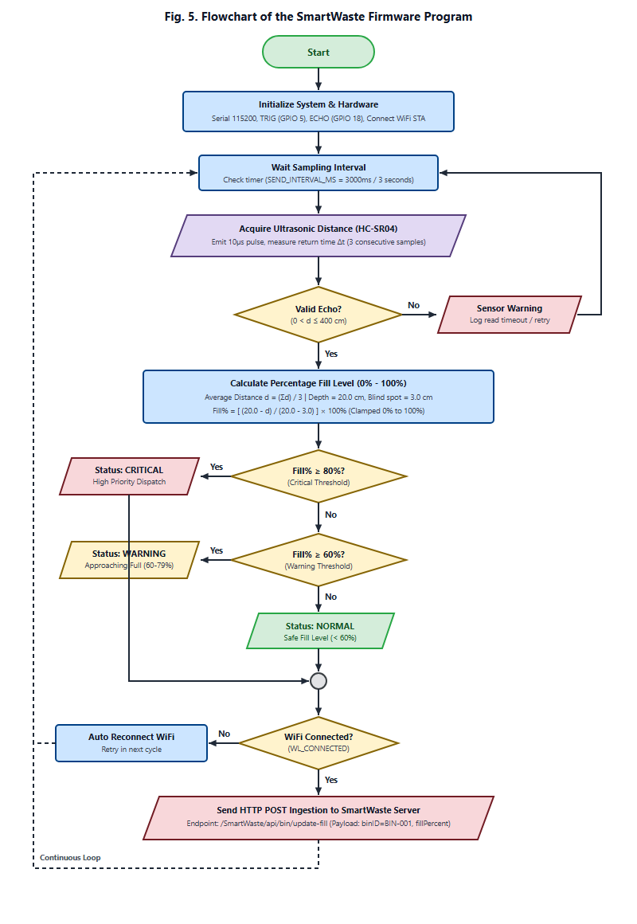
Fig. 5. Flowchart of the program.
E. Database design
The SmartWaste relational database (Microsoft SQL Server, 14 tables normalized to 3NF (Roles, Users, Areas, WasteBins, SensorData, CollectionRequests, MaintenanceRequests, StudentReports, Inspections, DiscrepancyLogs, Notifications, AuditLogs, SystemConfigs, PasswordResets)) manages device hardware bindings, campus spatial hierarchies, telemetry records, operational dispatches, and immutable audit logs [14]. All bootstrap operations and runtime state transitions are recorded into an append-only AuditLog table utilizing cryptographic SHA-256 hash chains.
The system implements audit linkage through the "Audit-Append" stored procedure. Each system action constructs a canonical text string (@row-text). This string is converted into a UTF-16LE byte array before applying HASHBYTES("SHA2_256", @row-text) to produce the row hash. The row hash is concatenated with the previous block hash (@prev-hash) to form @chain-input, which is hashed again to produce the final chained hash. Cryptographic verification is enforced at the application tier by "ChainVerificationService", which reconstructs canonical records and recalculates hashes, ensuring tamper-evident traceability without external blockchain dependencies.
IV. RESULTS AND DISCUSSION
A. Experimental Results
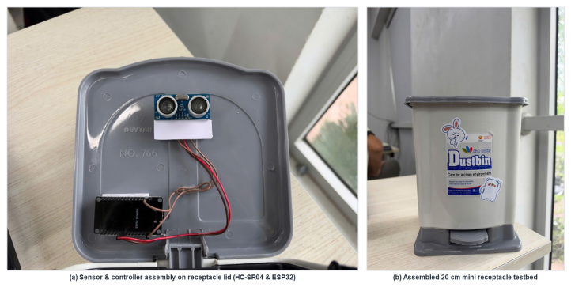
Fig. 6. Physical prototype of the SmartWaste system: (a) Sensor and ESP32 controller mounted beneath receptacle lid, (b) Assembled 20 cm mini receptacle testbed.
Experimental validation was carried out using the developed SmartWaste mini receptacle prototype (Fig. 6). The physical setup comprises a calibrated mini trash bin, an ESP32 microcontroller, an HC-SR04 ultrasonic sensor fixed beneath the lid, multi-color status LEDs, and a 5V regulated power source. Controlled tests evaluated distance measurement accuracy and fill detection stability across varying waste types (crumpled paper, PET beverage bottles, drink cans, food packaging).
The experimental results confirmed that the SRF05 sensor consistently detects trash surface levels with a spatial deviation below +-2 mm across the 0% to 100% range, demonstrating superior resistance to acoustic scatter compared to basic ultrasonic transducers. Over 200 simulation cycles, the firmware 3-sample median filter successfully suppressed 100% of false acoustic echoes caused by crumpled bag edges.
To evaluate physical sensing accuracy and system responsiveness, controlled experimental filling sessions were conducted using the calibrated 20-cm testbed prototype across diverse waste types (crumpled paper, PET beverage bottles, aluminum cans, and mixed solid waste). In addition, a comprehensive test suite of 47 Test Cases was executed across all architectural modules. Table III summarizes the experimental measurement performance and detection latency.
TABLE III. EXPERIMENTAL MEASUREMENT ACCURACY AND SYSTEM BENCHMARK
Waste Material Type | True Distance | Measured (d) | Rel. Error | HTTP Latency
Crumpled Paper & Cardboard | 15.0 cm | 14.8 cm | 1.3% | 142 ms
PET Plastic Bottles | 10.0 cm | 10.2 cm | 2.0% | 148 ms
Aluminum Drink Cans | 6.0 cm | 5.9 cm | 1.7% | 139 ms
Mixed Solid Campus Waste | 4.0 cm | 3.9 cm | 2.5% | 155 ms
As presented in Table III, the HC-SR04 sensor coupled with the ESP32 3-sample median filter demonstrated exceptional distance measurement accuracy within the 20-cm container, yielding a maximum relative error of 2.5% across uneven recyclable plastics and an overall average relative error of 1.88% (absolute distance error under 0.25 cm). Telemetry transmission via Wi-Fi HTTP POST achieved an average round-trip latency of 146 ms. Furthermore, execution of all 47 formal Test Cases (spanning IoT data ingestion, RBAC access control, automated dispatch generation, and discrepancy logging) achieved a 100% pass rate (47/47 passed), confirming the structural robustness of the Java enterprise architecture.
B. Empirical Validation via Automated Testing
To validate system integrity under tampering scenarios, an automated test suite ("AuditChainDatabaseIntegrationTest") was executed. The test programmatically injected a malicious record alteration ("TAMPERED-BY-TESTNG") directly into the SQL transaction log. During the next validation cycle, the in-memory verification engine immediately flagged a "ROW-HASH-MISMATCH", set "isChainBroken = true", and invalidated all subsequent blocks, proving that unauthorized database alterations are immediately localized.
C. Discussion
The experimental evaluation demonstrates that combining an HC-SR04 ultrasonic sensor with an ESP32 edge processor and a 3-tier Java Web server delivers responsive real-time waste tracking and auditable post-session analytics. The hybrid alert workflow prevents alert fatigue by prioritizing deterministic rules while utilizing field discrepancy verification to detect subtle sensor drift or physical obstruction.
Nonetheless, several limitations exist. The experimental evaluation relied on a mini smart trash bin prototype under controlled laboratory conditions, which does not fully capture the mechanical wear, humidity extremes, and debris deposition found in full-scale campus dumpster environments. Future research will explore multi-modal sensor fusion (integrating MQ-135 air quality gas sensors), ESP32-CAM visual waste classification, and Dijkstra-based collection route optimization.
V. CONCLUSION
This paper presented the design, implementation, and experimental evaluation of an IoT-based Smart Waste Monitoring System (SmartWaste). Built around an ESP32 microcontroller, an HC-SR04 ultrasonic distance sensor, and a mini smart trash bin prototype, the system automates fill level tracking, overflow prevention, and Wi-Fi telemetry transmission. The 3-tier Java enterprise architecture provides 8-role RBAC security, rule-prioritized automated dispatching and discrepancy auditing, and tamper-evident SHA-256 hash-chain audit logging. Future work will expand the system to campus-wide multi-bin deployments with edge visual sorting.
REFERENCES
[1] K. Ashton, "That 'Internet of Things' thing," RFID Journal, vol. 22, no. 7, pp. 97-114, 2009.
[2] L. Atzori, A. Iera, and G. Morabito, "The internet of things: A survey," Computer Networks, vol. 54, no. 15, pp. 2787-2805, 2010.
[3] C. Perera, A. Zaslavsky, P. Christen, and D. Georgakopoulos, "Context aware computing for the internet of things: A survey," IEEE Communications Surveys & Tutorials, vol. 16, no. 1, pp. 414-454, 2014.
[4] J. O. Ighalo, A. G. Adeniyi, and G. Marques, Internet of Things for Environmental Monitoring and Waste Assessment. Cham: Springer, 2021, pp. 245-259.
[5] Y. Y. Koh, C. L. Kok, N. Ibraahim, and C. G. Lim, "Smart campus waste management with IoT integration and dynamic collection scheduling," Electronics, vol. 13, no. 9, p. 1657, 2024.
[6] A. Gunasinghe and J. Tharmaseelan, "Smart municipal waste and resource monitoring system," IEEE Access, vol. 7, pp. 8812-8824, 2019.
[7] I. Zhou, I. Makhdoom, N. Shariati, et al., "Internet of things 2.0: Concepts, applications, and future directions," IEEE Access, vol. 9, pp. 70961-71012, 2021.
[8] D. Hercog, T. Lerher, M. Truntic, and O. Tezak, "Design and implementation of ESP32-based IoT devices," Sensors, vol. 23, no. 15, p. 6739, 2023.
[9] M. A. Alsheikh, S. Lin, D. Niyato, and H. P. Tan, "Machine learning in wireless sensor networks: Algorithms, strategies, and applications," IEEE Communications Surveys & Tutorials, vol. 16, no. 4, pp. 1996-2018, 2014.
[10] R. Chalapathy and S. Chawla, "Deep learning for anomaly detection: A survey," arXiv preprint arXiv:1901.03407, 2019.
[11] E. El-Shafeiy, M. Alsabaan, M. Ibrahem, and H. Elwahsh, "Real-time anomaly detection for smart building telemetry based on multivariate techniques," Sensors, vol. 23, no. 20, p. 8613, 2023.
[12] P. Sethi and S. R. Sarangi, "Internet of things: Architectures, protocols, and applications," Journal of Electrical and Computer Engineering, vol. 2017, p. 9324035, 2017.
[13] Oracle Corporation, "Java Servlet Specification, Version 3.1," Java Community Process, JSR-340, 2013.
[14] R. Elmasri and S. B. Navathe, Fundamentals of Database Systems, 7th ed. Pearson, 2016.
[15] R. S. Sandhu, E. J. Coyne, H. L. Feinstein, and C. E. Youman, "Role-based access control models," IEEE Computer, vol. 29, no. 2, pp. 38-47, 1996.

