Keywords

Place keywords here

Summary

Place summary here

References

Place references here

|  |  |  |  |  |  |  |  |
| --- | --- | --- | --- | --- | --- | --- | --- |
| Version | Date | Author | Initials | Review | Initials | Approval | Initials |
|  | jan. 2015 |  |  |  |  |  |  |
|  |  |  |  |  |  |  |  |
|  |  |  |  |  |  |  |  |

|  |
| --- |
| State  draft  This is a draft report, intended for discussion purposes only. No part of this report may be relied upon by either principals or third parties. |

Contents

1 Introduction 1

2 Processes and model formulation 2

2.1 Domain and definitions 2

2.2 Hydrodynamics options 2

2.2.1 Stationary mode 2

2.2.2 Non-stationary (surfbeat) mode 2

2.2.3 Wave resolving mode 2

2.3 Short wave propagation 3

2.3.1 Wave action balance 3

2.3.2 Dissipation 4

2.3.3 Roller energy balance 7

2.4 Shallow water equations 7

2.5 Nonhydrostatic pressure correction 7

2.6 Groundwater flow 7

2.7 Bedload transport 7

2.8 Suspended load transport 7

2.9 Bottom updating 7

2.9.1 Due to sediment fluxes 7

2.9.2 Avalanching 7

2.9.3 Bed composition 7

3 Numerical implementation 8

3.1 Grid types 8

3.1.1 1D 8

3.1.2 Rectilinear 8

3.1.3 Curvilinear 8

3.2 Wave action balance 8

3.2.1 Stationary solver 8

3.2.2 Nonstationary solver 8

3.3 Shallow water equations 8

3.4 Nonhydrostatic pressure correction 8

3.5 Advection-diffusion equation for sediment 8

3.6 Bottom updating schemes 8

3.7 Avalanching 8

3.8 Bed composition 8

4 Boundary conditions 9

4.1 Waves 9

4.1.1 Time series 9

4.1.2 Spectra 9

4.1.3 Lateral boundary conditions 9

4.2 Shallow water equations 9

4.2.1 Absorbing-generating 9

4.2.2 River and point discharge 9

4.2.3 Ship motion 9

4.2.4 Lateral boundaries 9

4.2.5 Tide and surge 9

4.3 Sediment transport 9

5 Input description 10

5.1 General 10

5.2 Grid and bathymetry 10

5.3 Wave input 10

5.4 Tide and surge input 10

5.5 Water level (dam break) 10

5.6 Wind input 10

5.7 Sediment input 10

5.8 Output selection 10

5.9 Time parameters 10

5.10 Model coefficients 10

6 Tutorial 11

6.1 1-D profile model 12

6.2 2-D area model 12

6.3 Langsgetij + riveroutflow 12

# Introduction

Dano, Ad, Ap

# Processes and model formulation

## Domain and definitions

Dano - overnemen en nieuw plaatje curvi

## Hydrodynamics options

Dano

### Stationary mode

### Non-stationary (surfbeat) mode

### Wave resolving mode

## Short wave propagation

### Wave action balance

Kees - bezig

The wave forcing in the shallow water momentum equation is obtained from a time dependent version of the wave action balance equation. Similar to Delft University’s (stationary) HISWA model (Holthuijsen et al., 1989) the directional distribution of the action density is taken into account whereas the frequency spectrum is represented by a frequency, best represented by the spectral parameter *fm-1,0*.The wave action balance is then given by:



In which the wave action *A* is calculated as:



In *θ* represents the angle of incidence with respect to the x-axis, *Sw* represents the wave energy density in each directional bin and *σ* the intrinsic wave frequency. The wave action propagation speeds in x- and y-direction are given by:



With *uL* and *vL* the cross-shore and alongshore depth-averaged Lagrangian velocities respectively (defined below), and the group velocity cg obtained from linear theory. If wave-current interaction is turned off (*wci=0*) then the last term in either equation is not taken into account. The propagation speed in θ-space is obtained from:



In *h* represents the total water depth and in this formulation bottom refraction (first term) and wave-current interaction (last two terms) are taken into account. If wave-current interaction is turned off (*wci=0*) then the last two terms are neglected.

The wave number *k* is obtained from the eikonal equations that is described in . In this formulation the subscripts refer to the direction of the wave vector components and *ω* represents the absolute radial frequency.



The wave number is then obtained from .



The absolute radial frequency *ω* is given by . The intrinsic frequency *σ* is obtained from the linear dispersion relation. If wave-current interaction is turned off (*wci=0*) then the last two terms are not taken into account.



### Dissipation

#### Breaking

Kees - bezig

There are in four different wave breaking formulations implemented in XBeach. The formulations are coded with the keyword *break*.

1. Non-stationary waves: formulation of Roelvink (1993a)
2. Stationary waves: formulation of Baldock et al. (1998)
3. Non-stationary waves: adaptation of break=1
4. Non-stationary waves: adaptation of break=1 (Daly et al. ,2010)

For the non-stationary (surf beat) approach the total wave energy dissipation, i.e. directionally integrated, due to wave breaking is modelled according to Roelvink (1993a). This is coded as *break=1*. In *α* is applied as wave dissipation coefficient, *Qb* is the fraction breaking waves, *p* stands for the water density and *γ* is the breaker index. The total wave energy *Ew* is calculated by integrating over the wave direction per directional bin.



In a variation of , one could also use the third wave breaking formulation, presented in . This formulation is somewhat different than the formulation of Roelvink (1993a). This is coded as *break=3.*



On top of that, Daly et al. (2010) developed a formulation presented in , which states that waves are fully breaking if the wave height exceeds a threshold (*γ*) and stop breaking if the wave height fall below another threshold (*γ2*). This is coded as *break=4*.



In the stationary case Baldock et al. (1998) is applied, which is presented in . In this breaking formulation the fraction breaking waves *Qb* and breaking wave height *Hb* is calculated differently compared to the breaking formulations used for the non-stationary situation. In *α* is applied as wave dissipation coefficient, *frep* represents a representative intrinsic frequency and *y* is a calibration factor. The stationary wave breaking formulation is coded with *break=4*.



In either the non-stationary or stationary case the total wave dissipation is distributed proportionally over the wave directions with the formulation in .



#### Bottom friction

Kees

#### Vegetation

Arnold

### Roller energy balance

Dano

## Shallow water equations

Kees

## Nonhydrostatic pressure correction

Robert

## Groundwater flow

Kees/Robert

## Bedload transport

Kees + Lodewijk

## Suspended load transport

Kees + Lodewijk

## Bottom updating

### Due to sediment fluxes

Kees

### Avalanching

Kees + Pieter

### Bed composition

Bas

# Numerical implementation

Dano behalve 3.4,3.8

## Grid types

### 1D

### Rectilinear

### Curvilinear

## Wave action balance

### Stationary solver

### Nonstationary solver

## Shallow water equations

## Nonhydrostatic pressure correction

Robert

## Advection-diffusion equation for sediment

## Bottom updating schemes

## Avalanching

## Bed composition

Bas

# Boundary conditions

## Waves

### Time series

Kees, Ap review

### Spectra

Kees, Ap review

### Lateral boundary conditions

Dano

## Shallow water equations

### Absorbing-generating

Ap met appendix

### River and point discharge

Bas

### Ship motion

Dano

### Lateral boundaries

Kees

### Tide and surge

Kees

## Sediment transport

Dano

# Input description

Bas - params en attribute files

## General

Files: params

## Grid and bathymetry

Files: Xbeach + Delft3D, prescribed bedfile

## Wave input

Files: Jonswap, vardens, SWAN, wbcversion=3, FILELIST, more?

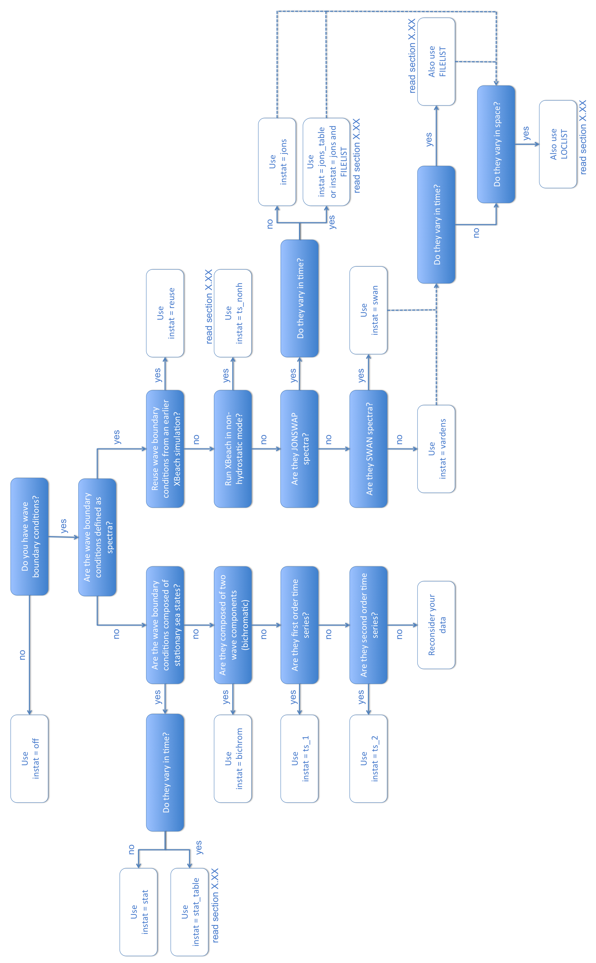

## Tide and surge input

Files: timeseries

## Water level (dam break)

Files: timeseries

## Wind input

Files: timeseries

## Sediment input

Files: fractions, layers

## Vegetation input

Files: species, maps

## Discharge input

Files: timeseries

## Ship input

Files: timeseries

## Output selection

Files: output

## Time parameters

## Model coefficients

# Bibliography

Holthuijsen, L., Booij, N., & Herbers, T. (1989). A prediction model for stationary, short-crested waves in shallow water with ambient currents. Coastal Engineering, 13(1):23-54.

Roelvink, J.A. (1993a) Dissipation in random wave groups incident on a beach. Coastal Engineering, pp. 127-150.

Roelvink, J.A. (1993b) Surf beat and its effect on cross-shore profiles. Ph.D. Thesis, Delft University of Technology.

Daly, C., Roelvink, J. A., Van Dongeren, A., Van Thiel de Vries, J. S. M., & McCall, R. (2010). Short wave breaking effects on low frequency waves. Proceedings of 32nd International Conference on Coastal Engineering, (1), 1–13.

# Tutorial

Nog niet verdeeld. Later nog in te vullen.

## 1-D profile model

Delfland Deltagoot

## 2-D area model

Ocean bay park: getij+surge, baai, duin, nonerodible, overwash, collision,

## Langsgetij + riveroutflow

getijmodel + rivier + stationair.