S13/02982/23. - Elvis Marube
COMP 231: FUNDERMENTALS OF CYBER SECURITY.
PRACTICAL 1.
PART A: A PROGRAM TO CONVERT A MESSAGE FROM PLAIN TEXT TO CIPHER TEXT AND VICE VERSA USING CEASAR METHOD.
Introduction.
The Caesar Cipher is one of the simplest and oldest methods of encrypting messages, named after Julius Caesar, who reportedly used it to protect his military communications. This technique involves shifting the letters of the alphabet by a fixed number of places. For example, with a shift of three, the letter ‘A’ becomes ‘D’, ‘B’ becomes ‘E’, and so on. Despite its simplicity, the Caesar Cipher formed the groundwork for modern cryptographic techniques.
How Ceasar Method Works.
The Caesar cipher is a simple symmetric encryption technique that shifts the letters in the plaintext message by a certain number of positions, known as the “shift” or “key”. Thus to cipher a given text we need an integer value, known as a key which indicates the number of positions each letter of the text has been moved down. -
Example:
Below is an example of a Program in Python to convert a message from plain text to cipher text:
def caesar_cipher(text, key, encrypt=True):
result = " "
for char in text:
if char.isalpha(): # Only encrypt letters
shift = key if encrypt else -key
base = ord('A') if char.isupper() else ord('a')
new_char = chr((ord(char) - base + shift) % 26 + base)
result += new_char.lower() # Convert all letters to lowercase
return result # Spaces are removed

# Define the key
key = 17

# Original message
message = "I Promise to attend all lectures so that I can pass all my exams."
print(key);
# Encrypt the message
encrypted_text = caesar_cipher(message, key, encrypt=True)
print("Encrypted message:", encrypted_text)

# Decrypt the message
decrypted_text = caesar_cipher(encrypted_text, key, encrypt=False)
print("Decrypted message:", decrypted_text)

Output.
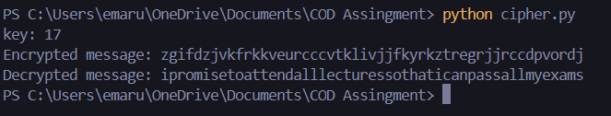
As you can see, this is the output for the code above, which demonstrates the Ceasar method of asymmetric encryption. It has pushed each letter by 17 shifts.
Advantages
- Easy to implement and use thus, making it suitable for beginners to learn about encryption.
- Can be physically implemented, such as with a set of rotating disks or a set of cards, known as a scytale, which can be useful in certain situations.
- Requires only a small set of pre-shared information.
- Can be modified easily to create a more secure variant, such as by using multiple shift values or keywords.
Disadvantages
- It is not secure against modern decryption methods.
- Vulnerable to known-plaintext attacks, where an attacker has access to both the encrypted and unencrypted versions of the same messages.
- The small number of possible keys means that an attacker can easily try all possible keys until the correct one is found, making it vulnerable to a brute force attack.
- It is not suitable for long text encryption as it would be easy to crack.
- It is not suitable for secure communication as it is easily broken.
- Does not provide confidentiality, integrity, and authenticity in a message.

PART B: REPORT WRITING FOR PRACTICAL SESSION ON FRIDAY.
In the Practical session on Friday, our instructor Mr. Richard demonstrated to us a project that consists of two hands-on cybersecurity practicals:
1. **Ransomware Simulation** – Encrypt and decrypt image files using a generated key.
2. **Password Hashing & Cracking** – Hash passwords and attempt to crack weak ones using John the Ripper.

1. Ransomware Simulation
Folder Structure:
Ransom/
├── encrypt_files.py
├── decrypt_files.py
├── generate_key.py
└── secret.key (Generated automatically)
Step 1: Install Dependencies
I had Python installed, and then I installed the required cryptography library using the command:
```
pip install cryptography
```
Step 2: Generate Encryption Key
I run the following command to generate a secret key:
```
python generate_key.py
```
This create a `secret.key` file, which is required for encryption and decryption.

Step 3: Encrypt Image Files
Place some `.jpg` or `.png` files in the `Ransom/` folder, then run:
```bash
python encrypt_files.py
```
Expected Outcome: The images will be encrypted and will no longer open properly.
Step 4: Decrypt Image Files
To restore the encrypted files, run:
```bash
python decrypt_files.py
```
Expected Outcome:nThe images were restored to their original state.

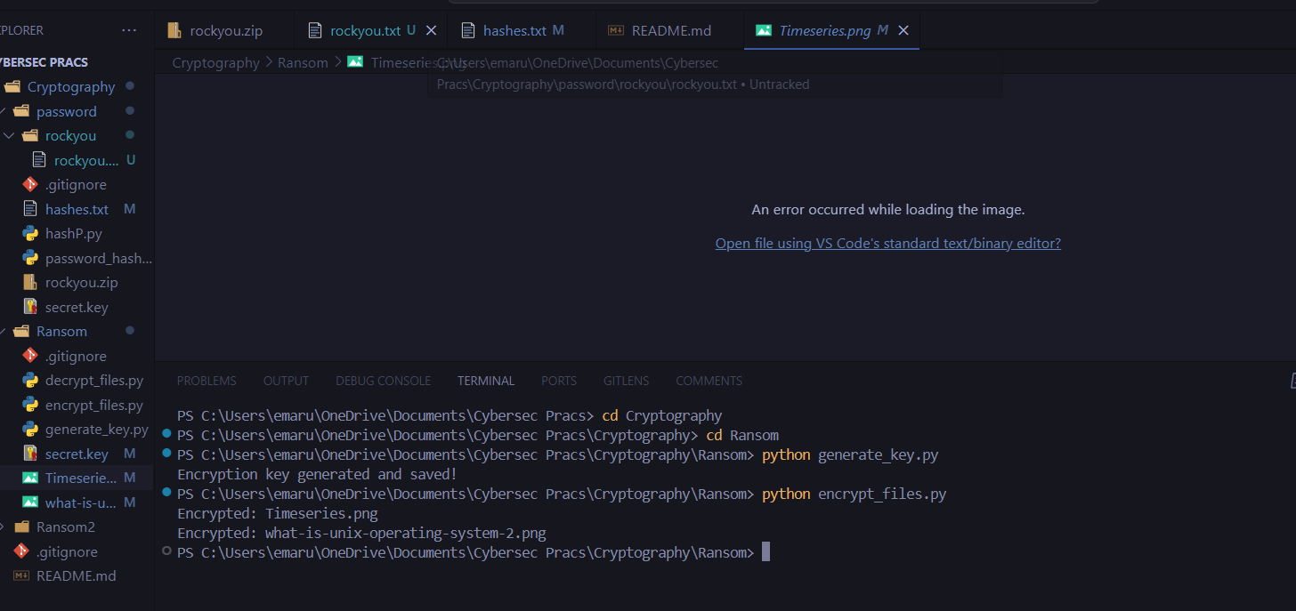
As seen in the image above, Timesseries.png and what-is-unix-operating system-2.png were encrypted and the message displayed on the screen was “An error occurred while loading the image.”

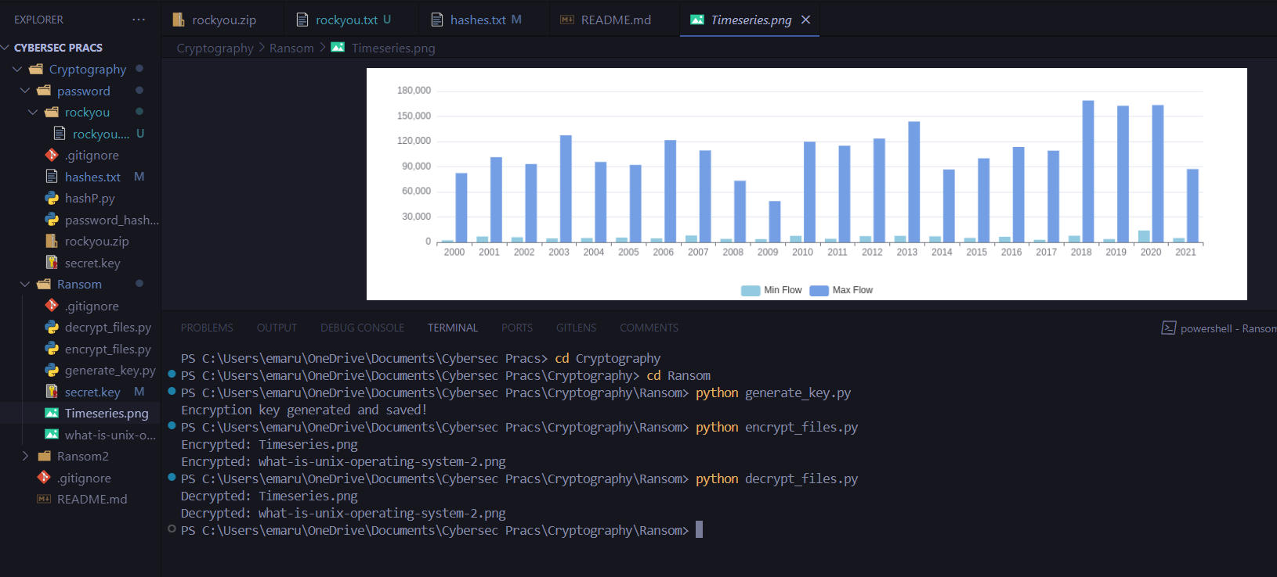
As seen in the image above, Timesseries.png and what-is-unix-operating system-2.png are now decrypted and the image of Timeseries.png is now shown on the screen.
## **2. Password Hashing & Cracking Using John the Ripper**
**Folder Structure:
Passwords/
├── password_hash.py
├── hashp.py
├── hashes.txt
├── rockyou.txt (Wordlist for cracking, extract first from zip)
Extracting rockyou.txt
Before starting, I extracted the rock.txt file which was approximately 133 MB.
### **Step 1: Install John the Ripper**
I Installed John the Ripper on your system (which uses Windows) but it gave me errors I don’t know why:
```bash
# Windows (Using Chocolatey)
choco install john
```
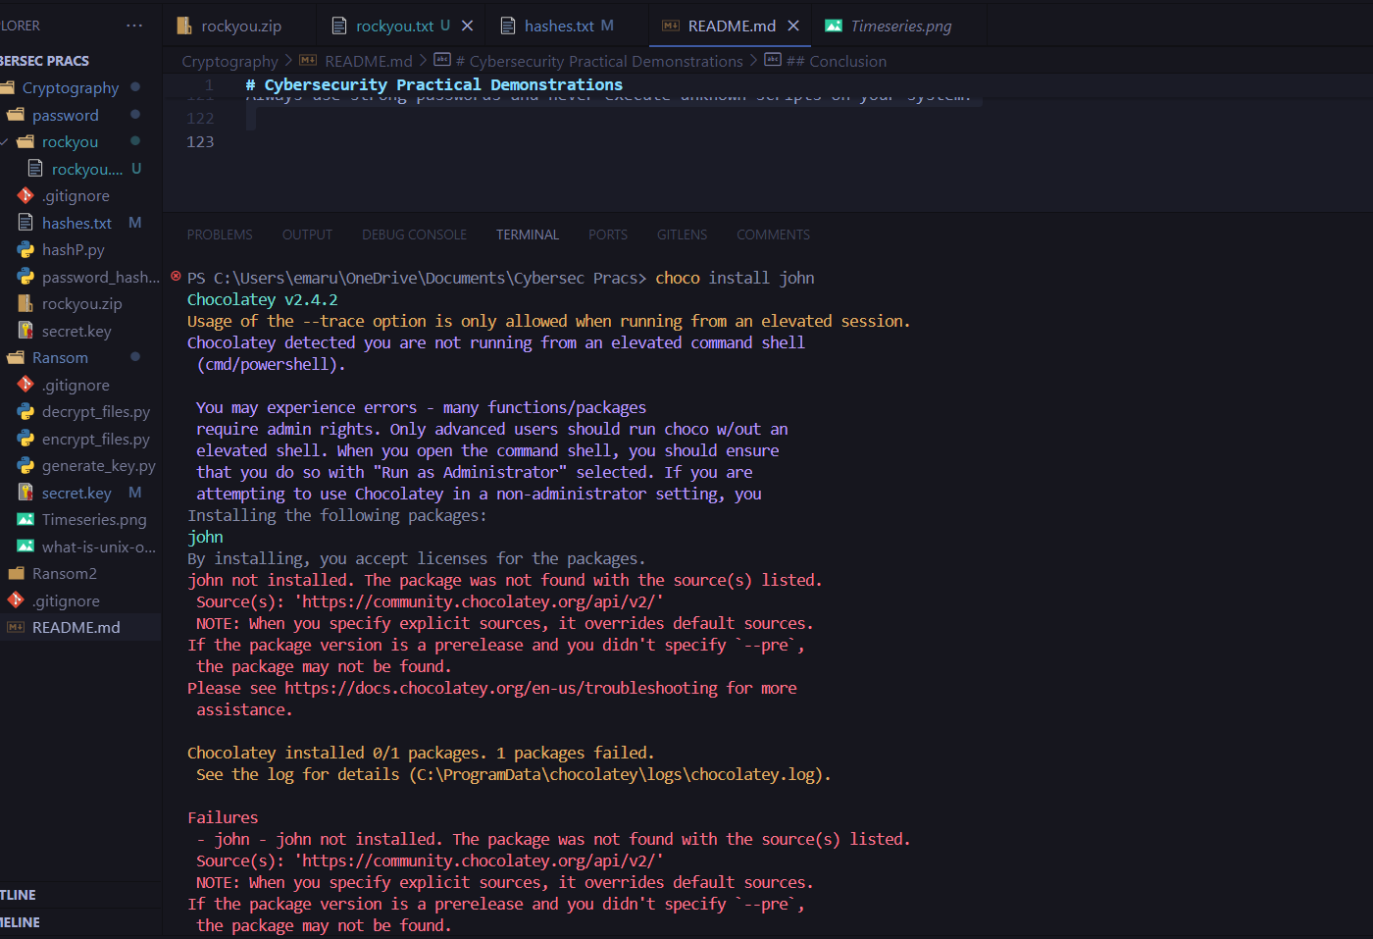
### **Step 2: Hash a Password (Basic Example)**
Run the Python script to hash a password using SHA-256:
```bash
python hashp.py
‘’’
Copy the generated hash and try checking it on online hash lookup databases.
example: [CrackStation](https://crackstation.net/)
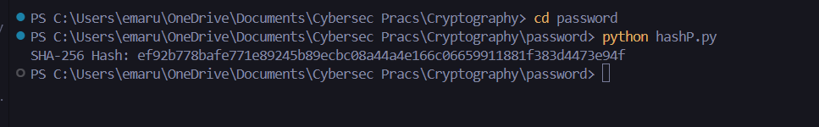
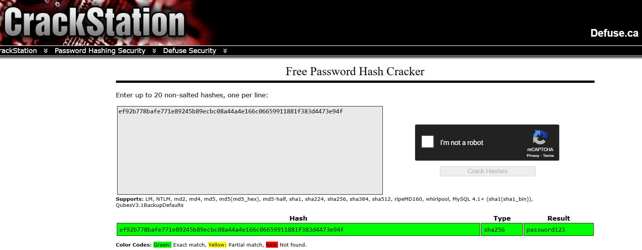
The following was the generated original password which was “password123” from the generated hashed and they matched.
### **Step 3: Hash a Password for Cracking**
I run the following script to generate a hash and saved it to `hashes.txt`:
```bash
python password_hash.py
```
Copy the generated hash and save it into `hashes.txt`.
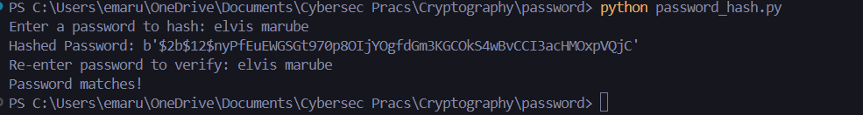
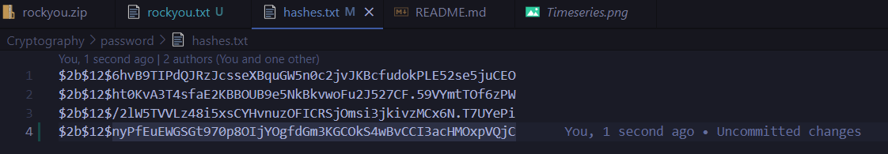

Step 4: Crack the Hashed Password
Ensure `rockyou.txt` (password wordlist) is in the same folder, then run:
```bash
john --format=bcrypt --wordlist=rockyou.txt hashes.txt
```
If the password exists in the wordlist, John will crack it.

### **Step 5: View Cracked Password**
To display the cracked password, run:
```bash
john --show hashes.txt
```
---
## **Conclusion**
These demonstrations provide practical insights into cybersecurity threats:
- **Ransomware Simulation:** Shows how attackers encrypt files and demand a ransom.
- **Password Cracking:** Demonstrates the importance of strong passwords by cracking weak hashes.
- **Basic Password Hashing:** Highlights how passwords are stored securely and how weak ones can still be compromised.
Always use strong passwords and never execute unknown scripts on your system!

