Executive Summary: Loan approval analysis:

Investigating potential bias in loan approval rates

Objective
This analysis was conducted to evaluate if there is bias in loan approvals based on education and self-employment status, controlling for CIBIL score and annual income. The objective was to uncover if educated and/or self-employed loan applicants were favoured more than their counterparts.

Key Findings
- When controlling for CIBIL score and income, there is no significant difference between the approval rates of applicants who are graduates (62.45%) and non-graduates (61.98%) and/or applicants who are self-employed (62.23%) and not self-employed (62.2%).

- Loan applicants with a CIBIL score of less than 550 (45% of all applicants) only experienced an approval rate of 10.36%. While applicants with a higher CIBIL score had a 99.48% approval rate. An applicant's creditworthiness significantly influences their loan approval rate more than their education or self-employment status.

- When zooming in on applicants with a low CIBIL score (<550), we have found that applicants with short-term loans (<4 years) have a 52.41% approval rate. While no applicants with longer loan terms (>4 years) had their loans approved. This may suggest that applicants who apply for smaller loans get approved more often.

Deeper Insights
#Applicants by education and employment status
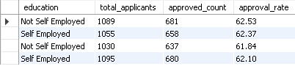
#Applicants by CIBIL scores
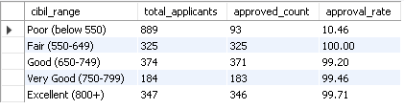
# Applicants with low CIBIL scores
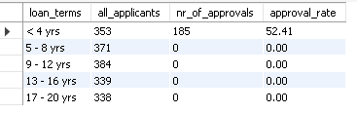

Conclusion
These findings confirm that loan approvals are significantly driven by the creditworthiness of applicants, not necessarily education status or self-employed status. For applicants with low CIBIL scores to increase their chances of being approved for loans, they should aim to apply for small loans or short-term, high-value loans. Ultimately, the data shows loan-performance-based categories such as CIBIL score and loan term are what influence an individual's chances of getting a loan approved the most.

