README

The purpose of the current project is to classify hand gestures into characters in American sign language. The brief procedure of our algorithm is illustrated in Fig. 2.

**Fig. 1** [**American Sign Language**](https://www.amazon.com/Gerard-Aflague-Collection-American-Language/dp/B076JTXSYG)

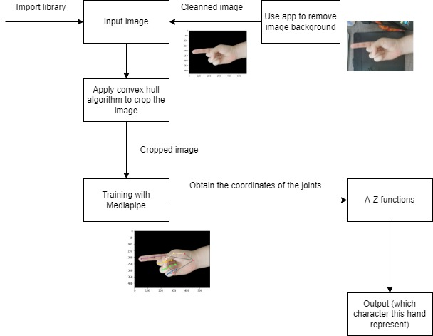

**Fig. 2 Program Flowchart**

**Step 1: Input**

The input for our code should be a hand image with its background cleaned. Our team members capture those hand images using their own hands, and we apply several methods to remove the background.

**The hand should have its palm facing toward the screen and its finger pointing to the left.**

**Fig. 3 Sample inputs**

Another kind of input is the 2d images converted from xyzm (3D file) using MATLAB. Using this input, you can also obtain the z coordinate data of every point on hand from xyzm. Currently, we are not using z data in our algorithm.

**Fig. 4 2D outputs from xyzm file**

**Background removal:**

We use a manual method to obtain a cleaned hand image to remove the background. This includes using some apps such as photoshop, PPT to achieve the goal.

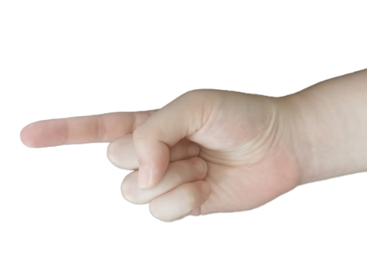

**Fig. 5 Original photo and cleaned photo**

Also, if you are using the 2D images generated from xyzm files, you can apply masking in MATLAB to clean the image. Mask is an array that contains only 0 and 1.

**Fig. 6 Mask and image covered with the mask**

**Step 2: Training**

We use the Mediapipe library to find the landmark of a hand. The output for training can be shown in

At every point on the hand landmark, we assign a number to it according to figure 8. After training, the training step will find the x and y coordinates of all those points(joints).

**Fig. 7 Hand with landmark**

**Fig. 8** [**Landmark label**](https://google.github.io/mediapipe/solutions/hands)

**Step 3: Find the relative position**

Given the coordinate of the joints, we can find their relative position to figure out how fingers are oriented. For example, the figure below is illustrating a ‘P’ hand. It can be observed that points 5-8 are on index fingers. Point 8 has smaller x coordinates than point 7, and point 7 has smaller x coordinates than point 6, etc. Based on this, we can find all different fingers’ positions and compositions to distinguish different gestures.

**Fig. 9 P Hand**

**Step 4: Test the hand**

We have finished writing all 26 characters’ functions, calling them will using the points(joints) coordinates to distinguish the character a gesture is representing. However, those functions have many limitations, such as the angles of how a hand is taken. So they are still under modification.