Question 1:

import java.util.Scanner;

public class PF_Calculator {

public static void main(String[] args) {

double TotalPF,emp_contr,emplr_contr ;

Scanner scanner = new Scanner(System.*in*);

// Read Monthly Income and AgeOfEmp data

System.*out*.println("Enter Basic Salary of the Employee:");

double MonthlyIncome = scanner.nextDouble();

System.*out*.println("Enter Age of the Employee:");

int AgeOfEmp = scanner.nextInt();

// Calculate contributions based on age

if(AgeOfEmp<=50) {

emp_contr = .15 * MonthlyIncome;

emplr_contr = .125 * MonthlyIncome;

}

else if (AgeOfEmp > 50 && AgeOfEmp <=60) {

emp_contr = .125 * MonthlyIncome;

emplr_contr = .10 * MonthlyIncome;

}

else {

emp_contr = .10 * MonthlyIncome;

emplr_contr = .075 * MonthlyIncome;

}

// Calculate and print TotalPF

TotalPF=emp_contr+emplr_contr;

System.*out*.println("Enmployee's contribution is:" +emp_contr);

System.*out*.println("Enmployer's contribution is:" +emplr_contr);

System.*out*.println("Total PF is " +TotalPF);

}

}

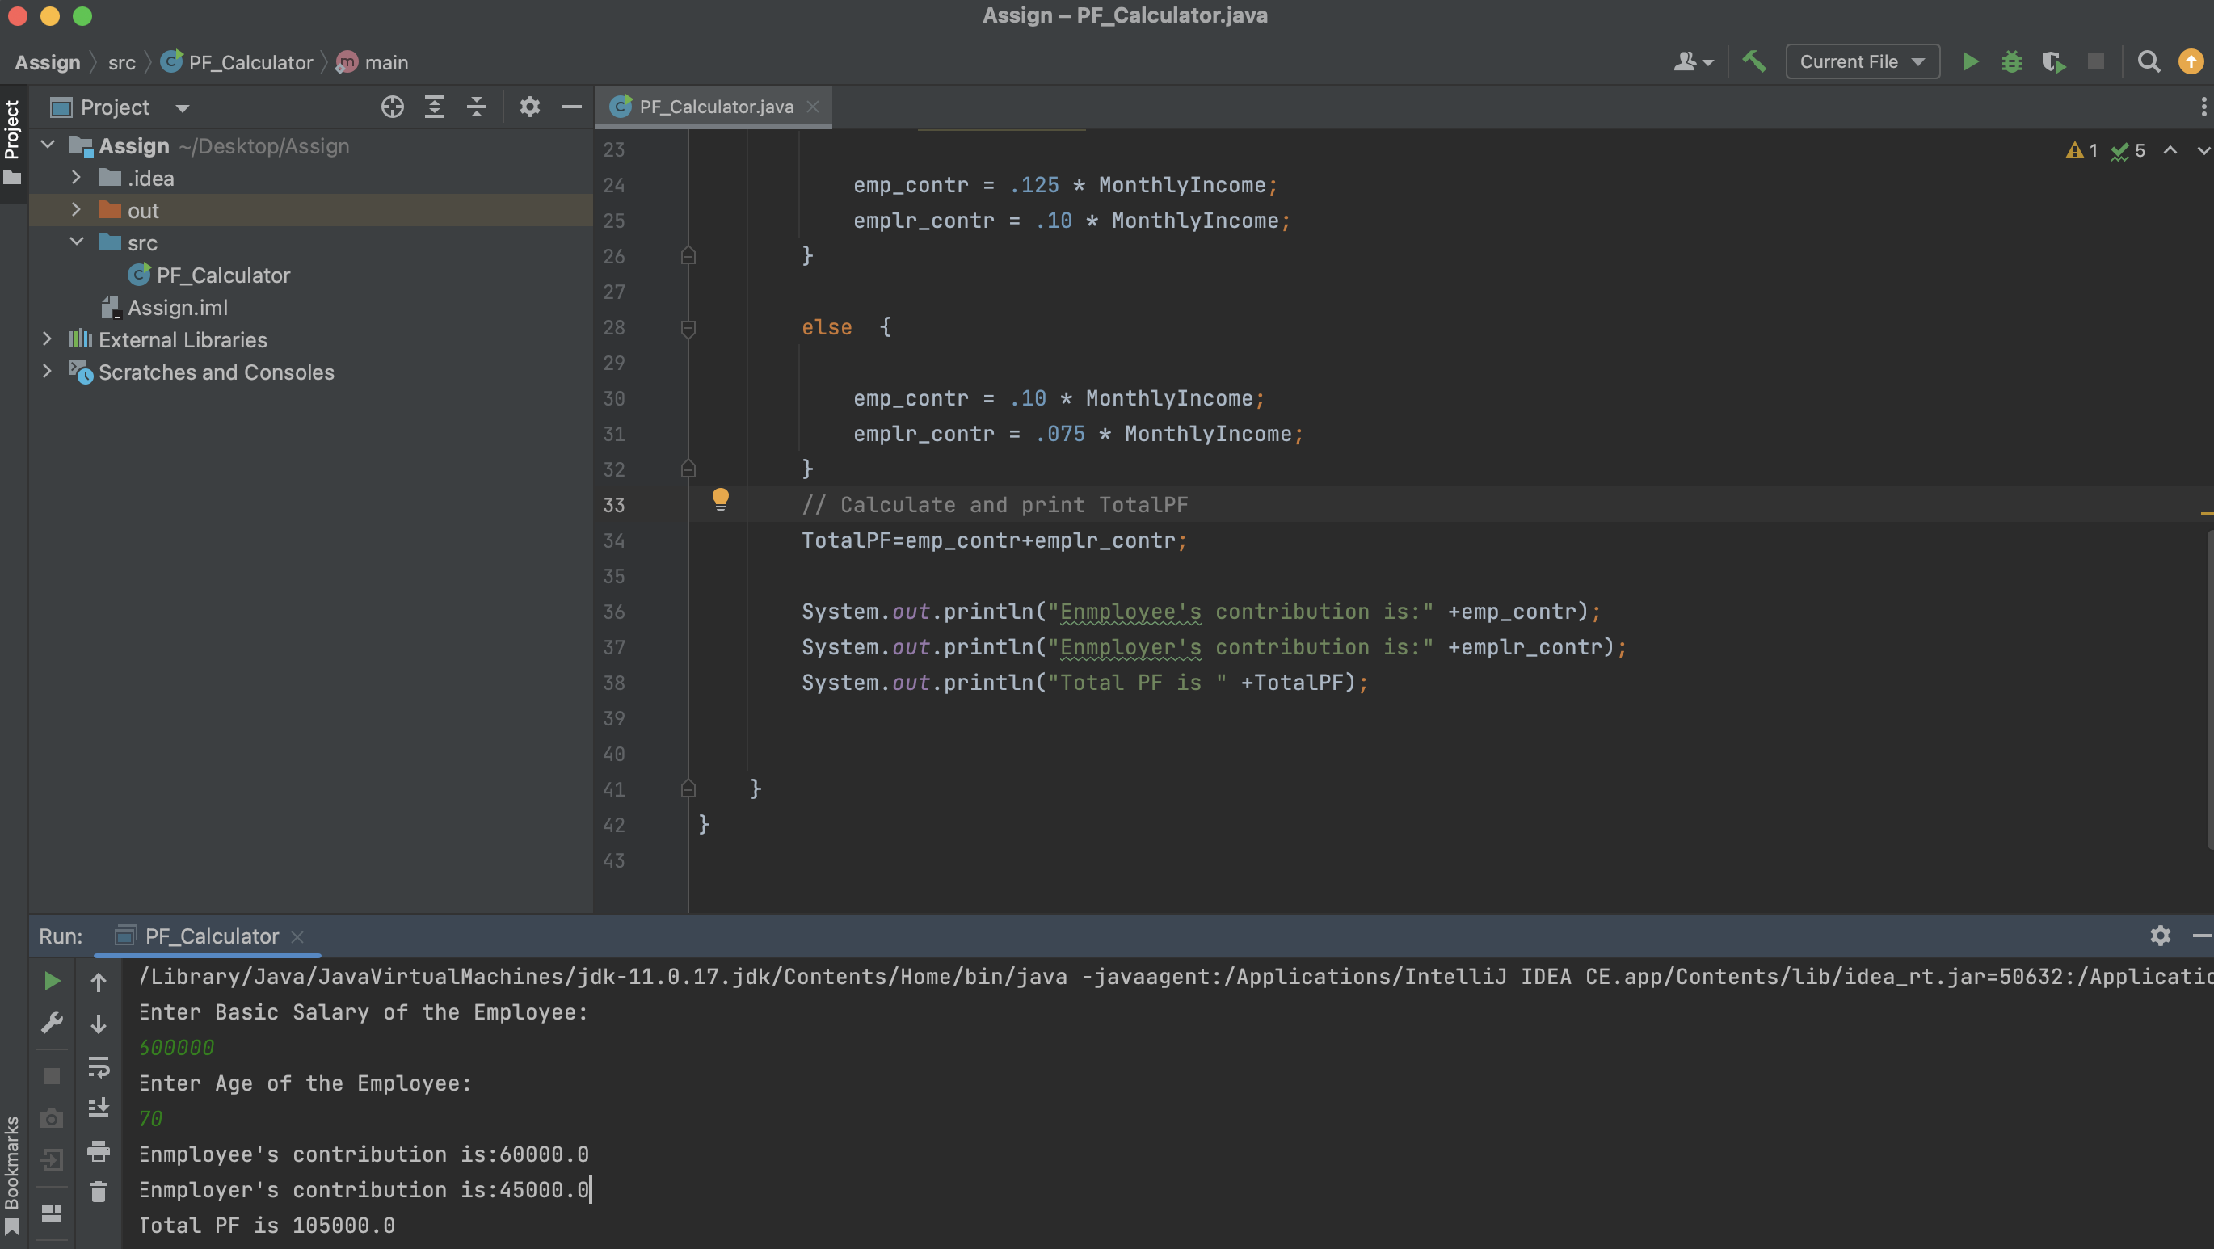

Question 2:

class CountVowelsPercentage:

def __init__(self):

self.input_data = ""

def read_input(self):

self.input_data = input("Enter a string containing characters and digits: ")

def count_vowels_percentage(self):

vowels = "AEIOUaeiou"

total_characters = len(self.input_data)

count_vowel = 0

for char in self.input_data:

if char in vowels:

count_vowel = count_vowel+1

if total_characters > 0:

percentage = (count_vowel / total_characters) * 100

else:

percentage = 0

return round(percentage, 2)

# Create an instance of the class

counter = CountVowelsPercentage()

# Read input from the console

counter.read_input()

# Count and print the percentage of vowels with 2 decimal places

percentage = counter.count_vowels_percentage()

print(f"Percentage of vowels in the input: {percentage:.2f}%")

Question 3:

import org.openqa.selenium.By;

import org.openqa.selenium.WebDriver;

import org.openqa.selenium.WebElement;

import org.openqa.selenium.chrome.ChromeDriver;

import org.openqa.selenium.chrome.ChromeOptions;

public class FreeCRMLogin{

public static void main(String[] args) {

// Set the path of ChromeDriver

System.setProperty("webdriver.chrome.driver",   
" D:\\Drivers\\chromedriver.exe ");

// Create a Chrome driver

ChromeOptions options = new ChromeOptions();

options.addArguments("--start-maximized"); // Maximize the browser window

WebDriver driver = new ChromeDriver(options);

// Navigate to the FreeCRM website

driver.get("https://www.freecrm.com/");

// Click on the Login button

WebElement loginButton = driver.findElement(By.xpath("//a[@title='Log In']"));

loginButton.click();

// Enter Invalid User Name and Password and click on Login button

WebElement usernameInput = driver.findElement(By.xpath("//input[@name='email']"));

WebElement passwordInput = driver.findElement(By.xpath("//input[@name='password']"));

WebElement loginButton2 = driver.findElement(By.xpath("//div[@class='ui fluid large blue submit button']"));

usernameInput.sendKeys("invalid_username");

passwordInput.sendKeys("invalid_password");

loginButton2.click();

// Verify that the Invalid error message is displayed

WebElement errorMessage = driver.findElement(By.xpath("//div[@class='ui negative message']"));

String errorText = errorMessage.getText();

if (errorText.contains("Invalid login. Please try again.")) {

System.out.println("Test case passed: Invalid error message is displayed.");

} else {

System.out.println("Test case failed: Invalid error message is not displayed.");

}

// Close the browser

driver.quit();

}

}

Question 4:

import org.openqa.selenium.By;

import org.openqa.selenium.WebDriver;

import org.openqa.selenium.WebElement;

import org.openqa.selenium.chrome.ChromeDriver;

import org.openqa.selenium.chrome.ChromeOptions;

public class FreeCRMTest {

public static void main(String[] args) {

// Set the path of ChromeDriver System.setProperty("webdriver.chrome.driver", " D:\\Drivers\\chromedriver.exe ");

// Create a Chrome driver

ChromeOptions options = new ChromeOptions();

options.addArguments("--start-maximized");

WebDriver driver = new ChromeDriver(options);

// Navigate to the FreeCRM website

driver.get("https://www.freecrm.com/");

// Click on the Login button

WebElement loginButton = driver.findElement(By.xpath("//a[@title='Log In']"));

loginButton.click();

// Click on the Signup button

WebElement signupButton = driver.findElement(By.xpath("//a[@title='Sign Up']"));

signupButton.click();

// Enter a dummy email address

WebElement emailInput = driver.findElement(By.xpath("//input[@name='email']"));

emailInput.sendKeys("dummy@example.com");

// Click on the "I'm not a robot" checkbox   
 WebElement captchaCheckbox = driver.findElement(By.xpath("//div[@class='recaptcha-checkbox-checkmark']"));

captchaCheckbox.click();

// Click on the Signup button

WebElement signupButton2 = driver.findElement(By.xpath("//input[@id='submitButton']"));

signupButton2.click();

// Verify that the error message is displayed

WebElement errorMessage = driver.findElement(By.xpath("//div[@class='ui message error']"));

String errorText = errorMessage.getText();

if (errorText.contains("Please accept the terms to continue.")) {

System.out.println("Testcase passed: Error message is displayed.");

} else {

System.out.println("Testcase failed: Error message is not displayed.");

}

// Close the browser

driver.quit();

}

}

Question 5:

Create a TestNG suite file (TestNG.xml) to configure and run the test cases

<!DOCTYPE suite SYSTEM "<http://testng.org/testng-1.0.dtd>">

<suite name="TestSuite">

<parameter name="browser" value="chrome" />

<test name="Program3TestCase">

<classes>

<class name="com.example. Program3Test " />

</classes>

</test>

<test name=" Program4TestCase">

<classes>

<class name="com.example. Program4Test />

</classes>

</test>

</suite>

Create Separate Test Classes for Question 3 and 4

import org.openqa.selenium.By;

import org.openqa.selenium.WebDriver;

import org.openqa.selenium.WebElement;

import org.openqa.selenium.chrome.ChromeDriver;

import org.testng.annotations.*;

public class Program3Test {

WebDriver driver;

String baseURL = "<https://www.freecrm.com/>";

@BeforeClass

public void setup() {

System.setProperty("webdriver.chrome.driver", "path_to_chromedriver.exe");

driver = new ChromeDriver();

driver.get(baseURL);

}

@Test

public void program3Test{

WebElement loginButton = driver.findElement(By.xpath("//a[@title='Log In']"));

loginButton.click();

WebElement usernameInput = driver.findElement(By.xpath("//input[@name='email']"));

WebElement passwordInput = driver.findElement(By.xpath("//input[@name='password']"));

WebElement loginButton2 = driver.findElement(By.xpath("//div[@class='ui fluid large blue submit button']"));

usernameInput.sendKeys("invalid_username");

passwordInput.sendKeys("invalid_password");

loginButton2.click();

WebElement errorMessage = driver.findElement(By.xpath("//div[@class='ui negative message']"));

String errorText = errorMessage.getText();

if (errorText.contains("Invalid login. Please try again.")) {

System.out.println("Test case passed: Invalid error message is displayed.");

} else {

System.out.println("Test case failed: Invalid error message is not displayed.");

}

}

@AfterClass

public void teardown() {

driver.quit();

}

}

import org.openqa.selenium.By;

import org.openqa.selenium.WebDriver;

import org.openqa.selenium.WebElement;

import org.openqa.selenium.chrome.ChromeDriver;

import org.testng.annotations.*;

public class Program4Test {

WebDriver driver;

String baseURL = "<https://www.freecrm.com/>";

@BeforeClass

public void setup() {

System.setProperty("webdriver.chrome.driver", "path_to_chromedriver.exe");

driver = new ChromeDriver();

driver.get(baseURL);

}

@Test

public void program4Test () {

WebElement loginButton = driver.findElement(By.xpath("//a[@title='Log In']"));

loginButton.click();

// Click on the Signup button

WebElement signupButton = driver.findElement(By.xpath("//a[@title='Sign Up']"));

signupButton.click();

// Enter a dummy email address

WebElement emailInput = driver.findElement(By.xpath("//input[@name='email']"));

emailInput.sendKeys("dummy@example.com");

// Click on the "I'm not a robot" checkbox   
 WebElement captchaCheckbox = driver.findElement(By.xpath("//div[@class='recaptcha-checkbox-checkmark']"));

captchaCheckbox.click();

// Click on the Signup button

WebElement signupButton2 = driver.findElement(By.xpath("//input[@id='submitButton']"));

signupButton2.click();

// Verify that the error message is displayed

WebElement errorMessage = driver.findElement(By.xpath("//div[@class='ui message error']"));

String errorText = errorMessage.getText();

if (errorText.contains("Please accept the terms to continue.")) {

System.out.println("Testcase passed: Error message is displayed.");

} else {

System.out.println("Testcase failed: Error message is not displayed.");

}

}

@AfterClass

public void teardown() {

driver.quit();

}

}

**Question 6**

**Question 7**

Question 8:

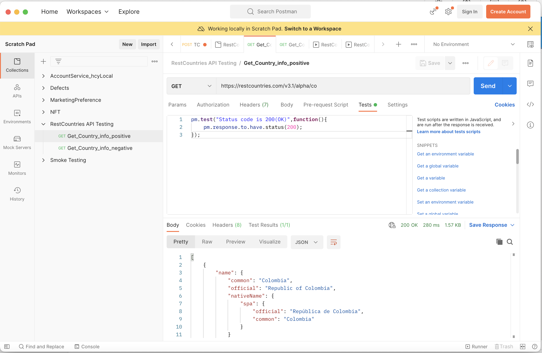

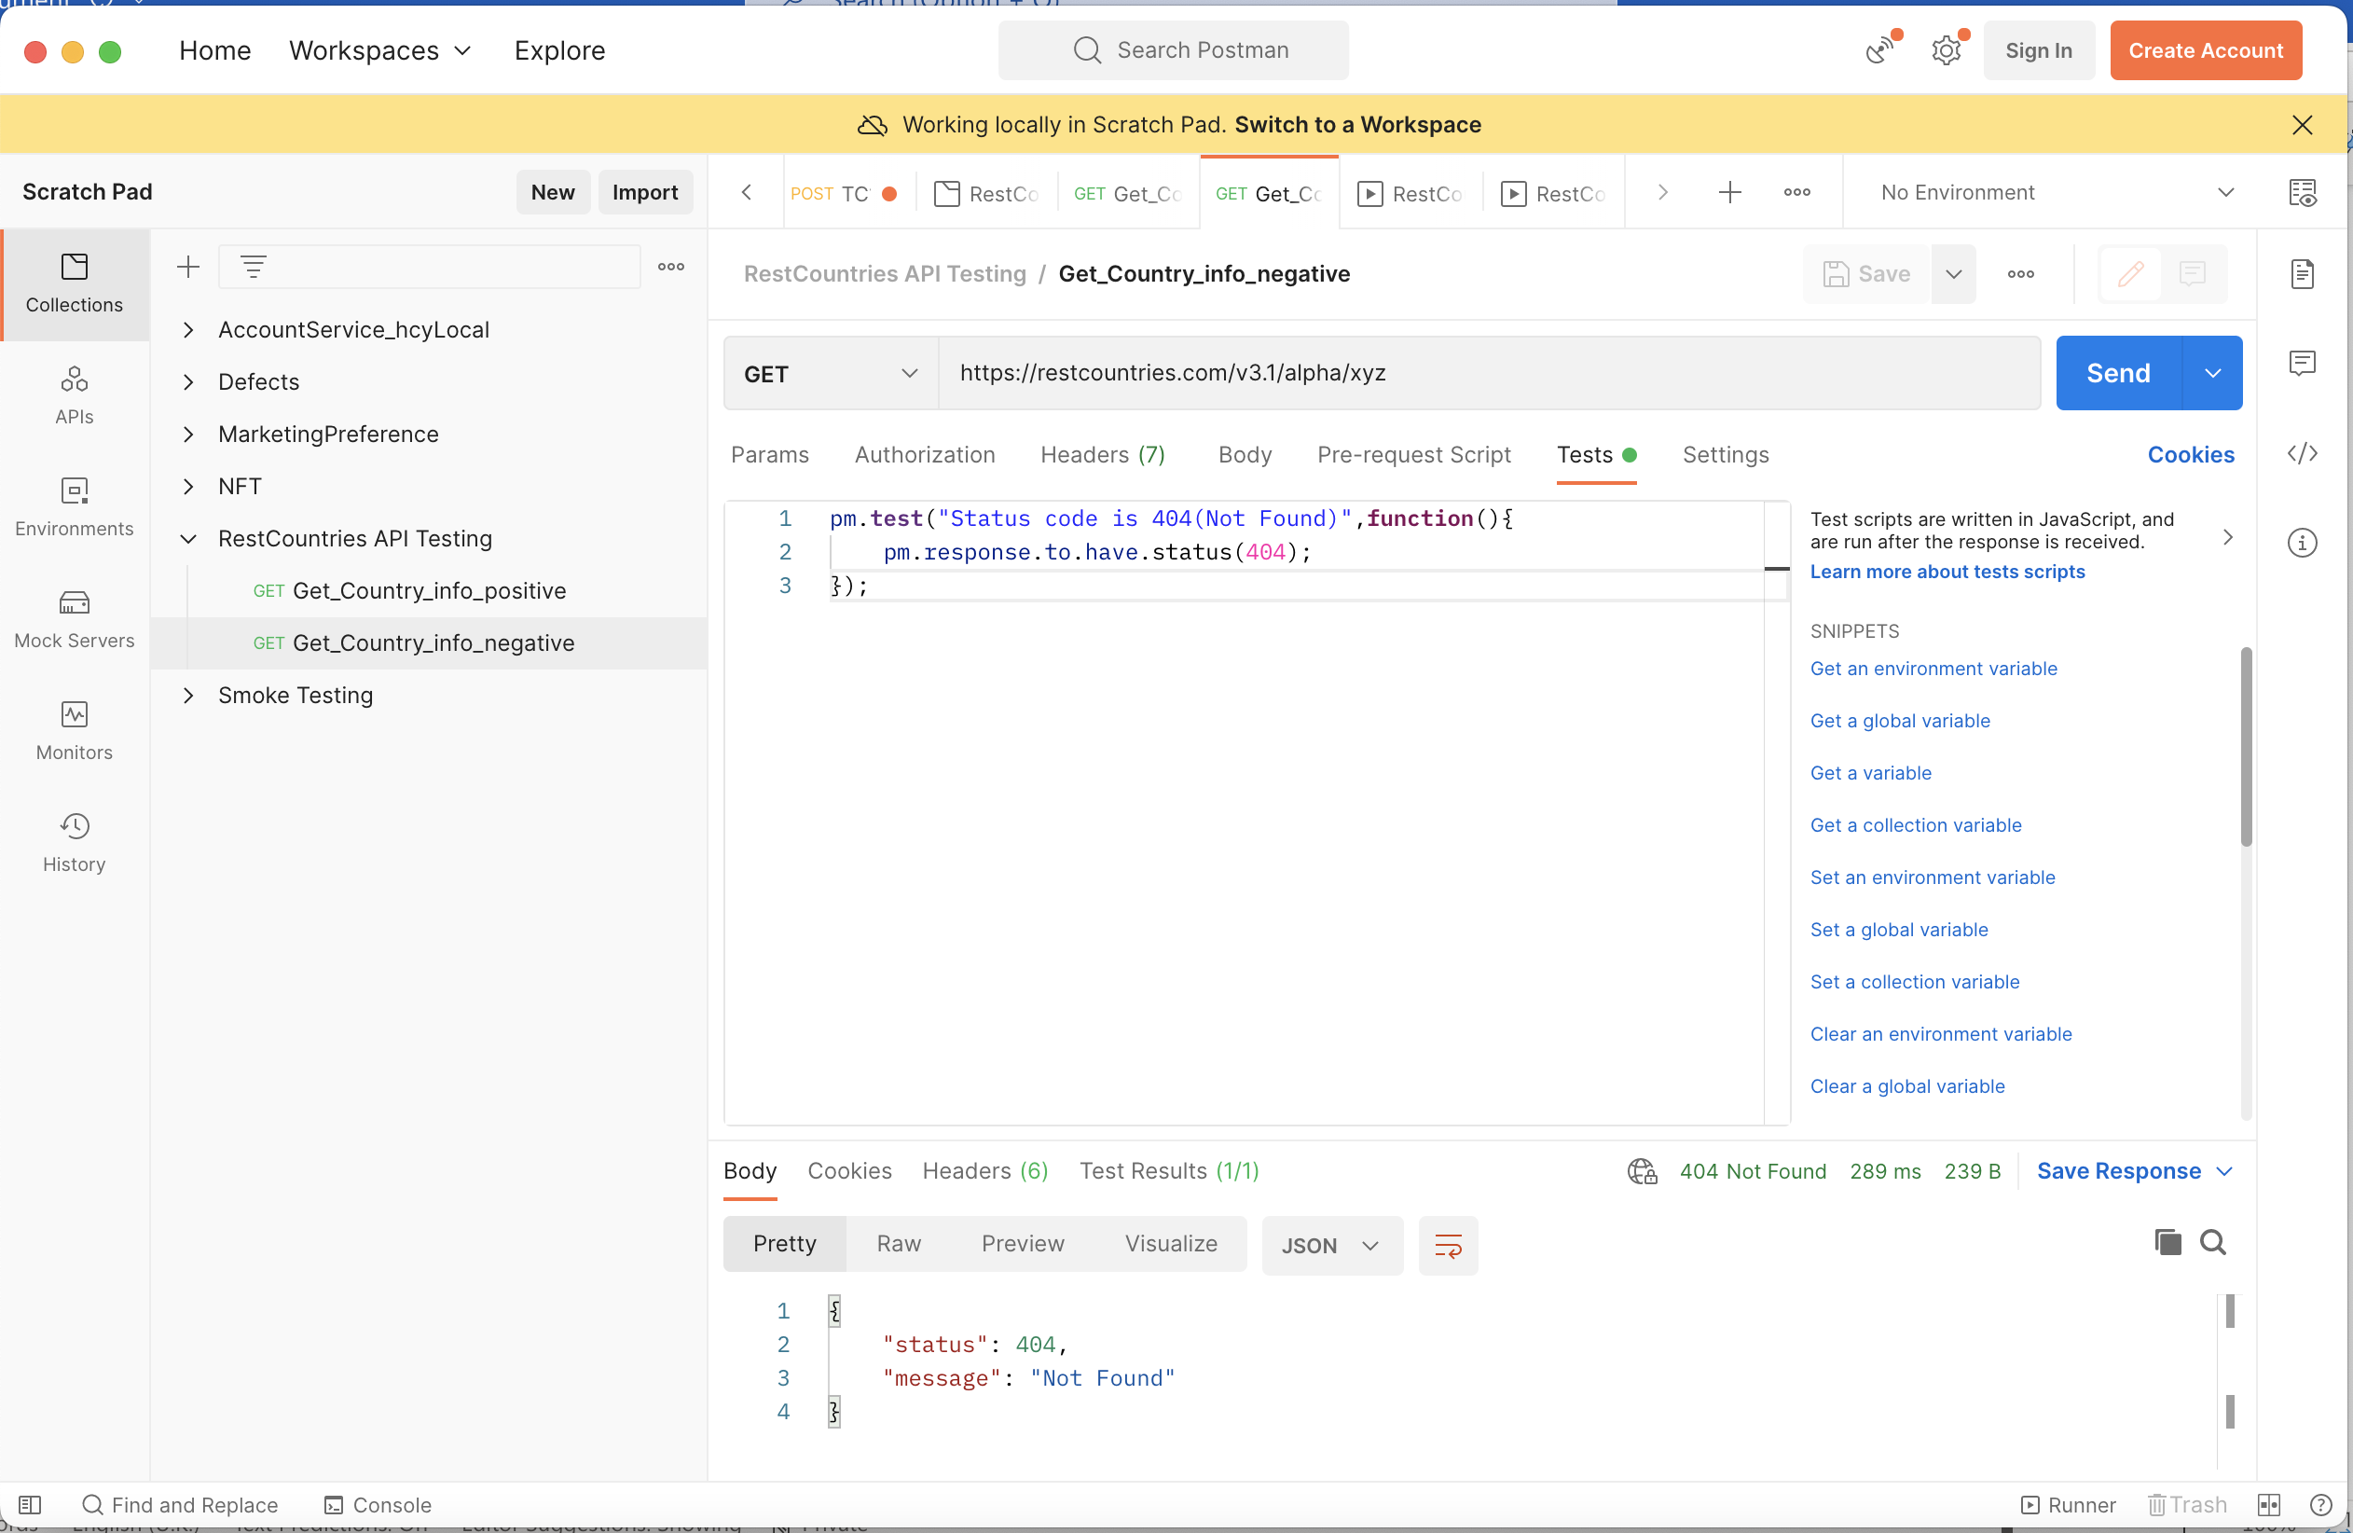

Question 9:

1. Create a Test Plan

Right-click on the "Test Plan" node in the tree on the left and select "Add > Threads > Thread Group."

2. Create a Thread Group and Add Number of Threads (Count is 1)

Under the "Thread Group," set the "Number of Threads " to 1.

3.Add HTTP Request (Use https protocol) and URL as <https://reqres.in>

Under the Thread Group, right-click and select "Add > Sampler > HTTP Request."

In the HTTP Request configuration:

Protocol: Select "https."

Server Name or IP: Enter "reqres.in."

Port Number: the default HTTPS port, which is 443.

4. Add Response Assertion

Right-click on the "HTTP Request"

Select "Add > Assertions > Response Assertion."

5. Use Text Response to validate texts present on Web Page

"Field to Test": Choose "Text Response."

In "Patterns to Test," enter the text which we want to validate.

6. Add assertion to validate Response Code  
 Right-click on the "HTTP Request."

Select "Add > Assertions > Response Code Assertion."

7. Run the Script and Analyze the test results

Save the Test Plan.

Click the "Run" menu and select "Start" to run the test.

After the test run is complete, we can analyze the results in the various listeners provided by JMeter.

Question 10

import pytest

from selenium import webdriver

from selenium.webdriver.common.by import By

from selenium.webdriver.common.keys import Keys

@pytest.fixture

def driver():

# Initialize the Chrome WebDriver

driver = webdriver.Chrome()

driver.maximize_window()

yield driver

driver.quit()

def test_login_with_invalid_credentials(driver):

# Navigate to the FreeCRM website

driver.get("https://www.freecrm.com/")

# Click on the Login button

login_button = driver.find_element(By.XPATH, "//a[@title='Log In']")

login_button.click()

# Enter Invalid User Name and Password and click on Login button

username_input = driver.find_element(By.XPATH, "//input[@name='email']")

password_input = driver.find_element(By.XPATH, "//input[@name='password']")

login_button2 = driver.find_element(By.XPATH, "//div[@class='ui fluid large blue submit button']")

username_input.send_keys("invalid_username")

password_input.send_keys("invalid_password")

login_button2.click()

# Verify that the Invalid error message is displayed

error_message = driver.find_element(By.XPATH, "//div[@class='ui negative message']")

error_text = error_message.text

expected_error_text = "Invalid login. Please try again."

assert expected_error_text in error_text, f"Error message does not match the expected message: {error_text}"

if __name__ == "__main__":

pytest.main(["-s", "your_test_script_name.py"])