Sadsad, Dairnel Reese
Jingco, Jaspher

Week 2 Goal:

Grid
Clicking cards
Basic flipping
Window
Output by end of week: Window opens, grid of cards visible, clicking a card changes its state.

Code Week 2:

import tkinter as tk
import random

root = tk.Tk()
root.title("Matching Card Game")
root.geometry("350x350")

ROWS = 4
COLS = 4

cards = []
buttons = []

values = list("1122334455667788")
random.shuffle(values)

def on_card_click(index):
card = cards[index]

if card["revealed"]:
return

card["revealed"] = True
buttons[index].config(text=card["value"], bg="pink")

for i in range(ROWS * COLS):
card = {
"value": values[i],
"revealed": False
}
cards.append(card)

for i in range(ROWS):
for j in range(COLS):
index = i * COLS + j

btn = tk.Button(
root,
text="?",
width=8,
height=4,
command=lambda idx=index: on_card_click(idx)
)

btn.grid(row=i, column=j, padx=5, pady=5)

buttons.append(btn)

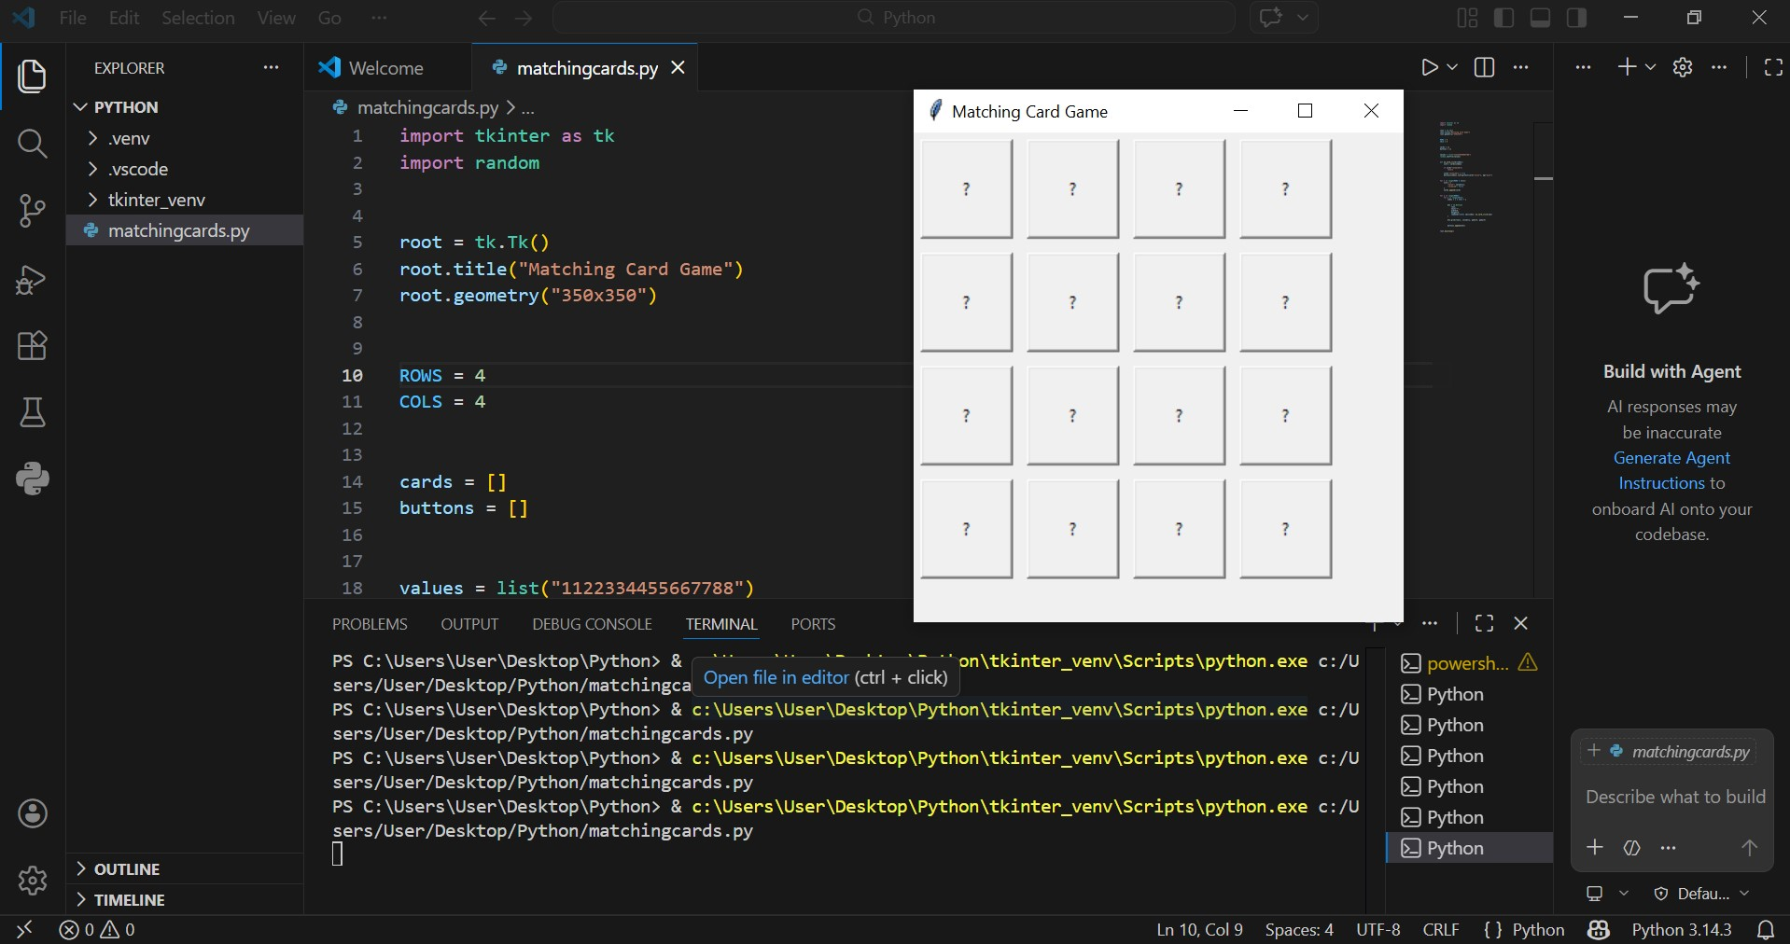
root.mainloop()
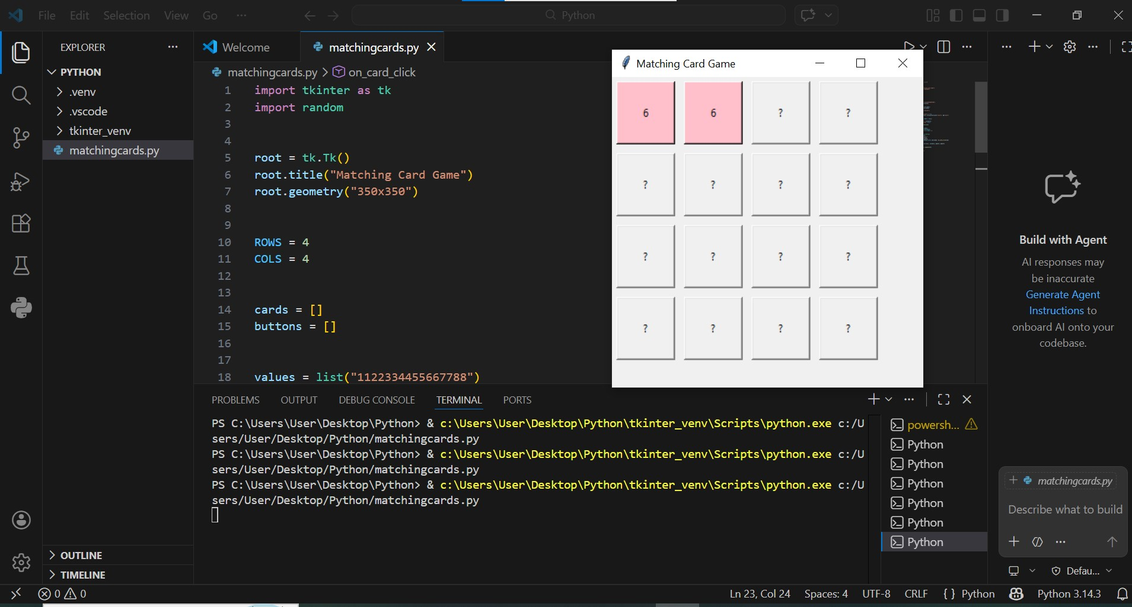
Note: The screen record submitted along with the document does not reflect the tkinter window for some reason, as seen in the screenshot above. The code runs successfully.

Summary:

The goal for this week is to navigate, understand and learn how to integrate tkinter for the project, including the first basic components we need for the game. We watched videos online on how to include tkinter in vs code python project. After including tkinter, the next task is to figure out how to open a window that would contain the needed gui elements. The window was given a title(the game title) and is in a 350x350 size and in a 4x4 form with 16 cards. Cards when flipped will show numbers from 1-8 and come as a pair. Each new game shuffles the cards.Only basic elements are included for now, hence why the cards will not flip back once opened.

