Part 1: Basic IPv4
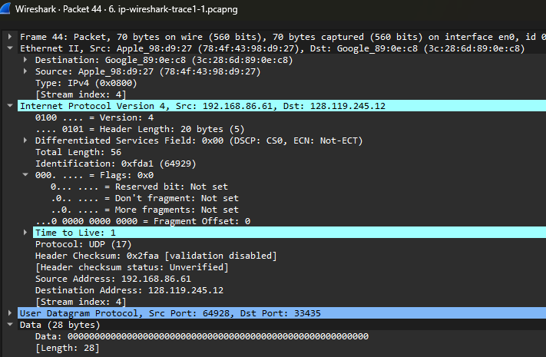
1. Select the first UDP segment sent by your computer via the traceroute command to gaia.cs.umass.edu. (Hint: this is 44th packet in the trace file in the ip wireshark-trace1-1.pcapng file in footnote 2). Expand the Internet Protocol part of the packet in the packet details window. What is the IP address of your computer?
44 1.865637 192.168.86.61 128.119.245.12 UDP 70 64928 → 33435 Len=28
Source 192.168.86.61

2. What is the value in the time-to-live (TTL) field in this IPv4 datagram’s header?
Time to Live: 1

3. What is the value in the upper layer protocol field in this IPv4 datagram’s header? [Note: the answers for Linux/MacOS differ from Windows here].
Protocol: UDP (17)

4. How many bytes are in the IP header?
.... 0101 = Header Length: 20 bytes (5)
5. How many bytes are in the payload of the IP datagram? Explain how you determined the number of payload bytes.
Total Length: 56
.... 0101 = Header Length: 20 bytes (5)
56 – 20 = 36 bytes

6. Has this IP datagram been fragmented? Explain how you determined whether or not the datagram has been fragmented.
NO
..0. .... = More fragments: Not set
...0 0000 0000 0000 = Fragment Offset: 0

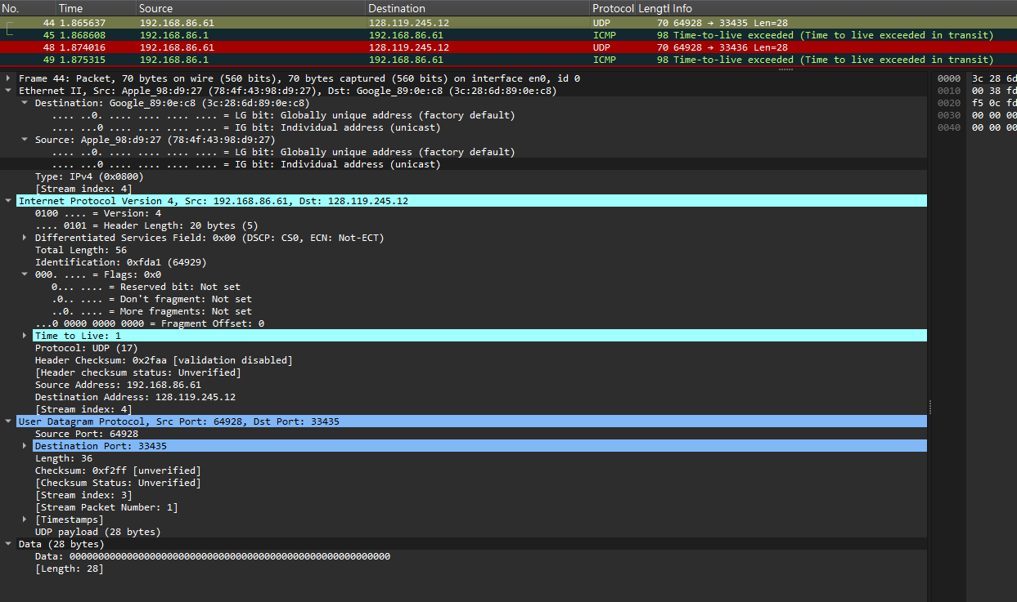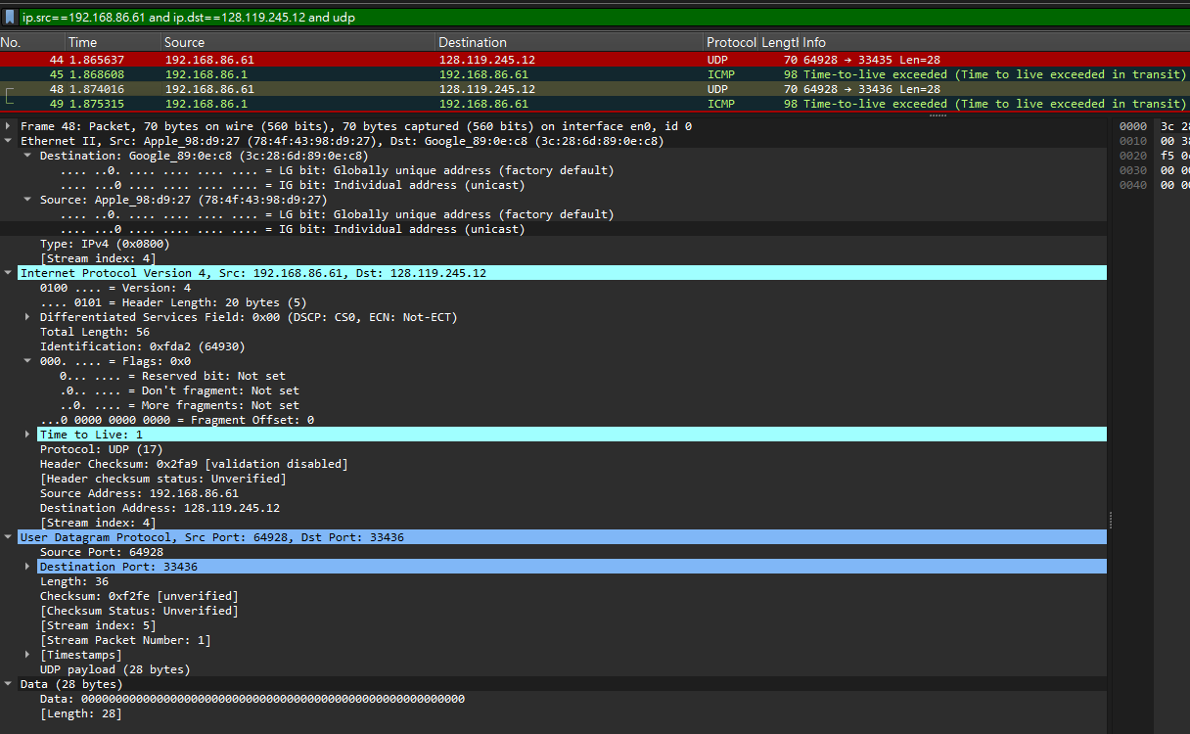
7. Which fields in the IP datagram always change from one datagram to the next within this series of UDP segments sent by your computer destined to 128.119.245.12, via traceroute? Why?
Time to Live & Header Checksum & Identification
Time to Live (TTL)： 這是 traceroute (路由追蹤) 的核心運作原理！它會故意發送一連串的封包，並將 TTL 的數值依序設定為 1、2、3... 逐次遞增。這樣才能讓封包在經過第一台、第二台、第三台路由器時剛好「壽終正寢（超時）」，藉此逼迫沿途的路由器回傳錯誤訊息，進而探測出整個傳輸路徑。
Identification (識別碼)： 你的電腦作業系統每產生並發送一個新的 IP 封包，就會賦予它一個獨立且（通常是）連續遞增的編號，用來在網路上唯一辨識這個封包，所以每一筆發出去的封包編號當然都會不一樣。
Header Checksum (標頭檢查碼)： 檢查碼是根據 IP 標頭內的所有資料數值計算出來的。既然前面提到的 TTL 和 Identification 的數值都在改變，代表整個 IP 標頭的內容就不一樣了，所以檢查碼理所當然必須跟著重新計算並改變。

8. Which fields in this sequence of IP datagrams (containing UDP segments) stay constant? Why?
Version、Header Length、Source Address、Destination Address這些欄位
因為都是用同一台電腦發給同一個目的地

9. Describe the pattern you see in the values in the Identification field of the IP datagrams being sent by your computer.
通常都是 +1
Identification: 0xfda1 (64929)
Identification: 0xfda2 (64930)
Identification: 0xfda3 (64931)

10. What is the upper layer protocol specified in the IP datagrams returned from the routers? [Note: the answers for Linux/MacOS differ from Windows here].
Internet Protocol Version 4, Src: 10.0.0.1, Dst: 192.168.86.61
Protocol: ICMP (1)
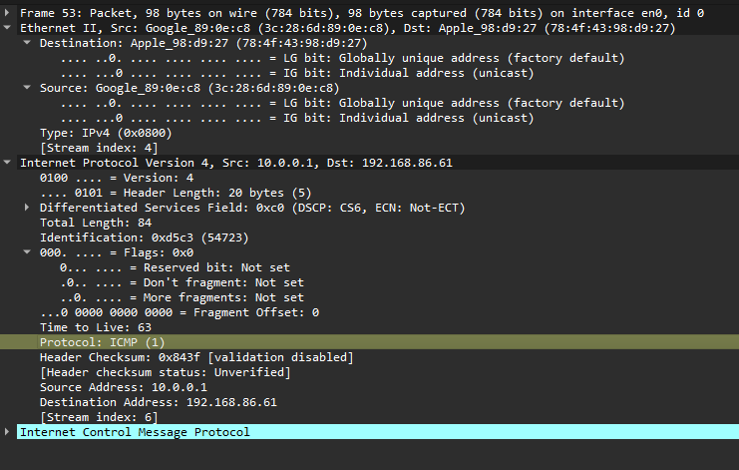

11. Are the values in the Identification fields (across the sequence of all of ICMP packets from all of the routers) similar in behavior to your answer to question 9 above?
53 Identification: 0xd5c3 (54723)
56 Identification: 0xfda5 (64933)
57 Identification: 0xd5cc (54732)
58 Identification: 0xfda6 (64934)
十六進位數字（0x...）完全是亂跳的，根本沒有連續 +1 的遞增規律

12. Are the values of the TTL fields similar, across all of ICMP packets from all of the routers?
53 Time to Live: 63
56 Time to Live: 2
57 Time to Live: 63
58 Time to Live: 2
61 Time to Live: 253
不一樣 (No)。
當沿途的路由器把 TTL 扣到 0 時，它會自己產生一個全新的 ICMP 封包寄回給你。這個回傳的 TTL 會不一樣，主要有兩個原因：
- 作業系統預設值不同： 不同的路由器（Cisco、Juniper 或 Linux 系統等）在產生新的 ICMP 封包時，給予的「初始 TTL」本來就不一樣（常見的有 64、128 或 255）。
- 距離（跳數）不同： 當這個 ICMP 封包從路由器出發，沿著網路原路返回你的電腦時，每經過一個節點，TTL 就會被扣掉 1。越遠的路由器，回程經過的節點就越多，被扣減的次數也越多。

Part 2: Fragmentation

13. Find the first IP datagram containing the first part of the segment sent to 128.119.245.12 sent by your computer via the traceroute command to gaia.cs.umass.edu, after you specified that the traceroute packet length should be 3000. (Hint: This is packet 179 in the ip-wireshark-trace1-1.pcapng trace file in footnote 2. Packets 179, 180, and 181 are three IP datagrams created by fragmenting the first single 3000-byte UDP segment sent to 128.119.145.12). Has that segment been fragmented across more than one IP datagram? (Hint: the answer is yes !) ⁴
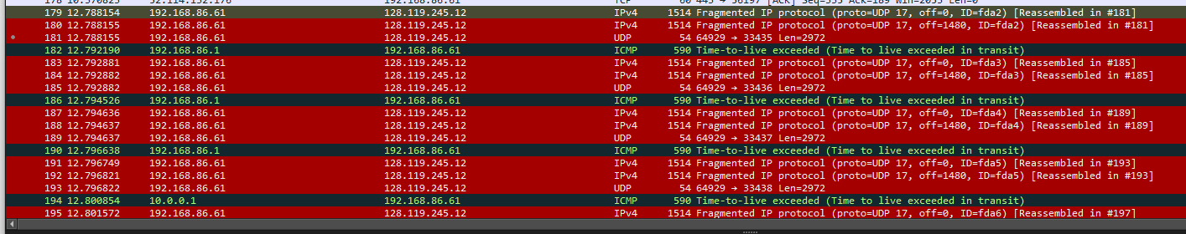
YES
14. What information in the IP header indicates that this datagram been fragmented?
在實際的 IP 標頭中，Flags（旗標）欄位裡面的 More fragments (MF) 旗標會被設定為 1 (Set)。這代表該封包後面還有其他的碎塊。
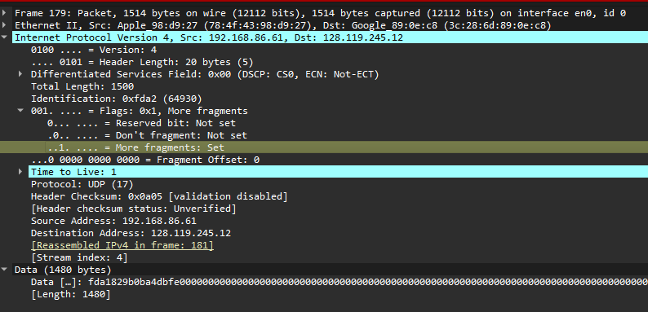
15. What information in the IP header for this packet indicates whether this is the first fragment versus a latter fragment?
觀察第 179 號封包後方的資訊 off=0。IP 標頭中的 Fragment Offset (分片偏移量) 數值為 0，代表這是這組資料的最前端，也就是第一個分片。
16. How many bytes are there in is this IP datagram (header plus payload)?
最上面的 Length 欄位顯示為 1514，但這是包含了最底層 Ethernet 標頭 (14 bytes) 的大小。將 1514 減去 14，可以得知整個 IP 封包的 Total Length 為 1500 bytes。實際上資訊也寫：Total Length: 1500
17. Now inspect the datagram containing the second fragment of the fragmented UDP segment. What information in the IP header indicates that this is not the first datagram fragment?
它的 Fragment Offset 數值大於 0（從紀錄中可以看到 off=1480）。只要偏移量不是 0，就代表它絕對不是第一個分片。
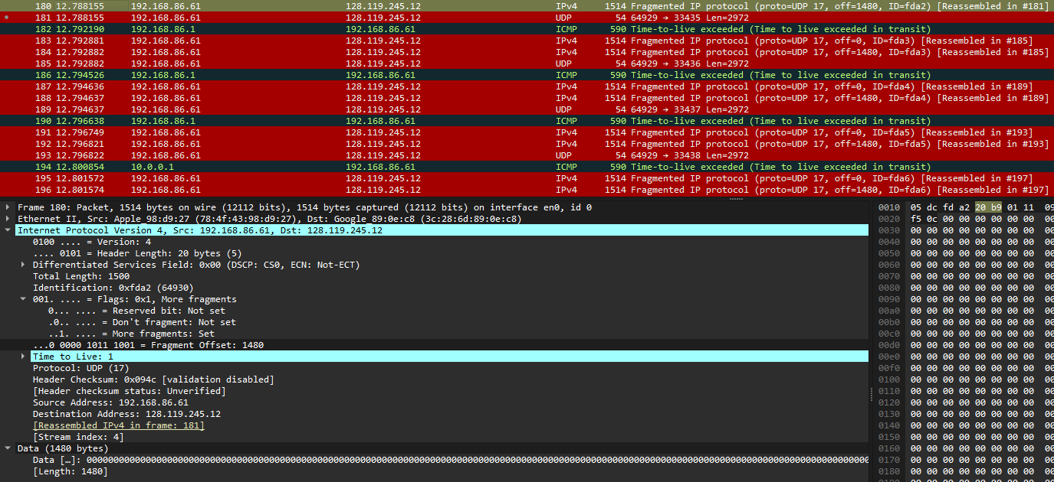
18. What fields change in the IP header between the first and second fragment?
主要改變的欄位有兩個：
- Fragment Offset (分片偏移量)：從 0 變成了 1480。
- Header Checksum (標頭檢查碼)：因為 Offset 數值改變了，整個 IP 標頭的內容也隨之改變，因此檢查碼必須重新計算，兩者的數值會不一樣。
19. Now find the IP datagram containing the third fragment of the original UDP segment. What information in the IP header indicates that this is the last fragment of that segment?
判斷是最後一個分片的關鍵在於，該封包 IP 標頭中的 More fragments 旗標會變回 0 (Not set)，這代表它後面已經沒有其他碎塊了。

Part 3: IPv6
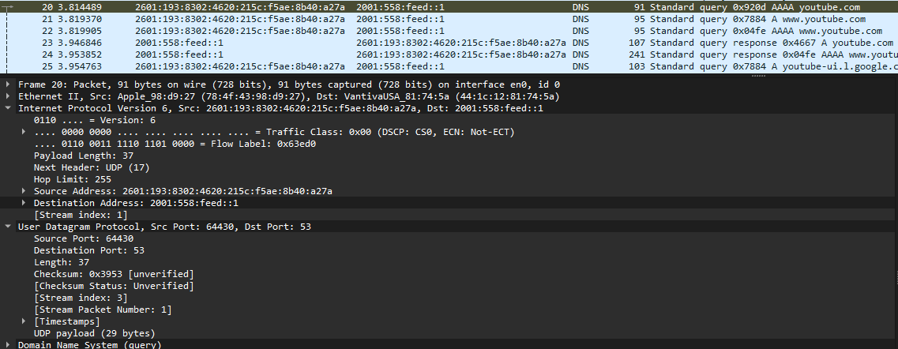
20. What is the IPv6 address of the computer making the DNS AAAA request? This is the source address of the 20th packet in the trace. Give the IPv6 source address for this datagram in the exact same form as displayed in the Wireshark window .⁵
Source Address: 2601:193:8302:4620:215c:f5ae:8b40:a27a
21. What is the IPv6 destination address for this datagram? Give this IPv6 address in the exact same form as displayed in the Wireshark window.
Destination Address: 2001:558:feed::1
22. What is the value of the flow label for this datagram?
.... 0110 0011 1110 1101 0000 = Flow Label: 0x63ed0
23. How much payload data is carried in this datagram?
Payload Length: 37
24. What is the upper layer protocol to which this datagram’s payload will be delivered at the destination?
Next Header: UDP (17)
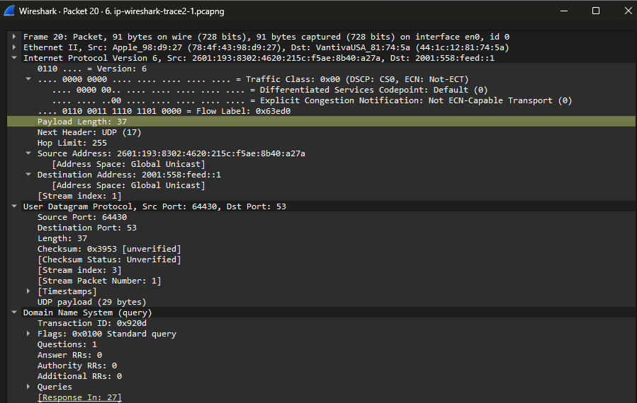
25. How many IPv6 addresses are returned in the response to this AAAA request?
Answer RRs: 1
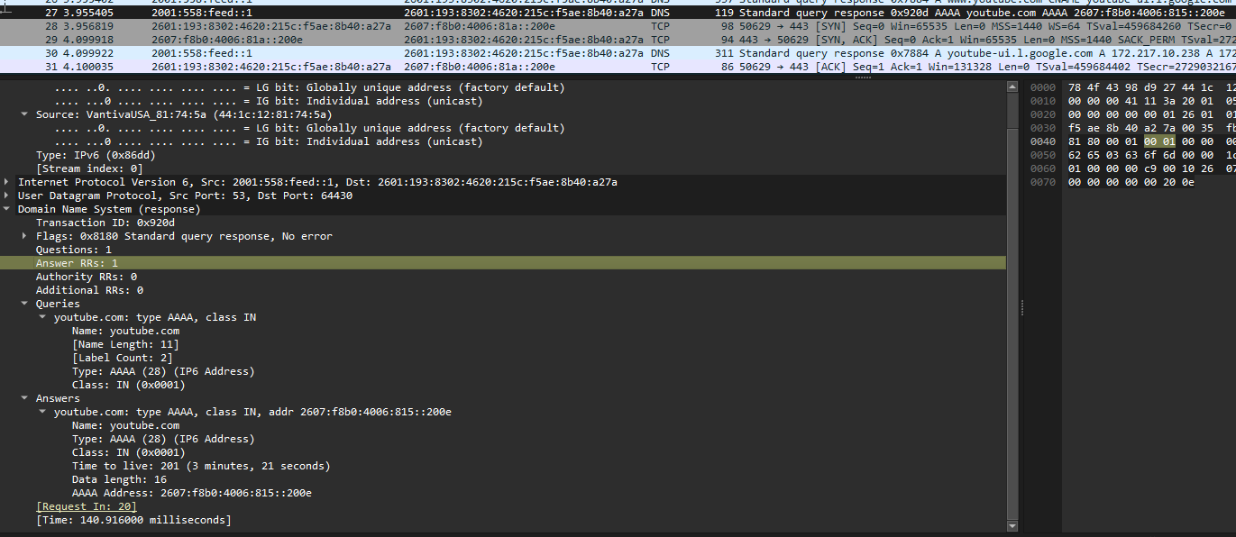
26. What is the first of the IPv6 addresses returned by the DNS for youtube.com (in the ip-wireshark-trace2-1.pcapng trace file, this is also the address that is numerically the smallest)? Give this IPv6 address in the exact same shorthand form as displayed in the Wireshark window.
2607:f8b0:4006:815::200e
27 3.955405 2001:558:feed::1 2601:193:8302:4620:215c:f5ae:8b40:a27a DNS 119 Standard query response 0x920d AAAA youtube.com AAAA 2607:f8b0:4006:815::200e
