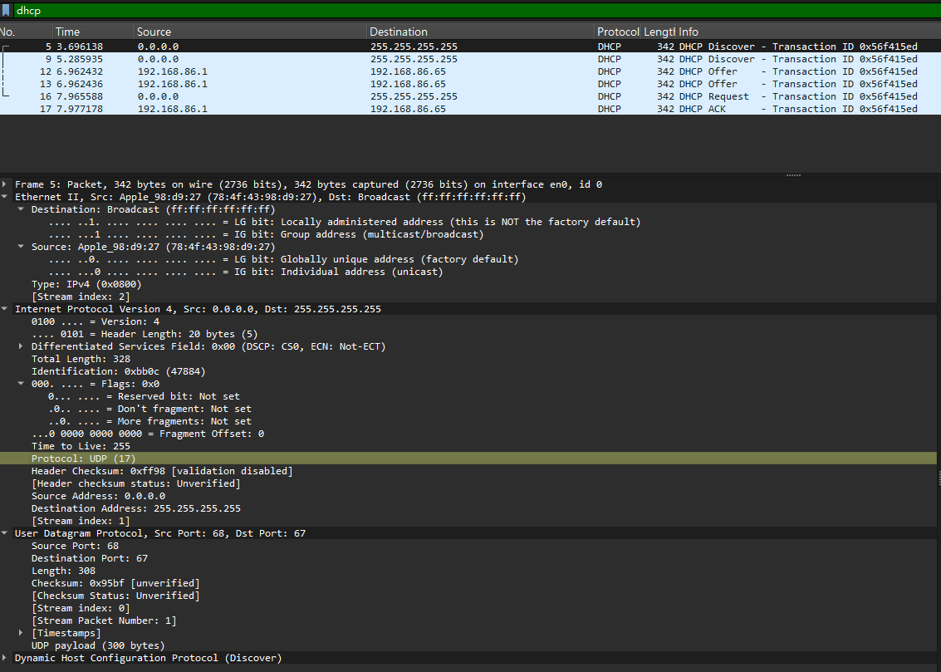
1. Is this DHCP Discover message sent out using UDP or TCP as the underlying
transport protocol?
Protocol: UDP (17)

2. What is the source IP address used in the IP datagram containing the Discover
message? Is there anything special about this address? Explain.
Source IP 為 0.0.0.0 。這個位址很特殊，代表「未指定」，因為此時 Client 端尚未從 DHCP Server 取得任何有效的 IP 位址。

3. What is the destination IP address used in the datagram containing the Discover
message. Is there anything special about this address? Explain.
Destination IP 為 255.255.255.255 。這是一個廣播（Broadcast）位址，因為 Client 此時不知道區網內哪裡有 DHCP Server，所以必須向整個網域廣播請求。

4. What is the value in the transaction ID field of this DHCP Discover message?
Transaction ID: 0x56f415ed
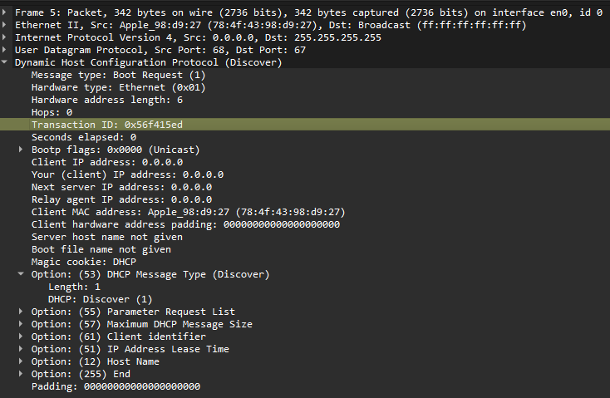
5. Now inspect the options field in the DHCP Discover message. What are five
pieces of information (beyond an IP address) that the client is suggesting or
requesting to receive from the DHCP server as part of this DHCP transaction?
- Subnet Mask (子網路遮罩)
- Classless Static Route (無類別靜態路由)
- Router (預設閘道/路由器)
- Domain Name Server (DNS 伺服器)
- Domain Name (網域名稱)
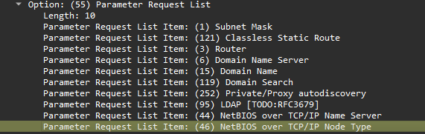
6. How do you know that this Offer message is being sent in response to the DHCP
Discover message you studied in questions 1-5 above?
5 3.696138 0.0.0.0 255.255.255.255 DHCP 342 DHCP Discover - Transaction ID 0x56f415ed
9 5.285935 0.0.0.0 255.255.255.255 DHCP 342 DHCP Discover - Transaction ID 0x56f415ed
12 6.962432 192.168.86.1 192.168.86.65 DHCP 342 DHCP Offer - Transaction ID 0x56f415ed
13 6.962436 192.168.86.1 192.168.86.65 DHCP 342 DHCP Offer - Transaction ID 0x56f415ed
它的 Transaction ID 依然是 0x56f415ed，因為 Transaction ID 相同，Client 才能確認這個 Offer 是針對它剛剛發出的 Discover 的回應

7. What is the source IP address used in the IP datagram containing the Offer
message? Is there anything special about this address? Explain.
Source Address: 192.168.86.1
這是 DHCP Server 的實際 IP 位址（單播位址），與 Discover 時的 0.0.0.0 不同。
8. What is the destination IP address used in the datagram containing the Offer
message? Is there anything special about this address? Explain. [Hint: Look at
your trace carefully. The answer to this question may differ from what you see in
Figure 4.24 in the textbook. If you really want to dig into this, consult the DHCP
RFC, page 24.]
Destination Address: 192.168.86.65
在這次的封包擷取中，Server 是直接將目的地位址填上「準備要配發給 Client 的新 IP」，這取決於作業系統與 DHCP 的實作方式

9. Now inspect the options field in the DHCP Offer message. What are five pieces
of information that the DHCP server is providing to the DHCP client in the DHCP
Offer message?
- DHCP Server Identifier (DHCP 伺服器識別碼：192.168.86.1)
- IP Address Lease Time (IP 位址租約時間：1 day)
- Subnet Mask (子網路遮罩：255.255.255.0)
- Router (預設閘道/路由器：192.168.86.1)
- Domain Name Server (DNS 伺服器：192.168.86.1)
- Broadcast Address (廣播位址：192.168.86.255)
- Domain Name (網域名稱：lan)
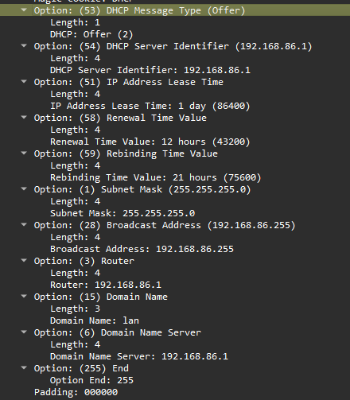
10. What is the UDP source port number in the IP datagram containing the first
DHCP Request message in your trace? What is the UDP destination port number
being used?
Source Port 會是 68（Client 端），Destination Port 會是 67（Server 端）
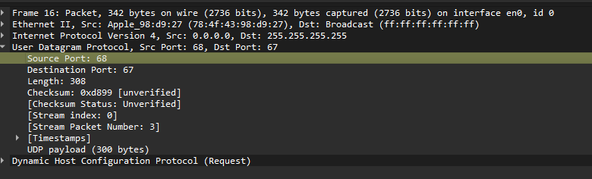

11. What is the source IP address in the IP datagram containing this Request message?
Is there anything special about this address? Explain.
16 7.965588 0.0.0.0 255.255.255.255 DHCP 342 DHCP Request - Transaction ID 0x56f415ed
依然是 0.0.0.0。特別之處在於，即使 Client 已經收到 Offer，但在 Server 尚未回傳 ACK 正式確認前，Client 依然不會將該 IP 綁定到自己的網卡上。

12. What is the destination IP address used in the datagram containing this Request
message. Is there anything special about this address? Explain.
16 7.965588 0.0.0.0 255.255.255.255 DHCP 342 DHCP Request - Transaction ID 0x56f415ed
通常是廣播位址 255.255.255.255。這個廣播動作除了告訴發送 Offer 的 Server「我接受你的 IP」之外，也是為了告知網域內其他的 DHCP Server「我已經拿到 IP 了，你們可以收回為我保留的其他 IP 提案」。

13. What is the value in the transaction ID field of this DHCP Request message?
Does it match the transaction IDs of the earlier Discover and Offer messages?
5 3.696138 0.0.0.0 255.255.255.255 DHCP 342 DHCP Discover - Transaction ID 0x56f415ed
9 5.285935 0.0.0.0 255.255.255.255 DHCP 342 DHCP Discover - Transaction ID 0x56f415ed
12 6.962432 192.168.86.1 192.168.86.65 DHCP 342 DHCP Offer - Transaction ID 0x56f415ed
13 6.962436 192.168.86.1 192.168.86.65 DHCP 342 DHCP Offer - Transaction ID 0x56f415ed
16 7.965588 0.0.0.0 255.255.255.255 DHCP 342 DHCP Request - Transaction ID 0x56f415ed
17 7.977178 192.168.86.1 192.168.86.65 DHCP 342 DHCP ACK - Transaction ID 0x56f415ed
數值與前面的相同。這代表它們屬於同一次的 DHCP 交易過程。

14. Now inspect the options field in the DHCP Discover message and take a close
look at the “Parameter Request List”. The DHCP RFC notes that
“The client can inform the server which configuration parameters the
client is interested in by including the 'parameter request list' option. The
data portion of this option explicitly lists the options requested by tag
number.”
What differences do you see between the entries in the ‘parameter request list’
option in this Request message and the same list option in the earlier Discover
message?
第五題是看到這些

現在是看到這些，看起來沒差
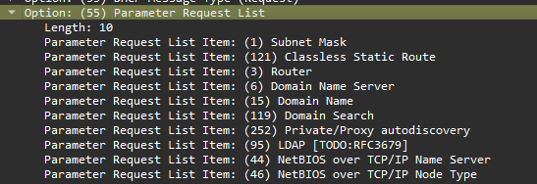
但真正有多的應該是多了 Option: (50) Requested IP Address (192.168.86.65)

15. What is the source IP address in the IP datagram containing this ACK message?
Is there anything special about this address? Explain.
17 7.977178 192.168.86.1 192.168.86.65 DHCP 342 DHCP ACK - Transaction ID 0x56f415ed
這裡會是 DHCP 伺服器的 IP。這代表這是由伺服器正式發出的最終確認配發訊息。
16. What is the destination IP address used in the datagram containing this ACK
message. Is there anything special about this address? Explain.
這裡應該是單播（Unicast）位址 192.168.86.65。這表示伺服器直接將確認訊息發送給 Client 即將要正式啟用的這個新 IP。
17. What is the name of the field in the DHCP ACK message (as indicated in the
Wireshark window) that contains the assigned client IP address?
Your (client) IP address: 192.168.86.65
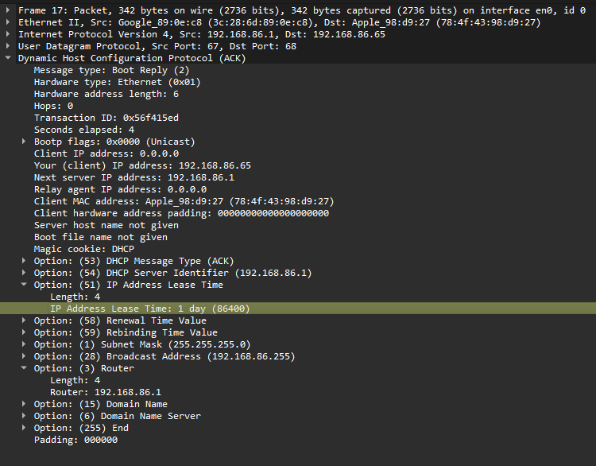
18. For how long a time (the so-called “lease time”) has the DHPC server assigned
this IP address to the client?
IP Address Lease Time: 1 day (86400)

19. What is the IP address (returned by the DHCP server to the DHCP client in this
DHCP ACK message) of the first-hop router on the default path from the client to
the rest of the Internet?
Router: 192.168.86.1

