- TCP, HTTP, STUN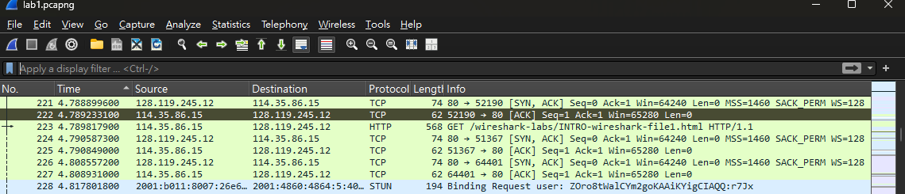
- 4.99 – 4.78 = 0.21s
- gaia.cs.umass.edu 的IP: 128.119.245.12；我的IP: 114.35.86.15
- 已存成pdf
