- Is your browser running HTTP version 1.0 or 1.1? What version of HTTP is the server running?
186: HTTP/1.1
197: HTTP/1.1
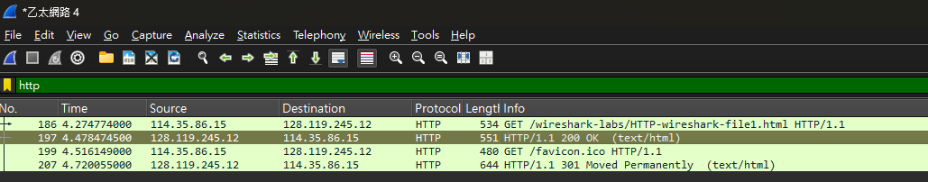
- What languages (if any) does your browser indicate that it can accept to the server?
zh-TW,zh;q=0.9
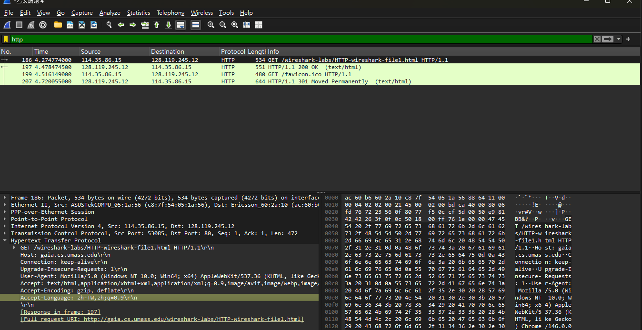
- What is the IP address of your computer? Of the gaia.cs.umass.edu server?
我的IP: 114.35.86.15
伺服器: 128.119.245.12
- What is the status code returned from the server to your browser?
200
- When was the HTML file that you are retrieving last modified at the server?
Tue, 28 Oct 2025 05:59:01 GMT
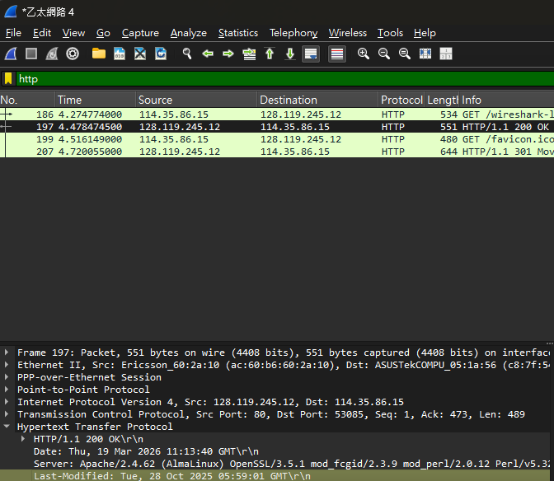
- How many bytes of content are being returned to your browser?
128
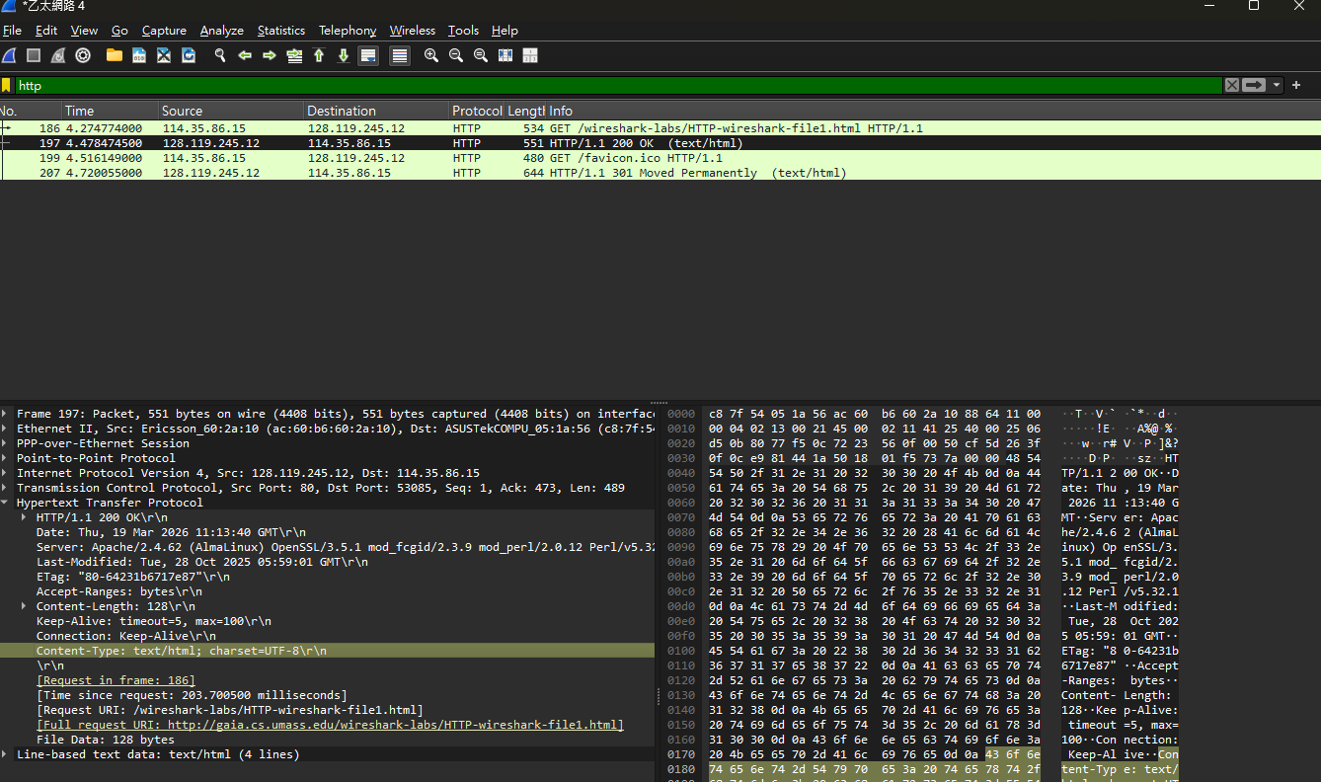
- By inspecting the raw data in the packet content window, do you see any headers within the data that are not displayed in the packet-listing window? If so, name one
不會看到
因為進行實驗前使用了訪客模式，瀏覽器不會儲存檔案的版本，會發送發送標準的 GET 請求，而不帶有條件標頭
- Inspect the contents of the first HTTP GET request from your browser to the server. Do you see an “IF-MODIFIED-SINCE” line in the HTTP GET?
不會看到
- Inspect the contents of the server response. Did the server explicitly return the contents of the file? How can you tell?
一：伺服器有回200
二：伺服器有回 content-length & Line-based text data
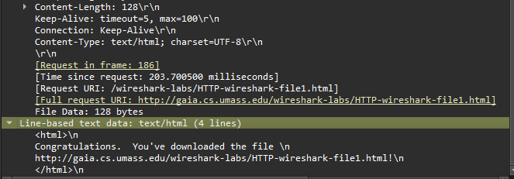
- Now inspect the contents of the second HTTP GET request from your browser to the server. Do you see an “IF-MODIFIED-SINCE:” line in the HTTP GET? If so, what information follows the “IF-MODIFIED-SINCE:” header?
有看到
會是該檔案最後一次被修改的「日期與時間」。瀏覽器會將第一次下載時伺服器告知的最後修改時間附加上去，用來向伺服器確認檔案從那個時間點之後有沒有再被更動過。
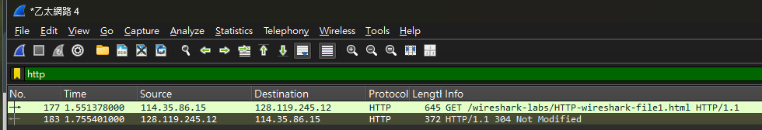

- What is the HTTP status code and phrase returned from the server in response to this second HTTP GET? Did the server explicitly return the contents of the file? Explain.
304，狀態詞是 Not Modified
沒有，伺服器這次「沒有」明確回傳檔案的內容。因為伺服器核對了瀏覽器送出的 IF-MODIFIED-SINCE 時間，發現檔案從那之後就沒有被修改過，所以僅僅回傳了 304 Not Modified 的狀態碼，指示瀏覽器直接讀取自己電腦裡的快取（Cache）即可，藉此節省網路頻寬與下載時間
。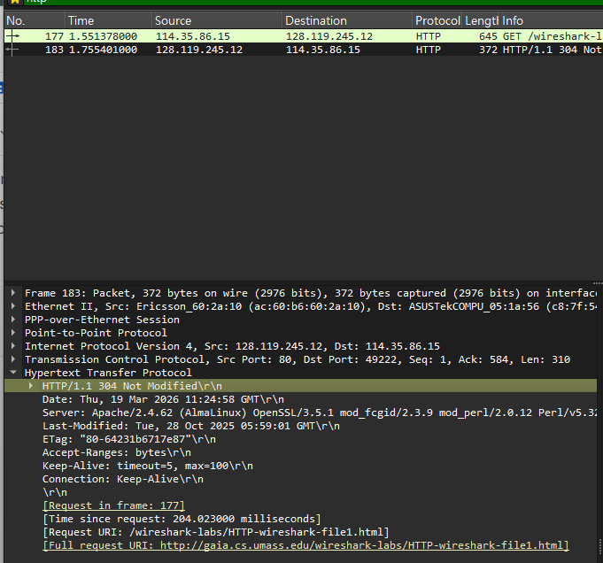
- How many HTTP GET request messages did your browser send? Which packet number in the trace contains the GET message for the Bill or Rights?
一個。編號：105。
GET /wireshark-labs/HTTP-wireshark-file3.html HTTP/1.1 。
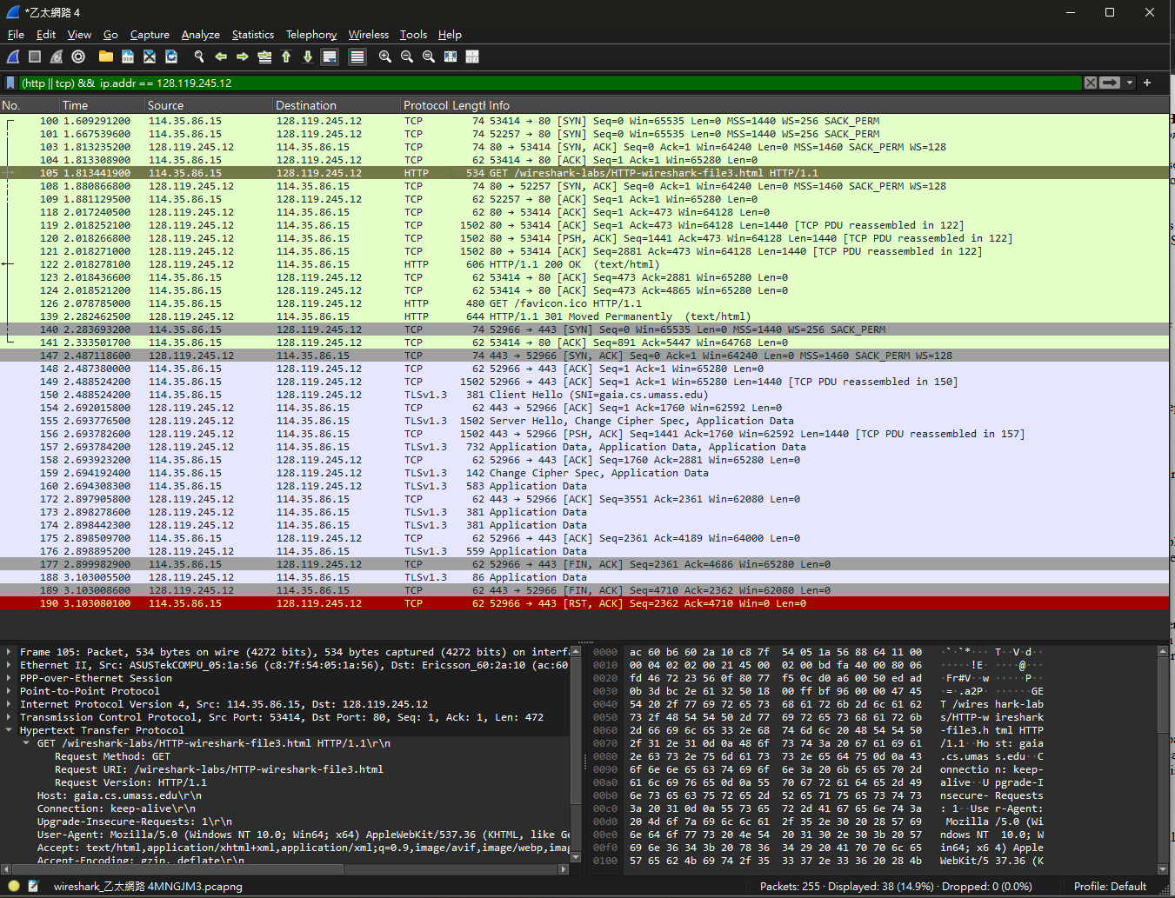
- Which packet number in the trace contains the status code and phrase associated with the response to the HTTP GET request?
122
- What is the status code and phrase in the response?
code：200。phrase：OK 。
- How many data-containing TCP segments were needed to carry the single HTTP response and the text of the Bill of Rights?
3個。
觀察封包 No. 119、120、121，其 Protocol 均標示為 TCP，長度（Length）為 1502 。在 Info 欄位中，這三個封包都標註了 [TCP PDU reassembled in 122]，代表它們共同組成了 No. 122 中的 HTTP 回應內容 。
- How many HTTP GET request messages did your browser send? To which Internet addresses were these GET requests sent?
四個。（包含 1 個 HTML 文件、2 張圖、1 個網站圖示）。
128.119.245.12 (gaia.cs.umass.edu)：負責提供 file4.html (No. 32)、pearson.png (No. 35) 以及 favicon.ico (No. 628) 。
2001:b011:8007:22ac:68d0:2ff8:ac5b:c6e1：負責提供 8E_cover_small.jpg (No. 76) 。
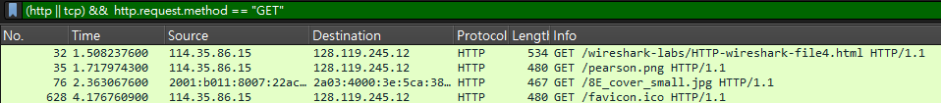

- Can you tell whether your browser downloaded the two images serially, or whether they were downloaded from the two web sites in parallel? Explain.
Parallel
理由：
pearson.png (No. 35) 在 1.717s 發出
而 8E_cover_small.jpg (No. 76) 隨即在 2.363s 發出
瀏覽器在尚未收到第一張圖片 (pearson.png) 的完整回應之前，就已經向另一個伺服器發出了第二張圖片的請求。
這顯示瀏覽器同時開啟了多個連線來加速網頁元件的下載，而不是等待前一個物件完成才開始下一個 。
- What is the server’s response (status code and phrase) in response to the initial HTTP GET message from your browser?
401 Unauthorized
瀏覽器在 1.723s 發出第一次請求（No. 22）
伺服器在 1.931s 回傳了 HTTP/1.1 401 Unauthorized（No. 27）
意義：這代表該頁面受到保護，伺服器要求瀏覽器必須提供身分驗證資訊（使用者名稱與密碼）才能存取
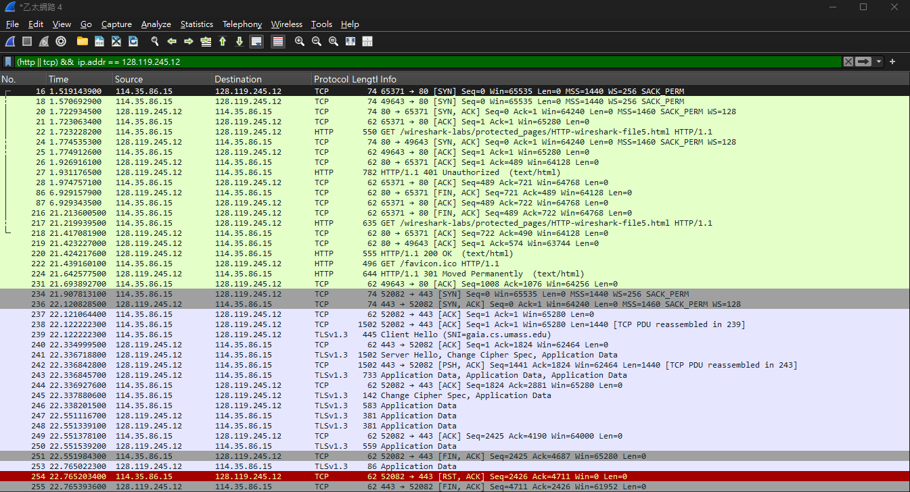
- When your browser’s sends the HTTP GET message for the second time, what new field is included in the HTTP GET message?
新增欄位：Authorization。
封包分析：
在輸入帳號密碼後，瀏覽器在 21.219s 發出了第二次請求（No. 217）。
點開 No. 217 的封包詳細資訊，在 Hypertext Transfer Protocol 區塊中會看到 Authorization: Basic ... 欄位 。
結果：伺服器驗證成功，並在隨後的 No. 220 封包中回傳了 200 OK，正式授予存取權限。
