- Run nslookup to obtain the IP address of the web server for the Indian Institute of Technology in Bombay, India: www.iitb.ac.in. What is the IP address of www.iitb.ac.in
103.21.124.133
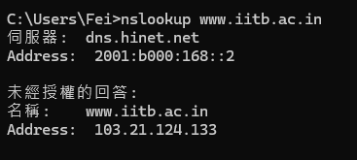
- What is the IP address of the DNS server that provided the answer to your nslookup command in question 1 above?
2001:b000:168::2
- Did the answer to your nslookup command in question 1 above come from an authoritative or non-authoritative server?
此答案來自非權威伺服器。
理由： 結果中明確標示了「未經授權的回答」，代表該結果是從 DNS 伺服器的Cache中取得，而非直接來自負責 iitb.ac.in 網域的權威伺服器
- Use the nslookup command to determine the name of the authoritative name server for the iitb.ac.in domain. What is that name? (If there are more than one authoritative servers, what is the name of the first authoritative server returned by nslookup)? If you had to find the IP address of that authoritative name server, how would you do so?
共有三台權威伺服器：dns1.iitb.ac.in、dns2.iitb.ac.in 以及 dns3.iitb.ac.in
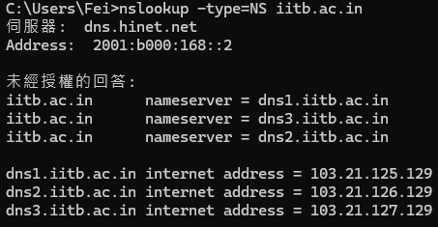

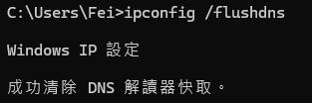
- Locate the first DNS query message resolving the name gaia.cs.umass.edu. What is the packet number in the trace for the DNS query message? Is this query message sent over UDP or TCP?
在No.68。使用UDP。
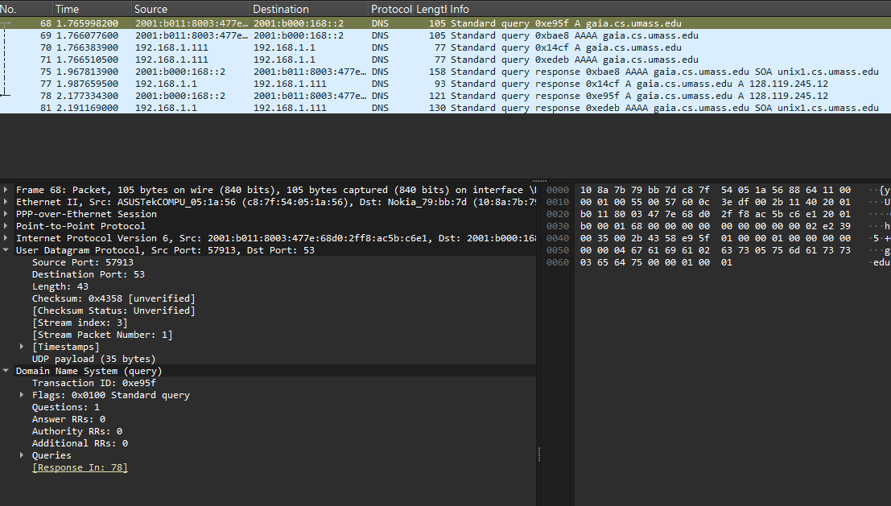
- Now locate the corresponding DNS response to the initial DNS query. What is the packet number in the trace for the DNS response message? Is this response message received via UDP or TCP?
在No.78。使用UDP。
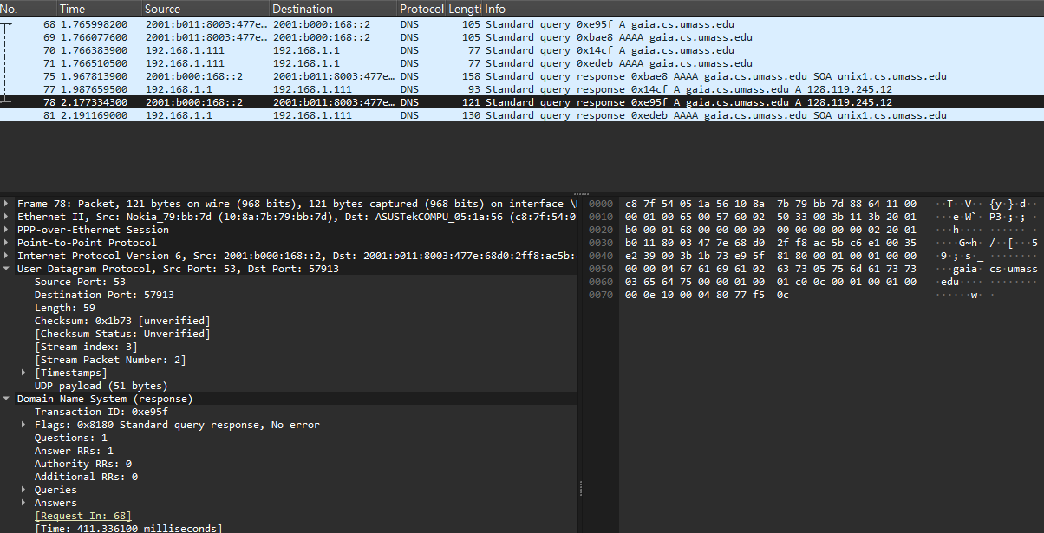
- What is the destination port for the DNS query message? What is the source port of the DNS response message?
查詢 (No.68) 的 Destination Port 為 53
回應 (No.78) 的 Source Port 為 53
- To what IP address is the DNS query message sent?
2001:b000:168::2
- Examine the DNS query message. How many “questions” does this DNS message contain? How many “answers” answers does it contain?
“Questions”: 1；”Answer RRs”: 0
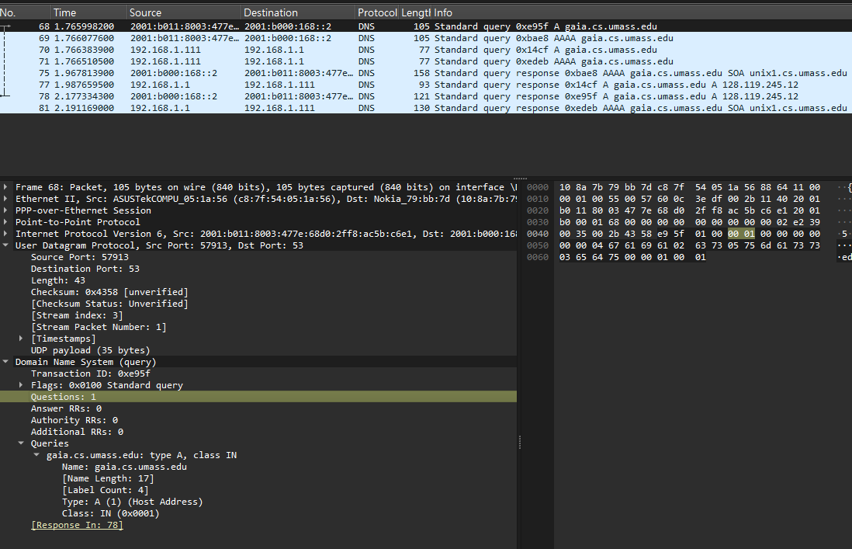
- Examine the DNS response message to the initial query message. How many “questions” does this DNS message contain? How many “answers” answers does it contain?
“Questions”: 1；”Answer RRs”: 1
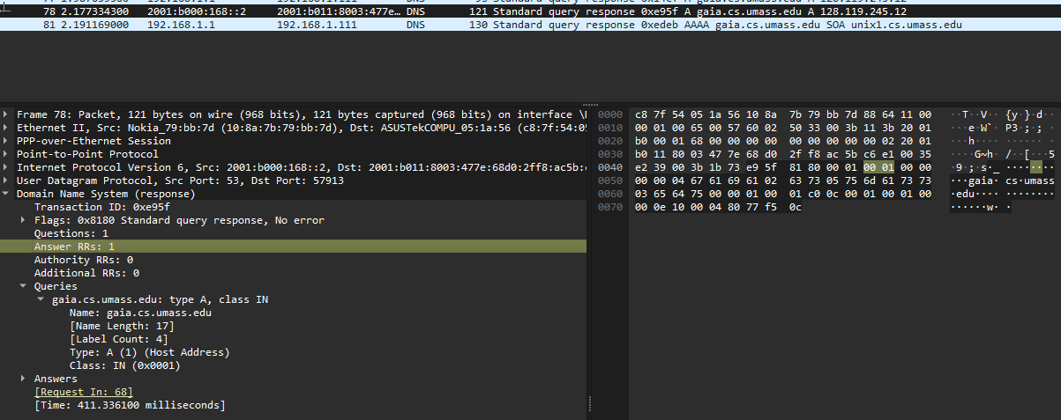
- http://gaia.cs.umass.edu/kurose_ross/ references the image object
http://gaia.cs.umass.edu/kurose_ross/header_graphic_book_8E_2.jpg ,
which, like the base webpage, is on gaia.cs.umass.edu.
What is the packet number in the DNS query made to resolve
gaia.cs.umass.edu so that this second HTTP request can be sent to the
gaia.cs.umass.edu IP address? Discuss how DNS caching affects the answer to
this last question.
在追蹤紀錄中，找不到為了獲取圖片而發送的第二次 DNS 查詢封包。
這是因為 DNS 快取機制 。當第一次解析 gaia.cs.umass.edu 後，其 IP 位址（128.119.245.12）已被存入本機 DNS resolver cache。
因此，當瀏覽器隨後要抓取同一個伺服器上的圖片時，會直接從快取獲取 IP，不再重複發送 DNS 查詢

- What is the destination port for the DNS query message? What is the source port of the DNS response message?
query message destination port: 53
response message source port: 53
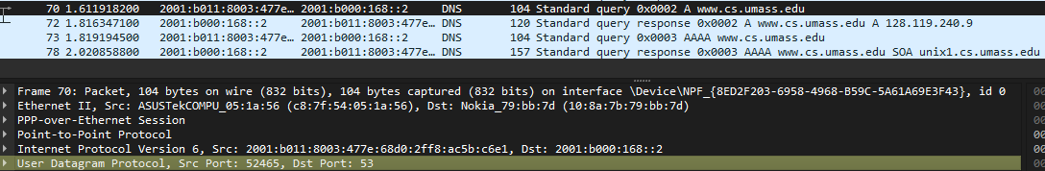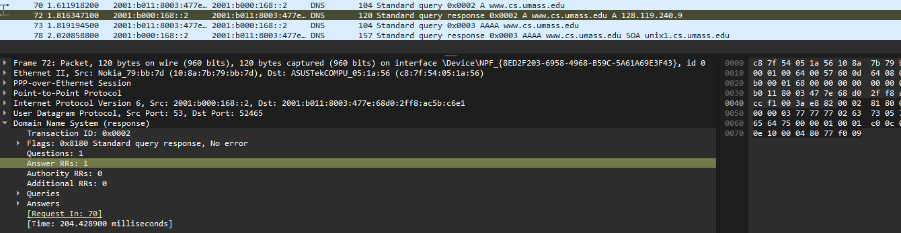
- To what IP address is the DNS query message sent? Is this the IP address of your default local DNS server?
2001:b000:168::2
是
- Examine the DNS query message. What “Type” of DNS query is it? Does the query message contain any “answers”?
Info 欄位顯示為 Standard query 0x0002 A www.cs.umass.edu
因此 Type 為 A （代表查詢 IPv4 地址）
Answer RRs 為 0，因為查詢封包本身不含答案
- Examine the DNS response message to the query message. How many “questions” does this DNS response message contain? How many “answers”?
“questions”: 1
“answers”: 1
- To what IP address is the DNS query message sent? Is this the IP address of your default local DNS server?
2001:b000:168::2
是
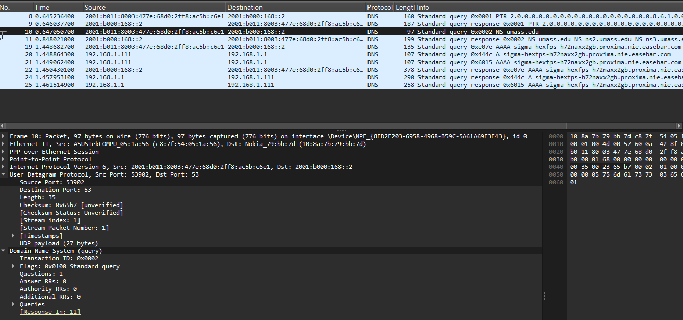
- Examine the DNS query message. How many questions does the query have? Does the query message contain any “answers”?
“questions”: 1
“answers”: 0

- Examine the DNS response message
How many answers does the response have?
What information is contained in the answers?
How many additional resource records are returned?
What additional information is included in these additional resource records?
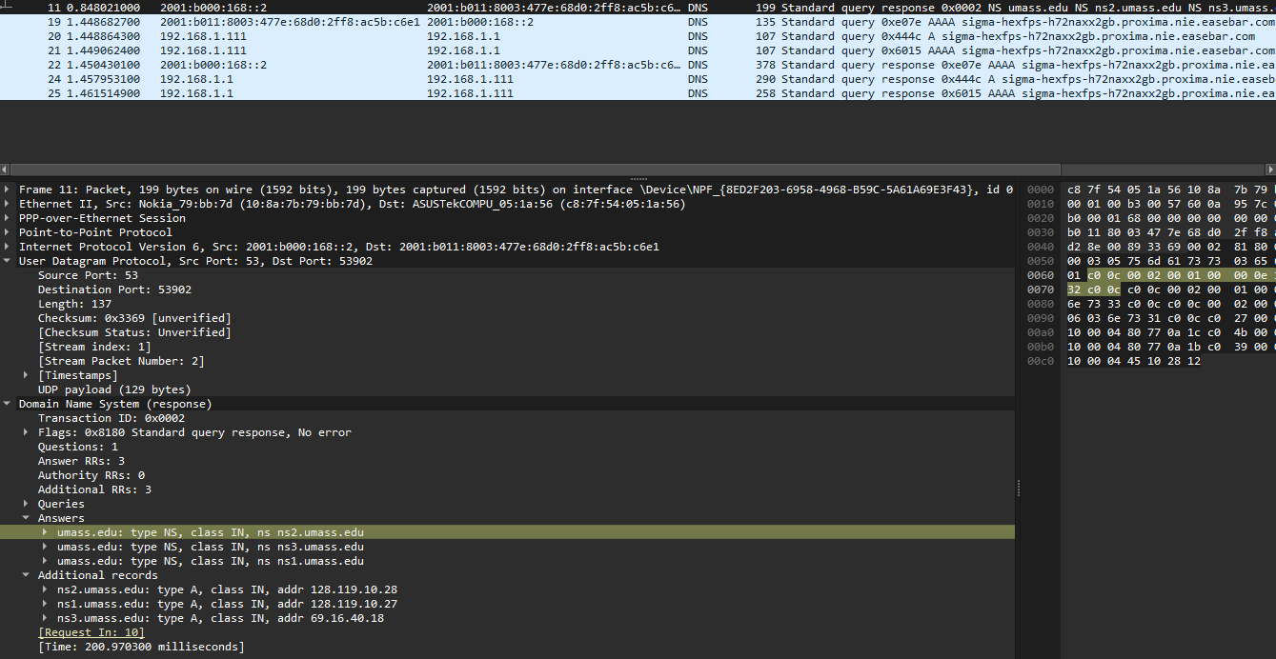
answers: 3
information: 包含 umass.edu 的權威名稱伺服器主機名稱：ns2.umass.edu、ns3.umass.edu 與 ns1.umass.edu
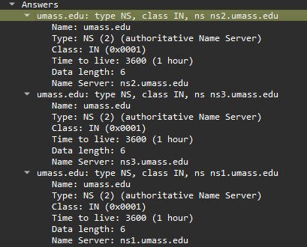
additional resource records are returned: 3
additional information: 這些紀錄（Type A）提供了上述名稱伺服器的 IP 位址 。例如：ns2.umass.edu 的位址是 128.119.10.28 。
