Part 1. Capturing a bulk TCP transfer from your computer to a remote server (無題目，僅上傳文字檔)
Part 2. A first look at the captured trace (第1~2題)
1. What is the IP address and TCP port number used by the client computer (source) that is transferring the alice.txt file to gaia.cs.umass.edu? To answer this question, it’s probably easiest to select an HTTP message and explore the details of the TCP packet used to carry this HTTP message, using the “details of the selected packet header window” (refer to Figure 2 in the “Getting Started with Wireshark” Lab if you’re uncertain about the Wireshark windows).
IP 位址：192.168.1.111
TCP Port：65376
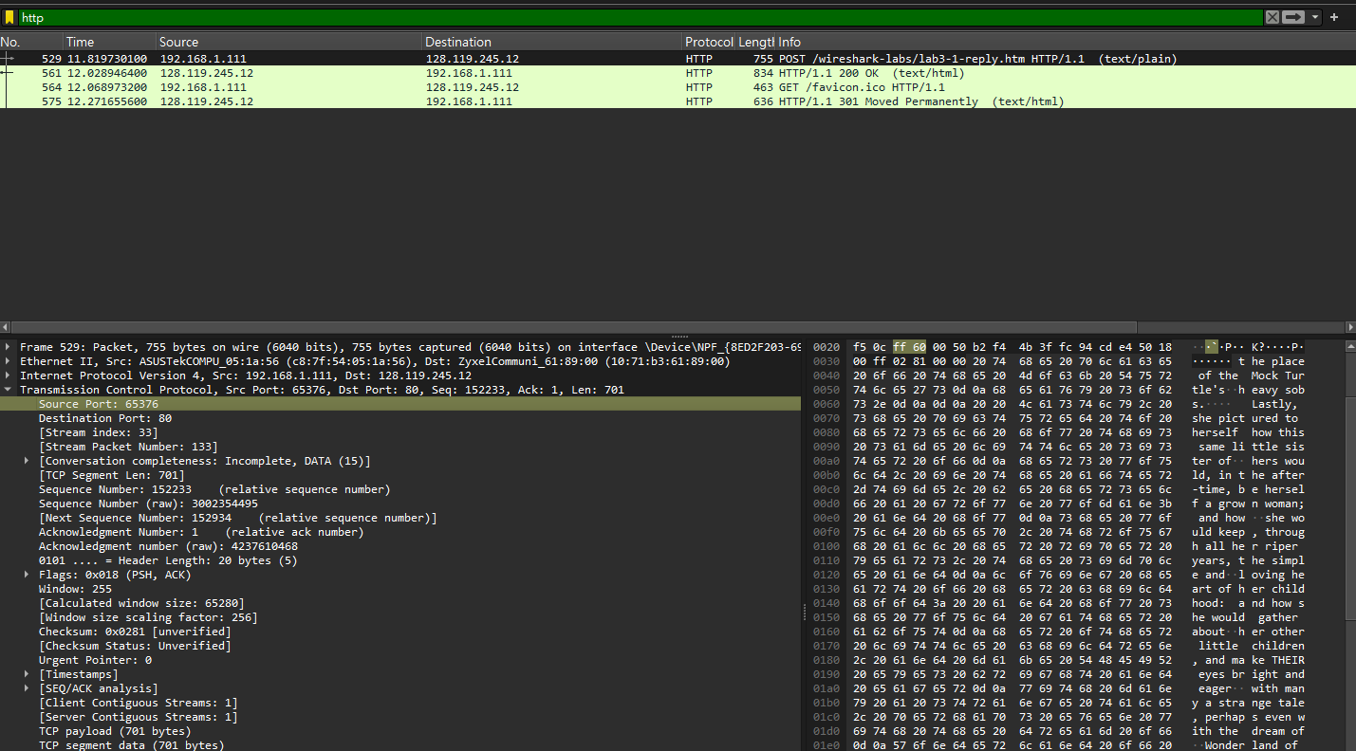
2. What is the IP address of gaia.cs.umass.edu? On what port number is it sending and receiving TCP segments for this connection?
IP 位址：128.119.245.12
TCP Port：80

Part 3. TCP Basics (第3~10題)
3. What is the sequence number of the TCP SYN segment that is used to initiate the TCP connection between the client computer and gaia.cs.umass.edu? (Note: this is the “raw” sequence number carried in the TCP segment itself; it is NOT the packet # in the “No.” column in the Wireshark window.) What is it in this TCP segment that identifies the segment as a SYN segment? Will the TCP receiver in this session be able to use Selective Acknowledgments?
Sequence Number (raw): 64353152
Flags: 0x002 (SYN)
TCP Option - SACK permitted Kind: SACK Permitted (4) Length: 2 => YES
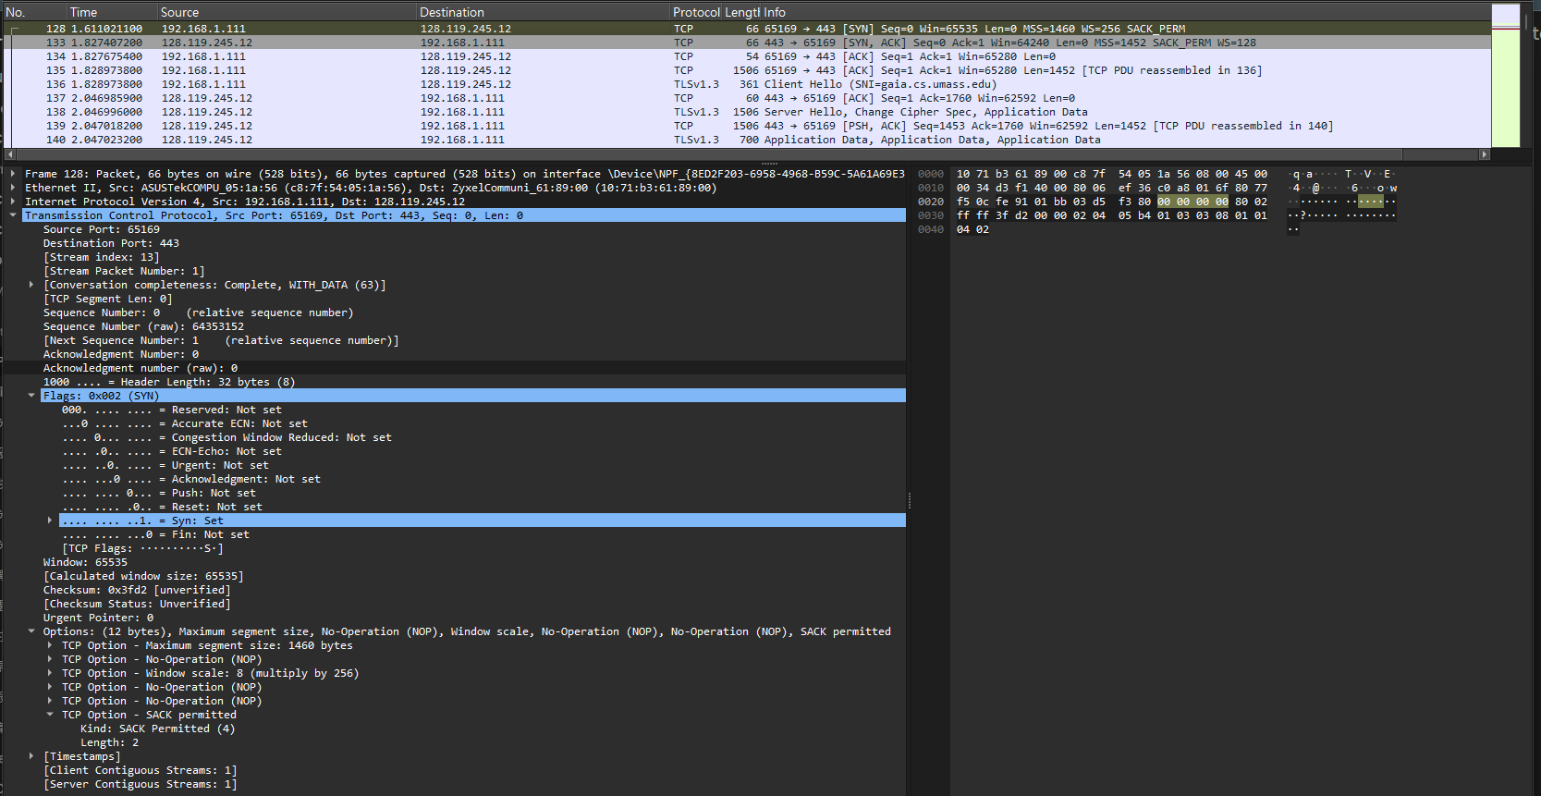

4. What is the sequence number of the SYNACK segment sent by gaia.cs.umass.edu to the client computer in reply to the SYN? What is it in the segment that identifies the segment as a SYNACK segment? What is the value of the Acknowledgement field in the SYNACK segment? How did gaia.cs.umass.edu determine that value?

Sequence Number (raw): 55775529
如何辨識此封包為 SYNACK 封包？Flags Syn = Set 或是 Flags = 0x012
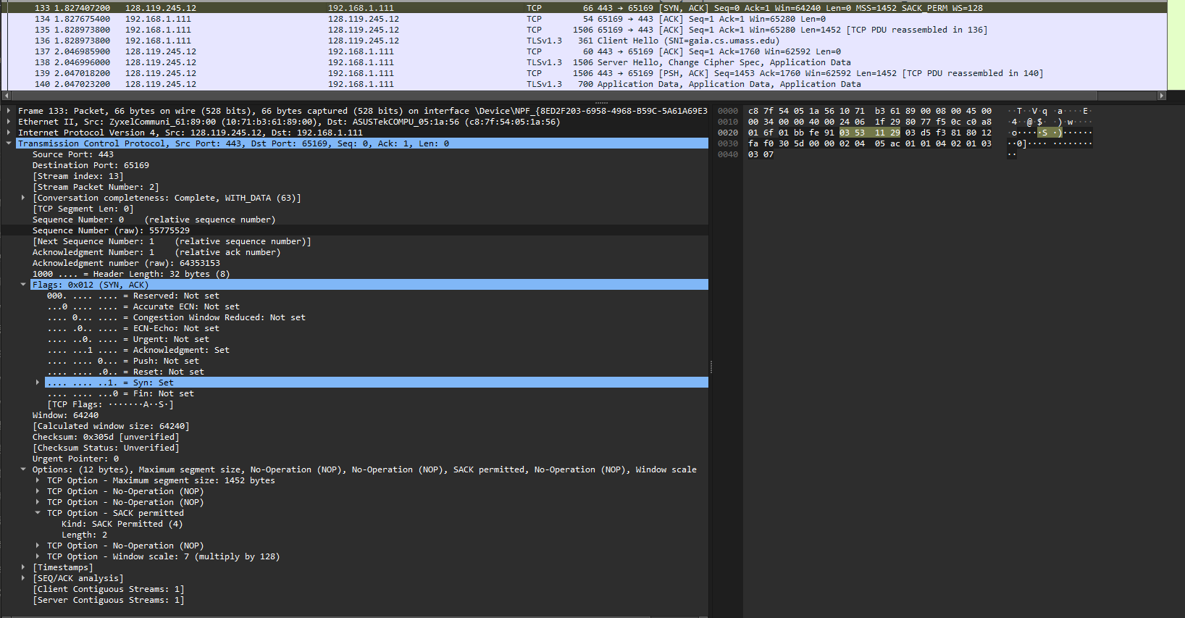
Acknowledgment number (raw): 64353153
伺服器 (gaia.cs.umass.edu) 如何決定此數值？：伺服器是將接收到的 SYN 封包原始序號直接 加 1 得到的。這個「+1」的動作代表伺服器已成功收到連線請求，並期待 Client 下一次發送序號從接續號碼開始的資料。

5. What is the sequence number of the TCP segment containing the header of the HTTP POST command? Note that in order to find the POST message header, you’ll need to dig into the packet content field at the bottom of the Wireshark window, looking for a segment with the ASCII text “POST” within its DATA field,. How many bytes of data are contained in the payload (data) field of this TCP segment? Did all of the data in the transferred file alice.txt fit into this single segment?
Sequence Number (raw): 3002354495
TCP payload (701 bytes)
否，alice.txt 148 KB
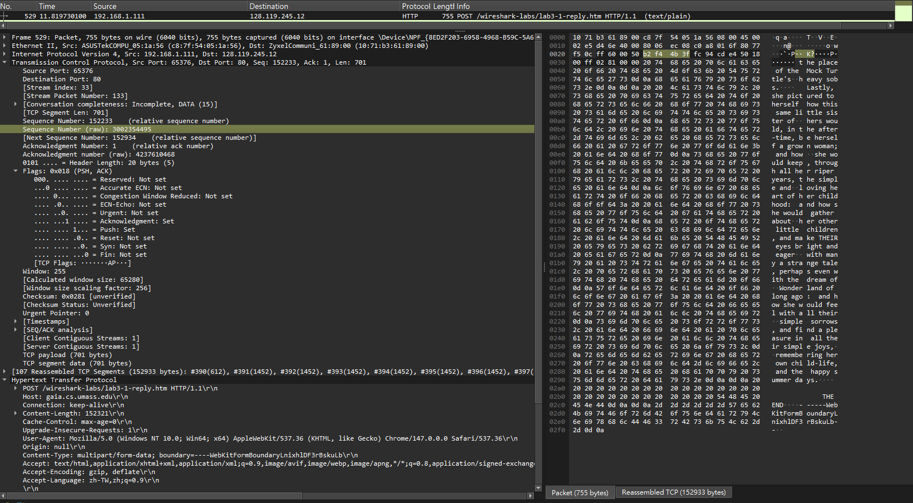

(第六題開始找不到答案，前面用自己抓的，這邊開始用 tcp-wireshark-trace1-1.pcapng 寫答案)
6. Consider the TCP segment containing the HTTP “POST” as the first segment in the data transfer part of the TCP connection.
- At what time was the first segment (the one containing the HTTP POST) in the data-transfer part of the TCP connection sent?
0.024047秒 (看編號 #4 封包)。
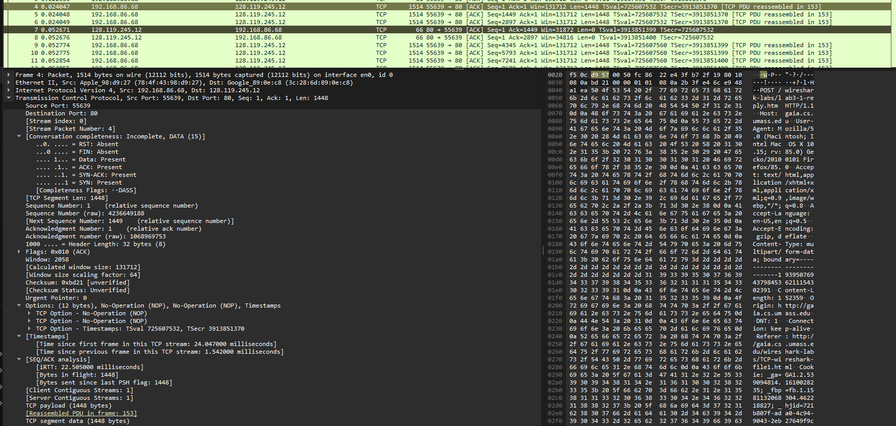
- At what time was the ACK for this first data-containing segment received?
0.052671 (看編號 #7 封包，其 Ack=1449 正好是針對 #4 的確認)。
- What is the RTT for this first data-containing segment?
計算：Frame 7 時間 0.052671 - Frame 4 時間 0.024047 = 0.028624 秒
- What is the RTT value the second data-carrying TCP segment and its ACK?
第二筆送出時間 (#5)：0.024048。其對應 ACK 時間 (#8)：0.052676。
計算結果：0.052676 - 0.024048 = 0.028628 秒。
- What is the EstimatedRTT value after the ACK for the second data-carrying segment is received? Assume that in making this calculation after the received of the ACK for the second segment, that the initial value of EstimatedRTT is equal to the measured RTT for the first segment, and then is computed using the EstimatedRTT equation on page 242, and a value of α = 0.125.
EstimatedRTT = 0.875 × 0.028624 + 0.125 × 0.028628 = 0.028624 秒
7. What is the length (payload) of each of the first four data-carrying TCP segments?
1448, 1448, 1448, 1448 bytes（都一樣）
8. What is the minimum amount of available buffer space advertised to the client by gaia.cs.umass.edu among these first four data-carrying TCP segments? Does the lack of receiver buffer space ever throttle the sender for these first four data-carrying segments?
看 server 回傳的 ACK 中的 Win 欄位（前四個資料段對應的 ACK）：
7 0.052671 128.119.245.12 192.168.86.68 TCP 66 80 → 55639 [ACK] Seq=1 Ack=1449 Win=31872 Len=0 TSval=3913851399 TSecr=725607532
8 0.052676 128.119.245.12 192.168.86.68 TCP 66 80 → 55639 [ACK] Seq=1 Ack=2897 Win=34816 Len=0 TSval=3913851400 TSecr=725607532
13 0.053626 128.119.245.12 192.168.86.68 TCP 66 80 → 55639 [ACK] Seq=1 Ack=4345 Win=37760 Len=0 TSval=3913851400 TSecr=725607532
16 0.080768 128.119.245.12 192.168.86.68 TCP 66 80 → 55639 [ACK] Seq=1 Ack=5793 Win=40576 Len=0 TSval=3913851421 TSecr=725607560
最小 buffer = 31872 bytes
有沒有被 throttle？沒有
- 理由：Frame 4-6 在 0.024秒立即發送
- Frame 7-8 的 ACK 一到（0.052秒），Frame 9-12 馬上繼續發送
- 說明 buffer 充足，sender 沒被限制
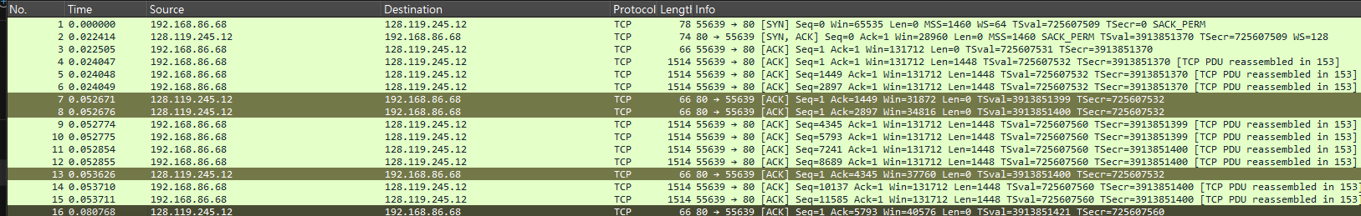

9. Are there any retransmitted segments in the trace file? What did you check for (in the trace) in order to answer this question?
沒有重傳
檢查方法：
- 看有沒有 [TCP Retransmission] 標記
- 看有沒有 相同 Seq number 出現多次
- 從 trace file 看，所有 Seq number 都是遞增的，沒有重複

10. What is the throughput (bytes transferred per unit time) for the TCP connection? Explain how you calculated this value.
看 trace file 中的時間和傳輸資料量：
傳輸時間 = 0.191496 - 0.024047 = 0.167449 秒
傳輸資料 = 153426 bytes
Throughput = 153426 bytes / 0.167449 秒 = 915,825 bytes/秒
≈ 915.8 KB/s 或 7.3 Mbps
[第一個數據段開始發送]
4 0.024047 192.168.86.68 128.119.245.12 TCP 1514 55639 → 80 [ACK] Seq=1 Ack=1 Win=131712 Len=1448 TSval=725607532 TSecr=3913851370 [TCP PDU reassembled in 153]
[server最後一個ACK]
178 0.191496 128.119.245.12 192.168.86.68 TCP 66 80 → 55639 [ACK] Seq=1 Ack=153426 Win=194816 Len=0 TSval=3913851541 TSecr=725607650

Part 4. TCP congestion control in action (第11~12題)
11. Use the Time-Sequence-Graph(Stevens) plotting tool to view the sequence number versus time plot of segments being sent from the client to the gaia.cs.umass.edu server. Consider the “fleets” of packets sent around t = 0.025, t = 0.053, t = 0.082 and t = 0.1. Comment on whether this looks as if TCP is in its slow start phase, congestion avoidance phase or some other phase.
TCP 在 Slow Start 階段
理由：
- 每個 RTT 後，發送的 packet 數量翻倍增長（3 → 4 → 8 → 11）
- Congestion Window (cwnd) 快速增加
- 這正是 slow start 的特徵：每收到一個 ACK，cwnd 增加 1 MSS
- 如果是 congestion avoidance，增長會更緩慢、線性
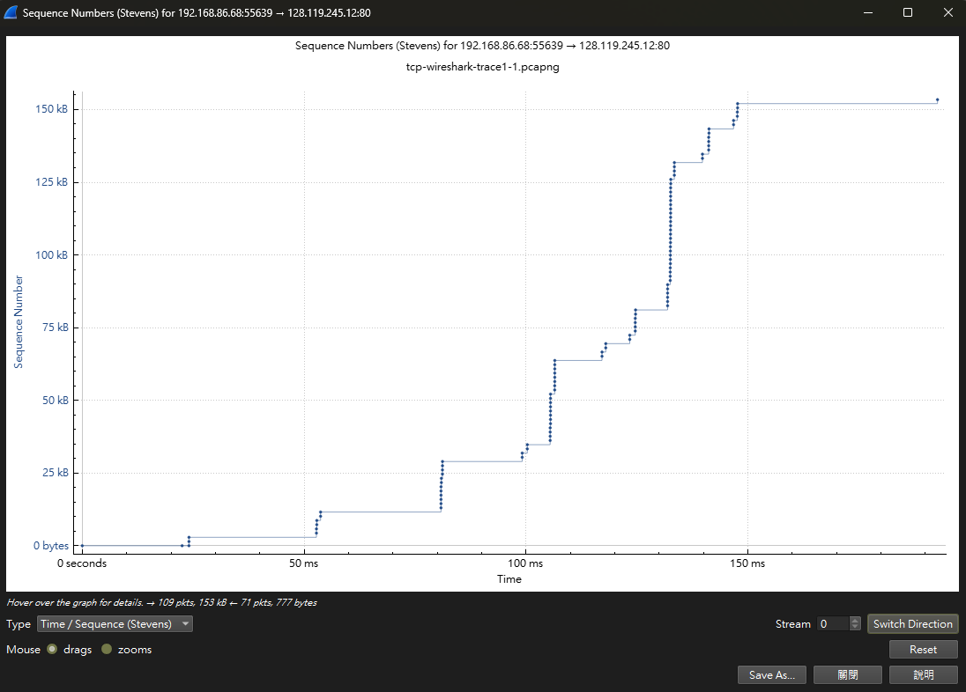

12. These “fleets” of segments appear to have some periodicity. What can you say about the period?
Fleet 1: 時間 0.024047
Fleet 2: 時間 0.052774 → 間隔 = 0.028727 秒
Fleet 3: 時間 0.080768 → 間隔 = 0.027994 秒
Fleet 4: 時間 0.105445 → 間隔 = 0.024677 秒
平均周期 ≈ 0.027-0.028 秒
周期性 ≈ 27-28 毫秒，接近 RTT (Round-Trip Time)
原因：每個 fleet 之間的間隔就是 RTT。當 client 發送完一批 packets 後，需要等待約 RTT 時間才能收到 ACK，然後觸發下一批 packets 發送。

