- Select the first UDP segment in your trace. What is the packet number⁴of this segment in the trace file? What type of application-layer payload or protocol message is being carried in this UDP segment? Look at the details of this packet in Wireshark. How many fields there are in the UDP header? (You shouldn’t look in the textbook! Answer these questions directly from what you observe in the packet trace.) What are the names of these fields?
Packet number：16
應用層協定：DNS
Header 欄位數量：4 個
欄位名稱：Source Port, Destination Port, Length, Checksum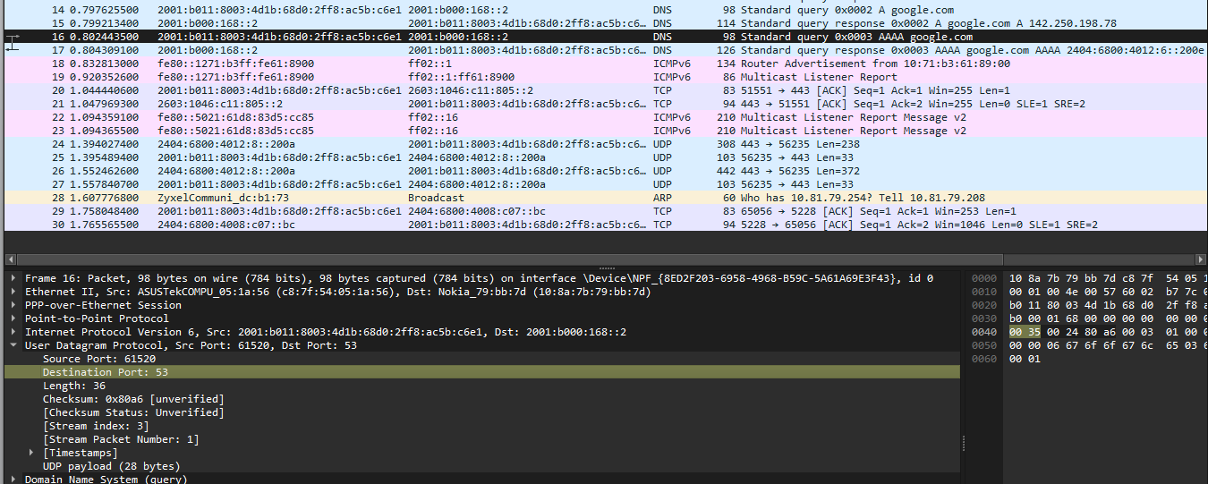
- By consulting the displayed information in Wireshark’s packet content field for this packet (or by consulting the textbook), what is the length (in bytes) of each of the UDP header fields?
每個 UDP Header 欄位（如 Source Port）的大小皆為 2 Bytes (16 bits)
- The value in the Length field is the length of what? (You can consult the text for this answer). Verify your claim with your captured UDP packet.
圖中顯示數值：36
驗證：UDP Header (8 bytes) + UDP payload (圖中標示為 28 bytes) = 36 bytes
這證明了 Length 欄位包含 Header 與資料的總長 。
- What is the maximum number of bytes that can be included in a UDP payload? (Hint: the answer to this question can be determined by your answer to 2. above)
Length 欄位最大值為 $2^{16} - 1 = 65535$。扣除 Header 的 8 bytes，最大可以攜帶 65527 bytes 的資料 。
- What is the largest possible source port number? (Hint: see the hint in 4.)
Port 欄位也是 16 bits，因此最大可能數值為 $2^{16} - 1 = 65535$ 。
- What is the protocol number for UDP? Give your answer in decimal notation. To answer this question, you’ll need to look into the Protocol field of the IP datagram containing this UDP segment (see Figure 4.13 in the text, and the discussion of IP header fields).
17
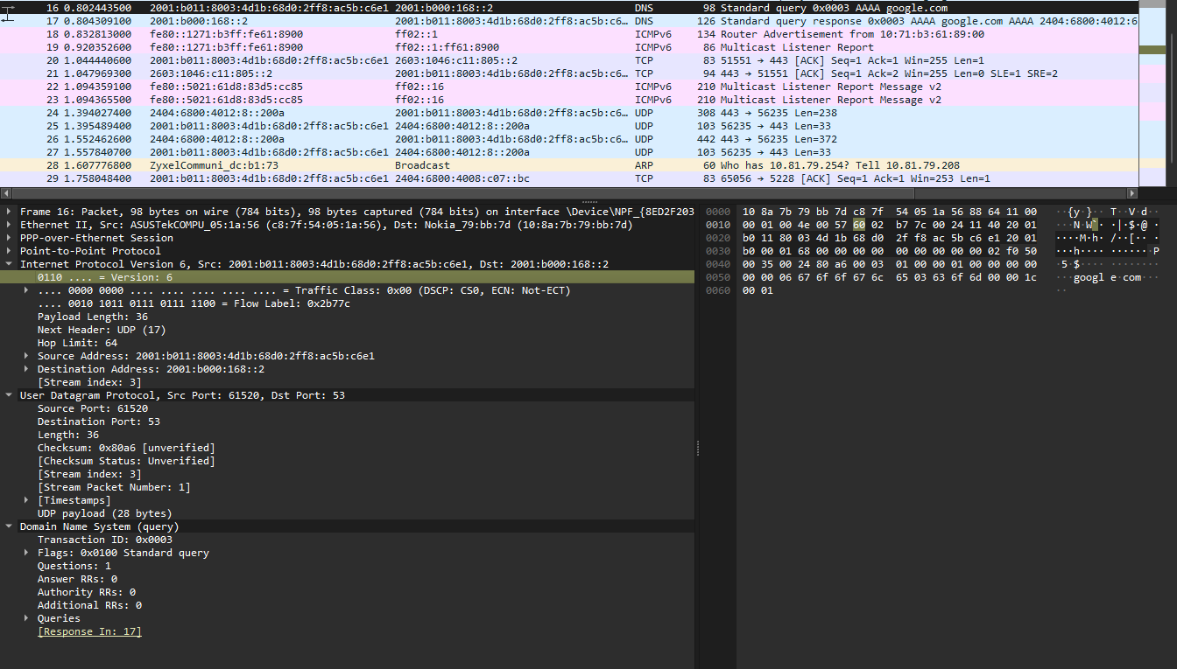

- Examine the pair of UDP packets in which your host sends the first UDP packet and the second UDP packet is a reply to this first UDP packet. (Hint: for a second packet to be sent in response to a first packet, the sender of the first packet should be the destination of the second packet). What is the packet number⁵of the first of these two UDP segments in the trace file? What is the packet number⁶of the second of these two UDP segments in the trace file? Describe the relationship between the port numbers in the two packets.
觀察封包 No. 16 與 No. 17，No. 16 為請求封包，其 Source Port 為 61520、Destination Port 為 53；而 No. 17 為其回應封包，兩者的埠號剛好對調，No. 17 的 Source Port 變為 53，Destination Port 則為 61520。
