Web Hybrid

PhoneGap

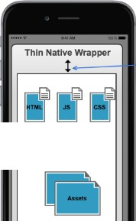

**WebView**

----Bridge

Device Access via plugins: camera, contacts, gps, file system etc