Original: 0.85253
Bayes: 0.85358
LDA: 0.85359
Most_popular: 0.85359
1.Abstract
2.Introduction: 或者不写abstract
3. Data Analysis
数据的多少，输入输出数据是什么，各个特征是什么，如何判断score
4. visualization
数据可视化，解释不同特征是否useful，特征对于结果的影响
5. Pre Processing (feature engineering)
对于数据处理： 如何处理missing data, 哪些特征应该去掉，对于age? 注册时间等如何处理，数据normalize
6.model :SVM为什么不行，贝叶斯，LDA，Xb, Random tree?没有做
7. result: 结果与分析，不同model的优劣，是否overfitting,
8. conclusion

后面的是我看报告时候乱记的，可以不用看

LDA和QDA除了前述linear_model的方法外，还有一个predict_proba(X)和predict_log_proba(X)来求对于给定样本X，数据属于不同类别的概率。
Missing data:
We should detect the missing data and replace them with Nan, if we see the gender colomun of train_users, we can show that we have a lot of -unkonown- value in the gender column :
Visualize data
present our data depending to different kind of features
to better select features
As we can see 98% of users speak English, this figure isn't verry useful, so let's see the histogram of languages without English.
We can say that there is no difference between the two gender, so this figure isn't verry useful
The age show some interesting differentiation by country destination that could be useful. Users how book trips to Spain and Portugal tend to be younger while those that book trips to Great Britain or United States.
people how doesn't book do much less action compared to people how book. In average people how doesn't book do 10 actions and people how book do 14 actions in average.

Feature engineering:

Preprocessing step and encoding categorical features using OneHotEncoder
The main goal of this approach is to encode categorical features (gender, language ...) using the OneHotEncoder algorithm

Data Analysis
Dataset
In this project, we are given a list of users along with their demographics, web session records, and summary statistics. The users are all from America and the data are real dataset from Airbnb.
The data sources include three files: train_users.csv, test_users.csv and session.csv. The train dataset has 213k users and the test dataset includes 62.1k other users.
The train set includes:
  - id: user id
  - date_account_created: the date of account creation
  - timestamp_first_active: timestamp of the first activity, note that it can be earlier than date_account_created or date_first_booking because a user can search before signing up
  - date_first_booking: date of first booking
  - gender
  - age
  - signup_method
  - signup_flow: the page a user came to signup up from
  - language: international language preference
  - affiliate_channel: what kind of paid marketing
  - affiliate_provider: where the marketing is e.g. google, craigslist, other
  - first_affiliate_tracked: whats the first marketing the user interacted with before the signing up
  - signup_app
  - first_device_type
  - first_browser
  - country_destination: this is the target variable you are to predict
The session.csv - web sessions log for users
  - user_id: to be joined with the column 'id' in users table
  - action
  - action_type
  - action_detail
  - device_type
  - secs_elapsed

Data Visualization
In this session, we need to visualize data in order to show the relation between each feature and the destination. We have got 15 features like shown in the Dataset, while some of them have nothing to do with predicting a user’s destination country. On the other hand, visualizing data could help us get rid of the unreasonable and useless data.
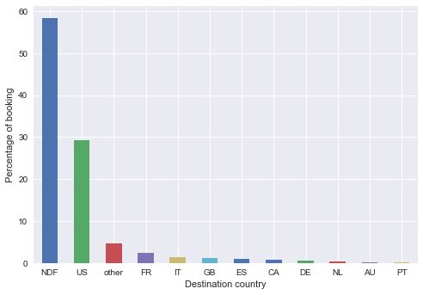
first, we see the distribution of the destination country of the 213k users. As we can see from the figure that nearly 60% of users do not make a booking and of those who booked, most of them choose to travel in US.
Now we see the influence of gender and language to destination country. As shown in Figure.2, there is basically no difference between the genders, so we could drop this feature with no effect on prediction. We could tell from Figure 1 that people who booked tend to travel in US.
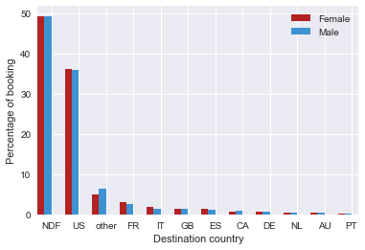
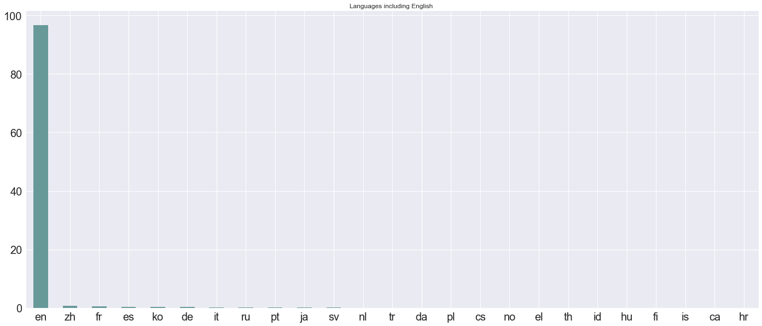
Since all of the users in train set are from US, no surprisingly almost all language lie in English. So we could remove this feature to make our model more clear.
Age:
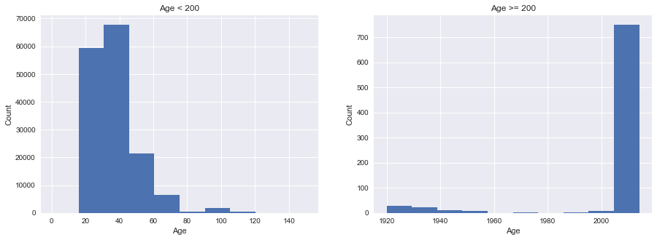
We can observe from Figure 5 that people who signed up are largely in range [20,40] and some signed up with age larger than 1900 which is phony undoubtedly. So we should get rid of these false data. The specific process is shown in next section.
figure 4 shows the probability density of four destination outputs versus age. Young people are inclined to choose US while older people have more booking to other countries. So age is an important feature for prediction.

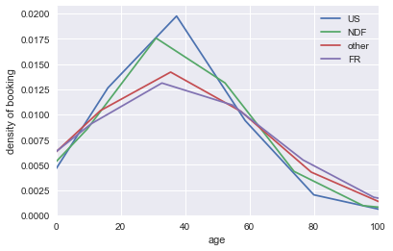
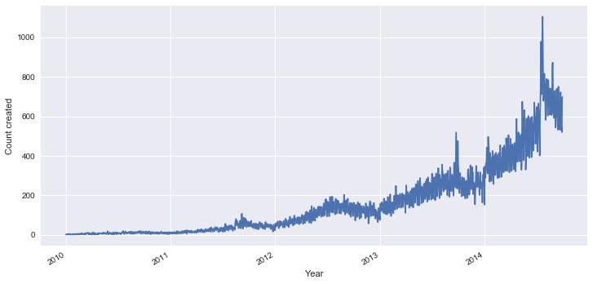
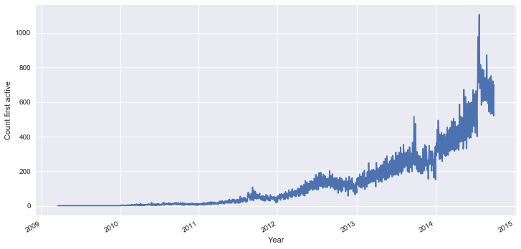
th
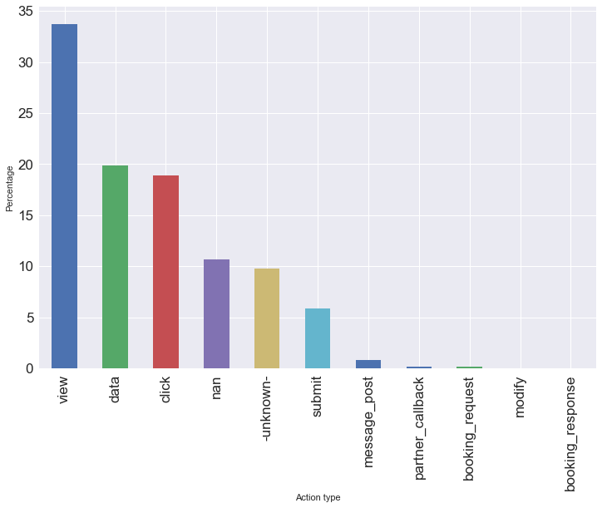
Since we may assume the distribution of data in a wrong way, we determine to choose a model that can adapt the unknown and hidden nonlinearity of data, and is not very sensitive to noise in the input data. One popular method is to use boosting whose basic idea is to learn from the previous error and then correct. This method can select the useful features automatically and is easy to understand highly dimensional data. Because of the gradient descent of function space, the performance could be adjusted by the negative descent of the previous round through GradientBoostingClassifier. A challenge is to select a proper set of parameter in order not to overfit.

