Palau Indicators

Phoebe.Woodworth-Jefcoats@noaa.gov & Hui.Shi@noaa.gov

2023-08-23

Table of contents

# 1. Index

## 1.1 Introduction

Here are two ocean and climate indicators for the Palau EEZ. Have questions or want to suggest a change? Simply [create an issue](https://github.com/pwoodworth-jefcoats/Palau-ocean-climate/issues) or email <phoebe.woodworth-jefcoats@noaa.gov>.

# 2. Chlorophyll-Concentration

## 2.1 **Indicator: Chlorophyll Concentration**

Phytoplankton are the foundation of the marine food web. Their abundance affects food availability for all consumers, ranging from zooplankton to apex predators. Chlorophyll concentration is used as a proxy for phytoplankton abundance. Some climate change projections suggest a shift towards lower phytoplankton abundances, particularly in the ocean’s oligotrophic gyres. Chlorophyll concentration (and phytoplankton abundance) varies greatly across the Pacific basin, with higher concentrations generally found at higher latitudes and particularly around coastlines. Chlorophyll concentrations also vary in response to natural climate variability.

Chlorophyll-a concentration is estimated from satellite remotely sensed observations of ocean color, which extend back to 1998. The basin-wide average (1998 – 2021) is shown below. The Palau EEZ is also highlighted as a spatial average (1998 – 2021) and a time series averaged over this area. No significant trend in chlorophyll concentration was detected over this region and time span.

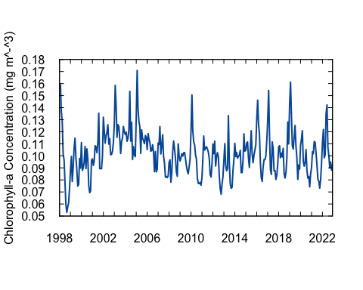

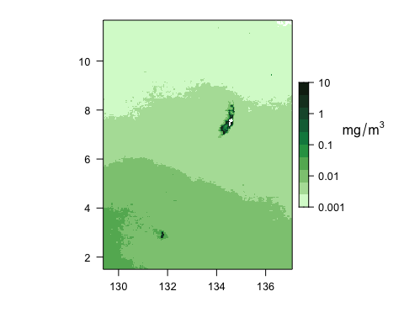

# 3. Estimated-Phytoplankton-Size

## 3.1 **Indicator: Estimated Phytoplankton Size**

Phytoplankton size provides insight into ecosystem productivity with larger phytoplankton generally supporting more productive ecosystems with larger fish. Some climate change projections suggest a shift towards smaller phytoplankton, particularly in the ocean’s oligotrophic gyres, potentially reducing food available to all trophic levels. Phytoplankton size varies greatly across the Pacific basin, with larger phytoplankton generally found at higher latitudes and closer to coastlines.  
Phytoplankton size also varies with natural climate cycles such as ENSO, with larger phytoplankton more prevalent across the equatorial Pacific during cooler La Niña periods and vice versa during El Niño.

Estimated median phytoplankton size can be derived from satellite remotely sensed sea surface temperature and chlorophyll-a concentration. The basin-wide average (1998 – 2021) is shown below. The Palau EEZ is also highlighted as a spatial average (1998 – 2021) and a time series averaged over this area. A statistically significant (p < 0.05) decline in estimated median phytoplankton size was detected over this area. From 1998 through 2022, estimated median phytoplankton size declined by 0.031 $μ$ m Equivalent Spherical Diameter (ESD).

