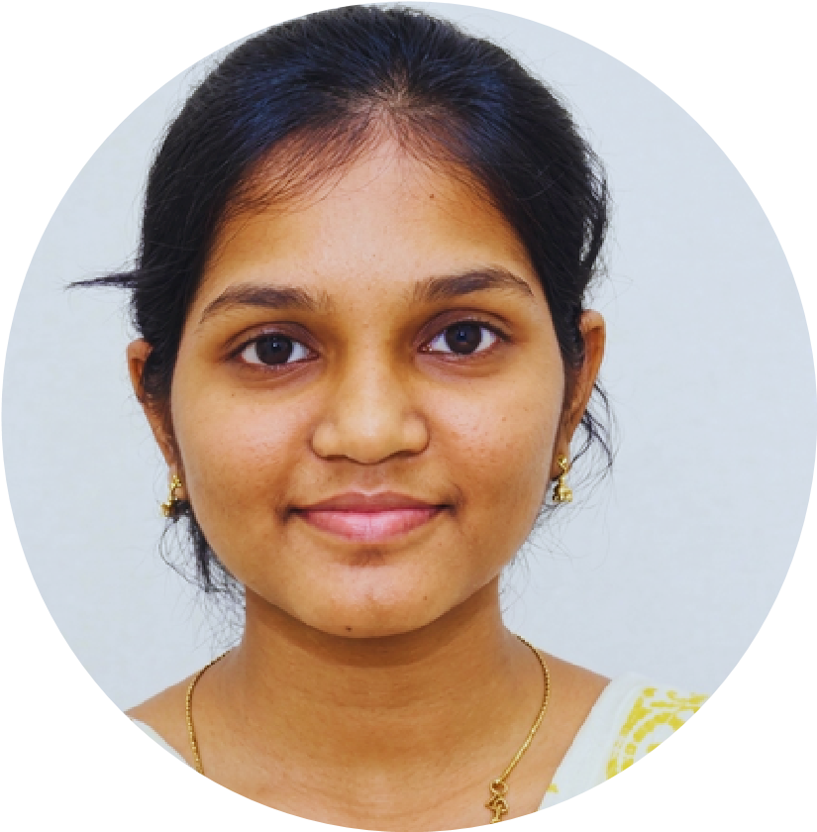
PROFILE INFO
STUDENT
DAISY
EDUCATION
SKILLS
LANGUAGES
CONTACT
Enthusiastic
and
dedicated
B.Tech
Computer
Science
student with a strong interest in software development
and
technology.
Possess
basic
knowledge
of
C,
Java,
Python, and HTML. Eager to learn new skills, participate in
innovative projects, and gain practical experience while
contributing effectively to team goals.
ACHIVEMENTS
Programming Languages
C
Java
Python (Basic)
Web Technologies
HTML
Tools & Applications
MS Office
Soft Skills
Communication Skills
Teamwork
Problem Solving
Quick Learning
Vijayawada,Andhra Pradesh
+91 8688808104
daisybollepogu15@gmail.com
B.Tech – Computer Science and Engineering
DhaneKula
Institute
of
Engineering
&

Technology, Ganguru
2028
–
2024
Intermediate (MPC)

Sri Bhavishya Junior College
2022
–
2024
Secondary School Certificate (SSC)

ASNRA ZPHS, Kanuru
2022
–
2021
VOLUNTEER EXPERIENCE
SMART INDIA HACKATHON
(
SIH
)
PARTICIPANT
P
ARTICIPAT
ED IN IDEA DISCUSSIONS AND
PROJECT ACTIVITIES.
D
EVELOPED TEAMWORK AND ANALYTICAL SKILLS.
COMPUTER SKILLS
Programming Fundamentals (C, Java)
Basic Python Development
HTML & Web Page Design
Microsoft Office Suite
Visual Studio Code (VS Code)
TELUGU
ENGLISH
HINDI
NPTEL CERTIFIED IN QUANTUM COMPUTING
PARTICIPATED IN SMART INDIA HACKATHON (SIH)

