Natural History Study Results

July 02, 2024

# Original Data Received

* On May 30th, 2024, Muhammad Jehanzeb Khan sent an Excel sheet containing the Natural History study data.
* Total 30 consented patients.

# Data Error:

* On June 10th, 2024, a biostatistician sent an email to confirm a potential data entry error for NRP-008, Visit 5, with EZ_width_OD recorded as 89 and EZ_width_OS as 88.
* On June 12th, 2024, feedback indicated that the correct values should be 2369 for EZ_width_OD and 2451 for EZ_width_OS.

# Data merge from Redcap

* On June 10th, 2024, Dagmar Wehling provided a list of NAC Attack patients also enrolled in the Natural History Study.
* Merged the Natural History data with the Redcap data for EZ width and calculated the follow-up month.

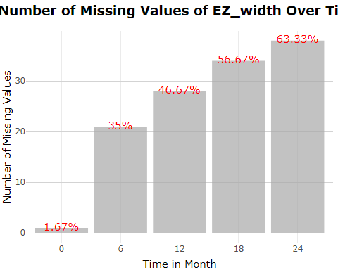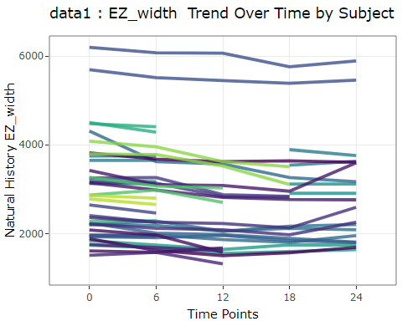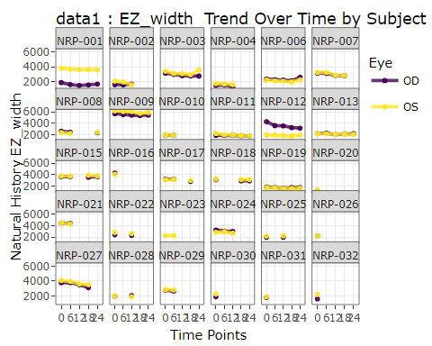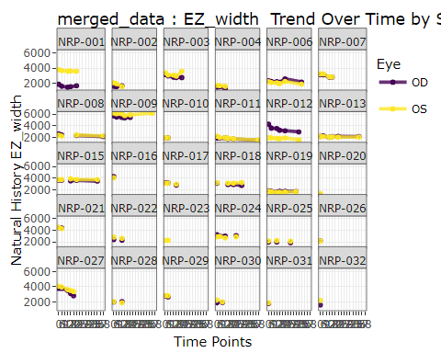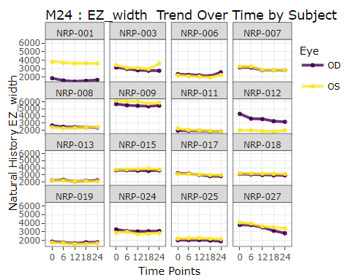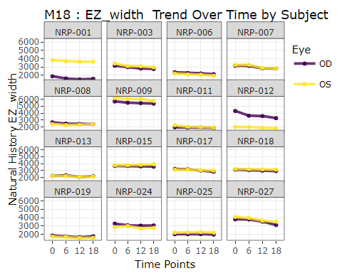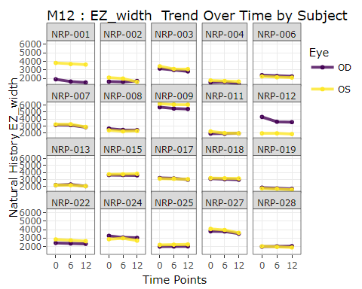

# To understand the missing data patterns in the dataset for EZ_width, we counted the number of missing as well as the percentage of missing for all consented patients.

* The table shows the missing number and missing percentage for EZ_width for each time point among all consented patients.

| Time | n_missing_EZ_width | total_EZ_width | proportion_missing |
| --- | --- | --- | --- |
| 0 | 1 | 60 | 1.67% |
| 6 | 21 | 60 | 35% |
| 12 | 28 | 60 | 46.67% |
| 18 | 34 | 60 | 56.67% |
| 24 | 38 | 60 | 63.33% |

* Time 0 represent for the baseline visit. other numeric number represent the month of the follow up visit. (i.e. 6 is Month 6 Followup time point).
* Based on the missing data patterns for EZ_width, We selected baseline to 24 month data to calculate the AAC and change of MAIA as well as VA, 6 month gap between each visit.
* Below is a summary of missing {outcome variable} among eligible patients.

**Summary of missing EZ among eligible patients**

| **Characteristic** | **OD**, N = 30 | **OS**, N = 30 |
| --- | --- | --- |
| **time0_missing** |  |  |
| Missing | 1 (3.3%) | 0 (0%) |
| Non-Missing | 29 (97%) | 30 (100%) |
| **time24_missing** |  |  |
| Missing | 19 (63%) | 19 (63%) |
| Non-Missing | 11 (37%) | 11 (37%) |
| **time_both_missing** |  |  |
| Baseline Not Missing, Follow up Missing | 18 (60%) | 19 (63%) |
| Missing | 1 (3.3%) | 0 (0%) |
| Non-Missing | 11 (37%) | 11 (37%) |

**Summary of missing MAIA among eligible patients**

| **Characteristic** | **OD**, N = 30 | **OS**, N = 30 |
| --- | --- | --- |
| **time0_missing** |  |  |
| Missing | 1 (3.3%) | 0 (0%) |
| Non-Missing | 29 (97%) | 30 (100%) |
| **time24_missing** |  |  |
| Missing | 19 (63%) | 19 (63%) |
| Non-Missing | 11 (37%) | 11 (37%) |
| **time_both_missing** |  |  |
| Baseline Not Missing, Follow up Missing | 18 (60%) | 19 (63%) |
| Missing | 1 (3.3%) | 0 (0%) |
| Non-Missing | 11 (37%) | 11 (37%) |

**Summary of missing VA among eligible patients**

| **Characteristic** | **OD**, N = 30 | **OS**, N = 30 |
| --- | --- | --- |
| **time0_missing** |  |  |
| Non-Missing | 30 (100%) | 30 (100%) |
| **time24_missing** |  |  |
| Missing | 19 (63%) | 19 (63%) |
| Non-Missing | 11 (37%) | 11 (37%) |
| **time_both_missing** |  |  |
| Baseline Not Missing, Follow up Missing | 19 (63%) | 19 (63%) |
| Non-Missing | 11 (37%) | 11 (37%) |

# Missing Data Imputation for for calculating EZ width AAC

* Filling Missing EZ Width Values: We used linear interpolation and carry forward method to fill in missing Ellipsoid Zone (EZ) width values in the data set.
* The key steps were:
* Identified patients with available data group by (patient_id,Eye). • Applied na.approx() function to linearly interpolate missing EZ width values, and used carry forward method to fill missing for those missed last visit.

# Area Above Curve with outcome measurements observed at pre-specified follow-up visits. The AAC can be empirically and non-parametrically estimated as the sum of all the trapezoids determined by the measurements at all visits.

To estimate the AAC, the area can be non-parametrically estimated as the sum of trapezoids (Let y_i be the outcome variable measured at visit j, j = 0,1,2…K ; The interval length, denoted as t;

$$AAC=\left(\sum_{j=1}^{k−1}{\left(\left(y_{0}−y_{i}\right)+\frac{1}{2}×\left(y_{0}−y_{k}\right)\right)}\right)×\left(t\right)$$

# General calculations for the AAC are conducted. Following this, the between-eye correlation analysis for the AAC of EZ-width is performed.

Protocol Addendum to be added as 6.1.2.4

Although EZ loss is expected to be a degenerative process, it is unknown whether EZ width at a follow-up visit may be greater than that at baseline due to measurement error or due to intervention effect. The AAC is the cumulative loss of EZ width overtime. Its calculation needs to consider if there was gain of EZ width during follow-up (i.e. negative loss). Section 6.1.2.3 derives the AAC calculation if y1 is increased compared to y0 . Here we provide an algorithm that derives the general AAC calculation without assuming whether a follow-up EZ-width measurement is greater than y0. general_AAC_calculation is a function will escalate for AAC

## Month 24 EZ width AAC & Correlation

[1] “Month24 data: Between-eye correlation of the AAC of EZ-width:” Correlation Coefficient: 0.2251643 95% Confidence Interval - Lower Bound: -0.3045314 95% Confidence Interval - Upper Bound: 0.6484885

| correlation | lower_bound | upper_bound |
| --- | --- | --- |
| 0.2251643 | -0.3045314 | 0.6484885 |

[1] “Month24 and Month 18data are same for : Baseline EZ-width Correlation” Correlation Coefficient: 0.7104933 95% Confidence Interval - Lower Bound: 0.3315628 95% Confidence Interval - Upper Bound: 0.8920299

| correlation | lower_bound | upper_bound |
| --- | --- | --- |
| 0.7104933 | 0.3315628 | 0.8920299 |

[1] “Month12 data: Baseline EZ-width Correlation” Correlation Coefficient: 0.7536708 95% Confidence Interval - Lower Bound: 0.4668523 95% Confidence Interval - Upper Bound: 0.8970215

| correlation | lower_bound | upper_bound |
| --- | --- | --- |
| 0.7536708 | 0.4668523 | 0.8970215 |

[1] “Summary statistics for EZ width : Baseline until Month24”

| **Eligible Sample Eyes** | **N = 32***1* |
| --- | --- |
| **y0** | 3,031 (1,054); 1,740~6,197; 3,129 [2,210 - 3,481] |
| **y1** | 2,934 (1,024); 1,625~6,075; 3,020 [2,174 - 3,354] |
| **y2** | 2,837 (1,018); 1,507~6,065; 2,827 [2,058 - 3,245] |
| **y3** | 2,780 (969); 1,574~5,758; 2,795 [2,087 - 3,113] |
| **y4** | 2,816 (972); 1,642~5,888; 2,818 [2,129 - 3,133] |
| **Category** |  |
| DownDownDownDown | 19 (59%) |
| DownDownDownUp | 4 (13%) |
| DownUpDownDown | 1 (3.1%) |
| EqualDownDownDown | 1 (3.1%) |
| EqualUpUpUp | 1 (3.1%) |
| UpDownDownDown | 4 (13%) |
| UpUpDownDown | 2 (6.3%) |
| **AAC_general** | 3,899 (3,682); -1,332~18,291; 2,975 [1,445 - 5,505] |
| **Eye** |  |
| OD | 16 (50%) |
| OS | 16 (50%) |
| *1*Mean (SD); Minimum~Maximum; Median [IQR]; n (%) | |

## Month 18 EZ width AAC

[1] “Month 18 data: Between-eye correlation of the AAC of EZ-width:” Correlation Coefficient: 0.1560498 95% Confidence Interval - Lower Bound: -0.3681323 95% Confidence Interval - Upper Bound: 0.6049587

| correlation | lower_bound | upper_bound |
| --- | --- | --- |
| 0.1560498 | -0.3681323 | 0.6049587 |

[1] “Summary statistics for EZ width : Baseline until Month18”

| **Eligible Sample Eyes** | **N = 32***1* |
| --- | --- |
| **y0** | 3,031 (1,054); 1,740~6,197; 3,129 [2,210 - 3,481] |
| **y1** | 2,934 (1,024); 1,625~6,075; 3,020 [2,174 - 3,354] |
| **y2** | 2,837 (1,018); 1,507~6,065; 2,827 [2,058 - 3,245] |
| **y3** | 2,780 (969); 1,574~5,758; 2,795 [2,087 - 3,113] |
| **Category** |  |
| DownDownDown | 23 (72%) |
| DownUpDown | 1 (3.1%) |
| EqualDownDown | 1 (3.1%) |
| EqualUpUp | 1 (3.1%) |
| UpDownDown | 4 (13%) |
| UpUpDown | 2 (6.3%) |
| **AAC_general** | 2,501 (2,343); -867~11,739; 2,133 [942 - 3,434] |
| **Eye** |  |
| OD | 16 (50%) |
| OS | 16 (50%) |
| *1*Mean (SD); Minimum~Maximum; Median [IQR]; n (%) | |

## Month 12 EZ width AAC

[1] “Month 12 data: Between-eye correlation of the AAC of EZ-width:” Correlation Coefficient: -0.04231747 95% Confidence Interval - Lower Bound: -0.4759259 95% Confidence Interval - Upper Bound: 0.4078407

| correlation | lower_bound | upper_bound |
| --- | --- | --- |
| -0.0423175 | -0.4759259 | 0.4078407 |

[1] “Summary statistics for EZ width : Baseline until Month12”

| **Eligible Sample Eyes** | **N = 32***1* |
| --- | --- |
| **y0** | 3,031 (1,054); 1,740~6,197; 3,129 [2,210 - 3,481] |
| **y1** | 2,934 (1,024); 1,625~6,075; 3,020 [2,174 - 3,354] |
| **y2** | 2,837 (1,018); 1,507~6,065; 2,827 [2,058 - 3,245] |
| **y3** | 2,780 (969); 1,574~5,758; 2,795 [2,087 - 3,113] |
| **Category** |  |
| DownDownDown | 23 (72%) |
| DownUpDown | 1 (3.1%) |
| EqualDownDown | 1 (3.1%) |
| EqualUpUp | 1 (3.1%) |
| UpDownDown | 4 (13%) |
| UpUpDown | 2 (6.3%) |
| **AAC_general** | 2,501 (2,343); -867~11,739; 2,133 [942 - 3,434] |
| **Eye** |  |
| OD | 16 (50%) |
| OS | 16 (50%) |
| *1*Mean (SD); Minimum~Maximum; Median [IQR]; n (%) | |

# Calculate Correlation and Summary Statistics Using Month 24 data; (Mean and standard deviation) for Secondary Outcome(change_MAIA,change_VA)

[1] “change_MAIA Correlation” Correlation Coefficient: 0.7595595 95% Confidence Interval - Lower Bound: 0.293344 95% Confidence Interval - Upper Bound: 0.933908

| correlation | lower_bound | upper_bound |
| --- | --- | --- |
| 0.7595595 | 0.293344 | 0.933908 |

[1] “MAIA Baseline Correlation” Correlation Coefficient: 0.8397695 95% Confidence Interval - Lower Bound: 0.5894318 95% Confidence Interval - Upper Bound: 0.9429467

| correlation | lower_bound | upper_bound |
| --- | --- | --- |
| 0.8397695 | 0.5894318 | 0.9429467 |

[1] “MAIA Month 24 Correlation” Correlation Coefficient: 0.8263804 95% Confidence Interval - Lower Bound: 0.4491702 95% Confidence Interval - Upper Bound: 0.9535546

| correlation | lower_bound | upper_bound |
| --- | --- | --- |
| 0.8263804 | 0.4491702 | 0.9535546 |

[1] ” ” [1] ” ” [1] “change_VA Correlation” Correlation Coefficient: 0.2980389 95% Confidence Interval - Lower Bound: -0.3675487 95% Confidence Interval - Upper Bound: 0.7617276

| correlation | lower_bound | upper_bound |
| --- | --- | --- |
| 0.2980389 | -0.3675487 | 0.7617276 |

[1] “VA Baseline Correlation” Correlation Coefficient: 0.6623981 95% Confidence Interval - Lower Bound: 0.2481856 95% Confidence Interval - Upper Bound: 0.8718333

| correlation | lower_bound | upper_bound |
| --- | --- | --- |
| 0.6623981 | 0.2481856 | 0.8718333 |

[1] “VA Month 24 Correlation” Correlation Coefficient: 0.8717405 95% Confidence Interval - Lower Bound: 0.5698713 95% Confidence Interval - Upper Bound: 0.966302

| correlation | lower_bound | upper_bound |
| --- | --- | --- |
| 0.8717405 | 0.5698713 | 0.966302 |

[1] “Summary statistics for MAIA”

| **Variable** | **N = 32***1* |
| --- | --- |
| **Eye** |  |
| OD | 16 (50%) |
| OS | 16 (50%) |
| **MAIA_Month24** | 10.1 (6.1); 3.1~22.9; 9.7 [4.9 - 14.5] |
| Unknown | 10 |
| **MAIA_Baseline** | 13.3 (5.6); 3.7~26.1; 13.8 [9.2 - 17.7] |
| **change_MAIA** | -2.65 (1.78); -7.70~0.00; -2.40 [-3.20 - -1.60] |
| Unknown | 10 |
| *1*n (%); Mean (SD); Minimum~Maximum; Median [IQR] | |

[1] “Summary statistics for VA”

| **Variable** | **N = 32***1* |
| --- | --- |
| **Eye** |  |
| OD | 16 (50%) |
| OS | 16 (50%) |
| **VA_Month24** | 82.8 (5.9); 69.0~94.0; 83.5 [79.3 - 86.5] |
| Unknown | 10 |
| **VA_Baseline** | 81 (8); 57~95; 84 [77 - 87] |
| **change_VA** | 1.1 (4.5); -5.0~15.0; 0.5 [-1.0 - 2.8] |
| Unknown | 10 |
| *1*n (%); Mean (SD); Minimum~Maximum; Median [IQR] | |

# Calculate Correlation and Summary Statistics Using Month 18 data; (Mean and standard deviation) for Secondary Outcome(change_MAIA,change_VA)

[1] “change_MAIA Correlation” Correlation Coefficient: 0.762961 95% Confidence Interval - Lower Bound: 0.3363236 95% Confidence Interval - Upper Bound: 0.9297556

| correlation | lower_bound | upper_bound |
| --- | --- | --- |
| 0.762961 | 0.3363236 | 0.9297556 |

[1] “MAIA Baseline Correlation” Correlation Coefficient: 0.8397695 95% Confidence Interval - Lower Bound: 0.5894318 95% Confidence Interval - Upper Bound: 0.9429467

| correlation | lower_bound | upper_bound |
| --- | --- | --- |
| 0.8397695 | 0.5894318 | 0.9429467 |

[1] “MAIA Month 18 Correlation” Correlation Coefficient: 0.7967208 95% Confidence Interval - Lower Bound: 0.4105294 95% Confidence Interval - Upper Bound: 0.9405609

| correlation | lower_bound | upper_bound |
| --- | --- | --- |
| 0.7967208 | 0.4105294 | 0.9405609 |

[1] ” ” [1] “change_VA Correlation” Correlation Coefficient: 0.2021774 95% Confidence Interval - Lower Bound: -0.3925351 95% Confidence Interval - Upper Bound: 0.6776722

| correlation | lower_bound | upper_bound |
| --- | --- | --- |
| 0.2021774 | -0.3925351 | 0.6776722 |

[1] “VA Baseline Correlation” Correlation Coefficient: 0.6623981 95% Confidence Interval - Lower Bound: 0.2481856 95% Confidence Interval - Upper Bound: 0.8718333

| correlation | lower_bound | upper_bound |
| --- | --- | --- |
| 0.6623981 | 0.2481856 | 0.8718333 |

[1] “VA Month 18 Correlation” Correlation Coefficient: 0.4747132 95% Confidence Interval - Lower Bound: -0.1032881 95% Confidence Interval - Upper Bound: 0.8130398

| correlation | lower_bound | upper_bound |
| --- | --- | --- |
| 0.4747132 | -0.1032881 | 0.8130398 |

[1] “Summary statistics for MAIA”

| **Variable** | **N = 32***1* |
| --- | --- |
| **Eye** |  |
| OD | 16 (50%) |
| OS | 16 (50%) |
| **MAIA_Month18** | 10.6 (5.7); 3.5~22.6; 10.1 [5.4 - 14.7] |
| Unknown | 8 |
| **MAIA_Baseline** | 13.3 (5.6); 3.7~26.1; 13.8 [9.2 - 17.7] |
| **change_MAIA** | -2.36 (1.62); -5.90~0.30; -2.10 [-3.43 - -1.18] |
| Unknown | 8 |
| *1*n (%); Mean (SD); Minimum~Maximum; Median [IQR] | |

[1] “Summary statistics for VA”

| **Variable** | **N = 32***1* |
| --- | --- |
| **Eye** |  |
| OD | 16 (50%) |
| OS | 16 (50%) |
| **VA_Month18** | 81.5 (5.9); 67.0~95.0; 81.5 [78.3 - 84.8] |
| Unknown | 6 |
| **VA_Baseline** | 81 (8); 57~95; 84 [77 - 87] |
| **change_VA** | 0.9 (5.6); -8.0~16.0; 0.0 [-1.8 - 4.8] |
| Unknown | 6 |
| *1*n (%); Mean (SD); Minimum~Maximum; Median [IQR] | |

# Calculate Correlation and Summary Statistics Using Month 12 data; (Mean and standard deviation) for Secondary Outcome(change_MAIA,change_VA)

[1] “change_MAIA Correlation” Correlation Coefficient: 0.2983128 95% Confidence Interval - Lower Bound: -0.2316474 95% Confidence Interval - Upper Bound: 0.6917286

| correlation | lower_bound | upper_bound |
| --- | --- | --- |
| 0.2983128 | -0.2316474 | 0.6917286 |

[1] “MAIA Baseline Correlation” Correlation Coefficient: 0.8525186 95% Confidence Interval - Lower Bound: 0.6583742 95% Confidence Interval - Upper Bound: 0.9403032

| correlation | lower_bound | upper_bound |
| --- | --- | --- |
| 0.8525186 | 0.6583742 | 0.9403032 |

[1] “MAIA Month 12 Correlation” Correlation Coefficient: 0.8263804 95% Confidence Interval - Lower Bound: 0.4491702 95% Confidence Interval - Upper Bound: 0.9535546

| correlation | lower_bound | upper_bound |
| --- | --- | --- |
| 0.8263804 | 0.4491702 | 0.9535546 |

[1] ” ” [1] “change_VA Correlation” Correlation Coefficient: -0.2315858 95% Confidence Interval - Lower Bound: -0.6523971 95% Confidence Interval - Upper Bound: 0.2983721

| correlation | lower_bound | upper_bound |
| --- | --- | --- |
| -0.2315858 | -0.6523971 | 0.2983721 |

[1] “VA Baseline Correlation” Correlation Coefficient: 0.6602512 95% Confidence Interval - Lower Bound: 0.3076048 95% Confidence Interval - Upper Bound: 0.8534232

| correlation | lower_bound | upper_bound |
| --- | --- | --- |
| 0.6602512 | 0.3076048 | 0.8534232 |

[1] “VA Month 12 Correlation” Correlation Coefficient: 0.8717405 95% Confidence Interval - Lower Bound: 0.5698713 95% Confidence Interval - Upper Bound: 0.966302

| correlation | lower_bound | upper_bound |
| --- | --- | --- |
| 0.8717405 | 0.5698713 | 0.966302 |

# Linear mixed-effects model summary for primary outcome EZ_width

[1] “Summary of mixed-effects model for EZ_width” Linear mixed model fit by REML. t-tests use Satterthwaite’s method [ lmerModLmerTest] Formula: EZ_width ~ Time + (1 | patient_id) Data: data2

REML criterion at convergence: 2519.5

Scaled residuals: Min 1Q Median 3Q Max -2.9828 -0.2912 -0.0407 0.2501 3.7334

Random effects: Groups Name Variance Std.Dev. patient_id (Intercept) 892560 944.8  
Residual 151075 388.7  
Number of obs: 166, groups: patient_id, 24

Fixed effects: Estimate Std. Error df t value Pr(>|t|)  
(Intercept) 2816.599 198.546 24.592 14.186 2.42e-13 ** *Time -9.163 3.922 142.591 -2.337 0.0209*   
— Signif. codes: 0 ‘***’ 0.001 ’****’ 0.01 ’*’ 0.05 ‘.’ 0.1 ’ ’ 1

Correlation of Fixed Effects: (Intr) Time -0.170

# GEE Model for secondary outcomes(change_MAIA,change_VA)

[1] “Summary of GEE model for MAIA change”

Call: geeglm(formula = change_MAIA ~ 1, family = gaussian, data = MAIA, id = patient_id, corstr = “exchangeable”)

Coefficients: (Intercept) -2.645455

Degrees of Freedom: 22 Total (i.e. Null); 21 Residual

Scale Link: identity Estimated Scale Parameters: [1] 3.016116

Correlation: Structure = exchangeable Link = identity Estimated Correlation Parameters: alpha 0.7127552

Number of clusters: 11 Maximum cluster size: 2

Call: geeglm(formula = change_MAIA ~ 1, family = gaussian, data = MAIA, id = patient_id, corstr = “exchangeable”)

Coefficients: Estimate Std.err Wald Pr(>|W|)  
(Intercept) -2.6455 0.4846 29.8 4.78e-08 *** — Signif. codes: 0 ‘***’ 0.001 ’****’ 0.01 ’*’ 0.05 ‘.’ 0.1 ’ ’ 1

Correlation structure = exchangeable Estimated Scale Parameters:

Estimate Std.err

(Intercept) 3.016 1.388 Link = identity

Estimated Correlation Parameters: Estimate Std.err alpha 0.7128 0.121 Number of clusters: 11 Maximum cluster size: 2

[1] “Summary of GEE model for VA change”

Call: geeglm(formula = change_VA ~ 1, family = gaussian, data = VA, id = patient_id, corstr = “exchangeable”)

Coefficients: (Intercept) 1.136

Degrees of Freedom: 22 Total (i.e. Null); 21 Residual

Scale Link: identity Estimated Scale Parameters: [1] 19.21

Correlation: Structure = exchangeable Link = identity Estimated Correlation Parameters: alpha 0.283

Number of clusters: 11 Maximum cluster size: 2

Call: geeglm(formula = change_VA ~ 1, family = gaussian, data = VA, id = patient_id, corstr = “exchangeable”)

Coefficients: Estimate Std.err Wald Pr(>|W|) (Intercept) 1.14 1.06 1.15 0.28

Correlation structure = exchangeable Estimated Scale Parameters:

Estimate Std.err

(Intercept) 19.2 7.84 Link = identity

Estimated Correlation Parameters: Estimate Std.err alpha 0.283 0.192 Number of clusters: 11 Maximum cluster size: 2