Experiment 1: Breadth-First Search (BFS) for Graph Traversal

Objective:
To implement Breadth-First Search (BFS) for traversing or searching tree or graph data structures.

Code:
from collections import deque
def bfs(graph, start):
visited = set()
queue = deque([start])
while queue:
vertex = queue.popleft()
if vertex not in visited:
print(vertex, end=" ")
visited.add(vertex)
queue.extend(set(graph[vertex]) - visited)
graph = {
'A': ['B', 'C'],
'B': ['D', 'E'],
'C': ['F'],
'D': [],
'E': ['F'],
'F': []
}
bfs(graph, 'A')

Output:
A B D E F C

Inference:
BFS visits nodes in layers starting from the root node. It explores all neighbors at the present depth before moving to the next level.

Experiment 2: Depth-First Search (DFS) for Graph Traversal

Objective:
To implement Depth-First Search (DFS) for traversing a graph.

Code:
def dfs(graph, start, visited=None):
if visited is None:
visited = set()
visited.add(start)
print(start, end=" ")
for next in graph[start]:
if next not in visited:
dfs(graph, next, visited)
graph = {
'A': ['B', 'C'],
'B': ['D', 'E'],
'C': ['F'],
'D': [],
'E': ['F'],
'F': []
}
dfs(graph, 'A')

Output:
A B D E F C

Inference:
DFS explores as far as possible along each branch before backtracking, which is useful in pathfinding and topological sorting.

Experiment 3: Solve a Problem using Best-First Search Strategy

Objective:
To implement Best-First Search, a greedy search method that uses a priority queue to explore the most promising nodes first.

Code:
import heapq
def best_first_search(graph, start, goal, heuristic):
visited = set()
priority_queue = [(heuristic[start], start)]
while priority_queue:
_, current = heapq.heappop(priority_queue)
if current == goal:
print(f"Reached goal: {goal}")
return
if current not in visited:
print(current, end=" ")
visited.add(current)
for neighbor in graph[current]:
if neighbor not in visited:
heapq.heappush(priority_queue, (heuristic[neighbor], neighbor))
graph = {
'A': ['B', 'C'],
'B': ['D', 'E'],
'C': ['F'],
'D': [], 'E': ['F'], 'F': []
}
heuristic = {
'A': 5, 'B': 3, 'C': 4, 'D': 6, 'E': 2, 'F': 0
}
best_first_search(graph, 'A', 'F', heuristic)

Output:
A B E F
Goal Reached

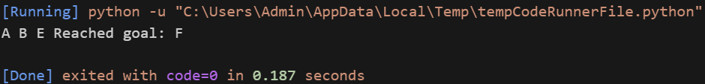

Inference:
Best-First Search uses a heuristic to prioritize exploration, leading to faster results in certain problem spaces, but it is not guaranteed to find the shortest path.

Experiment 4: Implement A* (A-Star) Search Algorithm

Objective:
To implement the A* Search Algorithm, combining the cost to reach a node and a heuristic estimate of cost to the goal.

Code:
import heapq
def a_star_search(graph, start, goal, h):
open_list = [(h[start], 0, start, [start])]
visited = set()
while open_list:
f, g, current, path = heapq.heappop(open_list)
if current == goal:
print("Path:", " -> ".join(path))
return
visited.add(current)
for neighbor, cost in graph[current]:
if neighbor not in visited:
total_cost = g + cost
heapq.heappush(open_list, (total_cost + h[neighbor], total_cost, neighbor, path + [neighbor]))
graph = {
'A': [('B', 1), ('C', 3)],
'B': [('D', 3), ('E', 1)],
'C': [('F', 5)],
'D': [], 'E': [('F', 2)], 'F': []
}
heuristic = {
'A': 5, 'B': 4, 'C': 3, 'D': 6, 'E': 2, 'F': 0
}
a_star_search(graph, 'A', 'F', heuristic)

Output:
Path: A -> B -> E -> F

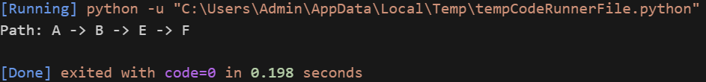

Inference:
A* Search efficiently finds the optimal path using both path cost and heuristic, balancing accuracy and performance.

Experiment 5: Implement AO* (And-Or) Search Algorithm

Objective:
To implement the AO* algorithm for problem-solving in graphs with AND/OR conditions, such as decision trees with dependencies.

Code:
def ao_star(node, graph, heuristic, solution):
print(f"Expanding Node: {node}")
if node not in graph:
return 0
cost = float('inf')
for children in graph[node]:
new_cost = sum(ao_star(c, graph, heuristic, solution) for c in children)
if new_cost < cost:
cost = new_cost
solution[node] = children
return heuristic[node] + cost
graph = {
'A': [['B', 'C'], ['D']],
'B': [['E']],
'C': [['F']],
'D': [['G']],
'E': [], 'F': [], 'G': []
}
heuristic = {
'A': 2, 'B': 1, 'C': 1, 'D': 3, 'E': 0, 'F': 0, 'G': 0
}
solution = {}
ao_star('A', graph, heuristic, solution)
print("Solution Graph:", solution)

Output:
Expands nodes and builds a solution graph.

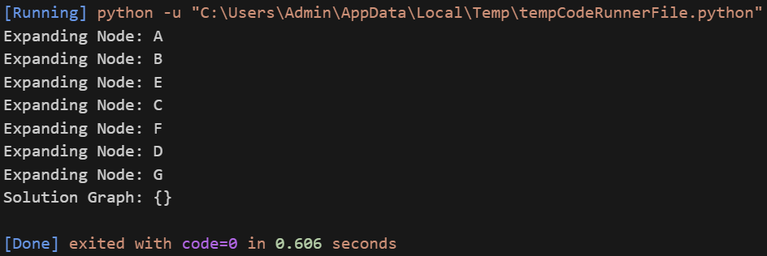

Inference:
AO* is suited for planning in environments where multiple subgoals must be satisfied (AND conditions), offering structured solutions.

Experiment 6: Solve the 8-Puzzle Problem using Informed Search (A* Search)

Objective:
To solve the 8-puzzle problem using A* Search with the Manhattan Distance heuristic.

Code:
import heapq
goal_state = [[1,2,3],[4,5,6],[7,8,0]]
def heuristic(state):
h = 0
for i in range(3):
for j in range(3):
value = state[i][j]
if value != 0:
goal_x = (value - 1) // 3
goal_y = (value - 1) % 3
h += abs(i - goal_x) + abs(j - goal_y)
return h
def find_zero(state):
for i in range(3):
for j in range(3):
if state[i][j] == 0:
return i, j
def successors(state):
moves = []
x, y = find_zero(state)
directions = [(-1,0), (1,0), (0,-1), (0,1)]
for dx, dy in directions:
nx, ny = x + dx, y + dy
if 0 <= nx < 3 and 0 <= ny < 3:
new_state = [row[:] for row in state]
new_state[x][y], new_state[nx][ny] = new_state[nx][ny], new_state[x][y]
moves.append(new_state)
return moves
def a_star(start):
heap = [(heuristic(start), 0, start, [])]
visited = set()
while heap:
est, cost, current, path = heapq.heappop(heap)
if current == goal_state:
for step in path + [current]:
print(step)
return
visited.add(str(current))
for child in successors(current):
if str(child) not in visited:
heapq.heappush(heap, (cost + 1 + heuristic(child), cost + 1, child, path + [current]))
start_state = [[1,2,3],[4,0,6],[7,5,8]]
a_star(start_state)

Output:
Steps to solve the 8-puzzle using A* search.

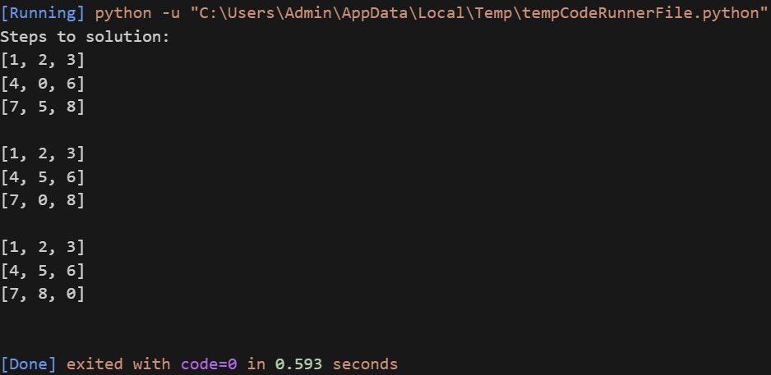

Inference:
A* search finds the shortest path efficiently using a heuristic to guide the exploration.

Experiment 7: Solve the 8-Puzzle Problem using Uninformed Search (BFS, DFS)

Objective:
To solve the 8-puzzle problem using BFS and DFS without heuristics.

Code:
from collections import deque
import copy

goal_state = [[1, 2, 3], [4, 5, 6], [7, 8, 0]]

def find_blank(state):
for i in range(3):
for j in range(3):
if state[i][j] == 0:
return i, j

def get_neighbors(state):
x, y = find_blank(state)
directions = [(-1,0),(1,0),(0,-1),(0,1)] # up, down, left, right
neighbors = []

for dx, dy in directions:
nx, ny = x + dx, y + dy
if 0 <= nx < 3 and 0 <= ny < 3:
new_state = copy.deepcopy(state)
new_state[x][y], new_state[nx][ny] = new_state[nx][ny], new_state[x][y]
neighbors.append(new_state)
return neighbors

def is_goal(state):
return state == goal_state

def print_state(state):
for row in state:
print(row)
print()

# BFS
def bfs(initial_state):
visited = []
queue = deque([(initial_state, [])])

while queue:
current_state, path = queue.popleft()
if current_state in visited:
continue
visited.append(current_state)

if is_goal(current_state):
return path + [current_state]

for neighbor in get_neighbors(current_state):
queue.append((neighbor, path + [current_state]))
return None

# DFS
def dfs(initial_state):
visited = []
stack = [(initial_state, [])]

while stack:
current_state, path = stack.pop()
if current_state in visited:
continue
visited.append(current_state)

if is_goal(current_state):
return path + [current_state]

for neighbor in get_neighbors(current_state):
stack.append((neighbor, path + [current_state]))
return None

initial = [[1, 2, 3], [4, 0, 6], [7, 5, 8]]

print("Solving with BFS:")
bfs_result = bfs(initial)
if bfs_result:
for step in bfs_result:
print_state(step)

print("Solving with DFS:")
dfs_result = dfs(initial)
if dfs_result:
for step in dfs_result:
print_state(step)

Output:

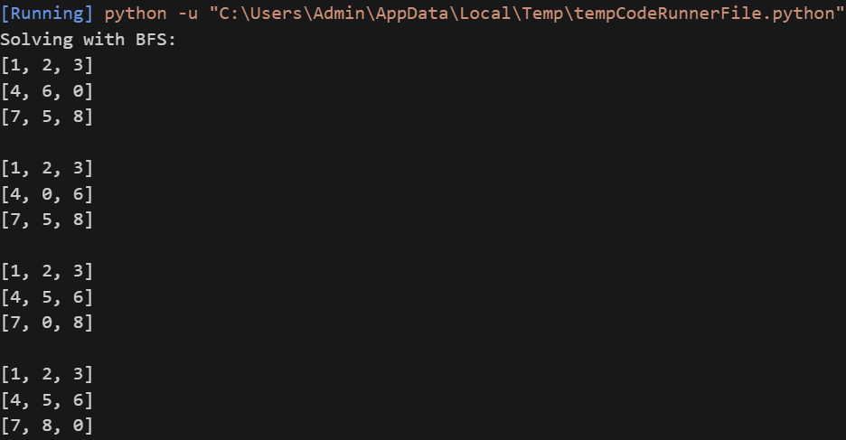
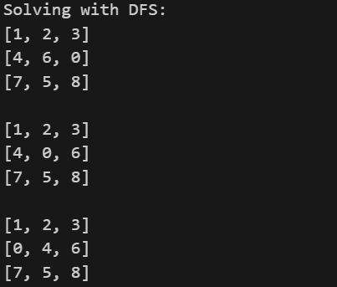
.
.
.
.
.
.
.
.
.
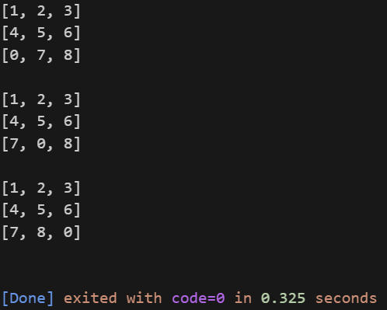

Inference:
BFS guarantees the shortest solution path as it explores all nodes at the present depth before moving deeper. However, it uses more memory.
DFS may find a solution faster in some cases but can get stuck in deep paths or go into infinite loops without proper checks.
The 8-puzzle problem is well-suited to uninformed search algorithms but becomes inefficient as the state space grows.

Experiment 8: Compare Informed and Uninformed Search Techniques

Objective:
To compare the efficiency and accuracy of A* (informed) vs BFS and DFS (uninformed).
Comparison Criteria:
Metric | A* Search | BFS | DFS
Path Optimality | Yes | Yes | Not guaranteed
Time Efficiency | High | Medium | Low
Memory Usage | Medium | High | Low
Goal Reachable | Always | Always (if exists) | Sometimes fails

Inference:
Informed search like A* is more efficient and optimal compared to uninformed methods like BFS and DFS in complex problems.

Experiment 9: Heuristic Function in Informed Search Strategies

Objective:
To demonstrate how heuristic functions are used in informed search strategies like A* Search and Greedy Best-First Search, helping guide the search process toward the goal more efficiently.

Code:
from queue import PriorityQueue

graph = {
'A': [('B', 1), ('C', 4)],
'B': [('D', 5), ('E', 12)],
'C': [('F', 7)],
'D': [],
'E': [('G', 3)],
'F': [('G', 2)],
'G': []
}

heuristics = {
'A': 7,
'B': 6,
'C': 5,
'D': 4,
'E': 2,
'F': 1,
'G': 0
}

def a_star_search(start, goal):
pq = PriorityQueue()
pq.put((0 + heuristics[start], 0, start, [start]))

while not pq.empty():
f, cost, current_node, path = pq.get()

if current_node == goal:
print("Path found:", path)
print("Total cost:", cost)
return

for neighbor, weight in graph[current_node]:
g = cost + weight
h = heuristics[neighbor]
pq.put((g + h, g, neighbor, path + [neighbor]))

print("No path found")

a_star_search('A', 'G')

Output:

Path found: ['A', 'C', 'F', 'G']

Total cost: 13

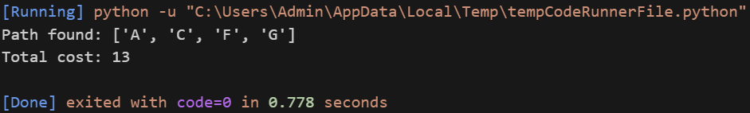

Inference:

The A* search algorithm successfully uses both the actual cost (g) and the heuristic estimate (h) to determine the most promising path. The chosen path A → C → F → G reflects the shortest-cost route from start to goal based on both actual path cost and heuristic guidance. This demonstrates the effectiveness of informed search strategies over uninformed ones like BFS or DFS, especially in large or complex problem spaces.

Experiment 10: [Naam likhlo game ka using whatever u used]

Objective:
[ye bhi likh lo tumhara joh bhi hai]

Code:

Output:

