**Lesson 06 Demo 01**

**Creating a Pipeline Script**

**Objective:** To create a pipeline script for automating build processes in Jenkins

**Tools required:** Jenkins

**Prerequisites:** None

Steps to be followed:

1. Log in to the Jenkins CI tool and create a pipeline script

**Step 1: Log in to the Jenkins Cl tool and create a pipeline script**

1. Open the browser, go to the Jenkins **Dashboard** by typing **localhost:8080** in your browser, provide the credentials, and click the **Sign in** button

|  |
| --- |
| **Note:** The credentials for accessing Jenkins in the lab are Username: **admin** and Password: **admin**. |

1. Click on the **New Item** option as shown in the screenshot below:

1. Enter a desired name for the project, select **Pipeline**, and then click on **OK** as shown in the screenshot below:

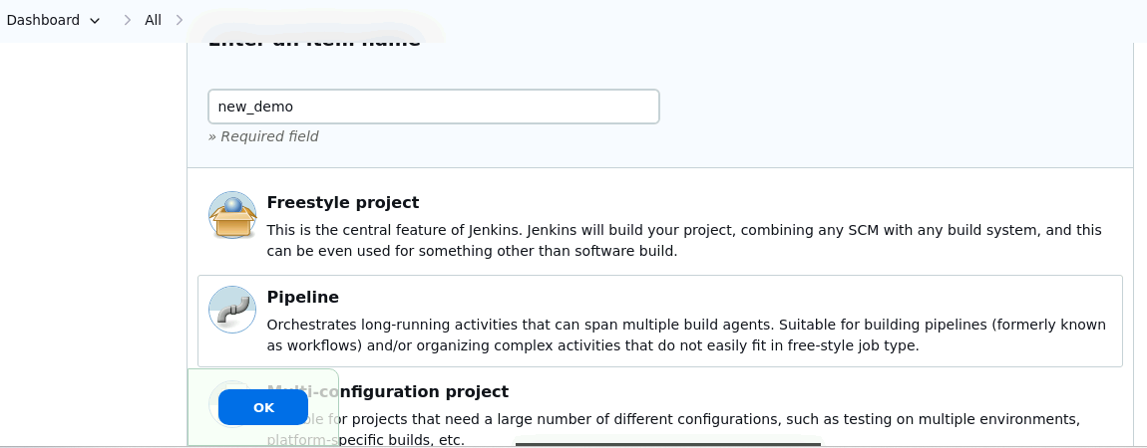

1. Click on **Pipeline** as shown in the screenshot below:

1. Enter the following pipeline script in the script editor and click on **Save** as shown in the screenshot below:

**pipeline {**

**agent any**

**stages {**

**stage("hello") {**

**steps{**

**echo"welcome to Jenkins pipeline"**

**}**

**}**

**}**

**}**

1. Click on **Build Now** to run the pipeline script as shown in the screenshot below:

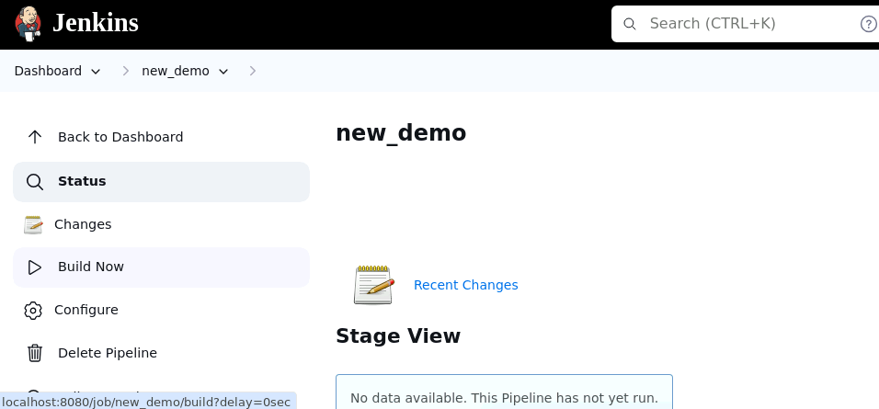

1. Hover over the milliseconds number next to the build stage name as shown in the screenshot below:

|  |
| --- |
| **Note:** Ensure that you hover the cursor over the milliseconds number without clicking on it |

1. Click on **Logs** as shown in the screenshot below:

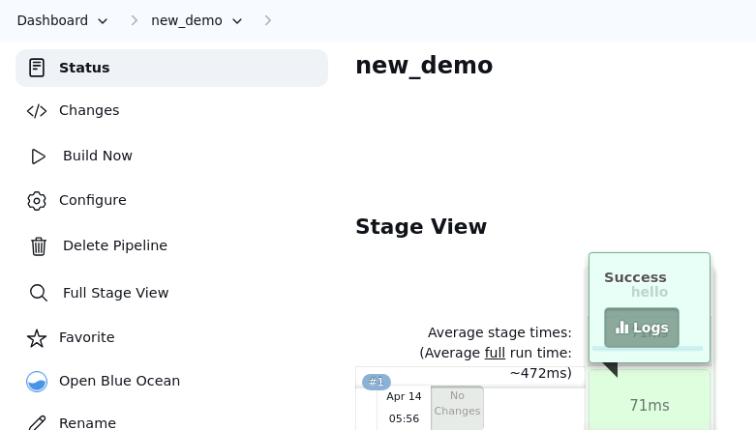

1. Check for the message in the top-left corner to confirm the successful execution of the pipeline stage as shown in the screenshot below:

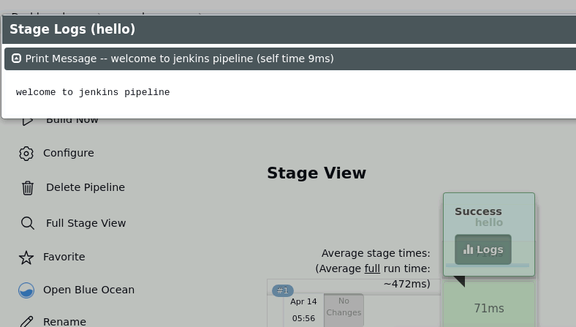

By following these steps, you have successfully created a pipeline script for automating build processes in Jenkins.