## 1. Potential Renewable Energy Spots in China

1.1 Download the following data sets and load them in R:

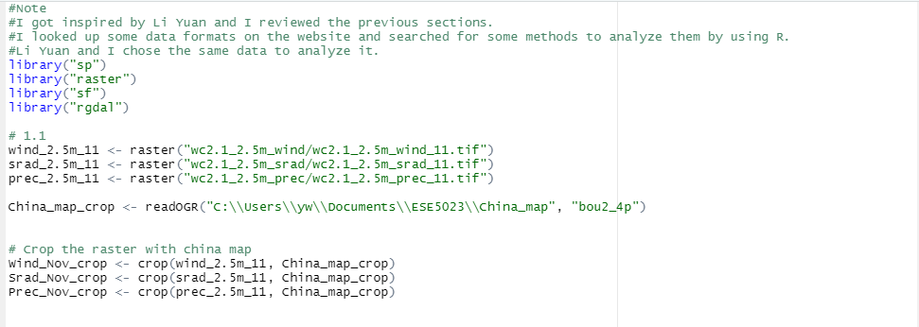

1.2 Plot the above data sets over China. You should make three plots, each should contain its own legend.

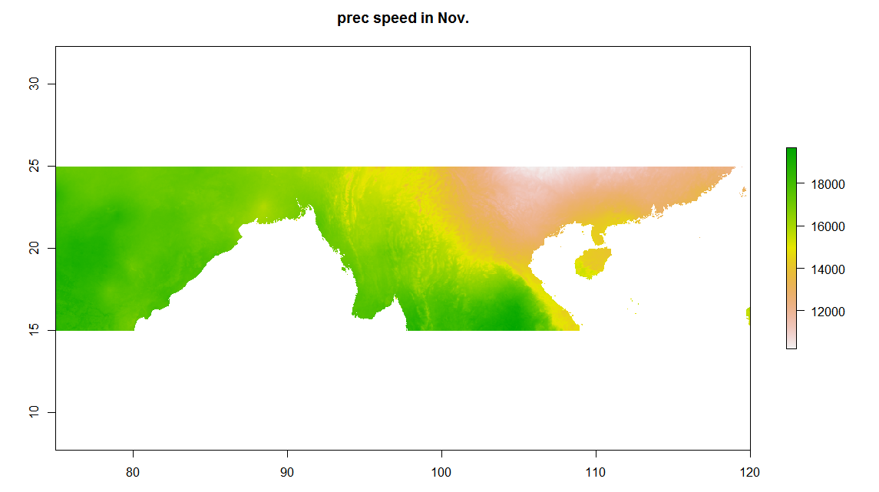

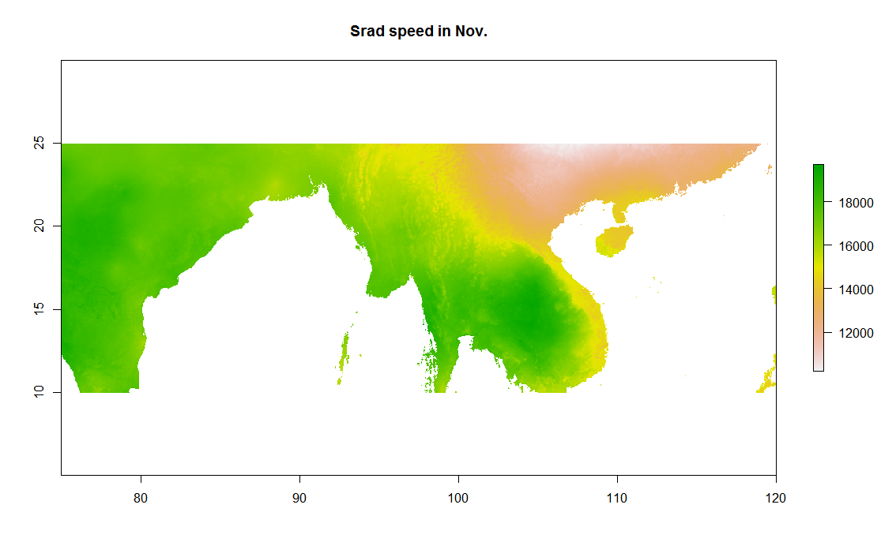

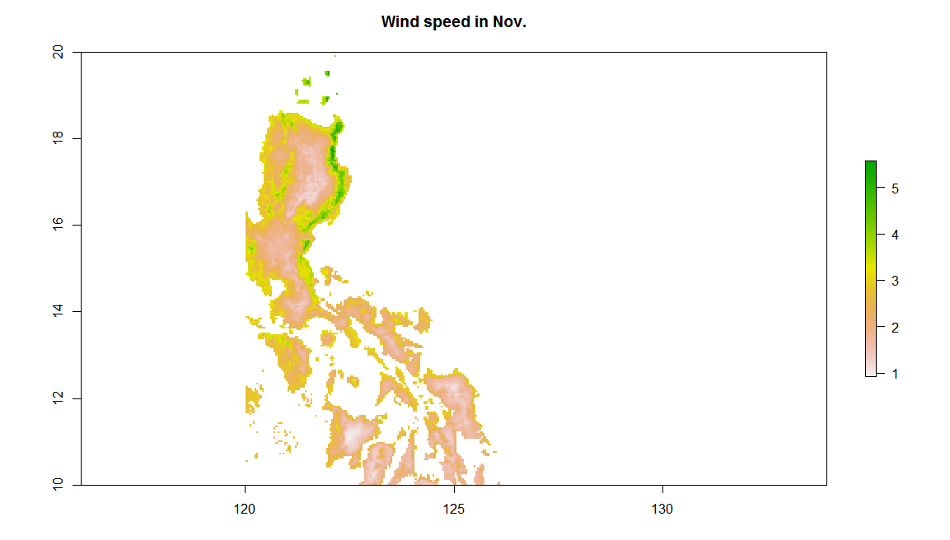

1.3 First, let’s search for regions with relatively high wind speed to build wind farms. Define a reasonable wind speed as the threshold, and describe your favorite spots.

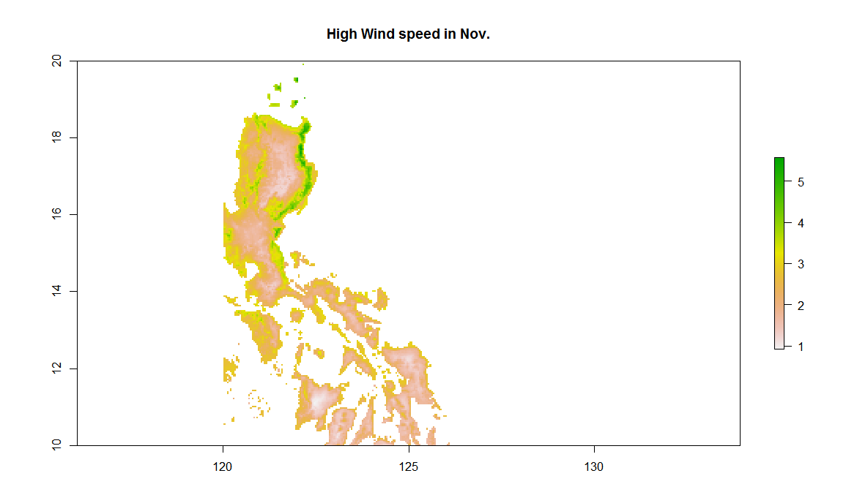

1.4 Second, let’s search for regions with relatively high solar radiation and low precipitation as potential locations of photovoltaics (PV) farms. Describe your favorite spots of PV farms.

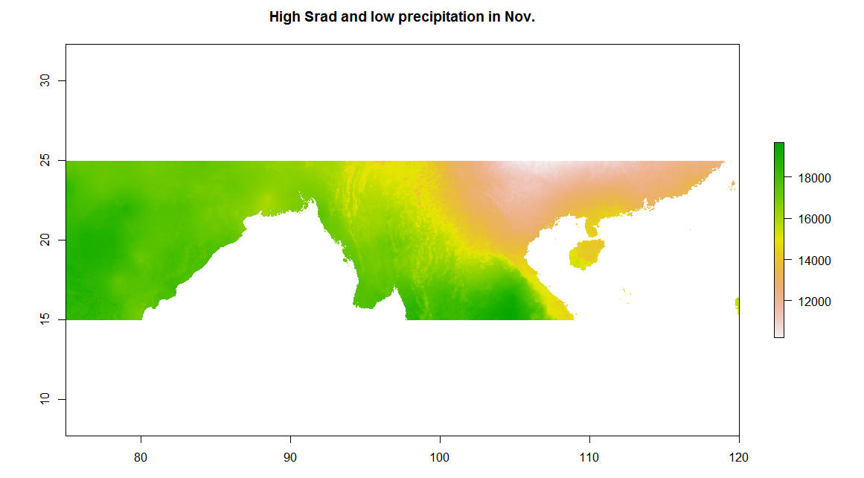

## 2. More Linux Commands

2.1 [2 points] Make a link called data_demo_link to data_demo folder using ln



2.2 [2 points] Go to data_demo/data/, make an empty file planets.txt_1st with touch.

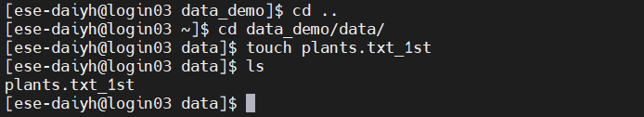

2.3 [2 points] Print your home directory using echo.

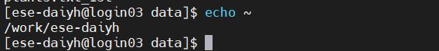

2.4 [3 points] Find how many files in data_demo/data/pdb/ using find.

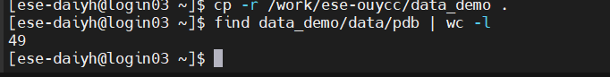

2.5 [3 points] Count how many C character appears in data_demo/data/pdb/tnt.pdb with grep.



2.6]Comparedata_demo/data/pdb/ethane.pdb and data_demo/data/pdb/ethanol.pdb with diff

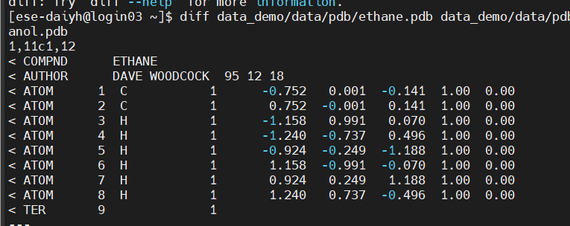

2.7 [2 points] Check the total file size of the data_demo folder using df.

ls 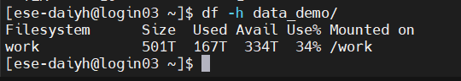

2.8 [3 points] Copy the data_demo folder to data_demo_new, compress it using zip, and decompress the .zip file with unzip.

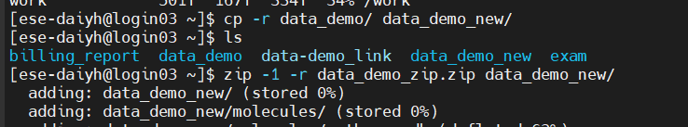 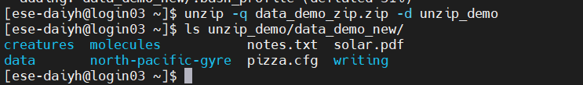

2.9 [3 points] Change the file permissions flags on data_demo_new to drwxr-x--- using chmod.

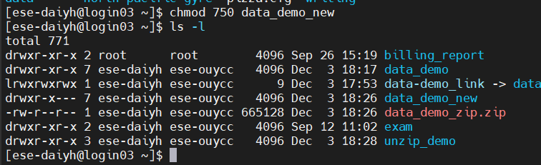

2.10 [3 points] Print the last 10 commands you made using history.

