Labcourses homework 7
Dakai Zhou
1531107

Exercise7.1:

Fox’s algorithm is faster than the algorithm in homework 6.

Strong scaling:
1) Matrix A is 120 x 60 matrix B is 60 x 90.

Number of processes: 4
Time elapsed with I/O: 1.463366e-02
Time elapsed without I/O: 2.807856e-03

Number of processes: 9
Time elapsed with I/O: 4.709578e-02
Time elapsed without I/O: 2.730393e-02

Number of processes: 16
Time elapsed with I/O: 1.823585e-01
Time elapsed without I/O: 4.140997e-02

Number of processes: 25
Time elapsed with I/O: 2.067270e-01
Time elapsed without I/O: 7.202792e-02

2) Matrix A is 1200 x 600, matrix B is 600 x 900.

Number of processes: 4
Time elapsed with I/O: 2.864336e+00
Time elapsed without I/O: 1.599047e+00

Number of processes: 9
Time elapsed with I/O: 2.273300e+00
Time elapsed without I/O: 9.177599e-01

Number of processes: 16
Time elapsed with I/O: 1.986329e+00
Time elapsed without I/O: 5.648458e-01

Number of processes: 25
Time elapsed with I/O: 1.799331e+00
Time elapsed without I/O: 3.468399e-01

Number of processes: 36
Time elapsed with I/O: 1.884356e+00
Time elapsed without I/O: 3.252900e-01

Number of processes: 64
Time elapsed with I/O: 2.415030e+00
Time elapsed without I/O: 4.841900e-01
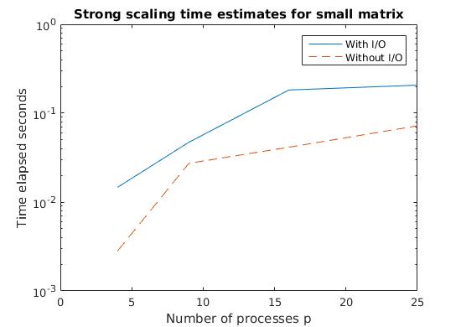
From the plot we can see that parallel Fox’s algorithm is not efficient, even worse for small matrix. More time needed when increase the number of processes. Actually, parallel algorithm is not suitable to solve small tasks. When parallelize a small task, the decreased solving task time is less than the increased communication time. Therefor, more time needed when p increase.

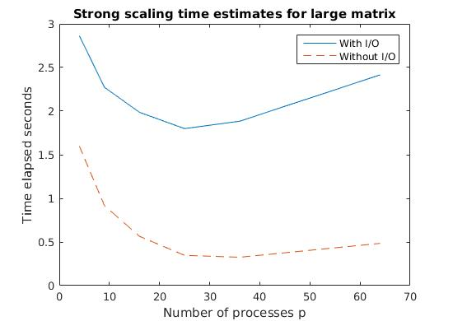
From the plot we can tell that there is a optimal number of processes. Solve the problem with number of processes larger or smaller than this optimal number demands more time. When p equals to the optimal number , the tasks on each processes is small enough. When p increases, the increment of communication time is more than the decrement of task solving time. Thus, the time consuming grows.
Because of the existence of communications in I/O, so the time needed in I/O increases as well.
Weak scaling:
Size of local matrix A 40 x 50, size of local matrix B 50 x 30.

Number of processes: 4
Time elapsed with I/O: 4.580951e-02
Time elapsed without I/O: 1.323605e-02

Number of processes: 9
Time elapsed with I/O: 3.760958e-01
Time elapsed without I/O: 1.792560e-01

Number of processes: 16
Time elapsed with I/O: 9.315650e-01
Time elapsed without I/O: 2.504880e-01

Number of processes: 25
Time elapsed with I/O: 2.028446e+00
Time elapsed without I/O: 4.677510e-01

Number of processes: 36
Time elapsed with I/O: 4.446542e+00
Time elapsed without I/O: 1.108203e+00

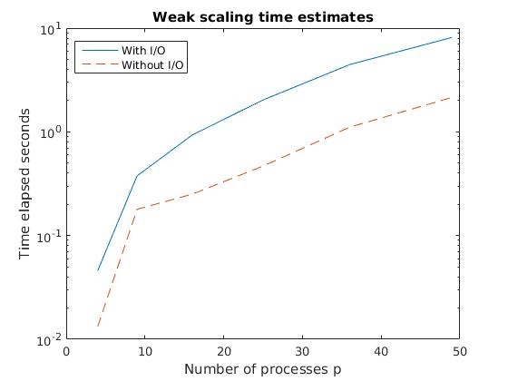
Number of processes: 49
Time elapsed with I/O: 8.138711e+00
Time elapsed without I/O: 2.149676e+00
In weak scaling, communication time increases as the number of processes increases. Thus, total time grows. Because of the increment of matrix entries and increment communication in I/O, so the I/O time also increases.

