Тухайн Attribute нь цэнхэр өнгөтэй байвал PrimaryKey юм.

UNF:

Staff[staff_no,staff_name,staff_position,staff_salary,(branch_no, branch_addresss, telNo)]

1NF:

Staff[staff_no,staff_name,staff_position,staff_salary]

Branch[branch_No,branch_Addresss, telNo]

2NF:

Staff[staff_no,staff_name,staff_position,staff_salary]

Branch[branch_No,branch_Addresss, telNo]

Telephone[staff_no, telNo]

3NF:

Staff[staff_no,staff_name,staff_position,staff_salary]

Branch[branch_No,branch_Addresss, telNo]

Telephone[staff_no, telNo]

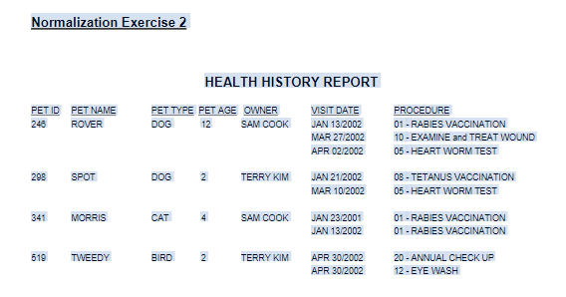

UNF:

Pet[ pet_id, pet_name, pet_type, pet_age, owner, (visitdate, procedure_no, procedure_name)]

1NF:

Pet[pet_id,pet_name,pet_type,pet_age,owner]

Pet_Visit[pet_id,visitdate,procedure_no,procedure_name]

2NF:

Pet[pet_id,pet_name,pet_type,pet_age,owner]

Pet_Visit[pet_id,visitdate,procedure_no]

Procedure[procedure_no,procedure_name]

3NF:

Pet[pet_id,pet_name,pet_type,pet_age,owner]

Pet_Visit[pet_id,visitdate,procedure_no]

Procedure[procedure_no,procedure_name]

UNF:

OrderForm[order_number, order_date, (customer_number, customer_name, customer_address, customer_city, ProductNo, Desscription, Quantity,Unit_Price)]

1NF:

OrderForm[order_number, order_date]

Customer[customer_number, customer_name, customer_address, product_No, product_Desscription, product_Quantity, product_UnitPrice]

2NF:

OrderForm[order_number, order_date]

Customer[customer_number, customer_name, customer_address]

Product[customer_name, product_No,product_Desscription,product_Quantity,product_UnitPrice]

3NF:

OrderForm[order_number, order_date]

Customer[customer_number, customer_name, customer_address]

Product[customer_name, product_No,product_Desscription,product_Quantity,product_UnitPrice]