NAME : D.GUNA VARDHAN

REG.NO : 192372041

COURSE CODE :CSA0689

SUB NAME : DESIGN AND ANALYSIS OF ALGORITHM

Day-1

1.Given an array of strings words, return the first palindromic string in the array. If there is no such string, return an empty string "". A string is palindromic if it reads the same forward and backward. Example 1: Input: words = ["abc","car","ada","racecar","cool"] Output: "ada"

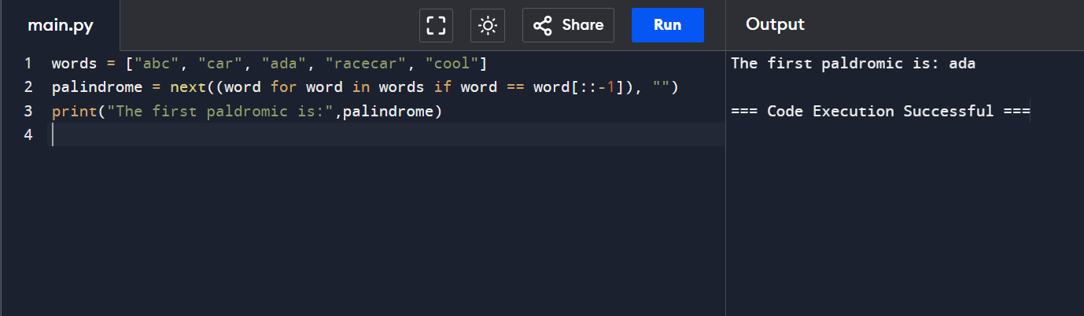

2. You are given two integer arrays nums1 and nums2 of sizes n and m, respectively. Calculate the following values: answer1 : the number of indices i such that nums1[i] exists in nums2. answer2 : the number of indices i such that nums2[i] exists in nums1 Return [answer1,answer2].

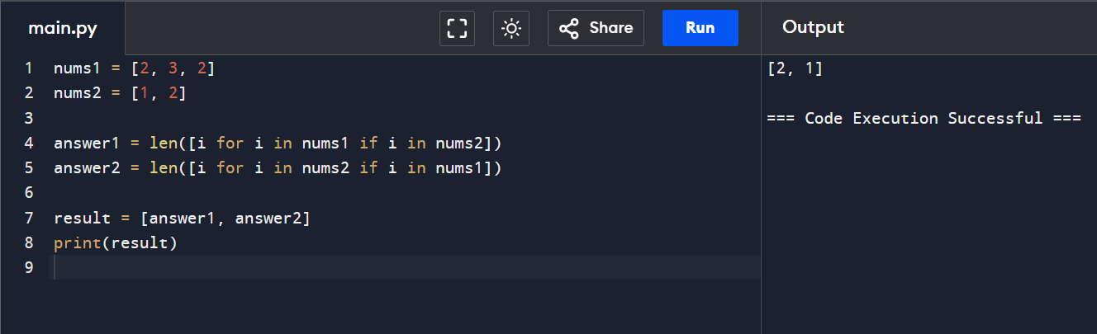

3. You are given a 0-indexed integer array nums. The distinct count of a subarray of nums is defined as: Let nums[i..j] be a subarray of nums consisting of all the indices from i to j such that 0 <= i <= j < nums.length. Then the number of distinct values in nums[i..j] is called the distinct count of nums[i..j]. Return the sum of the squares of distinct counts of all subarrays of nums. A subarray is a contiguous non-empty sequence of elements within an array. Example 1: Input: nums =

[1,2,1] Output: 15

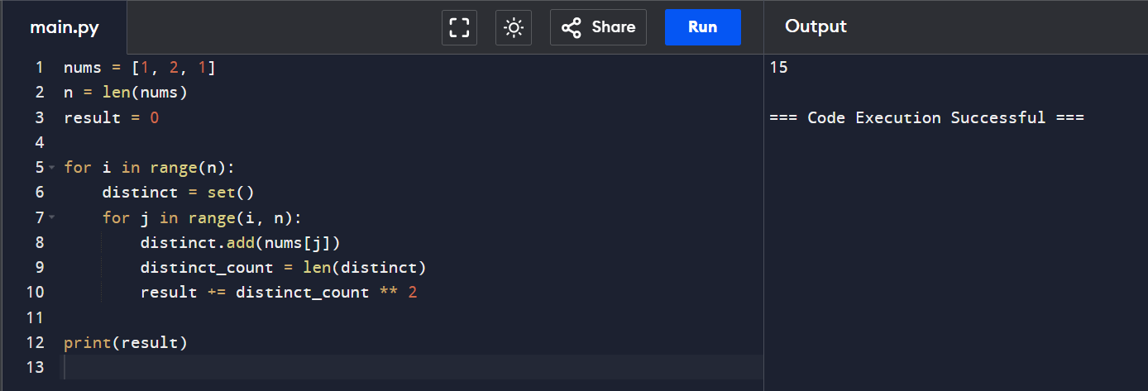

4.Given a 0-indexed integer array nums of length n and an integer k, return the number of pairs (i, j) where 0 <= i < j < n, such that nums[i] == nums[j] and (i \* j) is divisible by k. Example 1: Input: nums = [3,1,2,2,2,1,3], k = 2 Output: 4

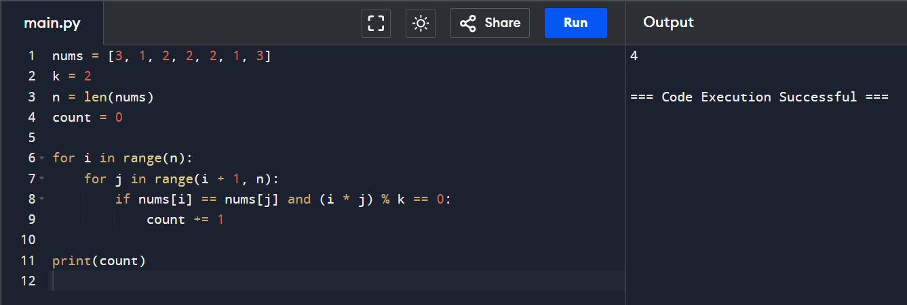

5. Write a program FOR THE BELOW TEST CASES with least time complexity Test Cases: - 1) Input: {1, 2, 3, 4, 5} Expected Output: 5

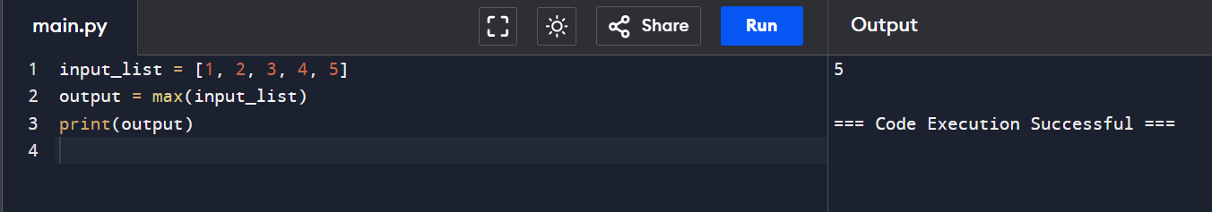

6. You have an algorithm that process a list of numbers. It firsts sorts the list using an efficient sorting algorithm and then finds the maximum element in sorted list. Write the code for the same.

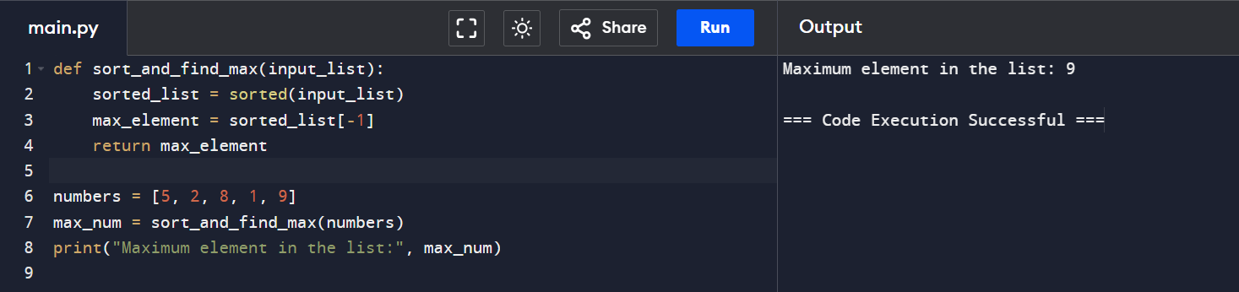7

7. Write a program that takes an input list of n numbers and creates a new list containing only the unique elements from the original list. What is the space complexity of the algorithm?

Some Duplicate Elements • Input: [3, 7, 3, 5, 2, 5, 9, 2]

• Expected Output: [3, 7, 5, 2, 9] (Order may vary based on the algorithm used)

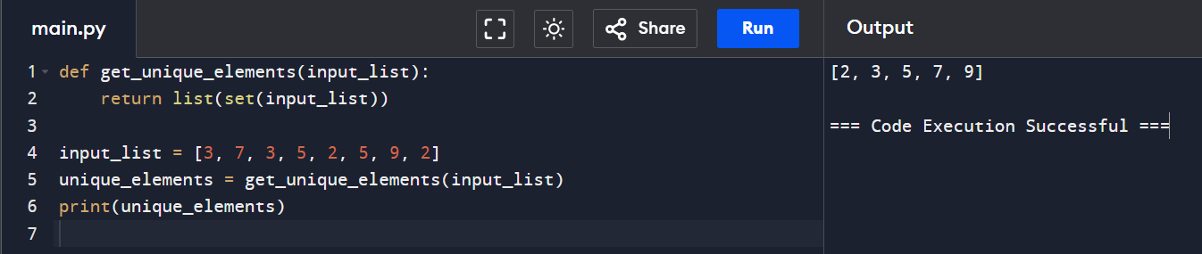

8. Sort an array of integers using the bubble sort technique. Analyze its time complexity using Big-O notation. Write the code

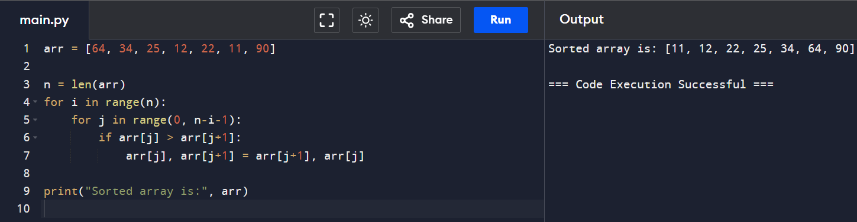

9. Checks if a given number x exists in a sorted array arr using binary search. Analyze its time complexity using Big-O notation. Test Case: Example X={ 3,4,6,-9,10,8,9,30} KEY=10 Output: Element 10 is found at position 5

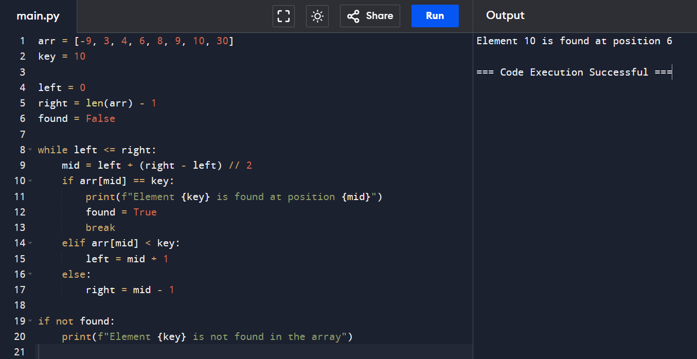

10. Given an array of integers nums, sort the array in ascending order and return it. You must solve the problem without using any built-in functions in O(nlog(n)) time complexity and with the smallest space complexity possible.

