AUTOMATIC BABY CRADLE

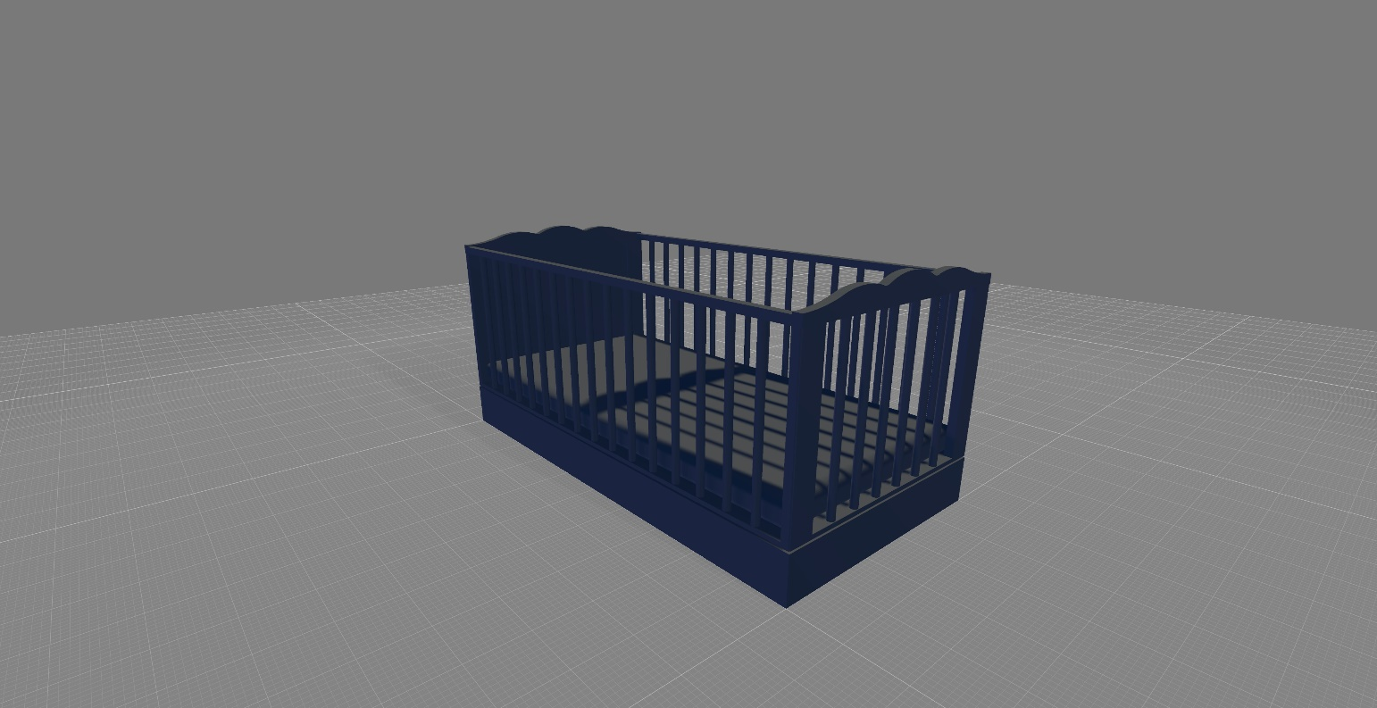An automatic cradle is a type of baby care device that is designed to help parents care for their infants. It typically consists of a bassinet or crib with a built-in motor that rocks or swings the baby gently, helping them to fall asleep. Some electronic cradles also come equipped with features such as music, white noise, and other sounds to help soothe the baby.

Homework Tips Checklist for Parents

Automatic cradles can be useful in a variety of situations where parents or caregivers may have limited time, energy, or ability to rock a manual cradle by hand.

It is important to note that an electric cradle is not a substitute for direct supervision and care. Infants should always be closely monitored while using an electric cradle and never left unattended.

# Potential benefits

Convenience: An automatic cradle can be a convenient tool for busy parents or caregivers. It can provide to rest while the caregiver tends to other tasks.

Customization: An electric cradles offer a range of motion options, such as different rocking or swinging speeds, as well as built-in music or white noise. This can allow parents to customize the motion and sound to their infant's preferences.

Consistent: An automatic cradle can provide a consistent and soothing motion that may be more effective in calming and soothing infants and young children than a manual cradle.

# Potential downsides

Cost: Automatic cradles tend to be more expensive than manual cradles.

Dependence on electricity: An electric cradle requires an electrical outlet or battery power to operate, which may not be convenient or possible in all locations.

Noise: Some electric cradles may be noisier than a manual cradle due to the motors or other mechanical components.

Limited use: An electric cradle is typically only suitable for infants up to a certain age or weight, after which it may no longer be appropriate or safe to use.

# Objectives

lorem

# Scope

lorem

# Requirements

lorem

# Timeline

lorem

# Communication plan

lorem