Q1. Develop a digital media plan to promote Bowtie VHIS in the post-COVID era, where the concerns around unexpected diseases are fading. You will have $1 million budget to target on the Working Class to drive awareness and achieve the business goal.

Please address the following:

1. Campaign Theme: What will be the central theme of your campaign to appeal to the working population?

***Answer:***

In the post-COVID era, the campaign will emphasize long-term security and health stability, focusing on:

* **Future Preparedness:** Highlighting the importance of being ready for uncertainties through preventive care and regular check-ups.
* **Empowerment:** Encouraging the working class to take control of their health and finances.
* **Affordability and Accessibility:** Highlighting Bowtie's commitment to providing budget-friendly coverage options for everyone.

This approach will resonate with the working population's desire for security and stability.

1. Objectives: What specific goals will you set for awareness, consideration, and conversions?

***Answer:***

**Awareness:**

* **Goal:** Increase brand recognition by 25% among the working class.
* **Metric:** Measure impressions across digital platforms and conduct pre- and post-campaign surveys to evaluate changes in brand awareness and recall.

**Consideration:**

* **Goal:** Boost website traffic by 20% from targeted demographics.
* **Metric:** Track unique visits generated from ad campaigns, analyzing traffic sources, user behavior, and engagement rates with content.

**Conversions:**

* **Goal:** Increase VHIS policy sign-ups by 15%.
* **Metric:** Monitor the number of new policy sign-ups during the campaign period, focusing on sales through online channels.

1. Targeting: Who is your target audience, including demographics and psychographics?

***Answer:***

* **Demographics:** Ages 25-45, middle-income, Hong Kong residents.
* **Psychographics:** Health-conscious, value security, interested in financial planning.

1. Budget Split: How will you allocate the $1 million across digital channels to maximize the conversions and cost efficiency effectively?

***Answer:***

1. **Proven Strategies (90% of Budget: $700,000)**

**Social Media Advertising** - 35% ($350,000):

* **Platforms:** Facebook, Instagram, LinkedIn
* **Focus:** Targeted ads with engaging visuals and testimonials to drive awareness and consideration.

**Search Engine Marketing** - 25% ($250,000):

* **Platforms:** Google Ads, Bing Ads
* **Focus:** High-intent keywords to capture users actively searching for health insurance solutions.

**Display Advertising** - 20% ($200,000):

* **Platforms:** Google Display Network, Programmatic Ads
* **Focus:** Retargeting and display ads to reinforce brand messaging and drive conversions.

**Content Marketing** - 10% ($100,000):

* **Platforms:** Sponsored content on Threads, relevant blogs, infographics, wheels and videos that educate the audience about health insurance.
* **Focus:** Articles and videos that educate about the benefits of VHIS and real-life scenarios. Use these materials to drive traffic to the website and improve SEO.

1. **New Initiatives (10% of Budget: $200,000)**

**Email Marketing** - 5% ($50,000):

* **Focus:** Personalized emails to existing leads and past customers to encourage policy sign-ups.

**Influencer Collaborations** - 5% ($50,000):

* **Focus:** Partnering with health and finance influencers to reach a broader audience with authentic endorsements.

1. Product Selection: Which VHIS product(s) will you promote and why?

***Answer:***

Promoting these two products highlights Bowtie's commitment to flexible, affordable health insurance solutions, addressing the ongoing demand for health security in a post-COVID environment:

1. **Bowtie VHIS Flexi Plan**

**Reasons for Promotion:**

* **High Popularity:** The Flexi Plan is Bowtie's most sought-after option, reflecting strong demand and customer satisfaction.
* **Comprehensive Benefits:** It offers extensive coverage with no lifetime limits, appealing to those seeking robust protection.
* **Affordability:** Competitive premiums make it attractive for cost-conscious consumers looking for long-term medical coverage.

1. **Bowtie Pink**

**Reasons for Promotion:**

* **Full Reimbursement Feature:** Provides a 100% reimbursement rate, ensuring complete coverage for medical needs.
* **Flexibility:** Offers various deductible options and room choices, allowing customization based on individual finances.
* **Targeted Audience:** Ideal for those with existing group insurance seeking additional protection without significant cost increases.

1. Ad Angles: What ad angles will you test to engage the working population?

***Answer:***

1. **Real-Life Testimonials:** Showcase stories from satisfied customers who have benefited from VHIS, highlighting peace of mind and security.
2. **Future Security:** Emphasize the importance of being prepared for any health situation, with a focus on long-term health benefits.
3. **Cost-Effectiveness:** Highlight the affordability and value of comprehensive coverage, appealing to budget-conscious individuals.
4. **Health Empowerment:** Encourage proactive health management, emphasizing the empowerment that comes with having reliable health insurance.
5. **Family Well-being:** Focus on protecting loved ones, appealing to the working class's desire to ensure family security.
6. Success Measurement: How will you measure campaign success (KPIs)?

**Answer:**

1. **Impressions:** Reach and visibility across all digital platforms.
2. **CTR:** Percentage of users who click on ads
3. Website Traffic: Increase in unique visitors to the Bowtie website from campaign sources.
4. **Conversion Rate:** Percentage of visitors who sign up for VHIS policies.
5. **CPA:** Calculating the average cost to acquire a new customer.
6. **ROAS:** Revenue generated for every dollar spent on advertising.
7. **Customer Feedback and Surveys:** Understand customer perceptions and areas for improvement.

Q2. At Bowtie, customers can visit our website to try out the online application anytime anywhere. Through the online application, they can experience the underwriting process and get a personalized quote anonymously. The data we collect through the online application journey is very useful not only to understand the customers behaviour but also a valuable source for developing custom bidding strategies for digital performance campaigns e.g. value based bidding.

Based on the online application for VHIS, please propose a custom bidding strategy. Consider how you would utilize data from the application process to optimize the bids and increase conversions down the funnel. Discuss any specific metrics you would track, methodologies you would implement, and how you would measure the success of this strategy.

***Answer:***

1. **Data Utilization**

**User Segmentation**: Identify segments based on behavior (pages visited, time on site) and demographics (age, location) from the application process.

**Behavioural Signals:** Track actions like repeat visits, feature interactions, and drop-off points.

1. **Bidding Methodology**

**VBB:** Assign higher bids to segments with a greater likelihood of conversion (e.g., users who reached the quote stage but did not complete the purchase). Use historical data to adjust bids based on predicted user value.

**Dynamic Retargeting:** Retarget users who abandoned the application with personalized ads to encourage completion.

**A/B Testing:** Continuously test different ad creatives and landing pages to optimize engagement and conversions.

1. **Metrics to Track**

**CTR:** Measure ad engagement.

**CVR:** Track the percentage of users completing the application after clicking an ad.

**CPA:** Monitor campaign cost efficiency.

**Conversion Rate:** Percentage of visitors who sign up for VHIS policies.

**Time on Site and Page Depth:** Analyse user engagement and likelihood of application completion.

**Lead Quality Score:** Develop a scoring system based on user actions indicating purchase intent.

1. **Success Measurement**

**Increase in Conversion Rate:** Assess the effectiveness of the bidding strategy.

**Reduction in CPA:** Aim to lower costs while maintaining or increasing conversion volume.

**Improved Lead Quality:** Ensure targeting of high-value users through lead quality scores.

**User Journey Analysis:** Regularly analyse the user journey for potential improvements in the application process.

By implementing this comprehensive custom bidding strategy, Bowtie can optimize its digital performance campaigns, strategically targeting high-value users to increase conversions and enhance ROI.

Q3. There is some sample data for a Paid Search campaign in the Excel file. The raw data are from 2 sources – ad platform and Campaign Manager (CM). By merging the data (using Power Query), please evaluate the performance of the ad versions in terms of traffic (CTR, CPC) and conversions (conversion rate, CPA). You will need to return the working file as part of the assessment.  
Based on the evaluation, if we’d run a 30% off campaign next month, please write 1-2 ad copies that would help optimize the campaign performance.  
Hints for calculating the metrics:  
- CTR = Clicks / Imp  
- CPC = Cost / Clicks  
- CVR = Conversions / Clicks  
- CPA = Cost / Conversions

***Answer:***

*Unable to obtain CTR, No impression data

Working excel attached – ‘Q3 Answer Paid Search campaign.xlsx’

**Evaluation Summary**

1. **Top Performers in Traffic:**

**Lowest CPC:** "Existing-Offer-70off_5coin" at 0.2868

**Ad Copies:** “We are here to help, not sell”

1. **Top Performers in Conversions:**

**Highest CVR:** "20M-Mature-Comparison-HighestSA" at 63.83%

**Lowest CPA:** "20M-Mature-Comparison-HighestSA" at 1.6982

**Ad Copies:** “Love without burden, leave without regrets”

**Recommendations for 30% Off Campaign**

1. **"Ensure Your Loved Ones' Future with 30% Off!**

Protect your family's peace of mind with Bowtie's comprehensive life insurance. Enjoy market-exclusive benefits and flexible coverage—apply now!"

1. **"30% Off: Secure Your Legacy and Leave Without Regrets!**

With Bowtie, gain affordable, pure protection and ensure your loved ones are cared for. No commission, no burden—just peace of mind."

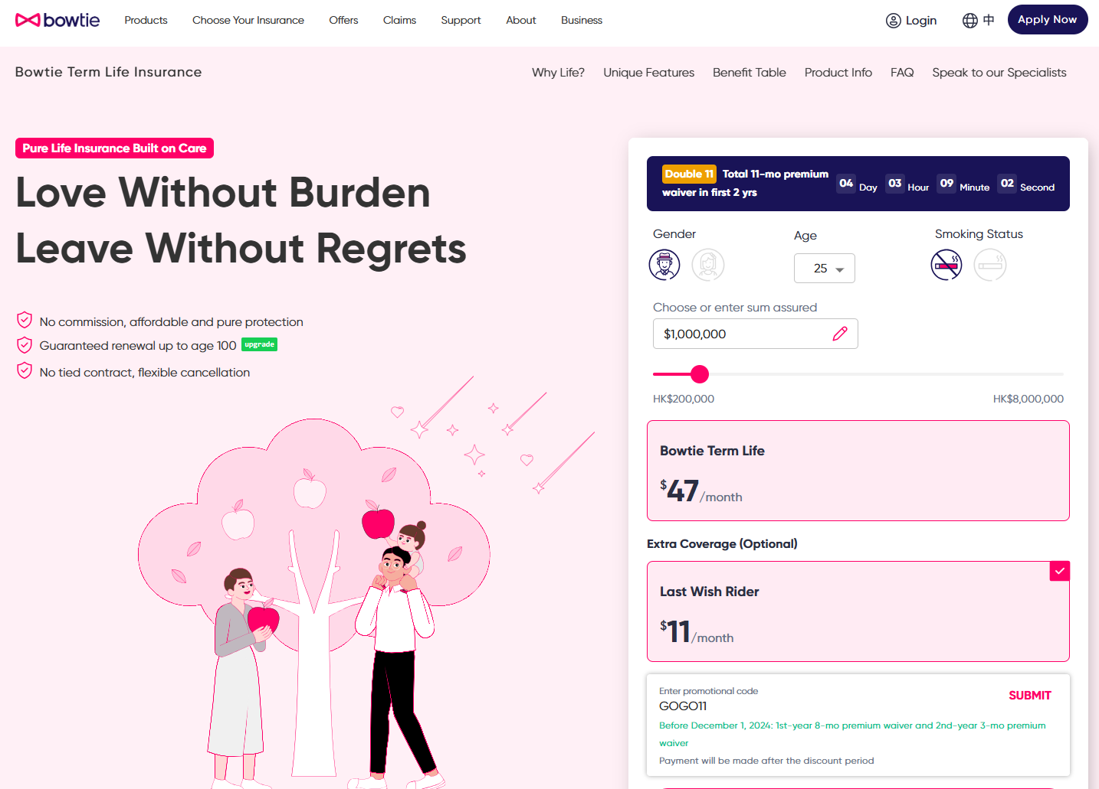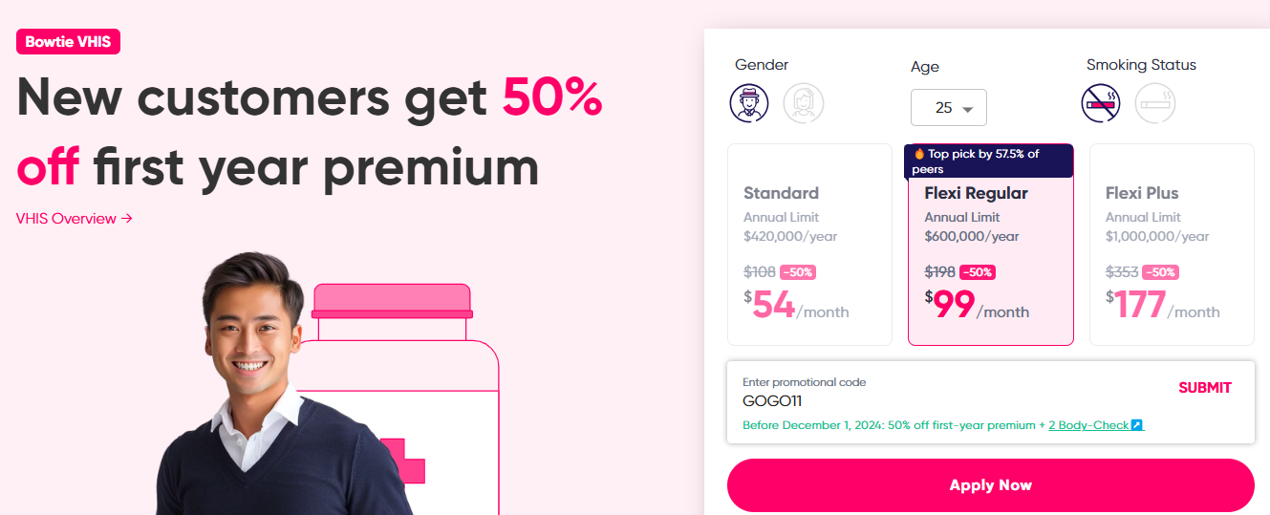

Q4. Creative/Ad performance analysis is one of our routine tasks to not only monitor the performance, but also relying on the data for decision making on optimization and budget allocation, etc. To evaluate the ad performance in terms of how good they can trigger their purchase intention, we’d use both data from the ad platform and the 3rd party tracking platform. You are given a set of sample data as attached, please try to create a summary report and answer the following questions.

1. To merge the data from Tracking Raw (Session manual ad content) with Campaign Raw (Landing Page)

***Answer:***

Working excel attached – ‘Q4 Summary report.xlsx’ Campaign Raw Tab

1. To analyze the ad performance based on the below metrics:  
   - Lead vol.: No. of leads generated per ad  
   - Lead CVR (= Lead/Clicks): The Lead Conversion Rate shows how good each ad is able to arouse the purchase intention of the customers  
   - Lead CPA (= Cost/Lead vol.): The Cost Per Acquisition (= Cost Per Lead here) shows the cost efficiency of generating each lead by the ad

***Answer:***

**Analysis:**

* **High Lead Volume Ads:**

**"20M LifeStage TopUp"** generated the highest number of leads (507), but with a moderate Lead CVR of 10.23% and CPA of 10.57.

**"20M Mature Comparison HighestSA"** has a high conversion rate (63.83%) but a lower lead volume (263), indicating strong interest from a niche audience.

* **High Conversion Rate Ads:**

**"20M Mature Comparison HighestSA"** and **"Offer MTB25off 30yo"** (53.85%) show high conversion rates, resonating well with their audiences despite lower lead volumes.

* **Cost Efficiency (Low CPA) Ads:**

**"20M Mature Comparison HighestSA"** has a low CPA (1.69) with a high conversion rate (63.83%), indicating excellent cost efficiency.

**"Blog WhyTerm Saving_MonkeyKing"** has a very high conversion rate (45.45%) with a low CPA (2.12), showing strong cost efficiency and engagement.

**Recommendations:**

* **Focus on Effective Ads:** Prioritize ads with high CVR and low CPA like **"20M Mature Comparison HighestSA"** for future campaigns.
* **Evaluate High Volume Ads:** Optimize **"20M LifeStage TopUp"** to improve CVR and CPA.
* **Targeting and Content Strategy:** Expand targeting for ads like **“Offer-MTB25off-30yo”** to reach larger audiences while maintaining appeal.
* **Focus on Cost Efficiency:** Scale ads with low CPA, such as **"Blog WhyTerm Saving_MonkeyKing."**
* **Optimize High Volume Ads:** Improve cost efficiency for high lead volume ads like **"20M LifeStage TopUp"** without compromising lead quality.

Q5. In this assignment, you will be working on a sample data set, which consists of three CSV files – policy.csv, invoice.csv, and claim.csv, the field id being the primary key respectively.

i. Treat each CSV file as a database table. Write SQL queries to perform the following tasks:

a. Obtain the number of submitted claims in the year 2021 by products.

***Answer:***

**SQL File:** <https://console.cloud.google.com/bigquery?sq=721656769525:0f2ac9894f6440a58d14c2878f88c06a>

**Please provide your email to access the project**

|  |  |
| --- | --- |
| ***product*** | ***number_of_claims*** |
| ***critical-illness*** | ***4*** |
| ***vhis*** | ***436*** |
| ***life*** | ***5*** |
| ***medical*** | ***4*** |
| ***accidental-medical*** | ***13*** |

**SQL:**

SELECT

p.product,

COUNT(c.id) AS number_of_claims

FROM

`bowtie-data-analyst.Sample_Data_Set.claim` c

JOIN

`bowtie-data-analyst.Sample_Data_Set.policy` p ON c.policy_number = p.policy_number

WHERE

EXTRACT(YEAR FROM c.submit_date) = 2021

GROUP BY

p.product;

b. Compare the average net premium received from new policies vs returning policies (i.e. the 2nd+ policy of the same user) Deliver your submission in .sql files. Note that you are NOT required to give out concrete numbers in the above tasks. The queries are the only required deliverables. Please also state as comments any assumptions you have made.

***Answer:***

**SQL File:** <https://console.cloud.google.com/bigquery?sq=721656769525:a4ce5f6a638a4c24ad85479fd8f89222>

**Please provide your email to access the project**

|  |  |
| --- | --- |
| ***policy_type*** | ***average_net_premium*** |
| ***New*** | ***344.74*** |
| ***Returning*** | ***282.39*** |

**SQL:**

WITH policy_orders AS (

SELECT

user_id,

policy_number,

ROW_NUMBER() OVER(PARTITION BY user_id ORDER BY issue_date) AS policy_order

FROM

`bowtie-data-analyst.Sample_Data_Set.policy`

),

invoice_premiums AS (

SELECT

policy_number,

AVG(pre_levy_amount) AS avg_net_premium

FROM

`bowtie-data-analyst.Sample_Data_Set.invoice`

WHERE

status = 'paid'

GROUP BY

policy_number

)

SELECT

CASE

WHEN po.policy_order = 1 THEN 'New'

ELSE 'Returning'

END AS policy_type,

AVG(ip.avg_net_premium) AS average_net_premium

FROM

policy_orders po

JOIN

invoice_premiums ip ON po.policy_number = ip.policy_number

GROUP BY

policy_type;

ii. Create a dashboard to help management monitor the following business metrics:

a. Premium received   
b. Number of policies issued   
c. Loss ratio

The dashboard should enable business users to detect abnormal trends/ patterns visually and serve as an entry point for management to ask the right questions in case some metrics go bad.

Feel free to use ANY tools (e.g. Excel, Tableau, PowerBI, Streamlit, Plotly, etc.) to create the dashboard and include a pointer to it (e.g. a URL, a file) in your submission. Ensure it can be opened without permission issues.

Push all deliverables into a private Github repository. Of course, you may include pointers to other third-party sources if necessary.

***Answer:***

**Dashboard Link:**<https://lookerstudio.google.com/reporting/692990bf-afa5-4ef0-b6db-4300934ff7f3>

**GitHub Link:** <https://github.com/Dakota-Chan-610/Bowtie-Market-Performance-Data-Analyst-Assesment>

**Please provide your Github account to access the repository.**