Time-frequency representations (TFR) is one of the most popular and efficient techniques in instantaneous frequency estimation, especially for multi-component signals   
Adaptive optimal-kernel (AOK) TFR is a signal depended instantaneous frequency estimation method.

The primary goal of reduced interference quadratic timefrequency distributions (QTFDs), applied to nonstationary signals, is to remove, or at least significantly attenuate, the cross-terms [1, 2]. These terms, which result from the bilinear data products underlying the quadratic distributions, act as interference and clutter the time-frequency signal representations. This could, in turn, lead to misinterpretations of the signal local power concentrations and misreading of the signal time-frequency signature, including the instantaneous frequencies. To solve this problem, many signal-independent and signal-dependent reduced interference distributions (RIDs) and their fast implementations have been devised [3-8]. The former involve applying a fixed two-dimensional (2-D) low-pass kernel to the ambiguity function, which amounts to smoothing the Wigner-Ville distribution. The employed kernel attempts to capture the auto-terms that pass through and cluster around the origin in the ambiguity domain, while giving low responses to cross-terms that are distant from the time-lag and Doppler frequency axes.

In the signal-dependent RID approach, the kernel shape changes according to the signal component structures and can be irregular.

<https://www.eurasip.org/Proceedings/Eusipco/Eusipco2014/HTML/papers/1569923333.pdf>

Using an optimization procedure, we obtain the kernel which satisfies the required constraints. Once the kernel is designed, the corresponding time-frequency signal representation can be obtained through the use of Cohen’s class, i.e., using 2-D Fourier transform of the modified ambiguity function. In this case, the new distribution becomes a member of QTFDs.

Since we assume that auto-terms are around the origin in the ambiguity domain, we specify the kernel class as radial Gaussian.

The rationale behind the introduction of white (Gaussian) noise is quite clear. It relies on the analogy with the spectrum of white light, as it can be observed with a prism, and states that “whiteness” just reflects the equipartition of all wavelengths (or colors). Being more precise, however, requires some care

Auto-terms : termes contenant les informations sur l’énergie

**Chirps** appear essentially as transient time-dependent variations on sustained harmonic oscillations, whence their ubiquity.

Fixed kernel : However, the downside of this approach is the need to have an extensive a priori knowledge about the nature of the considered signal in order to correctly design a TFD kernel

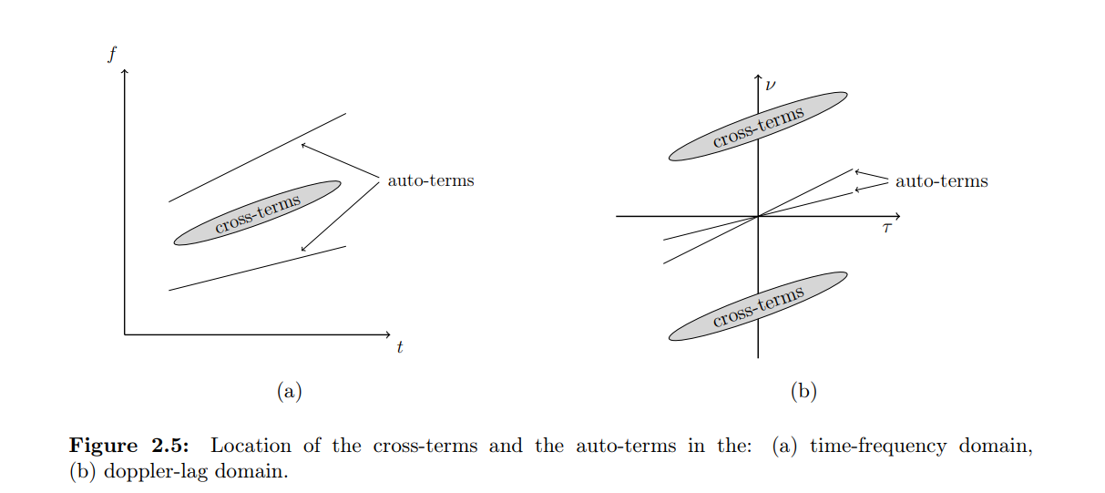

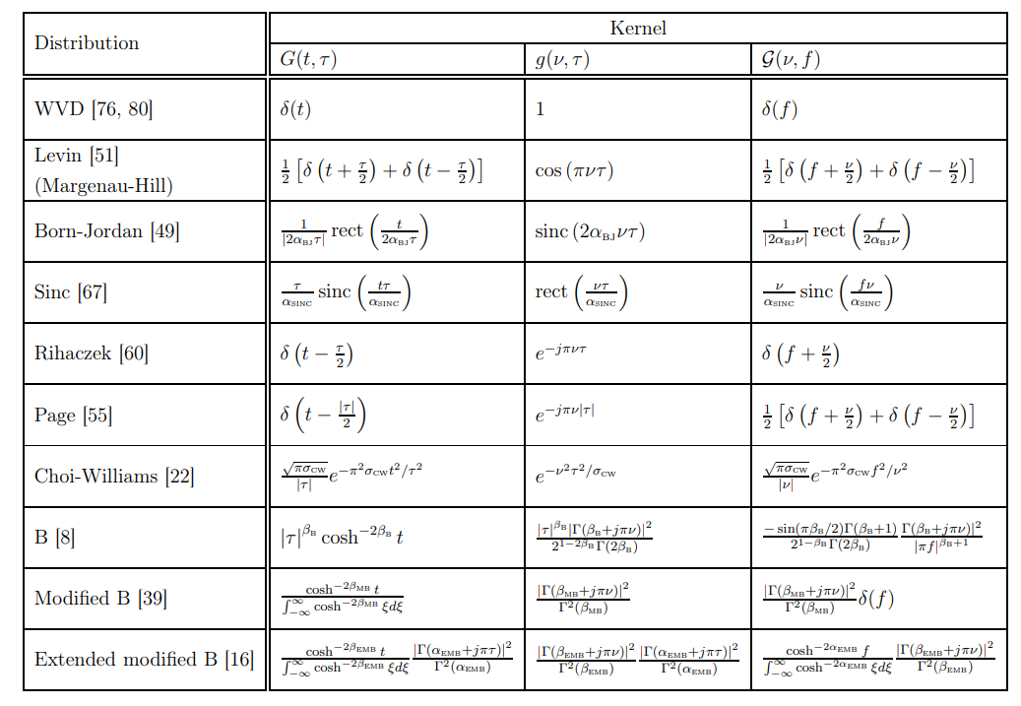[https://bib.irb.hr/datoteka/101a7274.Volaric_DoktorskaDisertacija_CD.pdf](https://bib.irb.hr/datoteka/1017274.Volaric_DoktorskaDisertacija_CD.pdf)

**Aok** :

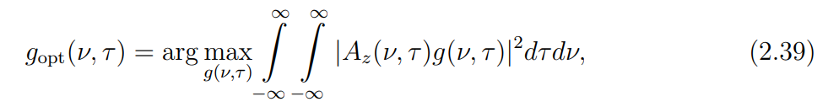the adaptive optimal kernel (AOK), which is based on the optimization of radial Gaussian functions in the ambiguity function (AF) domain [22], [23], is a commonly used signal-dependent kernel.

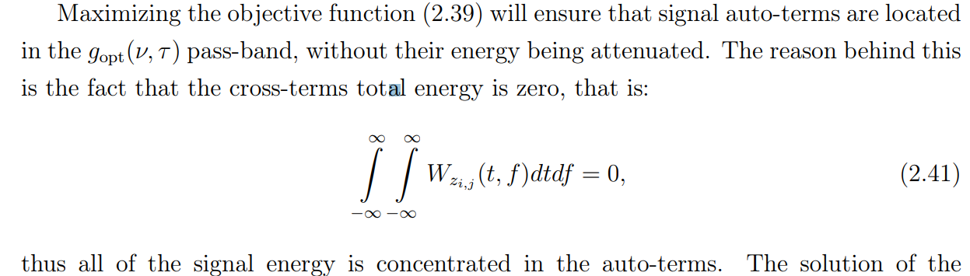

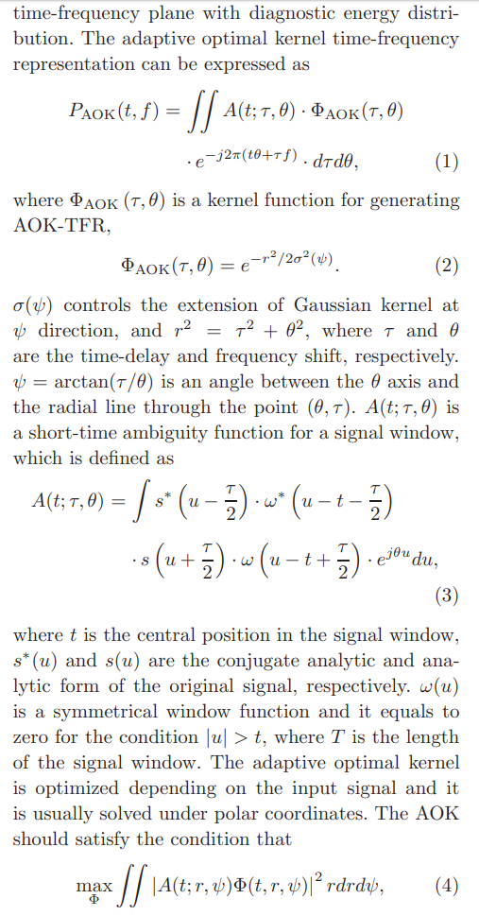

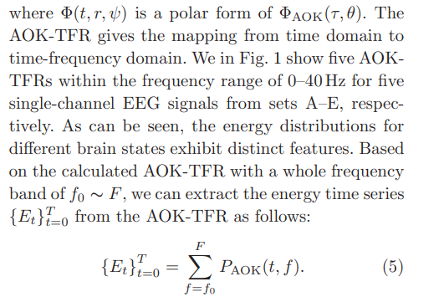

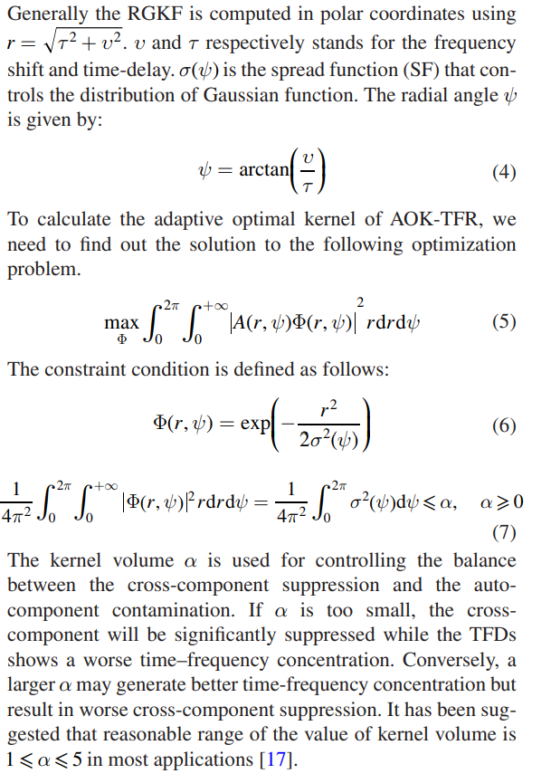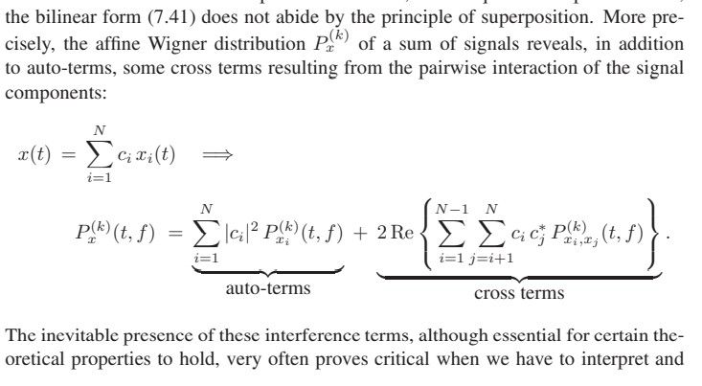

**STAF :**

