

Draw It Or Lose It

CS 230 Project Software Design Template
Version 1.0

Table of Contents

1.CS 230 Project Software Design Template 1
Table of Contents 2
Document Revision History 2
Executive Summary 3
Requirements 3
Design Constraints 3
System Architecture View 3
Domain Model 3
Evaluation 4
Recommendations 5
2.Operating Platform: <Recommend an appropriate operating platform that will allow The Gaming Room to expand Draw It or Lose It to other computing environments.> 5
3.Operating Systems Architectures: <Describe the details of the chosen operating platform architectures.> 5
4.Storage Management: <Identify an appropriate storage management system to be used with the recommended operating platform.> 5
5.Memory Management: <Explain how the recommended operating platform uses memory management techniques for the Draw It or Lose It software.> 5
6.Distributed Systems and Networks: <Knowing that the client would like Draw It or Lose It to communicate between various platforms, explain how this may be accomplished with distributed software and the network that connects the devices. Consider the dependencies between the components within the distributed systems and networks (connectivity, outages, and so on).> 5
7.Security: <Security is a must-have for the client. Explain how to protect user information on and between various platforms. Consider the user protection and security capabilities of the recommended operating platform.> 5

Document Revision History

Version | Date | Author | Comments
3 | 04/16/23 | Dakota Brown | Project 3

Instructions
Fill in all bracketed information on page one (the cover page), in the Document Revision History table, and below each header. Under each header, remove the bracketed prompt and write your own paragraph response covering the indicated information.

Executive Summary

Creative Technology Solutions needs assistance developing the environment and class infrastructure for their game, Draw It Or Lose It. It already exists on Android, but they wish to create a web-based version. A very basic framework has already been built, but in addition to the existing framework we will need to ensure that the game can be team-based and that each team can consist of multiple players. Each team name also must be unique and as before only one instance of the game can be in memory at one time.

A Singleton design pattern must be implemented to prevent multiple instances of the game from running simultaneously. We can also use an Iterator pattern to check a proposed team name against the current list and prevent duplicate names.

Requirements

< Please note: While this section is not being assessed, it will support your outline of the design constraints below. In your summary, identify each of the client’s business and technical requirements in a clear and concise manner.>

Design Constraints

The entire user interface will likely need to be completely redone to make it aesthetically pleasing on desktop. This could potentially be done by simply scaling, but given the scaling difficulties from a narrow to a wide viewport, it would be best to redo the interface all-together, so the web game likely won't look quite like the current Android version.

If mobile players will be playing with desktop players, we must ensure that the underlying tech and languages are compatible with each other so all data is ultimately sent to the main server in the same format regardless of platform. The code for both games should be in Java as it the native language for Android.

Beyond desktop vs. mobile, we also need to be sure that we implement code that ports well between Windows, Mac, and Linux.

System Architecture View

Please note: There is nothing required here for these projects, but this section serves as a reminder that describing the system and subsystem architecture present in the application, including physical components or tiers, may be required for other projects. A logical topology of the communication and storage aspects is also necessary to understand the overall architecture and should be provided.

Domain Model

The program begins with main in the ProgramDriver class which immediately instantiates a GameService object which acts as a sort of engine for the game that handles certain game management tasks.

The GameService class consists of a private default constructor which implements the Singleton design pattern by ensuring that only one instance of the game can be running in memory at once. The GameService class also maintains a list of all active games and facilitates the creation of games as Game class objects with the addGame() method. It also contains getGame() methods to search for active games by their ID or name and prevent duplicate names. This method implements the Iterator design pattern to achieve that.

From the Game class, we also have an addTeam() method which can add a new team and uses the same Iterator pattern to prevent duplicates. This also goes for the addPlayer() method within the Team class.

Entity is the parent class for the Game, Team, and Player classes and inherit from it. The private constructor of the Entity class will prevent objects from being created that are not passed arguments. If arguments are passed, the overloaded constructor will be called.

Inheritance is utilized in this program as the Game, Team, and Player classes inherit methods from the Entity class. Polymorphism is used via the overloaded constructors, so one method can take multiple forms. Encapsulation and abstraction are also present in this program because for example, Team and Player objects cannot be instantiated by the user via their constructors, but instead use the addTeam and addPlayer methods which are called from outside of the class which effectively hides some of the internal operation from the user.

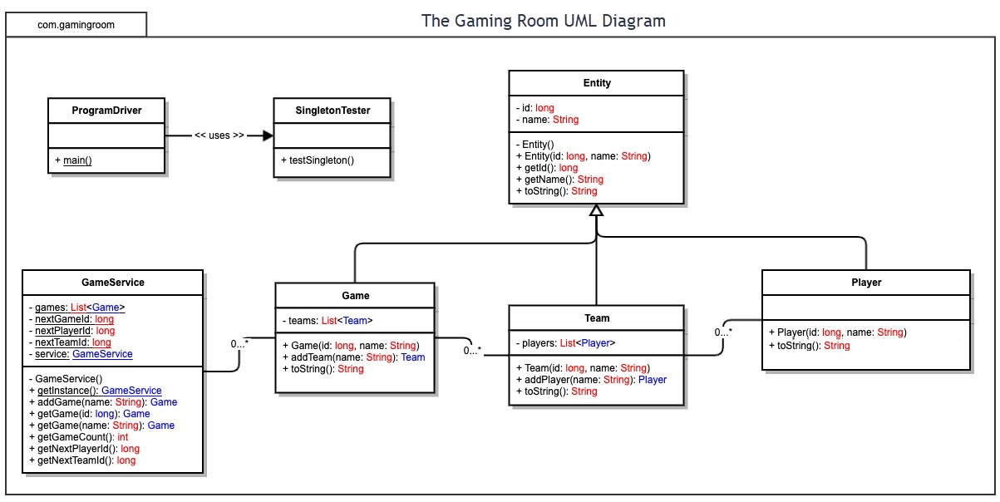

Evaluation

Using your experience to evaluate the characteristics, advantages, and weaknesses of each operating platform (Linux, Mac, and Windows) as well as mobile devices, consider the requirements outlined below and articulate your findings for each. As you complete the table, keep in mind your client’s requirements and look at the situation holistically, as it all has to work together.

In each cell, remove the bracketed prompt and write your own paragraph response covering the indicated information.

Development Requirements | Mac | Linux | Windows | Mobile Devices
Server Side | Before 2023, devs would need to pay for OS X for server side development, but now many of those features are included in the High Sierra OS. They can spend $99 for membership in Apple Developer Program which will give them advanced features and allow them to host the program on the app store. | When doing The Odin Project, Linux was highly recommended for both server and client side development. It is probably the cheapest option as it is free and open source.  Pretty much any cloud server can be used for hosting. Price will vary greatly depending on which package is selected. | Offers many server options that include a graphical user interface, so server side development can be very easy.  The cheapest starter option is about $600, which is quite expensive relative to Linux where this can be free. | Server side development and hosting really isn't an option here as mobile devices not specifically built for this purpose simply don't have the hardware resources to manage this.
Client Side | Apple Developer Program also necessary here for the $99 a month.  Will need Apple hardware specifically because only Apple hardware can run Mac OS.  Will also need to be familiar with Objective C or Swift as those are the only languages provided by the API. | This can be done on almost all hardware with the exception of Mac. Developing via Linux doesn't really have many stringent requirements due to its open source nature. | Will need to be familiar with C# and the .NET framework as this is the most common development set up on Windows.  Windows is by far the most popular desktop operating system on the market and natively allows for multiple users. | Developer kit for Android uses Java. And again, for iOS Swift and C are used.  Not natively meant to have more than one user though, so not the greatest option.
Development Tools | As mentioned before, the dev must be familiar with Swift and C.  For the IDE, Xcode is recommended, but other lesser known IDEs will work as well. Xcode costs $99. | Virtually any language can be used here including C++, Python, Javascript, Typescript etc.  There is a wide multitude of IDEs available which can range from as simple as Notepad++ to mid level ones like Eclipse, to more robust applications like Visual Studio. | As mentioned above, .NET and C#. But can use a multitude of languages.  Visual Studio is by far the most popular as far as IDEs go. It's free for the most basic version, but enterprise editions can cost $6000 per year! | As mentioned above, Android = Java. IOS = Swift or C.  IDE is the same as Macs, as Xcode is recommended. Android Studio is the official release for Android.

Recommendations

Analyze the characteristics of and techniques specific to various systems architectures and make a recommendation to The Gaming Room. Specifically, address the following:

- Operating Platform: Creative Technology Solutions' recommendation would be to use Linux as the operating platform for The Gaming Room's servers for Draw It Or Lose It. First and foremost, due to the open-source nature of the platform, costs can be kept extremely low compared to proprietary systems like Windows or Mac. It would make little economic sense to pay higher costs for a different platform when the open-source Linux platform offers even greater benefits that the costlier options. While Linux is much less commonly used than Windows by the general public, this does not matter as the clients are still welcome to use any platform that they choose to.

Given that Linux is the most commonly used platform for servers, it also offers a whole ton of flexibility in that there are many many tool options out there and available for use. The fact that one can use a shell to interact directly with the Linux kernel expands this flexibility even further. And once again, it's open-source nature allows The Gaming Room to modify this platform exactly as it likes which is also a huge plus in mitigating security vulnerabilities that may be unique to this application.

- Operating Systems Architectures: Under our recommendation, the client side would do a large amount of the heavy lifting to ensure that all players are on a level playing field regardless of their internet connection. The backend server would provide the overall environment and manage the gameplay itself. The client side on the front end would not consist of the user interface alone, but it would also be responsible for 100% of the image rendering responsibilities.

For these reasons, we also recommend that this game be it's own application rather than being played within a web browser. The initial download of a few gigabytes (primarily the high resolution images) can certainly be seen as a negative, but the fact that players can all have the exact same experience regardless of internet speed with client-side rendering is an overwhelming positive that negates the negatives related to the one time download.

If The Gaming Room plans to use this on mobile devices as well however, the backend will need to do the rendering for clients on that platform as a mobile application of several gigabytes is not feasible. Regardless, server strain will be far far less considering that all players on desktop will be doing these tasks themselves.

- Storage Management:

The best option would be to simply use a cloud based service like AWS to handle all storage management as these are of relatively low cost and they provide the advantage of The Gaming Room not having to worry about anything in regards to the storage. There would be no need to upgrade the drives or protect them from bad actors as this would all be managed by Amazon.

If The Gaming Room chooses to host all of the data themselves, there's no reason why SSDs should not be used. While SSDs are more expensive than HHDs, SSDs have no moving parts and thus use less electricity. Given the increased lifespan of SSDs, these savings on electricity expenses will pay for themselves over the long run. It is certainly worth the greater up front cost to have a far more reliable and durable option that will save on overhead expenses on a monthly basis.

Being that this game will not be at all resource intensive, speed isn't really a big issue for the time being, but regardless, SSDs are faster and if the game winds up becoming a big success the superior speed of SSDs will make greater scalability a much easier endeavor than it would be with HHDs.

- Memory Management: Given that most of the work will be done by the client's computer, memory management on the backend will be a somewhat negligible task. The backend servers will need to store a few things in RAM, but nothing intensive. For the client side however, they will need to deal with the rendering of the images. The application will receive a signal from the server to load a specified image into RAM. Once that round is over and a winner is established, the image can be cleared from memory and replaced with the next image in the next round.

While the high resolution images themselves will not be stored in main memory, other frequently used data can be stored in cache for much quicker usage.

In short, memory management is an extremely simple issue for this application and no advanced considerations need to be made.

- Distributed Systems and Networks: All interaction between the back and front ends can be managed through a RESTful API, but cloud services can be used and integrated within the API as many third parties have tools available that could improve and make seamless the interaction between clients through a distributed application.

In regards to integrating a cloud service, this is important because for this application to be successful, it's imperative that it doesn't unexpectedly go offline and the cloud providers are of course much more reliable in this respect.

- Security: As mentioned above, Linux does provide a plethora of tools to make applications as secure as humanly possible and allows administrators to modify the system itself to mitigate security vulnerabilities that are unique to this specific application. One tool for example is SELinux which is built into most instances/versions of Linux. It controls access as to what files and computing resources that an application can and cannot access from the server.

All users logging onto the game will need to authenticate themselves by providing their username and password. Once authenticated, the backend will determine authorization status which would be role based. There would be two roles, moderators and player. If someone is not an employee of The Gaming Room, there role will be “player”. Players of course will be able to access only the files and resources that they absolutely need in order to play the game, and this is consistent with The Principle of Least Privilege.

As far as encryption, the most commonly used standards will be sufficient. This will include the AES cipher and the SHA-256 hashing algorithm which is generally recommended as 256 bits is plenty as it to date has never been cracked. We also recommend that Comodo be used for SSL/TLS services.

Sources:

Silberschatz, A., Gagne, G., & Galvin, P. (2005). Operating System Concepts (7th ed.). John Wiley & Sons Inc.
Kili, A. (2017, November 22). 6 Reasons Why Linux Is Better Than Windows For Servers. TecMint. Retrieved March 16, 2023, from https://www.tecmint.com/why-linux-is-better-than-windows-for-servers/

