Label-efficient learning for High-Resolution Land Cover Classification using Large-Scale Self-Supervised Pre-Training and Transfer Learning
Dakota Hester
February 26, 2025
Abstract
Land cover data is a key component of environmental analysis and informs decision making in agriculture, urban planning, hydrology, and other applied domains. Most publicly available land cover products are produced at a coarse resolution due to the inherent difficulty in classifying high resolution data. Deep learning semantic segmentation models have been shown to be performant for such tasks but require large amounts of fully annotated tiles for training. This is problematic for land cover classification due to the expense and difficulty of annotating such data at scale. In our approach, we initially pre-train a ResNet-152 model on 377,913 unlabeled images using a denoising autoencoder to enable spatial feature extraction without the need for labeled data. This model is used as an encoder in a U-Net architecture where fully supervised pre-training is performed using 10,220 labeled images from another region. Finally, we fine-tune the U-Net with only 119 labeled images over the state of
Mississippi. When applied to 1-meter imagery in Mississippi, our model achieves over 80
Contents
1 Introduction 2
1.1 Unsupervised and self-supervised pre-training 3
2 Study area 4
3 Methodology 7
3.1 Training data generation 7
3.1.1 Sources of ground truth data 7
3.2 Stratifying by land cover composition 11
3.3 Residual U-Net model configuration 18
3.4 Multi-stage pre-training approach 18
3.5 Model evaluation and accuracy assessment 23
3.6 Wide area inference for large-scale land cover mapping 24
4 Preliminary Results 25
5 Conclusion 27

Introduction
Land cover data provides valuable information about the characteristics of the Earth’s surface for a wide variety of applications across many domains, including agriculture, urban planning, and environmental monitoring CITE!. Research into automated methods for land cover classification from remotely sensed data has been ongoing for several decades, with a majority of methods relying on supervised learning techniques to classify land cover using multispectral aerial or satellite imagery CITE!. Historically, these methods operate on a per-pixel basis, hand-engineered features are crafted from the raw data and used to train a classifier to predict the land cover class of each pixel in the image CITE!. However, these methods have shown to scale poorly with the increasing resolution of modern remote sensing data due to increased local variance and decreased inter-class separability CITE!.
Object-based Image Analysis (OBIA) techniques have been proposed as a potential workflow to address these issues, but their performance is highly dependent on the quality of objects or superpixels extracted from the imagery during the segmentation process CITE!. Further, the segmentation process is often computationally expensive, and the parameters of the segmentation algorithm must be carefully tuned to achieve optimal results, resulting in poor generalization to areas outside of the training data CITE!. Deep learning methods have shown promise in addressing these issues by learning to extract hierarchical, spatially organized, translation invariant features from the raw data, then using these feature maps to predict the land cover class of each pixel in the image based on the presence of learned spectral and spatial patterns CITE!. Such methods have been shown to be effective at classifying land cover from high spatial resolution multispectral imagery at scale, addressing the limitations of traditional pixel-wise algorithms as well as OBIA-based methods CITE!. However, these methods often require large amounts of labeled training data to achieve optimal performance, which can be difficult to obtain due to the inherent cost of labeling such data at scale. Transfer learning has been shown to be effective at this solution by leveraging models pre-trained on large, diverse datasets to extract features from the raw data, but the effectiveness... FINISH ME!!!!
Semantic segmentation for end-to-end land cover classification 2 paragraphs
Transfer learning for addressing data scarcity 2-3 paragraphs

Unsupervised and self-supervised pre-training
2-3 paragraphs
[4]

Study area
Our region of interest for this study is the state of Mississippi, USA. Mississippi is located in the southeastern United States, and is home to a diverse range of land cover types. The region’s humid subtropical climate and fertile soils in the Mississippi River Delta and Yazoo Basin lend themselves to a variety of agricultural activities [1], while the Northern Mississippi Hills and Piney Woods regions are characterized by forests and woodlands which comprise the majority of land cover in the state CITE!. The coastal region along the Gulf of Mexico is home to a sprawling urban network intertwined with herbaceous wetlands and barren beaches, and the state’s numerous water bodies, including the Mississippi and Pearl Rivers, provide valuable habitats for a variety of species while also serving as important transportation corridors for the broader southeastern and midwestern United States CITE!. The state’s diverse land cover types, geographical position along the Mississippi River and Gulf of Mexico, and economic dependence on agriculture and natural resources make the need for accurate land cover information at high spatial resolution in order to support natural resource management, agricultural planning, and environmental monitoring efforts.
National Agriculture Imagery Program (NAIP) For this study, we use USDA National Agriculture Imagery Program (NAIP) imagery as our primary data source. NAIP imagery is high-resolution (0.6 meter) multispectral aerial imagery collected during the summer months over the contiguous United States. Such imagery is collected on a 2-3 year cycle (depending on the state) and is predominantly used for agricultural purposes. While the temporal availability of NAIP imagery is limited, the high spatial resolution of the imagery and public availability of the data make it an attractive data source for remote sensing applications that require high spatial resolution data over large areas in the contiguous United States [5]. We use NAIP imagery collected in 2023 for the state of Mississippi, which is the most recent data available at the time of this study. The imagery is provided in 4 spectral bands (Red, Green, Blue, and Near-Infrared) at a spatial resolution of 0.6 meters per pixel. Our data is downloaded from the NRCS Geospatial Data Gateway, which provides color-infrared orthorectified, mosaiced imagery for each county for which NAIP imagery is available [21]. For each county, we resample the imagery to a spatial resolution of 1 m to reduce the computational cost of processing and storing the data, as well as to align with the desired spatial resolution of the land cover product we aim to generate. Further, in accordance with recommendation from the Mississippi Automated Resource Information System (MARIS), we reproject the imagery to the Misssissippi Transverse Mercator (MSTM) coordinate system (EPSG: 3813) to ensure that all data is in the same coordinate reference system, as both UTM and State Plane coordinate systems divide the state of Mississippi into two zones, which can introduce complexity when working with datasets that span the entire state [15]. Figure 1 shows the extent of the study area and the NAIP imagery used in this study in the MSTM coordinate system.
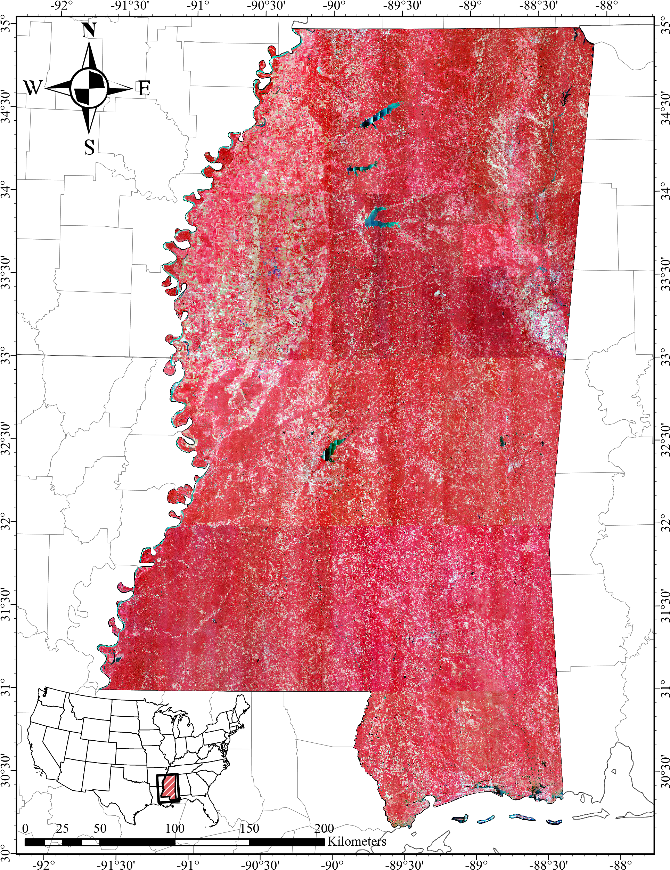
Figure 1: 2023 NAIP color-infrared imagery over Mississippi, USA.

Methodology

Training data generation

Sources of ground truth data
Mississippi High Resolution Land Cover For this study, we annotate a subset of the Mississippi NAIP imagery for the purposes of training and evaluating deep learning models for land cover classification over Mississippi. 250 256 × 256 pixel image tiles are sampled from the NAIP imagery using the process described in Section 3.2, and are subsequently annotated by a team of expert annotatues using the Computer Vision Annotation Tool (CVAT) platform. CVAT is an open-source web-based tool that facilitates rapid, high-quality, dense annotations of imagery data using a variety of utilities, including the ability to use a pre-trained Segment Anything Model (SAM) 2 [18] to quickly generate initial segmentation masks for objects using point prompts that can be refined and assigned to specific classes by human annotators [3]. Our land cover classes consist of 8 classes, with each class defined in Table 1. The inclusion of an ”Unclassified” class is intended to capture areas of the image that are poorly illuminated or occluded by shadows or other objects, where the annotators are unable to confidently assign a class label. This is particularly important due to the presence of dense forests in Mississippi, which cause varying intensities of shadows to be cast on the ground, which makes classifying the underlying land cover impossible in some cases. For this stage of the study, 250 tiles have been annotated, with the remaining tiles to be annotated in the future.
Index | Class | Description
1 | Open Water | Rivers, lakes, ponds, and other standing or moving water. Dark in CIR imagery due to nearinfrared absorption; may appear bluish-green depending on depth and turbidity.
2 | Impervious Structures | Elevated built features (e.g., buildings, sheds). Bright and reflective with sharp-edges and shadows.
3 | Impervious Surfaces | Paved areas such as roads and parking lots. Typically bright but may appear dark depending on material. Linear patterns and lack of shadows distinguish from barren land and impervious structures.
4 | Barren Land | Exposed soil, sand, or rock with minimal vegetation. Bright or neutral in CIR imagery, often interleaved with herbaceous areas.
5 | Forest/Woody Vegetation | Tree-covered areas with dense canopy. Deep red in CIR imagery due to high near-infrared reflectance. Uneven texture with large shadows.
6 | Herbaceous/Low Vegetation | Short vegetation, including grasses and shrubs. Smoother texture than forest, lighter red in CIR imagery. Common in clearings and field edges.
7 | Cultivated Crops | Actively farmed fields, often in distinct rows. Bright red or pink in CIR imagery at peak growth. Presence of rows or patterns distinguish from herbaceous areas.
8 | Unclassified | Shadows or occlusions obscuring surface features. Deep black regions near trees and buildings.
Table 1: Land cover classification scheme for the Mississippi dataset.
National Land Cover Database (NLCD) Land cover data from the USGS National Land Cover Database (NLCD) is used to guide the stratification of the Mississippi NAIP imagery for the purposes of sampling training, validation, and test data (see Section 3.2).
The NLCD is a multi-temporal land cover dataset produced by the Multi-Resolution Land Characteristics (MRLC) Consortium, which is a partnership between the USGS, NASA, and other federal agencies. The newest edition of the NLCD, Annual NLCD, provides annual land cover data at a 30 m spatial resolution for the entire United States, and is derived from Landsat satellite imagery using a combination of spectral and temporal information. Thus, while the NLCD provides a lower spatial resolution than the NAIP imagery used in this study, it is valuable for providing a broad overview of land cover types across the state of Mississippi, and can be used to guide the stratification of the NAIP imagery for the purposes of sampling training, validation, and test data. Prior to use in this study, the NLCD data is reprojected to the MSTM coordinate system to match the NAIP imagery, and is reclassified to match the land cover classes used in the Mississippi dataset as shown in Table ??.
NLCD Class Index | NLCD Class | Mississippi Class Index | Mississippi Class
11 | Open Water | 1 | Open Water
23  24 | Developed, Medium Intensity  Developed, High Intensity | 2 | Impervious Structures
21  22 | Developed, Open Space  Developed, Low Intensity | 3 | Impervious Surfaces
31 | Barren Land | 4 | Barren
41  42  43  90 | Deciduous Forest  Evergreen Forest  Mixed Forest  Woody Wetlands | 5 | Forest
52  71  81  95 | Shrub/Scrub  Grassland/Herbaceous  Pasture/Hay  Emergent Herbaceous Wetlands | 6 | Herbaceous
82 | Cultivated Crops | 7 | Cultivated Crops
250 | NoData | 0 | No Data
Table 2: Reclassification scheme for aligning NLCD land cover classes with our desired classification scheme.
Chesapeake Bay Land Use and Land Cover In addition to the NAIP imagery and
our Mississippi land cover labels, we integrate auxiliary land cover data from the Chesapeake Bay Land Use and Land Cover dataset [2]. The 2022 edition of the dataset, which provides land cover information over the Chesapeake Bay watershed at 1 m GSD for the 2017-2018 time period, is used in this study. Specifically, we use land cover data over Fairfax and Arlington counties in Virginia, which are part of the broader Washington, D.C. metropolitan area and are derived using 2018 NAIP imagery. This region was chosen due to the availability high-resolution land cover data, as well as the presence of dense urban and suburban land cover types that are not well-represented in the Mississippi NAIP dataset. Corresponding 2018 color-infrared NAIP imagery for this region is also used in this study, and is provided by the NRCS Geospatial Data Gateway. It is important to note that the orthoimages provided by the NRCS are not precisely clipped to the boundaries of the counties, and are instead provided as a single, large mosaic that includes multiple images with some overlap between adjacent counties. As such, though the dataset selected for this study is labeled as Fairfax and Arlington counties, it also includes portions of Alexandria, Loudon, and Prince William counties. The land cover data is reprojected to the UTM Zone 18N coordinate system (EPSG: 32618) to match the imagery, and the NAIP imagery is subsequently resampled to 1 m GSD such to align with the spatial resolution of the land cover data. Further, the land cover data is reclassified to more closely match the land cover classes usedin the Mississippi dataset, as shown in Table 3. The full extent of the subset of the Chesapeake Bay dataset used in this study is shown in Figure
2.
Chesapeake Class Index | Chesapeake Class | Reduced Class Index | Reduced Class Label
1 | Water | 1 | Open Water
3  10  11  12 | Tree Canopy  Tree Canopy over Impervious Structures  Tree Canopy over Other Impervious  Tree Canopy over Roads | 2 | Forest
4 | Shrubland | 3 | Herbaceous
2  5 | Emergent Wetlands  Low Vegetation | 4 | Herbaceous
6 | Barren Land | 5 | Barren
7 | Impervious Structures | 6 | Impervious Structures
8  9 | Other Impervious  Roads | 7 | Impervious Surfaces
Table 3: Reclassification scheme for reducing Chesapeake Bay land cover classes to more closely align with our desired classification scheme.
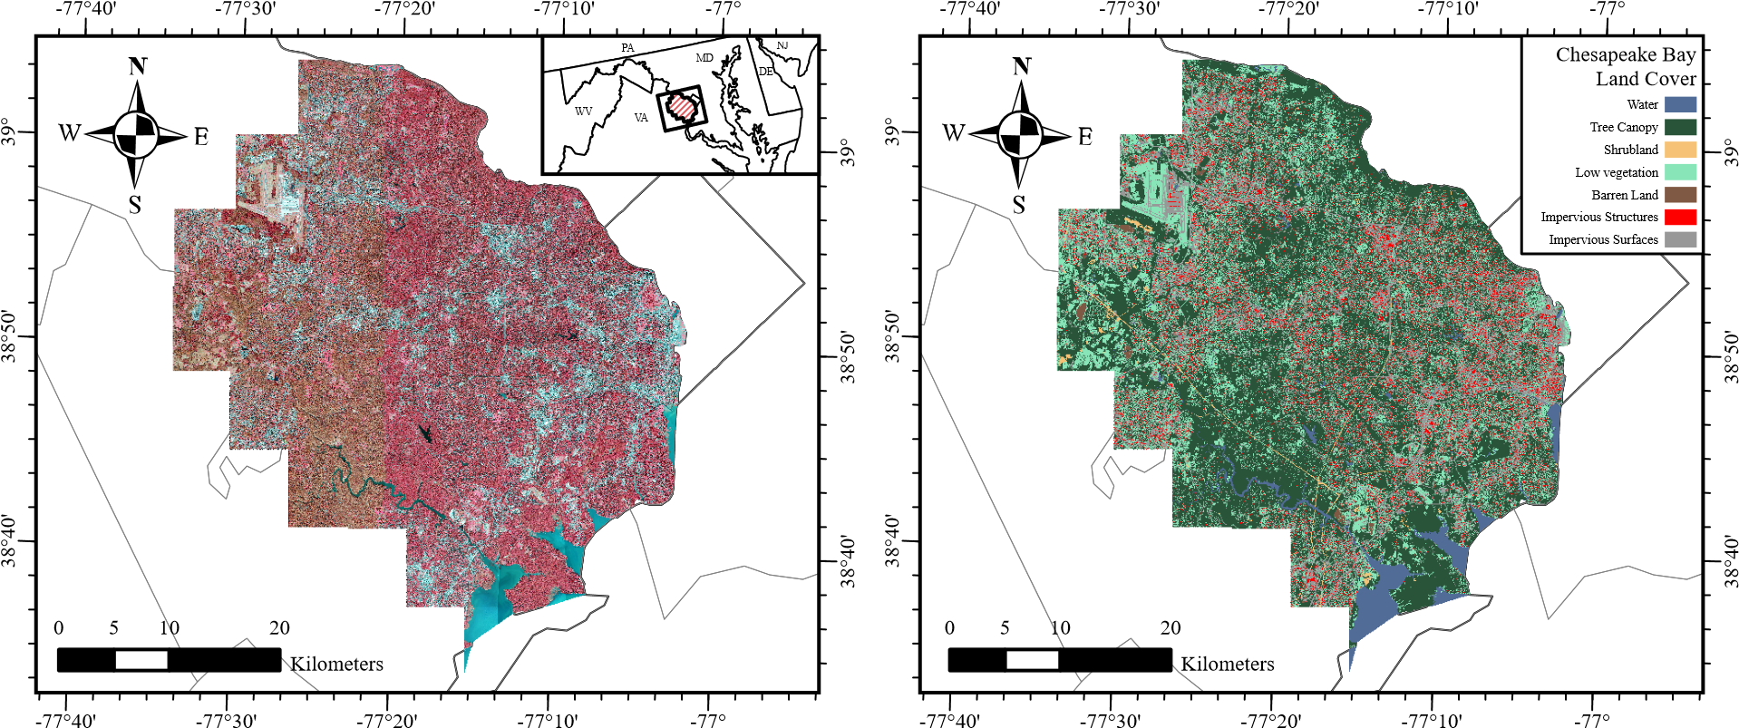
Figure 2: Extent of 2018 NAIP imagery (left) and 2018 Chesapeake Bay land cover (right) over Alexandria, Arlington, Fairfax, Loudon, and Prince William counties in Virginia, USA used in this study. REFERENCE ME!!

Stratifying by land cover composition
Ideally, land cover classification models should be trained and validated against samples that are representative of the study area. However, under the constraints of limited labeled data, it may be difficult to capture the full range of variation in the study area. Stratified sampling is a common approach to address this issue, where the study area is divided into strata based on some characteristic (such as land cover class or sub-region) and samples are drawn from each stratum. Unlike traditional land cover classification models, our semantic segmentation model necessitates the use of densely annotated tiles that exhibit a high degree of diversity with regards to spatial characteristics. Ideally, a single training tile should consist of a mix of land cover classes, and the arrangement of land cover classes should similarly be representative of the study area as a whole. To achieve this, we employ a stratified sampling strategy using the National Land Cover Database (NLCD) to guide the selection of training, validation, and testing tiles. This ensures that both the distribution of classes in the tiles is representative of the study area and the content of the tiles is heterogeneous and diverse in terms of spatial characteristics. The NLCD provides land cover data at a 30m resolution for the entire United States, and the most recent edition (Annual NLCD) provides yearly land cover data between 1985 and 2023. We use 2023 NLCD data to ensure the land cover data is consistent with the NAIP imagery acquired during the same year. For our land cover product, we reclassify the level 1 land cover product to correspond with our choice of legend according to the mapping schema in Table ??. A grid of 256 × 256 m square polygons is overlaid over the study area to create candidate tiles, and the proportion of each land cover class is calculated for each tile by computing zonal statistics on the NLCD data within each tile. Once the relative frequency of each land cover class is calculated, we scale the data by subtracting the median value and dividing by the interquartile range to ensure that the data is centered and scaled. Principal component analysis (PCA) is applied to the scaled land cover relative frequency data to reduce the dimensionality of the probabilities prior to clustering. Once the principal components are calculated, we identify the first two principal components that capture 94.24% of the data variance and use these components to guide the clustering of the tiles. Figure 4 visualizes these first two principal components of the land cover data at the tile level. Higher values of the first principal component correspond to a higher proportion of impervious land cover types in each tile, while higher values of the second principal component correspond to a higher proportion of forested and herbaceous land cover, with lower values correlating with regions that consist of tiles primarily or wholly composed of cultivated crops. These tiles are subsequently grouped into 250 clusters using K-means clustering operating on these two principal components. As shown in Figure 5, the clustering algorithm effectively divides the principal component space into regions that correspond to differing land cover compositions. From each cluster, we sample 2 candidate tiles for training, 1 for validation, and 1 for testing. This results in a total of 500 training tiles, 250 validation tiles, and 250 testing tiles. For this preliminary study, we randomly sample 1/4 of the tiles from the full dataset to create a smaller dataset in order to yield a preliminary evaluation of the model’s performance. As such, the training, validation, and testing dataset used in this phase of the study consists of 119, 61, and 70 tiles,
respectively.
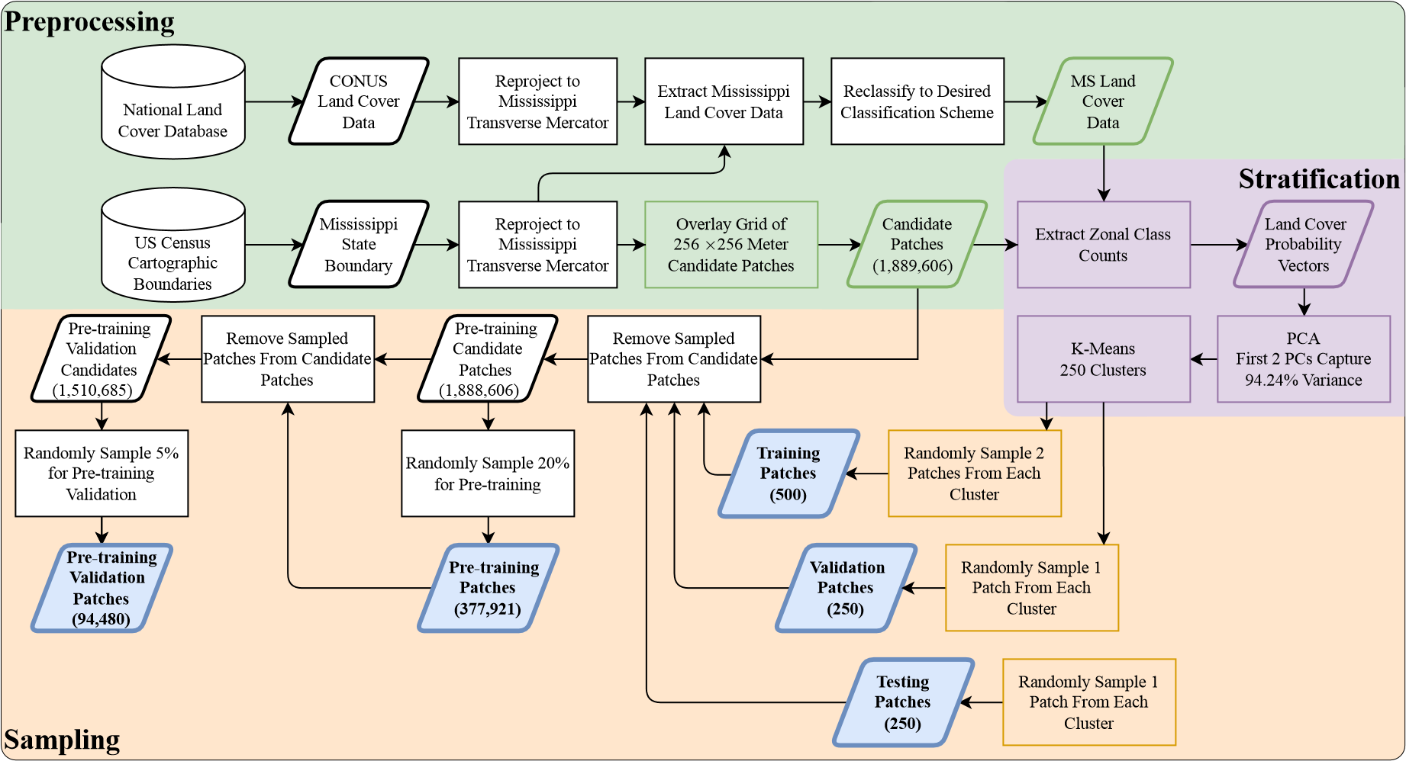
Figure 3: Flowchart of the stratified sampling process for selecting data for model training and validation.
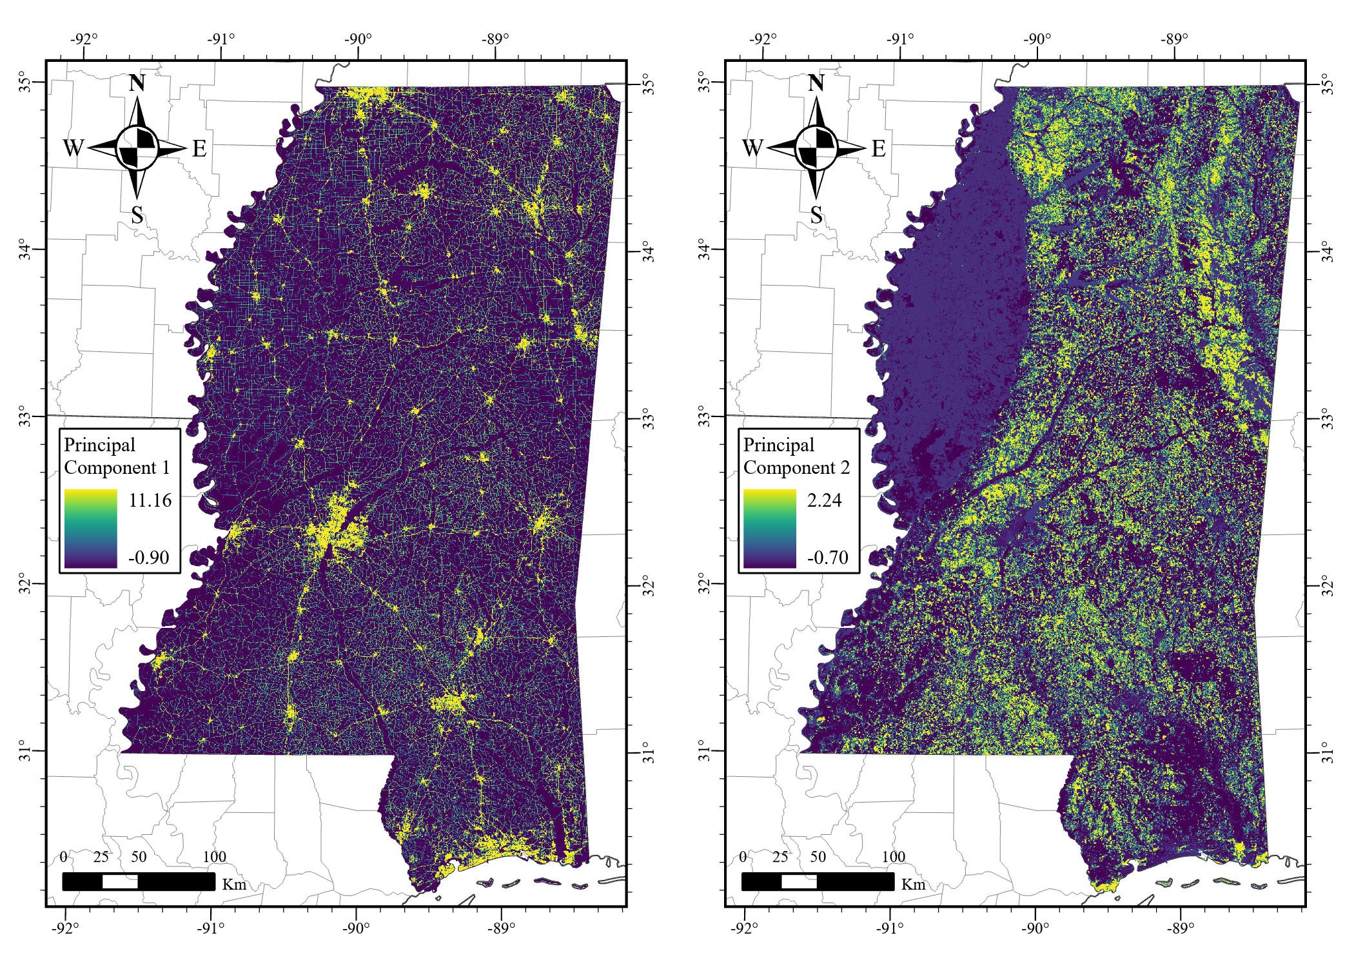
Figure 4: Principal components of NLCD relative frequencies per candidate tile.
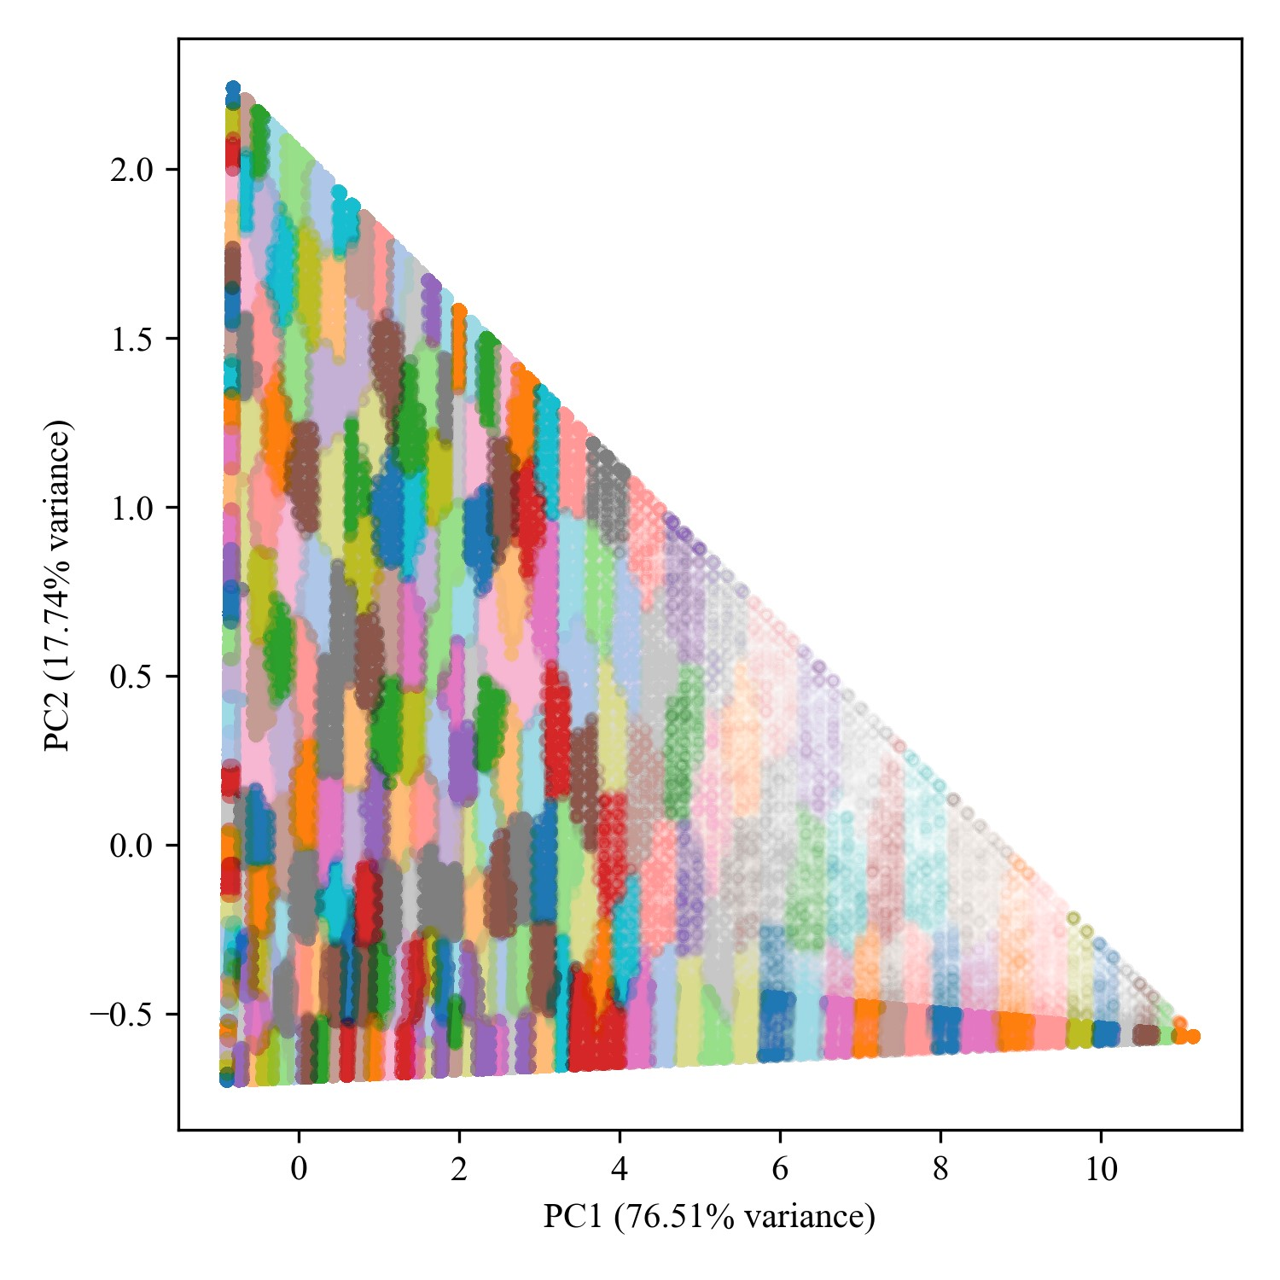
Figure 5: Clusters from which samples are draw in principal component space.
Ensuring this strategy yields high-quality training data that is representative of the study area is crucial to the success of the model. However, we recognize that a rigid evaluation of such an approach to stratification is not possible due to the lack of ground truth data for the study area. One measure we take to ensure the stratification is effective is to inspect the distribution of land cover classes across the splits. Figure 6 shows that the distribution of land cover classes is consistent across the training, validation, and testing splits, which is ideal for ensuring that the model is exposed to a representative sample of the study area’s land cover diversity. One important note is that the distribution of land cover classes in the study area is highly imbalanced, with the majority of Mississippi’s land cover being classified as forest, and a low density of urban and developed areas. To tackle this issue, other strategies often employ synthetic oversampling of minority classes or strategic undersampling of majority classes CITE. Although our approach to stratifying the data does not explicitly enforce such policies, comparing the land cover class distribution in the sampled tiles to the distribution across the entire state (as shown in Figure 6) demonstrates that our sampling strategy achieves a similar outcome to these oversampling and undersampling strategies. Furthermore, our approach tends to avoid sampling tiles that are composed of a single land cover class. In the original NLCD data, 29.96% of the tiles are composed of a single land cover class, while only 1.90% of the sampled tiles are composed of a single land cover class. This is promising, as these homogeneous tiles are likely to be less informative for training the model CITE. Additionally, a visual inspection of the location of the sampled tiles in Figure 7 shows that the tiles are distributed across the state of Mississippi without any apparent spatial bias.
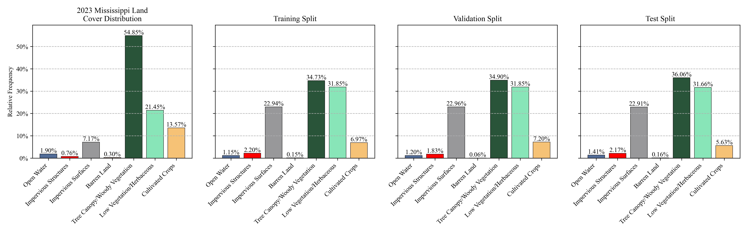
Figure 6: Distribution of 2023 NLCD land cover classes across Mississippi: statewide distribution compared with training, validation, and test splits.
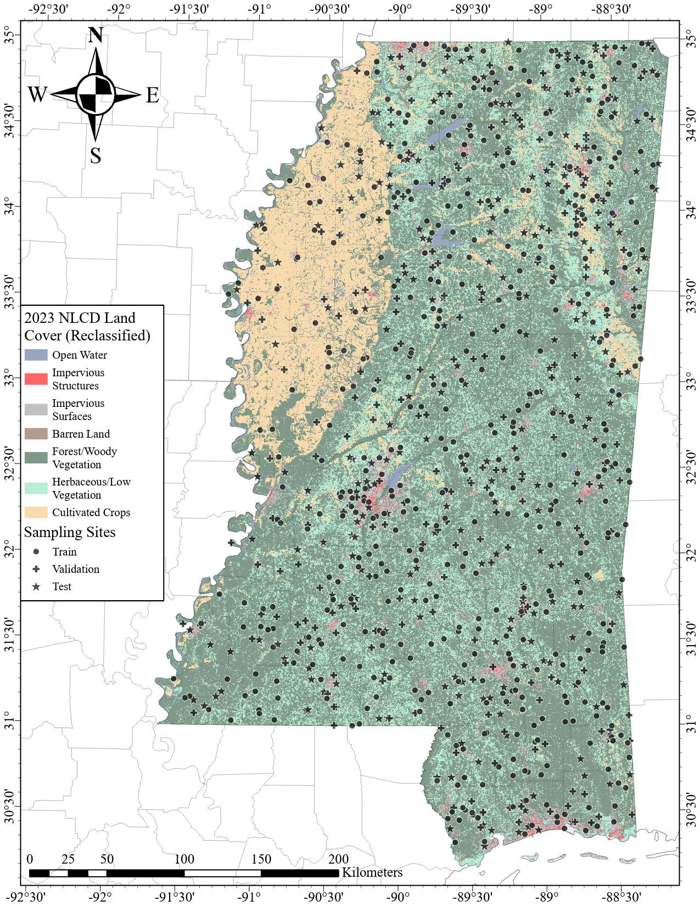
Figure 7: Sample locations for the Mississippi dataset REFERENCE ME!!!.

Residual U-Net model configuration
Our model is based on the U-Net architecture, which is a popular choice for semantic segmentation tasks due to its relatively simple yet effective design [19] OTHERS!!!. First, in lieu of the original convolutional encoder network in the original implementation, we employ a much deeper ResNet-152 network as the encoder. Our reasoning for this choice is that the increased number of layers in the ResNet-152 network will facilitate more complex feature extraction, particularly during the self-supervised pre-training phase, where the large amount of unlabeled data will allow the encoder to learn to capture rich representations of spatial features in the input imagery. The number of channels accepted and produced by the decoder convolutions are subsequently adjusted to match the output of their corresponding encoder blocks. Second, we replace the transposed convolutional layers in the original U-Net decoder with bilinear upsampling to reduce the presence of checkerboard artifacts in the upsampled feature maps, which can inhibit the quality of the output segmentation maps [17, 20]. Finally, in each decoder block, we introduce a residual connection between the output of the first convolutional layer and the output of the second convolutional layer to facilitate the flow of information through the network and improve training stability [6].

Multi-stage pre-training approach
Our pre-training approach consists of two phases: a self-supervised pre-training phase and a fully supervised pre-training phase. As shown in Figure 8, our proposed model is first trained using the unannotated NAIP imagery over the state of Mississippi, then additional pre-training is performed using NAIP imagery over Fairfax County, Virginia using ground truth land cover data from the Chesapeake Bay Land Cover Dataset, before being fine-tuned on our hand-labeled training data from Mississippi. The purpose of such a pretraining regimen is to leverage the large volume of imagery available to train the encoder network to extract features that are useful for image reconstruction as well as relevant for land cover classification [22]. The second phase of pre-training encourages the model to refine these features in a supervised setting, while also initializing the decoder network using a land cover classification task that is nearly aligned with the downstream Mississippi land cover classification task [24, 13]. The goal of such an approach is to reduce the amount of labeled data required to achieve optimal performance on the final land cover classification task [25, 8, 10, 23].
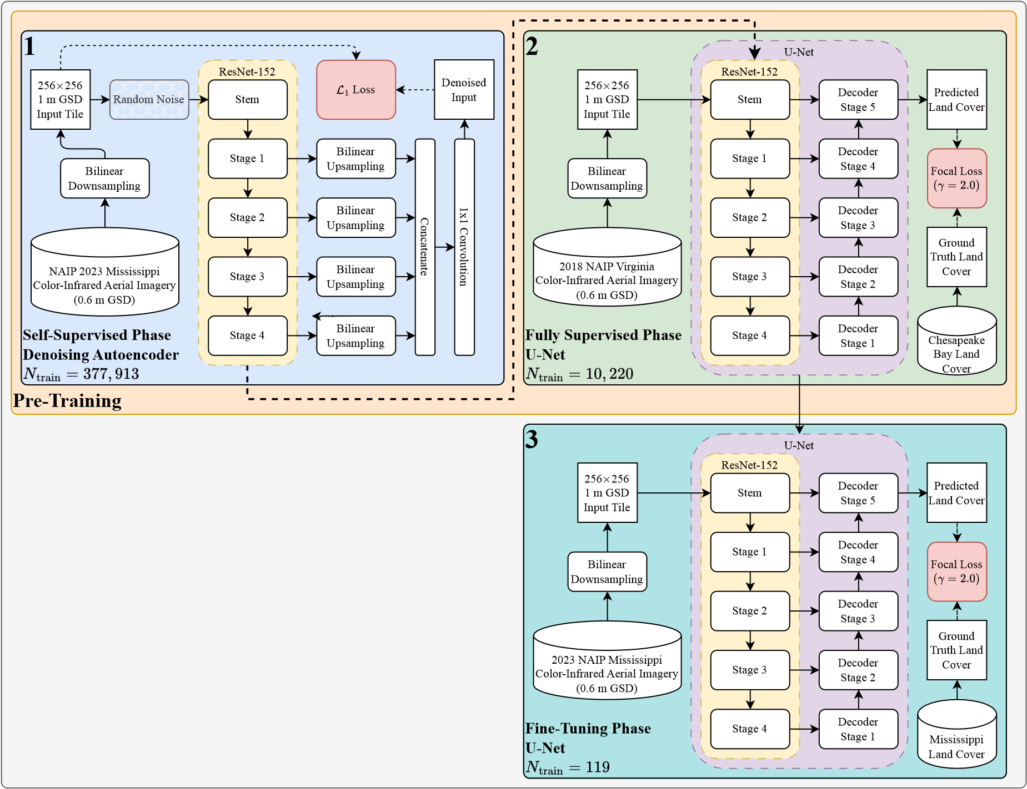
Figure 8: Flowchart of the model training workflow. REFERENCE ME!
Self-supervised pre-training In the first stage of pre-training, we train a denoising autoencoder using the unannotated NAIP imagery over the state of Mississippi. Our denoising autoencoder consists of a ResNet-152 encoder network and a simple decoder network that receives feature maps from each stage of the encoder network, resamples them to the original input resolution using bilinear interpolation, concatenates them, and passes them through a single 1×1 convolutional layer to produce an output with the same dimensions as the input. The ResNet-152 encoder network is initialized with ImageNet-1k pre-trained weights, while the decoder network is randomly initialized. A full decoder network (as is common in traditional autoencoders) is not used in this phase, as our primary goal is to force the encoder network to learn robust features present in the imagery that are necessary for reconstruction, rather than to necessarily learn to denoise the input images with a high degree of accuracy. Further, a U-Net architecture (like the one used in the subsequent fully supervised stages of training) are not used, as the presence of skip connections in the network can inhibit strong representation learning in the encoder network/ The single-layer decoder network is designed to ensure that backpropagation primarily influences the parameters of the encoder network, while also reducing the computational cost of pre-training the model.
Two types of noise are added to the image: Gaussian noise and Poisson noise. The intensity of the Gaussian noise is controlled by the standard deviation parameter σ, which is randomly sampled from a uniform distribution U(0,2). Similarly, the intensity of the Poisson noise is controlled by the rate parameter λ, which is also randomly sampled from a uniform distribution U(0,1). Since random variables sampled from a Poisson distribution are strictly non-negative, Poisson noise is both added and subtracted from the input image (using the same λ value) to increase the impact of the noise on the input image. Model inputs are standardized to have zero mean and unit variance on a per-band basis using the mean and standard deviation of the pre-training data prior to adding noise. We opt for a relatively small batch size of 8 to reduce the memory requirements of the model during pre-training and to better approximate the stochasticity of the training data, improving the model’s generalization ability — an important consideration given our goal of transfering the encoder network to a downstream task [9, 14]. The loss function used during this self-supervised pre-training phase the mean absolute error between the model’s raw output and the normalized input image. While the mean squared error is a common choice for autoencoder models, we opt for the mean absolute error as it tends to produce sharper images in the output [26, 16]. The AdamW optimizer is used to train the model, with an initial learning rate of 1e-6 and a weight decay of 1e-2 [12]. After each epoch of pre-training, the model is evaluated using the pre-training validation set to ensure that the model is fitting the data properly and to adjust the learning rate if necessary. If the validation loss does not decrease after an epoch, the learning rate is reduced by a factor of 0.1. While such a scheduler is aggressive, given the large volume of samples in the pretraining dataset and the sheer number of parameter updates that occur within a single epoch, we find that the model tends to optimize quickly and that there is little benefit to continuing to train at a learning rate where previous epochs have not shown improvement. Further, if the pretraining validation loss does not decrease for 5 consecutive epochs, the pre-training phase is terminated early. As such, while the model is trained for a maximum of 100 epochs, our model is capable of converging in 9 epochs ADD FIGURE FOR PRE-TRAINING LOSS CURVE. In order to estimate the quality of the reconstructions, we track the peak signal-to-noise ratio (PSNR) and structural similarity index (SSIM) between the input and output images during training [7].

FIGURE: DIFFERENT TYPES OF NOISE
Fully supervised pre-training Once the self-supervised pre-training phase is complete, the encoder network is used as the encoder in the U-Net architecture, and the decoder network is initialized with random weights. The model is trained to minimize the Focal loss, defined as:
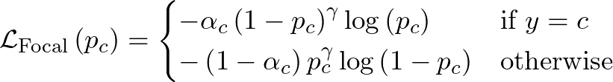 (1)
where p_{c} is the predicted probability of class c, y is the true class label, α_{c} is the class weight for class c, and γ is a hyperparameter that controls the degree of class weighting.
In order to address the class imbalance present in the data (REFERENCE FIGURE HERE, we employ a class weighting strategy that assigns class weights according to the formula:
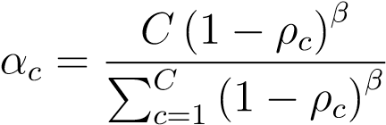 (2)
where ρ_{c} is the proportion of class c in the training set, β is a hyperparameter that controls the degree of class weighting, and C is the total number of classes. For our experiments, we set γ = 2.0 in accordance with the authors’ findings in the original Focal loss paper [11], and β = 2.0 such that minority classes are emphasized without majority classes being under-represented in the loss function. Like the previous pre-training stage, the model’s parameters are updated using the AdamW optimizer, with an initial learning rate of X.XX and a weight decay of X.XX. The model is evaluated after every epoch using the validation set to adjust the learning rate and terminate the training early if necessary: if no improvement is observed in the validation loss for 3 consecutive epochs, the learning rate is reduced by a factor of 0.1, and if no improvement is observed for 15 consecutive epochs, the training is terminated early. During this phase, we train the model using two different configurations: one where the encoder network is frozen and only the decoder network is trained, and one where the entire model is trained end-to-end. We also experiment with different encoder weights, including the ImageNet-1k pre-trained weights without any further pre-training, as well as randomly initialized weights. After each model has been trained, we evaluate using the holdout testing set to evaluate the performance of each training configuration on the Fairfax County land cover classification task. Evaluating the model on this task, while not directly related to the downstream Mississippi land cover classification task, gives us an idea of each model’s ability to fit the land cover data under a moderate data availability scenario.
Fine-tuning Once the model has been pre-trained, we fine-tune the model using our labeled data from the state of Mississippi. We employ the same loss function, class weighting strategy, optimizer, and hyperparameters as the fully supervised pre-training phase, with the exception that the learning rate is reduced to X.XX. We experiment with different initial weights for the U-Net model, including random initialization, ImageNet-1k pre-trained weights in the encoder network, and all weights pre-trained using the selfsupervised and/or fully supervised pre-training phases. Further, for each model configuration, we experiment with training the entire model end-to-end, freezing the encoder parameters and only training the decoder, and freezing the entire model and only training the final classification layer. After training, we evaluate the model using the holdout testing set to evaluate the model’s efficacy on the Mississippi land cover classification task.

Model evaluation and accuracy assessment
In order to evaluate the performance of our model, we use the following metrics: overall accuracy, producer’s accuracy, user’s accuracy, F1 score, and Cohen’s Kappa. Due to the severe class imbalance present in the dataset, we measure the performance of the model on a per-class basis (using macro averaging) as well as on a per-pixel basis. We select the best performing model based on the macro-averaged F1 score on the testing set, and use this model to generate a land cover classification map for the entire state of Mississippi. In order to stratify sampled points for the accuracy assessment, the proportion of land cover classes in the final land cover map is calculated, and the number of points sampled for each class is proportional to the square root of the relative frequency of that class in the map. We take the square root of the relative frequency to reduce the impact of the majority classes on the accuracy assessment while simultaneously ensuring that the minority classes are adequately represented. Our goal is to have a minimum of 10,000 points sampled for the accuracy assessment such to ensure that the accuracy estimates are robust and reliable.

Wide area inference for large-scale land cover mapping
Once the best performing model has been selected based on the testing set performance, we place this model in an inference pipeline that allows us to generate land cover classificaiton maps for the entire state of Mississippi. As the NAIP imagery is split into countylevel subsets (see Section 2), we process each county individually, then stitch the resulting land cover classification maps together to create a single, seamless land cover classification map for the entire state. Prior to performing inference on a county, we obtain the county’s boundary from the US Census Bureau’s TIGER/Line Shapefiles, buffer the boundary by 1.5 times the model input size to ensure that the model has enough context to make accurate predictions near the county boundary, and crop the NAIP imagery to the buffered boundary. We apply a ”sliding window” approach to inference, where the model is applied to overlapping patches of the cropped NAIP imagery, and the resulting probabilities are post-processed and averaged to create a single land cover classification map for the county.
For our inference pipeline, we select a model input size of 256 × 256 pixels and a stride of 128 pixels, which allows for a 50% overlap between adjacent patches. To reduce the impact of edge effects on the stitched land cover classification map, we weight the probabilities of each pixel by its distance from the center of the tile by multiplying the probabilities by a 2D Gaussian kernel with the same dimensions as the model input size with a standard deviation of 128 pixels. This ensures that the probabilities of pixels near the center of the tile have a greater impact on the final land cover classification map than those near the edges of the tile. We perform a weighted average of the probabilities of each pixel with the same coordinates in each tile to create the final land cover classification map for the county.

Preliminary Results
WAITING ON RE-RUN OF EXPERIMENTS TO COMPLETE THIS SEC-
TION...
4 MAIN SCNEARIOS: 1) NO PRE-TRAINING, 2) SELF-SUPERVISED PRE-
TRAINING, 3) SUPERVISED PRE-TRAINING, 4) COMBINATION OF SU-
PERVISED AND SELF-SUPERVISED PRE-TRAINING
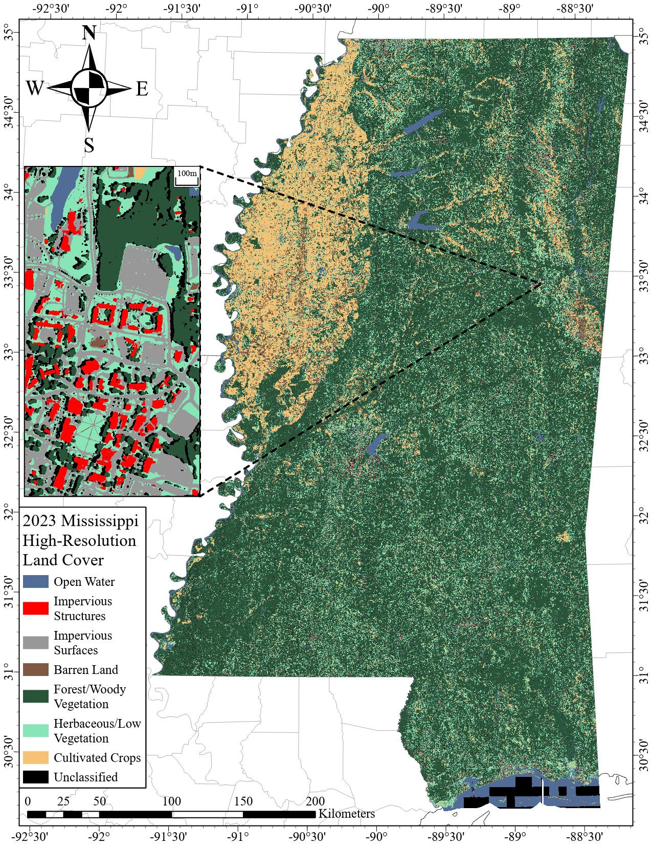
Figure 9: Preliminary high resolution land cover map of Mississippi REFERENCE ME!!!.
True
Label
Predicted
Label
Open
Water
Impervious
Structures
Impervious
Surfaces
Barren
Land
TreeCanopy/
WoodyVegetation
LowVegetation/
Herbaceous
Cultivated
Crops
Unclassified
Producer’s
Accuracy
OpenWater
7154
16
1066
0
344
41
45
141
81.23
%
Impervious
Structures
13
20776
1708
1335
2041
115
4891
0
%
67.28
Impervious
Surfaces
19
2590
124159
1722
9058
14407
13
3225
%
80.00
BarrenLand
21482
1964
298
130287
2798
100670
4008
24151
%
45.61
TreeCanopy/
WoodyVegetation
1064
1403
244
924
2336744
101005
26166
94750
%
91.20
LowVegetation/
Herbaceous
58379
2596
469
24339
57498
851272
29850
136447
73.33
%
CultivatedCrops
6685
0
0
171
3079
48908
148924
603
54.73
%
Unclassified
208
940
3546
384
14128
8236
106
147915
62.64
%
UserAcc.
44.34
78.75
%
70.54
%
70.07
%
64.26
%
96.53
%
75.78
%
%
51.11
%
OverallAccuracy
82.12
%
Table 4: Confusion matrix for the Mississippi dataset REFERENCE ME!.

Conclusion
References
- Michael D. Blum and Harry H. Roberts. The Mississippi Delta Region: Past, Present, and Future. Annual Review of Earth and Planetary Sciences, 40(Volume 40, 2012):655–683, May 2012.
- Chesapeake Bay Program. Chesapeake Bay Land Use and Land Cover (LULC) Database 2022 Edition, 2023.
- CVAT.ai Corporation. Computer vision annotation tool (CVAT), November 2023.
- Jonas Dippel, Steffen Vogler, and Johannes Ho¨hne. Towards Fine-grained Visual Representations by Combining Contrastive Learning with Image Reconstruction and Attention-weighted Pooling, February 2022.
- Earth Resources Observation and Science (EROS) Center. National Agriculture Imagery Program (NAIP), 2017.
- Kaiming He, Xiangyu Zhang, Shaoqing Ren, and Jian Sun. Deep Residual Learning for Image Recognition, December 2015.
- Alain Hor´e and Djemel Ziou. Image Quality Metrics: PSNR vs. SSIM. In 2010 20th International Conference on Pattern Recognition, pages 2366–2369, August 2010.
- F. Hu, G.-S. Xia, J. Hu, and L. Zhang. Transferring deep convolutional neural networks for the scene classification of high-resolution remote sensing imagery. Remote Sensing, 7(11):14680–14707, 2015.
- Nitish Shirish Keskar, Dheevatsa Mudigere, Jorge Nocedal, Mikhail Smelyanskiy, and Ping Tak Peter Tang. On Large-Batch Training for Deep Learning: Generalization Gap and Sharp Minima, February 2017.
- Adrien Lagrange, Bertrand Le Saux, Anne Beaup`ere, Alexandre Boulch, Adrien
Chan-Hon-Tong, St´ephane Herbin, Hicham Randrianarivo, and Marin Ferecatu. Benchmarking classification of earth-observation data: From learning explicit features to convolutional networks. In 2015 IEEE International Geoscience and Remote Sensing Symposium (IGARSS), pages 4173–4176, July 2015.
- Tsung-Yi Lin, Priya Goyal, Ross Girshick, Kaiming He, and Piotr Dollar. Focal Loss for Dense Object Detection. In Proceedings of the IEEE International Conference on Computer Vision, pages 2980–2988, 2017.
- Ilya Loshchilov and Frank Hutter. Decoupled Weight Decay Regularization, January
2019.
- V. S. Martins, D. P. Roy, H. Huang, L. Boschetti, H. K. Zhang, and L. Yan. Deep learning high resolution burned area mapping by transfer learning from Landsat-8 to
PlanetScope. Remote Sensing of Environment, 280:113203, October 2022.
- Dominic Masters and Carlo Luschi. Revisiting Small Batch Training for Deep Neural
Networks, April 2018.
- Misssissippi Automated Resource Information System. Mississippi Transverse Mercator (MSTM) Projection.
- Aamir Mustafa, Aliaksei Mikhailiuk, Dan Andrei Iliescu, Varun Babbar, and Rafal K. Mantiuk. Training a Task-Specific Image Reconstruction Loss. 2022 IEEE/CVF Winter Conference on Applications of Computer Vision (WACV), pages 21–30, January 2022.
- Augustus Odena, Vincent Dumoulin, and Chris Olah. Deconvolution and Checkerboard Artifacts. Distill, 1(10):e3, October 2016.
- Nikhila Ravi, Valentin Gabeur, Yuan-Ting Hu, Ronghang Hu, Chaitanya Ryali,
Tengyu Ma, Haitham Khedr, Roman Ra¨dle, Chloe Rolland, Laura Gustafson, Eric
Mintun, Junting Pan, Kalyan Vasudev Alwala, Nicolas Carion, Chao-Yuan Wu, Ross
Girshick, Piotr Doll´ar, and Christoph Feichtenhofer. SAM 2: Segment Anything in Images and Videos, October 2024.
- Olaf Ronneberger, Philipp Fischer, and Thomas Brox. U-Net: Convolutional Networks for Biomedical Image Segmentation, 2015.
- Karshiev Sanjar, Olimov Bekhzod, Jaeil Kim, Jaesoo Kim, Anand Paul, and Jeonghong Kim. Improved U-Net: Fully Convolutional Network Model for Skin-Lesion Segmentation. Applied Sciences, 10(10):3658, January 2020.
- Natural Resources Conservation Service USDA, Farm Service Agency USDA, and Rural Development USDA. Geospatial Data Gateway, 2016.
- Pascal Vincent, Hugo Larochelle, Yoshua Bengio, and Pierre-Antoine Manzagol. Extracting and composing robust features with denoising autoencoders. In Proceedings
of the 25th International Conference on Machine Learning, ICML ’08, pages 1096– 1103, New York, NY, USA, July 2008. Association for Computing Machinery.
- Karl Weiss, Taghi M. Khoshgoftaar, and DingDing Wang. A survey of transfer learning. Journal of Big Data, 3(1):9, May 2016.
- Michael Wurm, Thomas Stark, Xiao Xiang Zhu, Matthias Weigand, and Hannes Taubenb¨ock. Semantic segmentation of slums in satellite images using transfer learning on fully convolutional neural networks. ISPRS Journal of Photogrammetry and Remote Sensing, 150:59–69, April 2019.
- Jason Yosinski, Jeff Clune, Yoshua Bengio, and Hod Lipson. How transferable are features in deep neural networks?, November 2014.
- Hang Zhao, Orazio Gallo, Iuri Frosio, and Jan Kautz. Loss Functions for Image Restoration With Neural Networks. IEEE Transactions on Computational Imaging,
3(1):47–57, March 2017.

